Lab 6: Code and Branch Coverage Analysis

Roopa Sreedhar A
PES1UG24CS386
G

Before
Run tests:
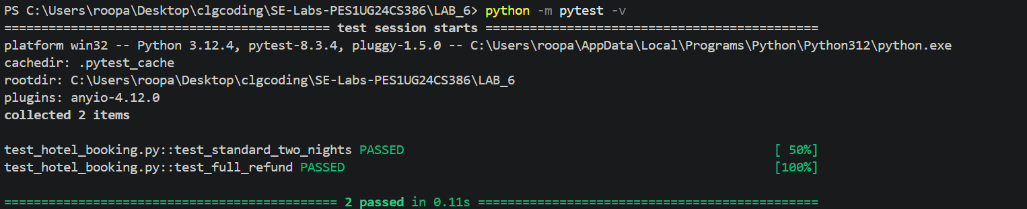

Line coverage:
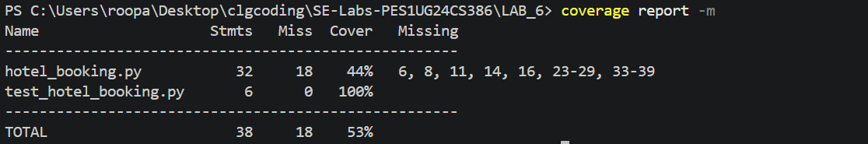

Branch coverage:
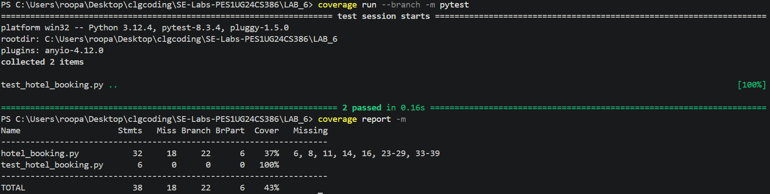

After
Code coverage:
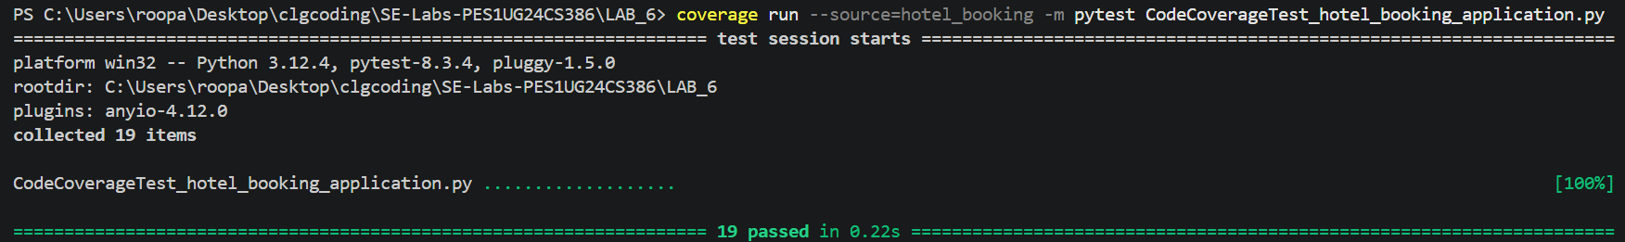
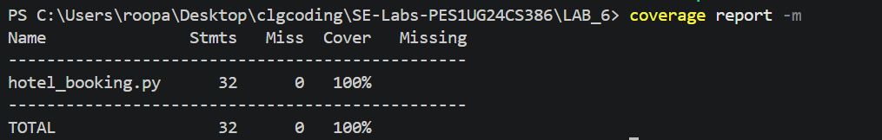

Branch Coverage:


