

|  |
| --- |
| **GROUP MEMBERS: Gracy Singha, Sayani Pramanik,**  **Somashree Mandal, Samrat Mallick**  **Stream: Computer Science and Engineering Year: 3rd**  **Semester: 5th** |
| **PROJECT NAME: STUDENT MANAGEMENT SYSTEM** |
| **SESSION – PHP AND MYSQL DATABASE** |

**Index**

|  |  |  |
| --- | --- | --- |
| SL NO. | Topic | Page No. |
| 1. | Introduction | 3 |
| 2. | Data Flow Diagram | 4-5 |
| 3. | E-R Diagram | 6 |
| 4. | Website Screenshot | 6-9 |
| 5. | Code | 10 |
| 6. | Cocomo Model | 11-12 |
| 7. | MYSQL Database | 13 |
| 8. | Project Name | 14 |
| 9. | Group Members | 15 |
| 10. | Acknowledgement | 15-16 |

**Introduction:**

A Student Management System (SMS) is a software application designed to simplify and automate the various tasks involved in managing student information and educational processes within schools, colleges, and universities. It provides a centralized platform where administrators, teachers, students, and sometimes parents can access and manage essential data related to student enrolment, academic progress, attendance, and communications.

This system enables institutions to handle student registrations, track attendance, manage grades, and even handle fee collection efficiently. It also facilitates communication between teachers, students, and parents by providing portals where they can exchange information or updates regarding a student’s progress. Moreover, an SMS offers tools for scheduling classes and exams, generating reports, and monitoring student performance, thereby improving the overall administrative efficiency of educational institutions. By centralizing and digitizing data, the system ensures easy access to information, enhances accuracy, and helps institutions make data-driven decisions for better educational outcomes.

**Data Flow Diagrams:**

**Level 0 Data Flow Diagram**

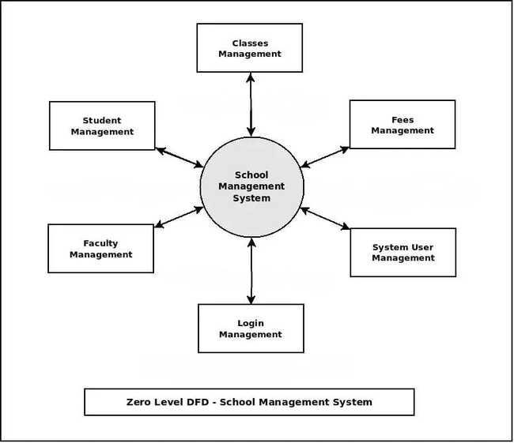

**Level 1 Data Flow Diagram (Customer)**

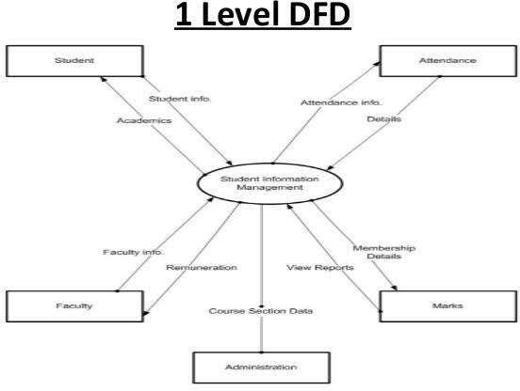

**Entity-Relationship Diagram:**

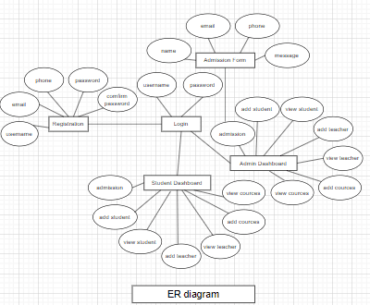

**Website Screenshot:**

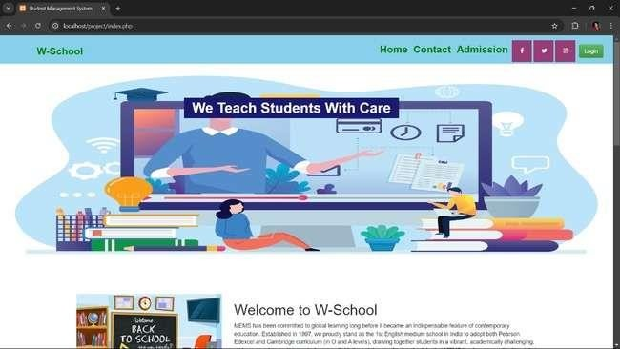

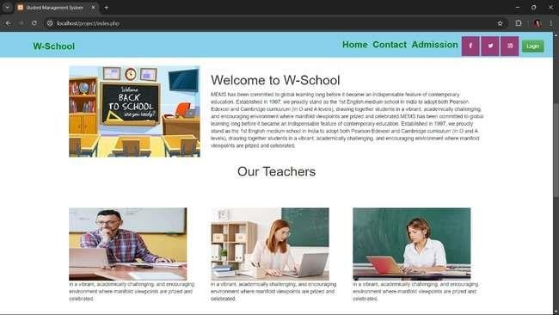

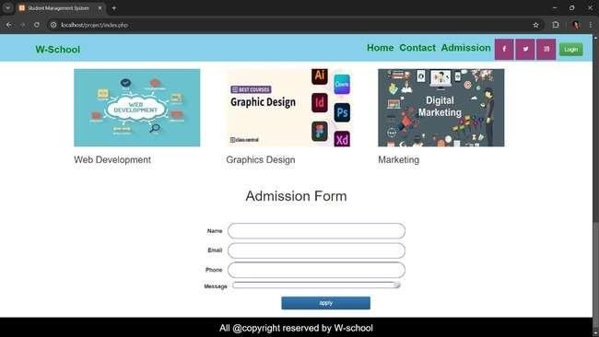

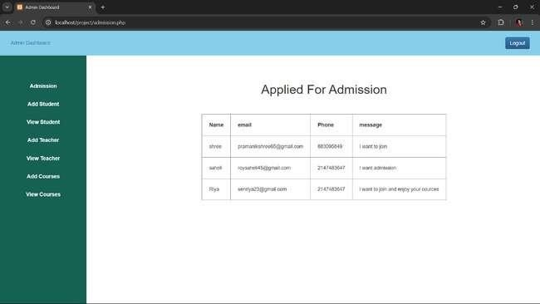

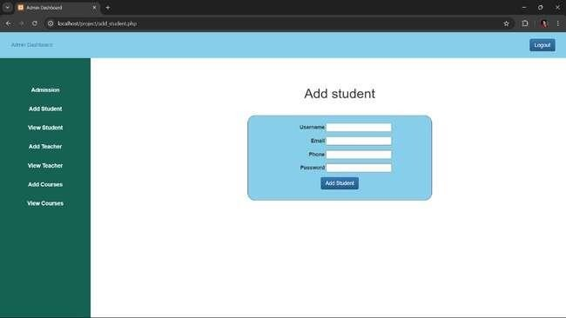

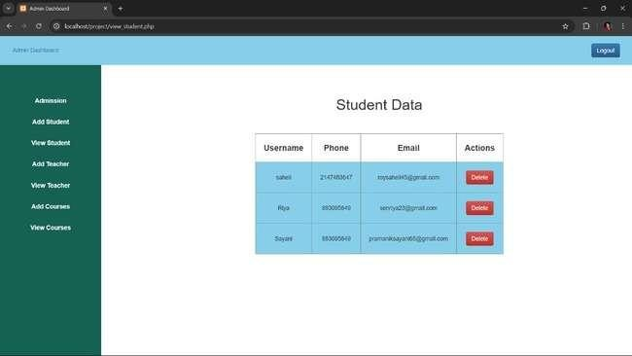

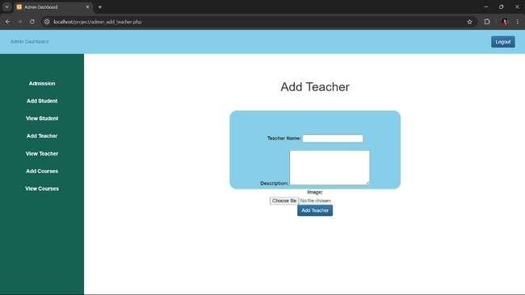

**Code:**

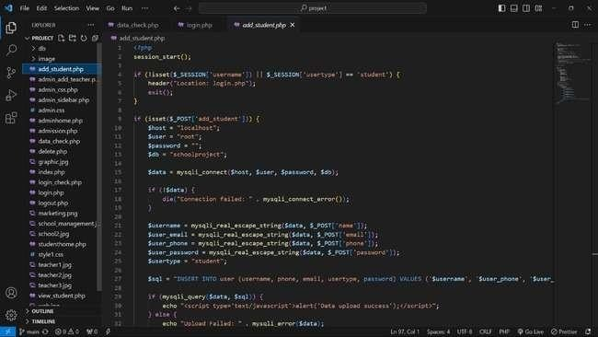

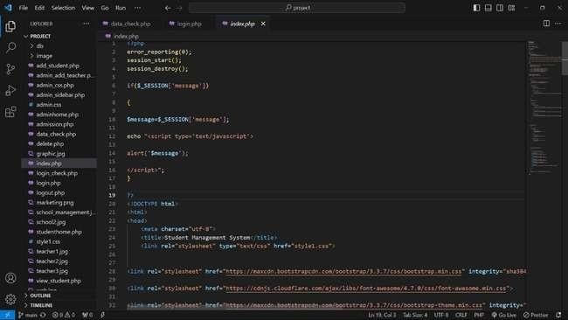

**Project zip file:**



project.zip

**COCOMO Model:**

The COCOMO (Constructive Cost Model) is used to estimate the effort, development time, and cost of software projects. Based on your project being classified as an "organic" type and having an estimated 4000 Lines of Code (LOC), we can use the basic COCOMO model formula for an organic project.

COCOMO Basic Model Formulas:

1. Effort (Person-Months):

𝐸 = 𝑎 × (𝐾𝐿𝑂𝐶)𝑏

where:

E = effort in person-months

KLOC = thousands of lines of code (4000 LOC = 4 KLOC) a and b are constants that depend on the type of project.

1. Development Time (Months):

𝑇 = 𝑐 × (𝐸)𝑑

where:

T = time to develop the software in months

c and d are constants based on the type of project.

For an organic type project, the standard constants are:

* + a = 2.4
  + b = 1.05
  + c = 2.5
  + d = 0.38

**Step 1: Calculate Effort (E):**

𝐸 = 2.4 × (4)1.05

𝐸 ≈ 2.4 × 4.28 ≈ 10.27 𝑝𝑒𝑟𝑠𝑜𝑛 − 𝑚𝑜𝑛𝑡ℎ

**Step 2: Calculate Development Time (T):**

𝑇 = 2.5 × (10.27)0.38

𝑇 ≈ 2.5 × 2.24 ≈ 5.6 𝑚𝑜𝑛𝑡ℎ𝑠

**Step 3: Calculate Number of People Needed (P):**

The average number of people required for the project can be found by dividing the effort by the development time:

𝐸

𝑃 =

𝑇

10.27

𝑃 =

5.6

≈ 1.83 𝑝𝑒𝑟𝑠𝑜𝑛

**Summary of COCOMO Estimation:**

* + Effort: ~10.27 person-months
  + Development Time: ~5.6 months
  + Average Team Size: ~1.83 persons (approximately 2 people)

This means our restaurant management project would take around **5.6 months** with an average **of 2 developers**, and it would require a total effort of **10.27 person-months** to complete.

**MYSQL Database:**

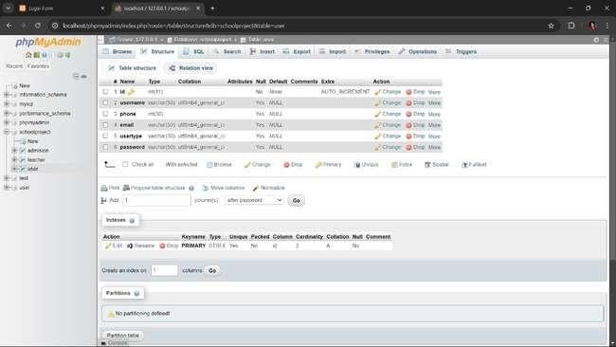

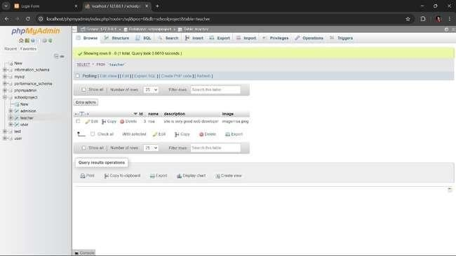

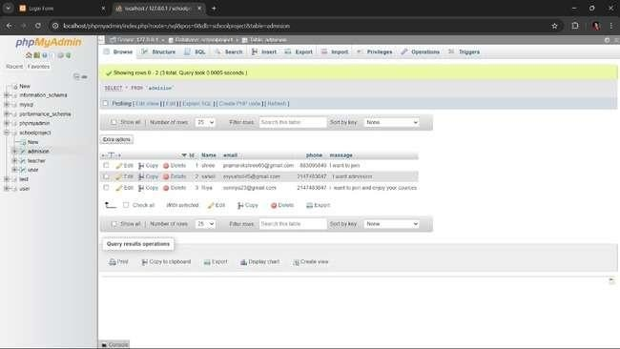

**MYSQL Database ZIP File:**



127_0_0_1.sql

**Group Members of Project:**

**“Student Management System”**

**GROUP MEMBER NAMES:**

* **Gracy Singha (CSE 3rd YEAR)**
* **Sayani Pramanik (CSE 3rd YEAR)**
* **Somashree Mandal (CSE 3rd YEAR)**
* **Samrat Mallick (CSE 3rd YEAR)**

**Acknowledgment:**

I would like to express my sincere gratitude to all those who contributed to the successful completion of the Student Management System. First and foremost, I would like to thank [GMIT] for providing me with the opportunity and resources to develop this project.

A special thanks to my project guide, [Somnath Barik sir], for their invaluable guidance, constant support, and constructive feedback throughout the development process. Their encouragement motivated me to improve and refine this project at every stage.

I am also grateful to my teachers and colleagues for their insightful suggestions and cooperation, which

helped in shaping the project. Additionally, I extend my heartfelt appreciation to my family and friends for their unwavering support and encouragement throughout this journey.

Lastly, I thank everyone involved in the development and testing of the system, whose input and efforts made this project a reality.