Sample of how I have been doing things thus far

* Organize FITS files into logical structure ideally named: bias, dark, ee_cep, flat, pol_std  
  Graphical user interface, application, table, Excel

  Description automatically generated
* Enter MJD (‘YYYY-MM-DD’date). Load FITS data and check file distributions

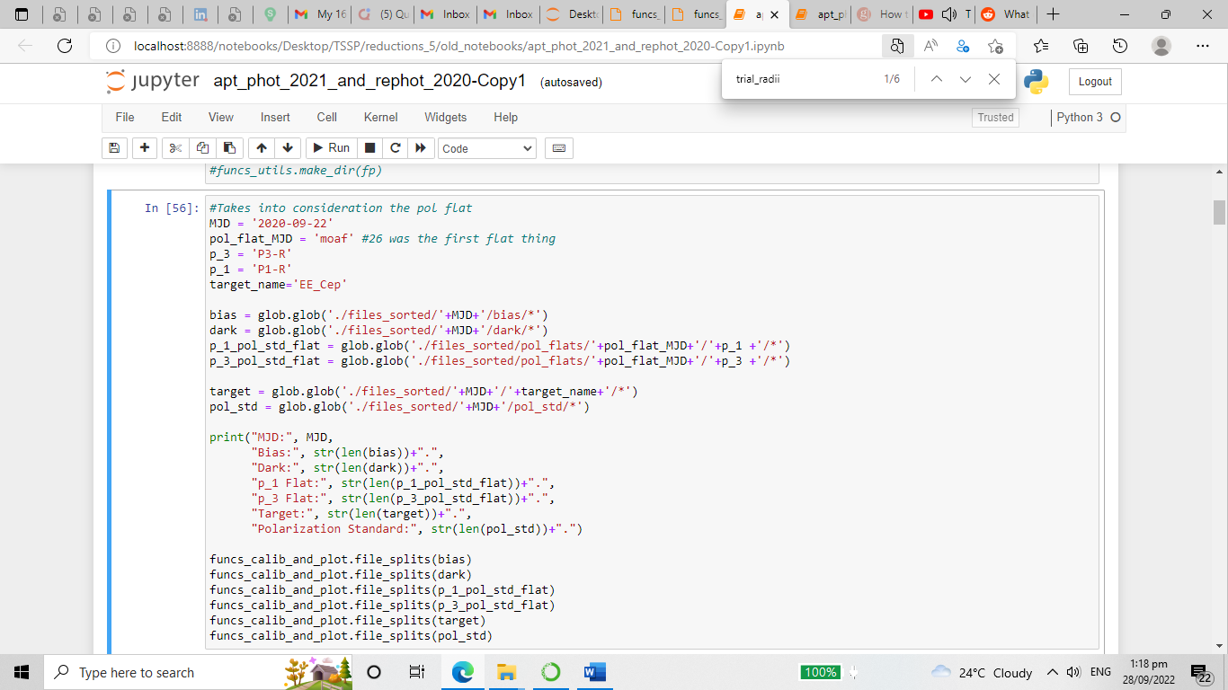

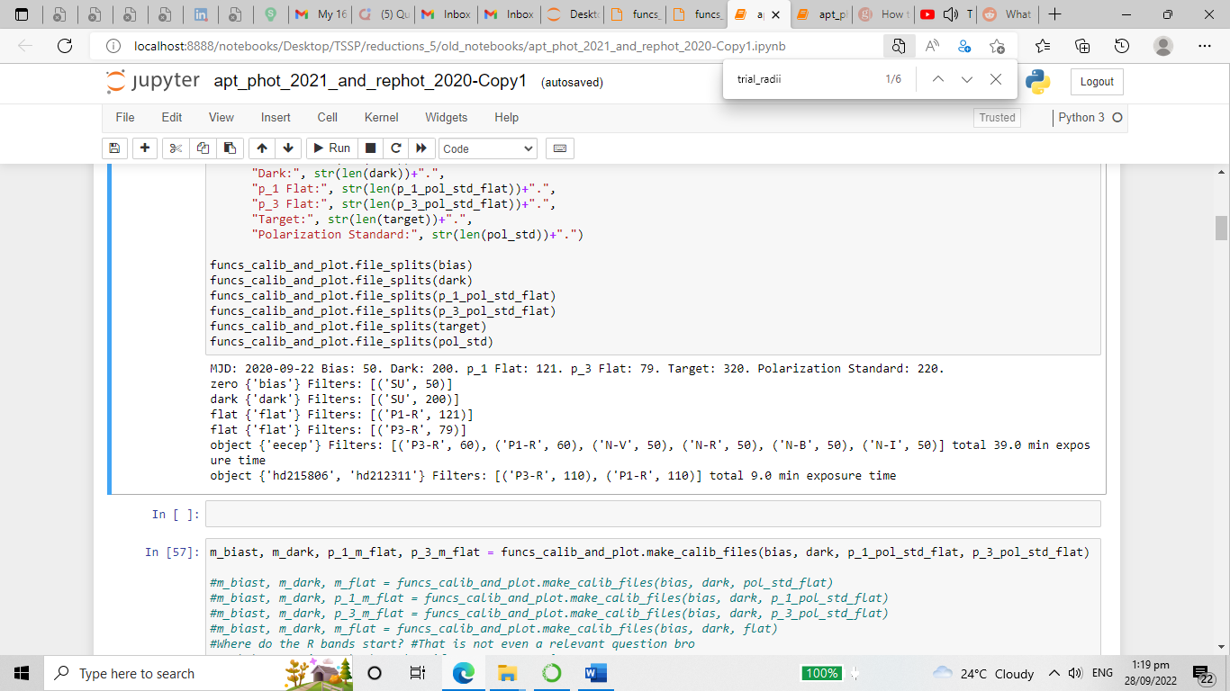

* You can visualize a section of the list sliced by string integer segment to check for meridian shift or anomalies (cosmic rays, bad data)

* Take a sample image and test the search_bracket to target (I like to call it “bracketing”) the star. Looking at the thresholding is optional.

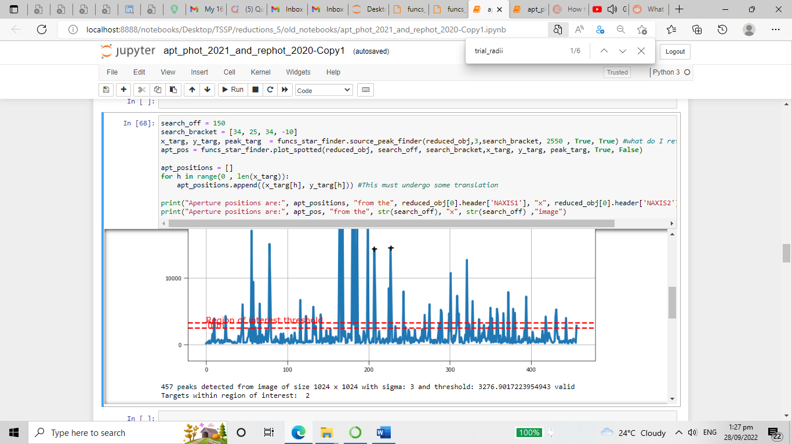

* Organize flux counts results and remove outliers
* Load flux results (Manually as of writing this documentation)
* Compute polarimetric and plot polarimetric parameters
* Analyze polarimetric parameters
* Load light curve
* Compare polarimetric data with light curve