STAT 805 Portfolio Report

This study seeks to examine the correlations between daily routines of an AUT student Afiq Abdul Hamid ID 18015518 in terms of 3 aspects of daily life. Those are:

* Sleep Time and Sleep Duration
* Caffeine intake/ Number of cups of coffee consumed per day and what time
* Productivity (Time spent on academic/ non-academic tasks that require utilization of cognitive ability)

Data was recorded for 30 Days beginning on 10 April of 2019 and the following essential fields are collected during the day.

* Wake Up time
* Morning Productivity
* Night Time Productivity
* Sleep Time
* Sleep Duration (calculated from Sleep and Wake Up time)
* Time of Caffeine Intake
* Number of Cups of coffee (calculated from Time of Caffeine Intake)

Additionally, the study was mainly conducted during 2-week midsemester break under duration of aiming to meet a submission date of the Torun Astrophysics Summer Program 2019 Application Submission Deadline which stimulates necessity for productivity despite leisure time. However, data is still recorded during a significant duration of normal semester dates.

|  |  |  |
| --- | --- | --- |
| Aspects of Daily Routine | | |
| Sleep | Coffee | Productivity |
|  |  |  |

Some questions that we seek to answer via this study/ statistical analysis.

* Is more work done in day time or night time/ am I a morning person or a Night Person?
* Sleep Hours vs Prod
* Is there a correlation between Cups of coffee and productivity?
* Do I a coffee addiction?
* Is more coffee consumed on week days?

# Test 1 Day/ Night Productivty

We wish to answer the question of whether more work is accomplished during morning time or at night. Am I a Night Owl or a Morning Bird?

**Null Hypothesis (Ho): Is that equal amount of work is done. During the day and during the night. There is no difference between the means of Morning Productivity and Night Productivity**

**Alternate Hypothesis (H1): I am either a Morning Person or A Night Person**

We use a two-sided paired T test because it concerns the difference between the average scores of a productivity hour assessed at two different times (Day/ Night) and the test can fall either way: Day or Night

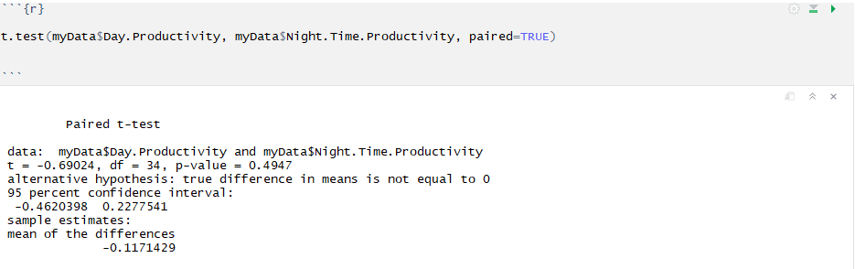

From the T test we fail to reject the null. There is no difference between significant difference between mean day or night time productivity hours.

# Test 2 Coffee and Productivity?

Coffee is great, it’s a confirmed stimulant that has probably led to quite a few scientific discoveries during the history of mankind. But is there a statistical correlation between cups of coffee and productivity. Poisson distribution is great, its practical application stemmed from observing the number of deaths by horse kicking (small p) in the Prussian army (large n)

We want to find whether we can use Poisson distribution to model high productivity and cups of coffee. Null Hypotheis.

**Ho: High productivity is not affected by coffee.**

**H1: High Productivity is affected by coffee.**

Step 1, find lambda.

Take Obs X = 3

# Test 3 Coffee am I addicted to it?

As previously mentioned, coffee is great but drinking moderate amounts of Coffee during the week is fine but there’s no need to take it to excess on the Weekends, since that would be no different from abusing it as a substance. Go hard or go home.

We define the case of having an excessive coffee as consecutive days of having 2 or more cups or singularly having 3 cups in a single day. We wish to use Fishers exact test to determine whether I have a coffee addiction or not i.e. whether I use on weekends.

**Null Hypothesis (Ho): Is that there is no substance abuse. No cause for concern.**

**Alternate Hypothesis (H1): I am a coffee addict. I have addiction to caffeine.**

First, we form out contingency table.

|  |  |  |
| --- | --- | --- |
|  | Consecutive days | Non-Consecutive days |
| Weekend | 4 | 6 |
| Weekday | 5 | 20 |

We define our parameters:

Weekend Ends Survey = 4 + 6 = 10

Week Days Survey = 5 + 20 = 25

Number of Consecutive Days of Drinking 2 or more Coffees/ 3 Cups in a single day = 5 + 4 = 9

Number of Days of Normal Drinking Habits = 20 + 6 = 26

Now Calculate P value.

# Test 3 Sleeping Late is Bad for Productivity

Pearson’s Chi Squared Test

Null Hypothesis (Ho): The later you sleep has no effect on your productivity the following day.

Alternate Hypothesis:

# Test 4 Sleep and Productivity Correlation

Linear Regression

Null Hypothesis (Ho): The longer you sleep the more productivity you get done

Alternate Hypothesis:

# Test 5 Coffee past 8 makes you sleep late

Null Hypothesis (Ho): Having a coffee past 8 has not severe correlation to sleep pattern/ Is not a cause for sleepless night.

Alternate Hypothesis: