ASTR 800 Advanced Topics in Astrophysics Report

Table of Contents

1. Introduction

Introduce Scientific Motivation

1. Relativity and Space Time Stuff
   1. Gravitational Waves

Original Prediction/ History of Detection/

* 1. The Search for Gravitational Waves
     1. Global Detection Effort (LIGO, Adv LIGO, VIRGO, LISA)

Global Efforts to detect gravitational waves

* + 1. Gravitational Wave Background

Characteristic strain vs frequency

* + 1. Gravitational Wave Astrophysical Significance: Multi Messenger Astronomy
       1. Tracing the Kilonova, Follow up from LIGO Observation
       2. What is Multi messenger Astronomy
       3. What this means for the Future

1. Pulsar Astronomy and Spectroscopy
   1. A Brief History of Pulsars

Original Discovery/ Physical Description/ Detection Characteristics

* 1. The Uses of pulsars
  2. Pulsar Timing Array
     1. Description of Experiment
  3. Challenges with Pulsar Spectroscopy (identify pain points)
     1. Multipath Scattering Delay
        1. Define the Challenge
        2. Effects on Timing Residual
     2. Time Domain/ Frequency Domain Resolution
        1. Define the challenge
        2. Effects on Signal Content
  4. Cyclic Spectroscopy
     1. Brief Description of Cyclostationary Process
        1. Probability Density Function
     2. Application of of Cyclic Spectroscopy to Pulsar Astronomy
        1. Example Implementation (How To do):
           1. Case Study: CYCLIC SPECTROSCOPY OF THE MILLISECOND PULSAR, B1937+21Mark A. Walker1, Paul B. Demorest2, and Willem van Straten3
           2. Case Study: Cyclic spectral analysis of radio pulsars P. B. Demorest NRAO
        2. Example Application Case Study: Scintillation Studies with LOFAR
     3. Additional Benefits Provided by Cyclic Spectroscopy
        1. Impulse Response of the Interstellar Medium

1. Conclusion and Future Works
   1. Proposal of Cyclic Spectra Processing Pipeline
   2. Final Remarks

# Introduction

1.3 Million Years Ago in a Galaxy Merger far far away; two Supermassive black holes began a Spiralling death dance into each other emitting travelling distortions in the fabric of space time. After having rippled through the Universe at the speed of light for over a billion years the travelling distortions of space time encountered the 3rd planet orbiting a humdrum star tucked nondescriptly between the Sagittarius and Perseus Arms of the milky way Galaxy. On the planet, two light beams that had been positioned by the ape risen inhabitants of that third planet to cancel each other out in their own similarly physically deathly encounter became a little out of step due to the minute distortions caused by the waves of propagating space time. It was with that glinting of light on two photodetectors on the planet that the inhabitants of that planet confirmed the existence of Gravitational Waves ushering in a New Era for Astronomy and Astrophysics on that planet. Although to most of the conscious apes that had organized the experiment the whole thing really seemed like quite the “stretch” of the “imagination”.

(Get it because gravity waves stretch and squeeze space Time)

# Relativity and Space Time Stuff

We live in very interesting times at the early 21st century. A time-period that comes with its own set of astrophysical Mysteries. One such mystery is the nature of gravity. One of the 4 Fundamental Forces of Nature alongside the strong/ weak nuclear forces and Electromagnetism. Gravity is the force that applies to very large objects in the Universe and it is the reason that Galaxies are shaped the way they are, that planets go around stars and not the other way around, and why apples fall onto the heads of English mathematicians trying to figure the whole thing out.

In 1687 One English Mathematician named Isaac Newton had figured out a piece of that mystery and called it the Law of Universal Gravitation that connects every particle in the Universe with every other particle with a force that is directly proportional to their masses and inversely proportional to the square of the distance between their centre of Mass. Newton had found out the ‘What’ of Gravity but was unable to solve the ‘Why’ of Gravity.

More than 200 years later in 1915, a German Physicist/Mathematician named Albert Einstein decided to pick up where Newton left off by introducing geometry into the solution in his Law of General Relativity (GR). According to Einstein’s GR objects with mass create curvatures in space time and move along straight line geodesics created by curvatures of even larger objects. The More Massive the object the More Curvature it creates, the more Curvature created the stronger the effect of Gravity.

In a nutshell (a symmetric nutshell): Mass tells space time how to be shaped while space time tells mass how to move.

## Gravitational Waves

Part of Einstein’s GR was a prediction of a phenomena called Gravitational Waves. That are described as travelling distortions (hu,v) in the fabric of otherwise flat Minkowsikan space time (nu,v). These waves are produced by the acceleration of massive objects like Neutron Stars and Black Holes.

These waves would stretch and squeeze the shape geometry of space time almost like a rubber band causing a measurable characteristic strain (hu,v) on that geometry. This Geometric Strain can be thought of as rate of change of Length per Unit Length (𝛿L/L).

However, Einstein thought nothing much of this stretching and squeezing, thinking the effect of being little physical significance because they would be too faint to measure. Having diminishing values in all cases. *Can I say faint values in all directions?

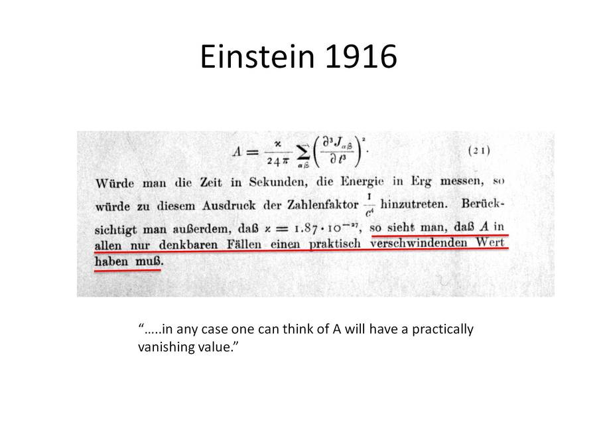

Figure 1: Einstein's Original Prediction of Gravity Waves and his original disregard for their consequence outlined in red.

Figure 1 shows Einstein’s original thoughts on Gravitational Waves where A is the rate change of length per unit length (𝛿L/L). The word “verschwindenden” describes how the waves would have properties that would “disappear” across all values. He was right in 1916. But now 100 years later standing on his shoulders, Physicists, Mathematicians, and Astronomers get a chance to do to Einstein, what Einstein did to Newton.

To take things one step further…

## The Search for Gravitational Waves

In order to take things one step further; and measure the faint distortions of space time metric (h) that Einstein had disregarded. Two types of condition are usually satisfied.

* Sufficiently Long Baseline Distances (L)
* Very Small Displacements Measures. (dL)

Since the value of A is very small, either L (The distance that we measure them over) must be very large or dL (The change of distance displacement measured has to be very small). The device that can be applied to this problem is called an Interferometer.

Interferometers are a commonly used tool that can be used to measure a diverse set of physical phenomena. They exist in many shapes and sizes but all work to superimpose beams of light to produce an *interference pattern* that when studied can shine light on the nature of the objects that created them.

The type of Interferometer used is a Michelson Interferometer.

Gravitational Waves are

To further get a better grounding in the theory let us compare Let’s compare Gravitational Waves are *In this section right here, highlight the fact that gravitational waves are not interacting

|  |  |  |
| --- | --- | --- |
| Characteristic | Gravitational Waves | Electromagnetic Waves |
|  |  |  |
| Propagation | Quadropole Transverse | Dipole Transverse |
|  |  |  |

### Observatories around the world

The effort to detect gravitational waves is a global effort involving observatories and from many nations and research Institutions using different types of Methods and Instrumentation to detect gravitational waves.

#### Ground Based Laser Interferometers

Observatories: LIGO/ Advance LIGO United States, VIRGO Italy

Using very sensitive lasers in a Michelson Interferometer configuration the LIGO Interferometers began construction in the early 1990’s, was finished and had its first light in 2002. After several observation runs the sites were upgraded to Advanced LIGO in 2015 operating at 3 times more sensitivity than the original LIGO. Advanced LIGO was successful at detecting the first gravitational wave in 2015.

The Following is a timeline of the detection of Gravitational Waves matched with their Merger Event Sources.

|  |  |  |  |  |  |  |  |  |  |
| --- | --- | --- | --- | --- | --- | --- | --- | --- | --- |
| GW Event | Date Time Event | Distance Estimate/ Where to find | Object A | | Object B | | Remnant | | Comments |
| Type | Mass | Type | Mass | Type | Mass |
| GW150914 |  |  | BH |  | BH |  | BH |  | First Detection |
| GW151012 |  |  |  |  |  |  |  |  |  |
| GW151226 |  |  |  |  |  |  |  |  |  |
| GW170104 |  |  |  |  |  |  |  |  |  |
| GW170608 |  |  |  |  |  |  |  |  |  |
| GW170729 |  |  |  |  |  |  |  |  |  |
| GW170809 |  |  |  |  |  |  |  |  |  |
| GW170814 |  |  |  |  |  |  |  |  |  |
| GW170817 |  |  |  |  |  |  |  |  |  |
| GW170818 |  |  |  |  |  |  |  |  |  |
| GW170823 |  |  |  |  |  |  |  |  |  |

Curiously enough BH on NS mergers have yet to be detected.

More detectors Soon to be built:

KAGRA Japan,

INDIGO India

#### Space Based Interferometers

The Laser Interferometer Space Antenna (LISA) by the European Space Agency (ESA) will take the concept of LIGO

#### Radio Telescope and Interferometers

PTA Pulsar Timing Arrays

Using the most powerful Radio Telescopes to detect difference in arrival time of Signals

#### Cosmic Microwave Background Radio Telescope

BICEP/ BICEP2

### Gravitational Wave Background

Since the formation of the Universe there have been many sources that could have produced Gravitational Waves over time. Mergers between Supermassive Objects have been going on for a very long time.

The big picture from all of this is that eventually we are moving towards a mapping of the gravitational wave background of the. Like the CMB image produced by the WMAP satellite (Figure 2) Gravitational Wave Astronomers want to build a Gravitational Wave baby picture.

The quest has just begun.

### Gravitational Wave Astrophysical Significance: Multi Messenger Astronomy

#### Tracing the Kilonova, follow up from LIGO Observation

Immediately following the LIGO detection of Gravitational Waves follow up observations were conducted using other telescopes operating across the electromagnetic spectrum. The other telescopes were able to confirm the occurrence of a Kilonova. A short-lived astronomical event that happens in compact binary systems of Neutron Stars and/or Black Holes merging into each other. These kilonvas are ​1⁄1000 th the brightness of the self-detonation of a massive star at the end of its life, typically called a supernova.

When viewed from other telescopes such as in the optical we can imply the existence of Rare/ Heavy Elements such as Platinum (Pt) and Gold (Au) further improving models of the origins of the elements found on planet Earth.

#### What is Multi Messenger Astronomy?

LIGO made other observatories point to Neutron Star Merger

Ice Cube made other observatories point to Blazar

#### What this means for the future

Astronomy is only going to get tougher to do on and therefore it will not pay to do it solo. Collaborations will be the way of the future. Gone are the days of a lone Astronomer sitting on top of Mount Wilson and figuring out the rate of Expansion of the Universe through observation. The Astronomer of Today works across multiple borders and via online channels to manage data and observational infrastructure.

We will need better and better crossmatching algorithms to match different sky surveys to each other. Cross Matching Algorithms for large catalogues. The catalogues will get bigger and will have to match between many different types of surveys.

Indirect Observations will become a key way to discover new Astrophysical Phenomena.

# Pulsar Astronomy and Spectroscopy

## A Brief History of Pulsars

Discovered in 50 years ago by

As astrophysical objects they are quite useful. They a

## The Uses of Pulsars

A stopwatch among the stars

A lighthouse in the heavens

A physics laboratory in deep space

## Pulsar Timing Arrays

Originally proposed by Foster and Backer 1990

Objective is to study the timing correlations of multiplw millisecond pulsars as a function of Angular Separation.

### Description of Experiments

Pulsar Timing

## Challenges of Pulsar Spectroscopy

### Multipath Scattering Delay

### Time domain/ Frequency Domain Resolution

## Cyclic Spectroscopy

### Brief Description of Cyclostationary Process

#### Probability Desnsity Function

### Application of Cyclic Spectroscopy to Pulsar Astronomy

#### Example Implementation

Case Study: CYCLIC SPECTROSCOPY OF THE MILLISECOND PULSAR, B1937+21Mark A. Walker1, Paul B. Demorest2, and Willem van Straten3

Case Study: Cyclic spectral analysis of radio pulsars P. B. Demorest NRAO

#### Example Case Study

Scintillation Studies with LOFAR

### Additional Benefits of Cyclic Spectroscopy

Impulse Response of the Interstellar Medium

# Conclusion and Future Works

In the 50 years since their discovery Pulsars continue to be a source of astrophysical Mystery and among all other mysteries one that may connect us with some very fundamental truths about the Universe.

## Proposal of Cyclic Spectra Processing Pipeline

## Final Remarks