EBook TSS Module Manual

1. EBook TSS user will login into the web application using the following web page:-

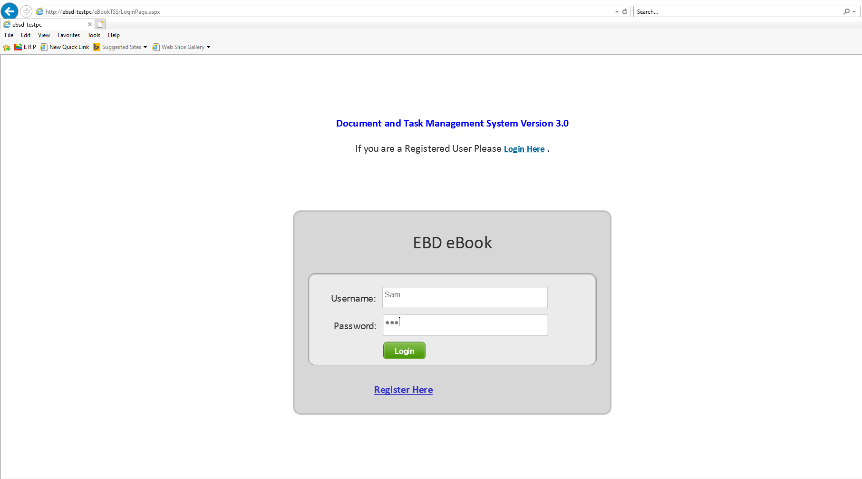

1. After successful login the following web page (Dashboard) will be displayed :-

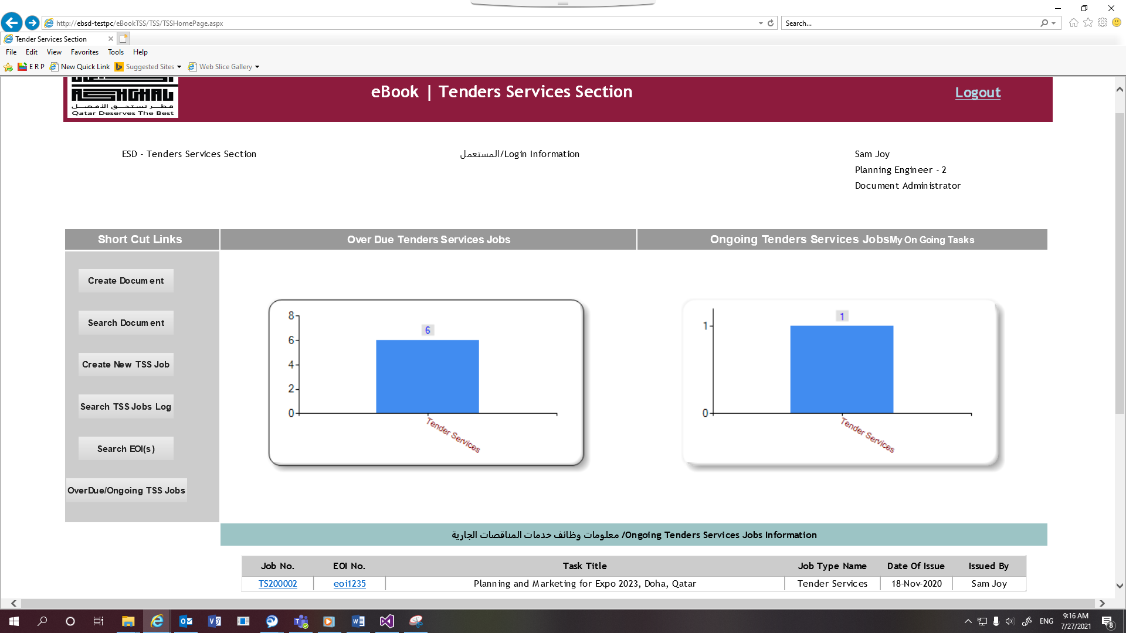

1. If the end user has privilege (usually Document Controller user has the privilege) to create document, then after click on “Create Document” button, first button on the left side under the Short Cut Links. The following web page will open:-

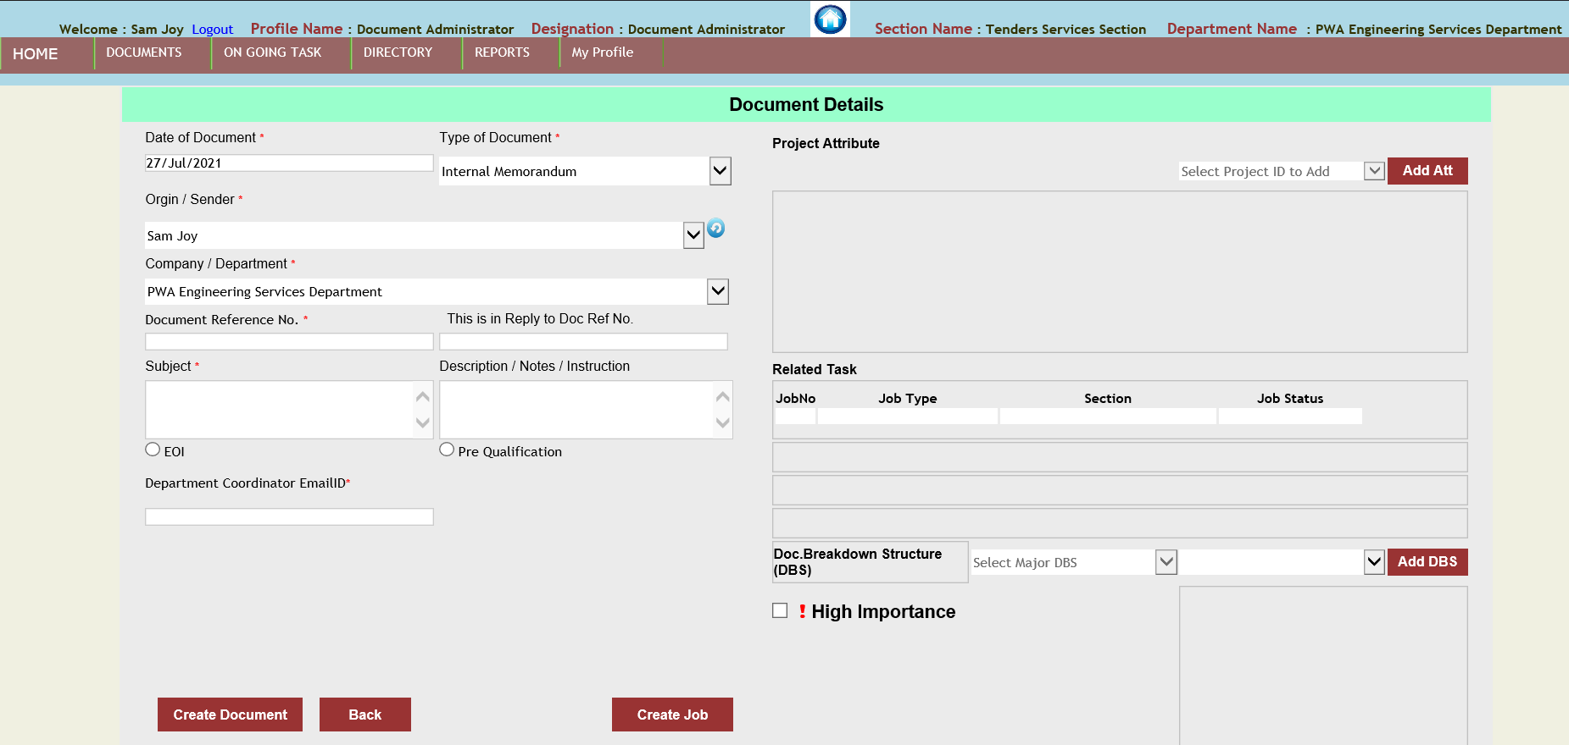

1. The following are two types of documents that an end user can create :-
   1. EOI (Expression of Interest)
   2. Pre-Qualification
2. User clicks on “Search Document” button to search for the documents created by them or received from others.

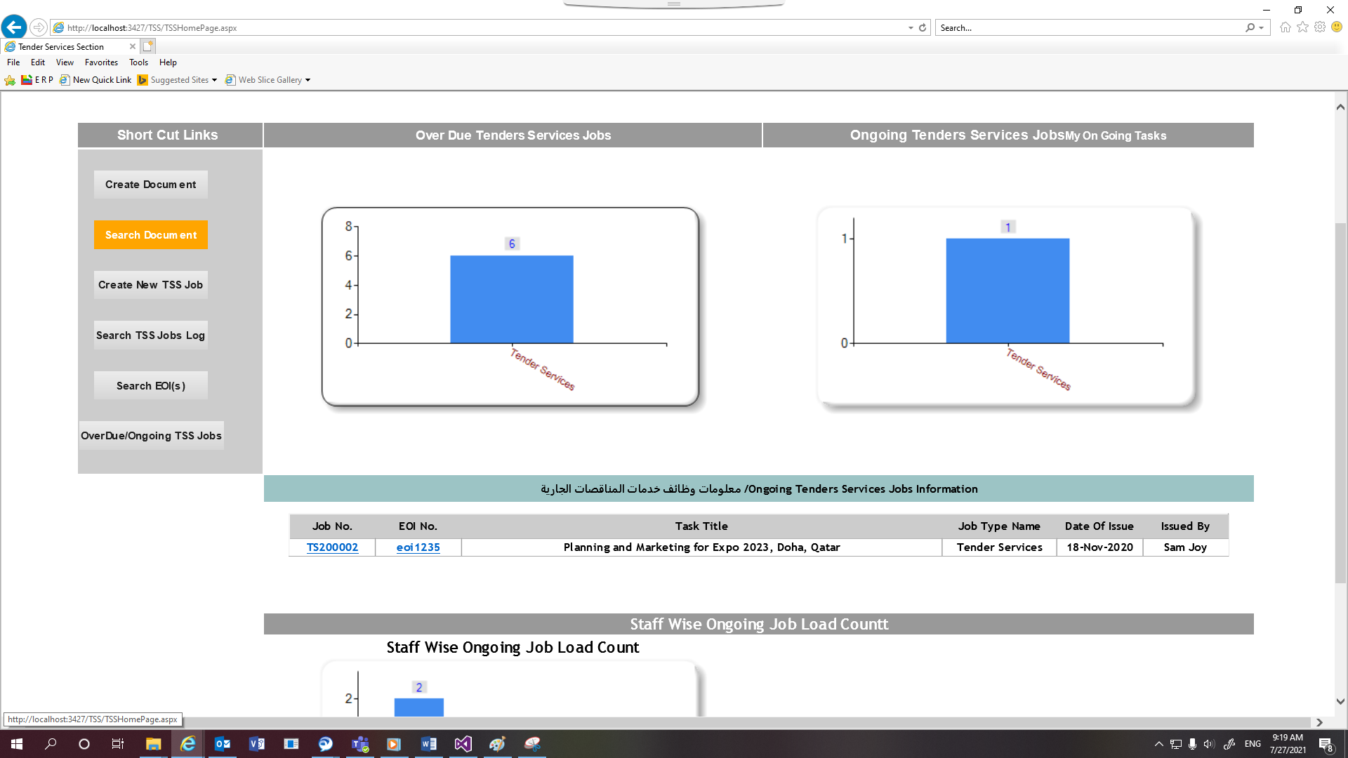

1. The following search document web page opens :-

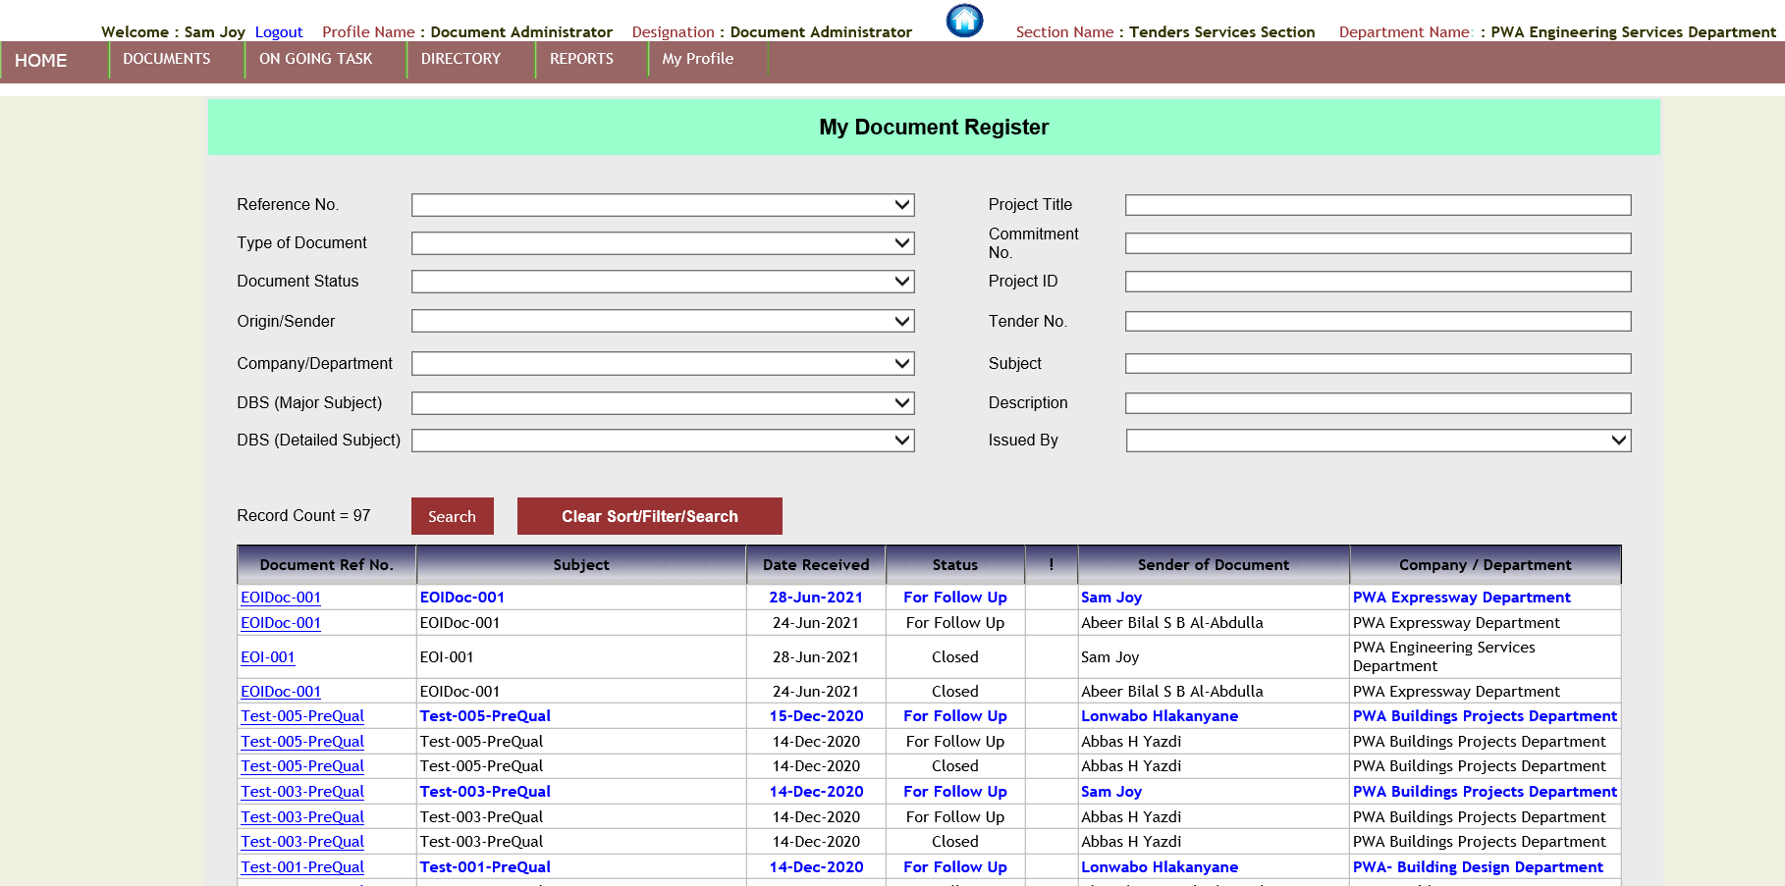

1. The user selects the reference number from the drop-down list and click on “Search” button. The EBook application will display the specific record of the document in the table below the “Search” button.

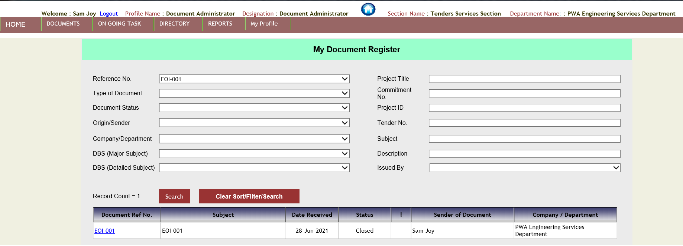

1. The user clicks on the “EOI-001” link under the document reference number column. The following web page opens :-

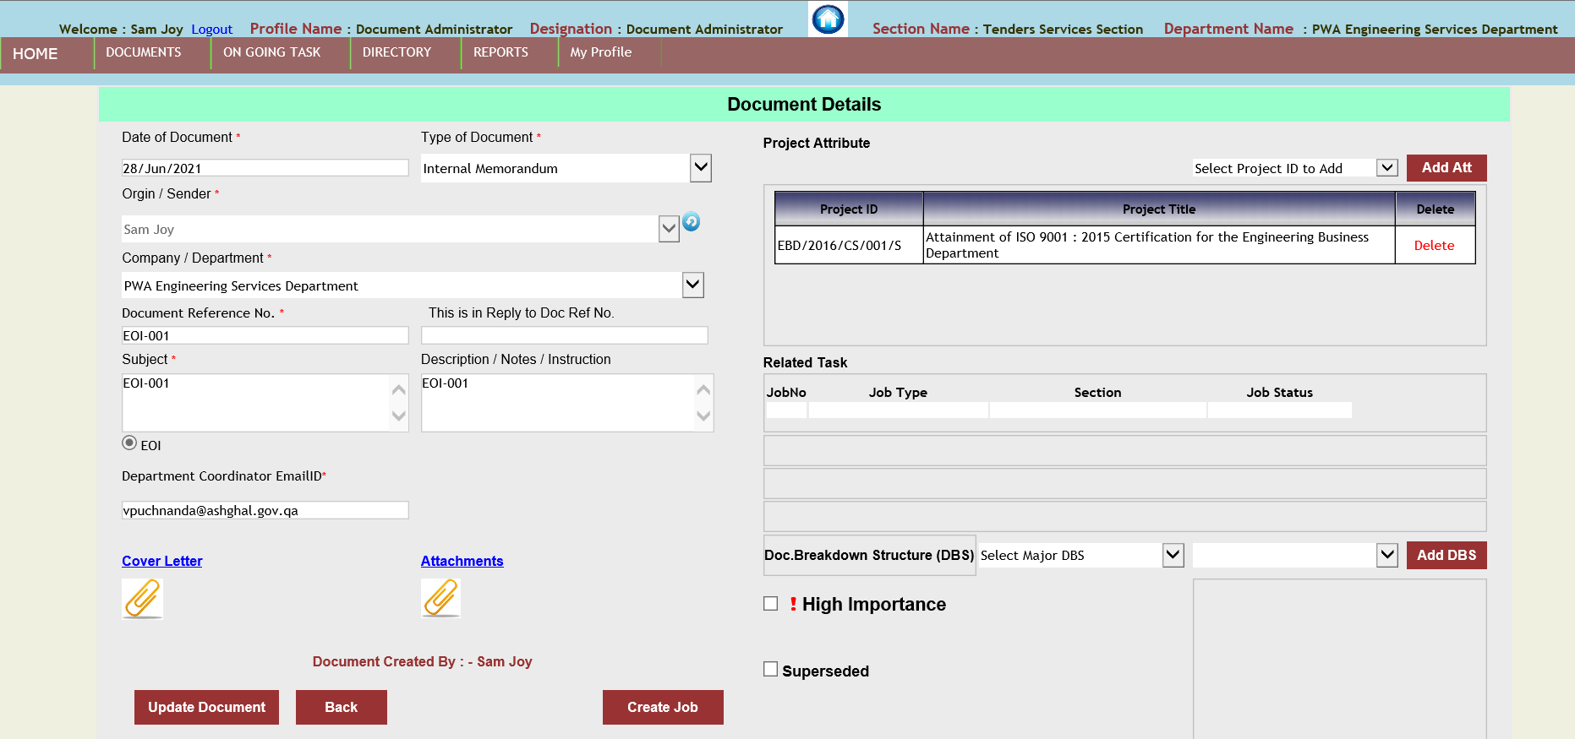

1. If the document is not associate with any job, then the “Create Job” button will be displayed, otherwise this button will be invisible.
2. After click on “Create Job” button. The web application will display the following web page :-

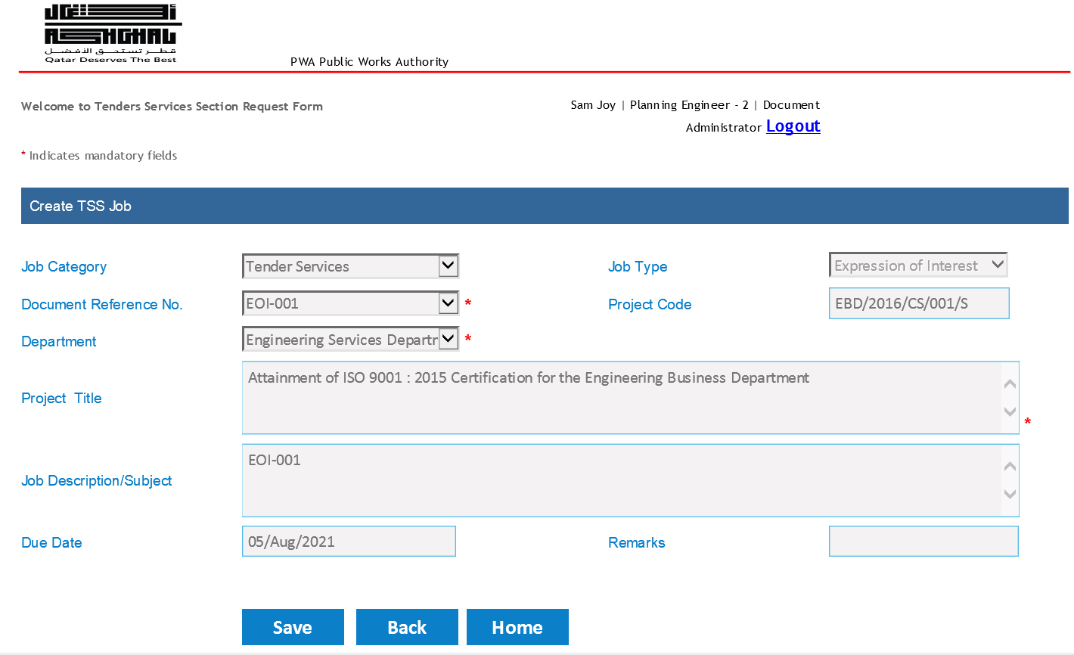

1. The Job type, document reference number, department, project title, Job description and due date will auto filled based on the values already present in the “Document Details” web page.
2. Once the EOI type Job have created, only EOI Admin user has privilege to assign the EOI Number.
3. According to the work-flow of the EOI number generation, usually head of section or team leader of TSS module will add EOI admin user for assigning the EOI number. The following is the screenshot of that :-

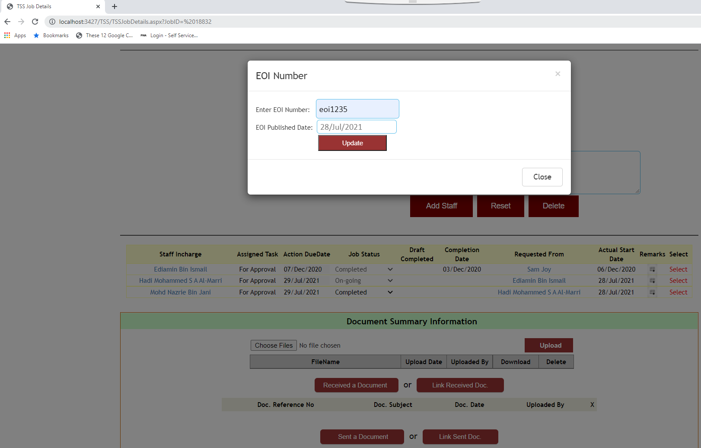

1. On every task assignment, the staff who has assigned a task will receive an email. If a task is assigned to the head of section of TSS and when the head of section of TSS logs into the web application. The head of section of TSS will view the following screen:-

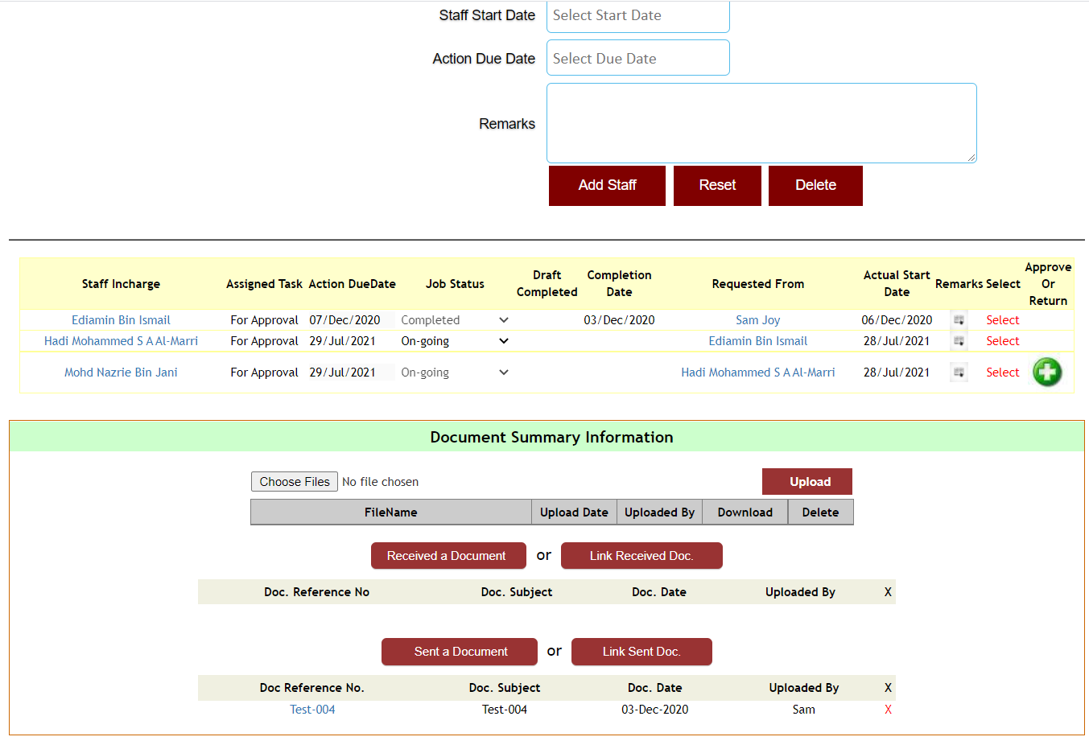

1. When the HOD of TSS module clicks on the green plus button the following window will open:-

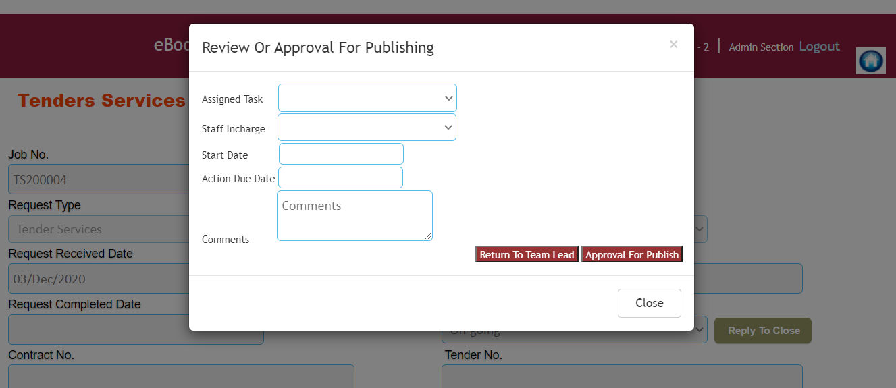

1. If the HOD of TSS selects For Distribution or For Approval assigned task, then under staff-in charge dropdown-list only those names of users who are having EOIAdmin profile will come. The following is the screen shot:-

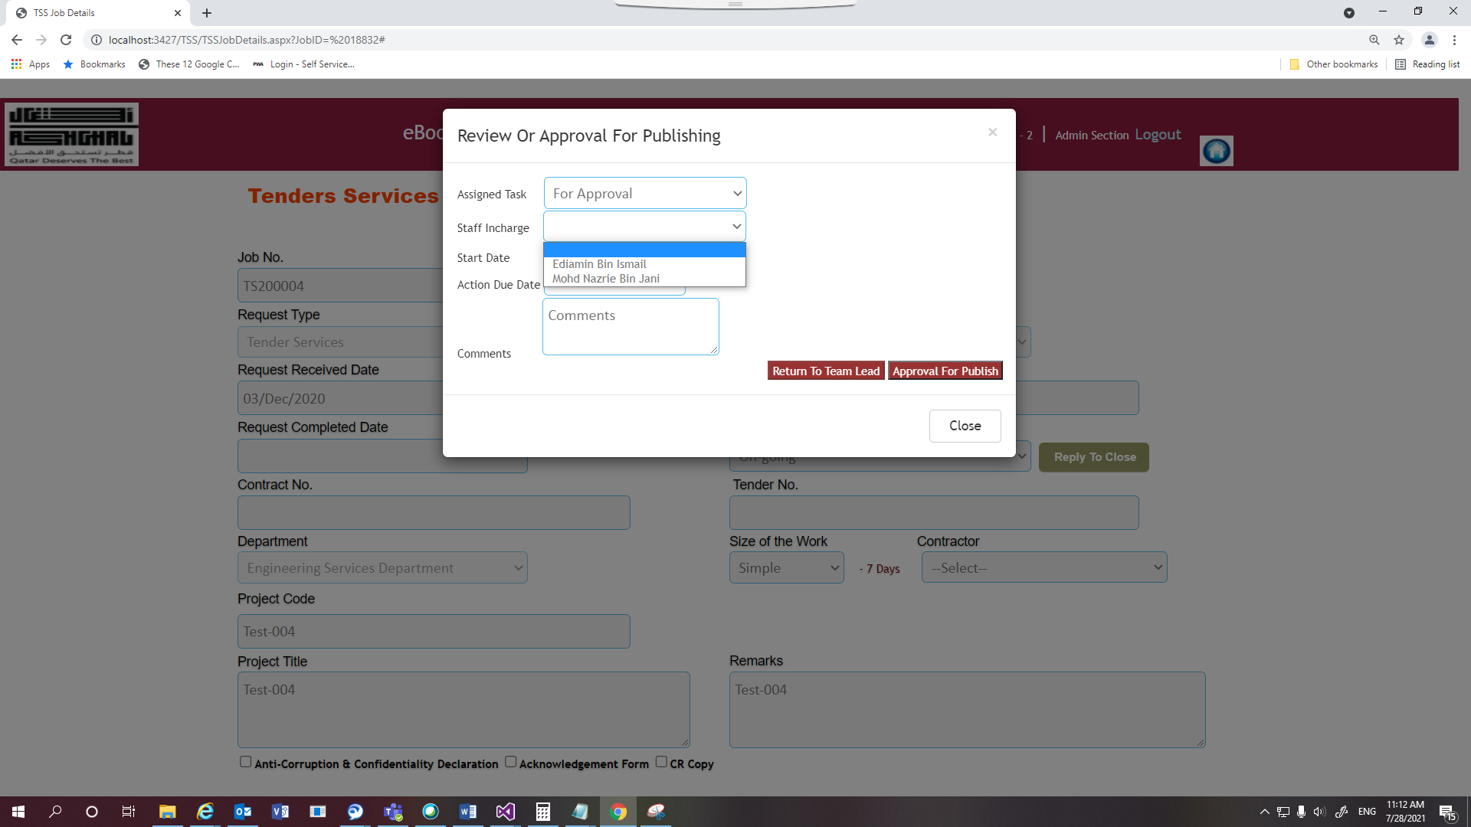

1. If the HOD of TSS selects other than For Distribution or For Approval assigned task, for instance, then For Action, then all the names of users under staff-in charge dropdown-list be displayed. The following is the screen shot:-

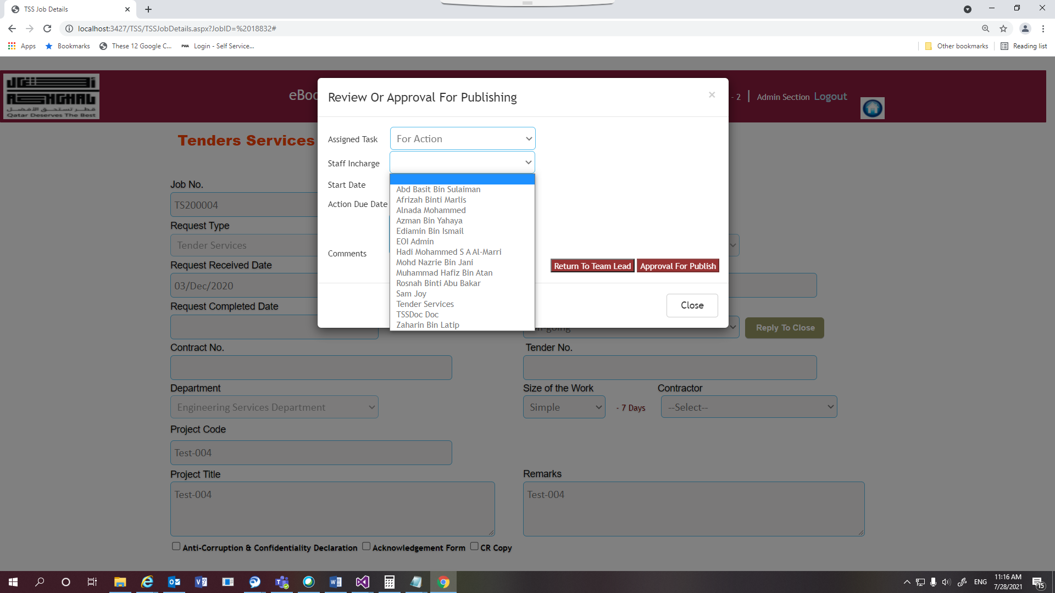

1. On selection of For Action, For Review and For Coordination user can only click on “Return To Team Lead” button. If the option selected is For Approval and For Distribution then only the button on the right of “Return To Team Lead” will be enabled. For example, “Approval For Publish” or “For Distribution”.
2. In case, the Job created is non-EOI, which is Pre-Qualification. There is no EOI number generation under Pre-Qualification Job.
3. User clicks on “Search TSS Jobs Log” link button on the dashboard of TSS module under the shortcut links on the left side.



1. The following web page opens :-

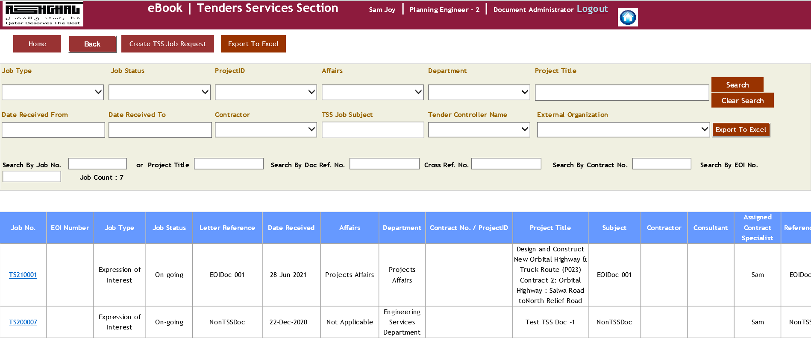

1. The search fields (mostly drop-down-list) from the top of the web page will search for the values based in the drop-down-list on the created TSS jobs. After selecting, the values from the drop-down-list user will click on the “Search” button.
2. The web application will display only those records of the Jobs, which matches the filter criteria.
3. The following is the screen shot of the records as a result of search based on Job Type values :-

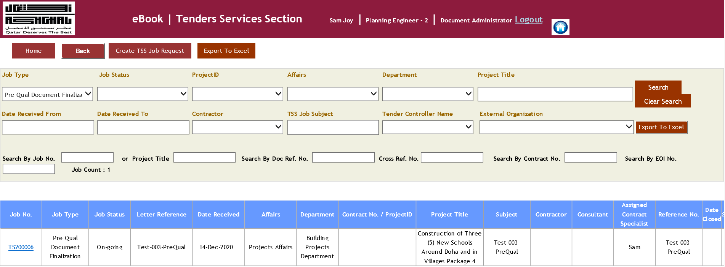

1. Below the “Export To Excel” button there are few other search text boxes, which can be used for searching for the records of the jobs. For example, Search By Job No., Project Title, Search By Doc. Ref. No., Cross Ref. No., Search By Contract No. and Search By EOI No.
2. If the user wants to modify the details of the Job, then after click on the Job Number link under “Search TSS Jobs Log” button. The following web page will open :-

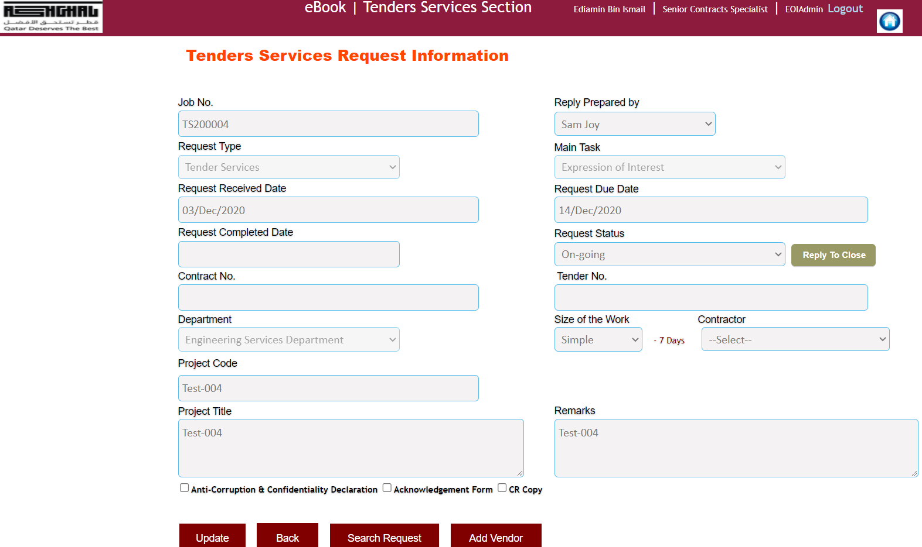

1. User clicks on the “Update” button for updating the Job details.
2. To attach the documents related to the Job, user could scroll down to “Document summary Information” section inside TSSJobDetails web page. The following is the screen shot of the section:-

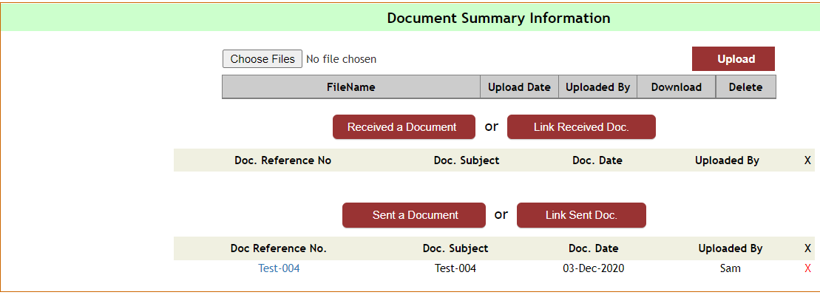

1. The following is the screen shot for linking the document with the Job:-

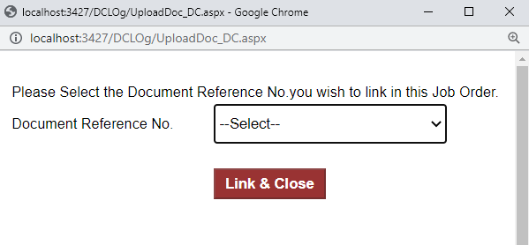

1. To attach cover letter or other attachments with the document. Open the document after clicking on the “Search Document” button on the dashboard. Click on the “Cover Letter” or “Attachments” link for attaching the documents. The following is the screen shot for that:-

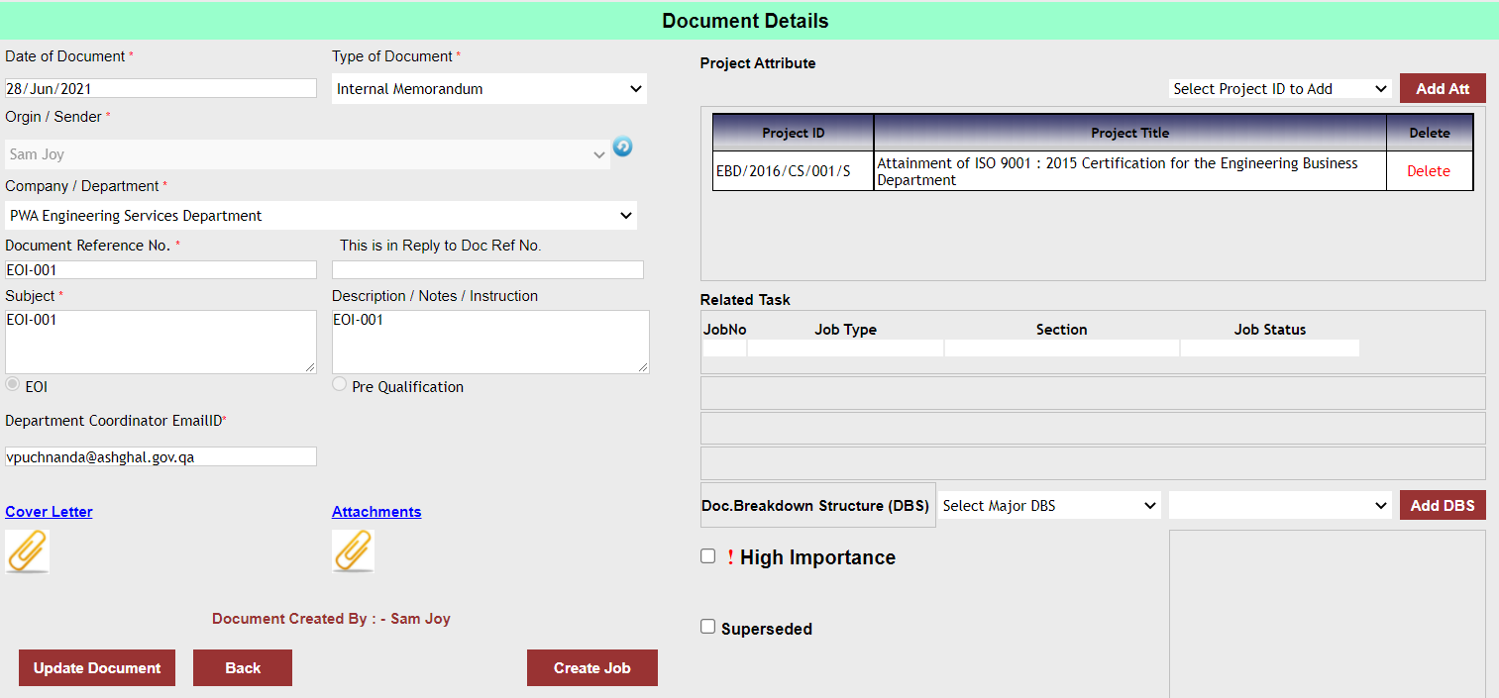

1. User clicks on “Search EOI(s)” link button on the dashboard of TSS module under the shortcut links on the left side.



1. User can only view the records of the Jobs based on the access rights assigned to the user. When a “Document Controller” clicks on this button. The following web page will be displayed :-

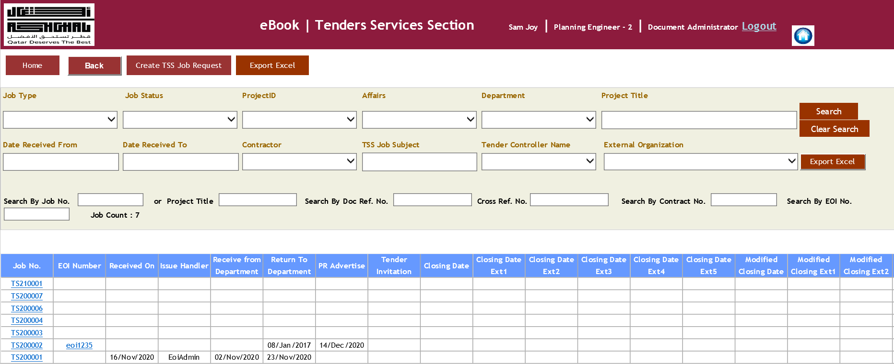

1. The search functionality is similar to “Search TSS Jobs Log” functionality.
2. User clicks on the link under EOI Number column. The following web page will be displayed :-

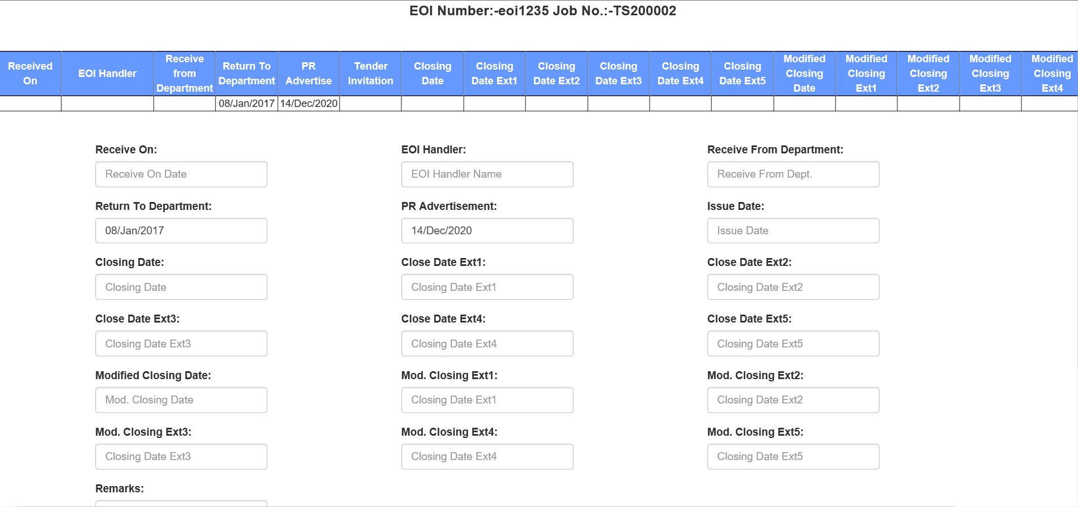

1. Based on access rights user can “Update” EOI details, “Add” or “View” vendors and Upload EOI Documents.
2. On the click of “Add Vendor” button the following web page will be displayed :-

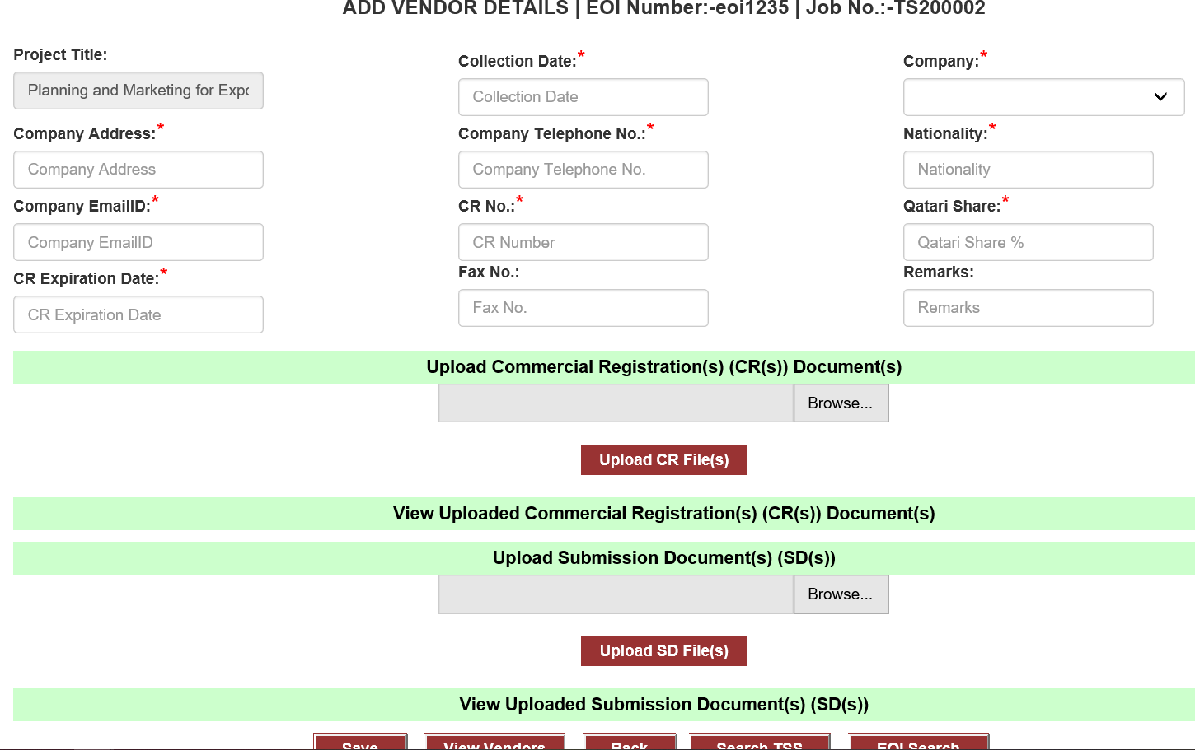

1. User can upload CR and SD files or view it if the vendor already exists in the system. After entering the vendor details user clicks on the “save” button to add the vendor details in the database of EBook TSS module.
2. Beside the “Save” button, there are View Vendors, Back, Search TSS and EOI Search buttons.
3. These buttons perform the intended action based on their name.
4. For example, View Vendors facilitates viewing of the vendor details, which are already associated with the Job.
5. The following web page will be displayed after click of View Vendors button :-

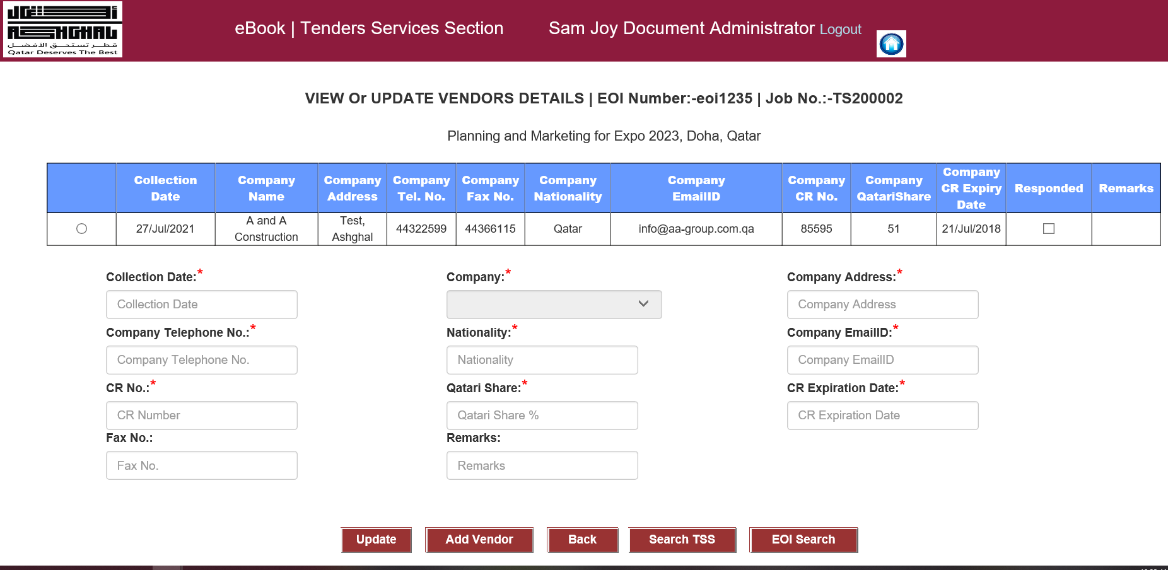

1. User has to click on the radio button to view the vendor details. Except company details user can modify other details of the company.
2. After modifying other details of the company user clicks on “Update” button to save their changes.
3. User clicks on “OverDue/Ongoing TSS Jobs” link button on the dashboard of TSS module under the shortcut links on the left side.



1. The following web page will be displayed after click of “OverDue/Ongoing TSS Jobs” link button:-

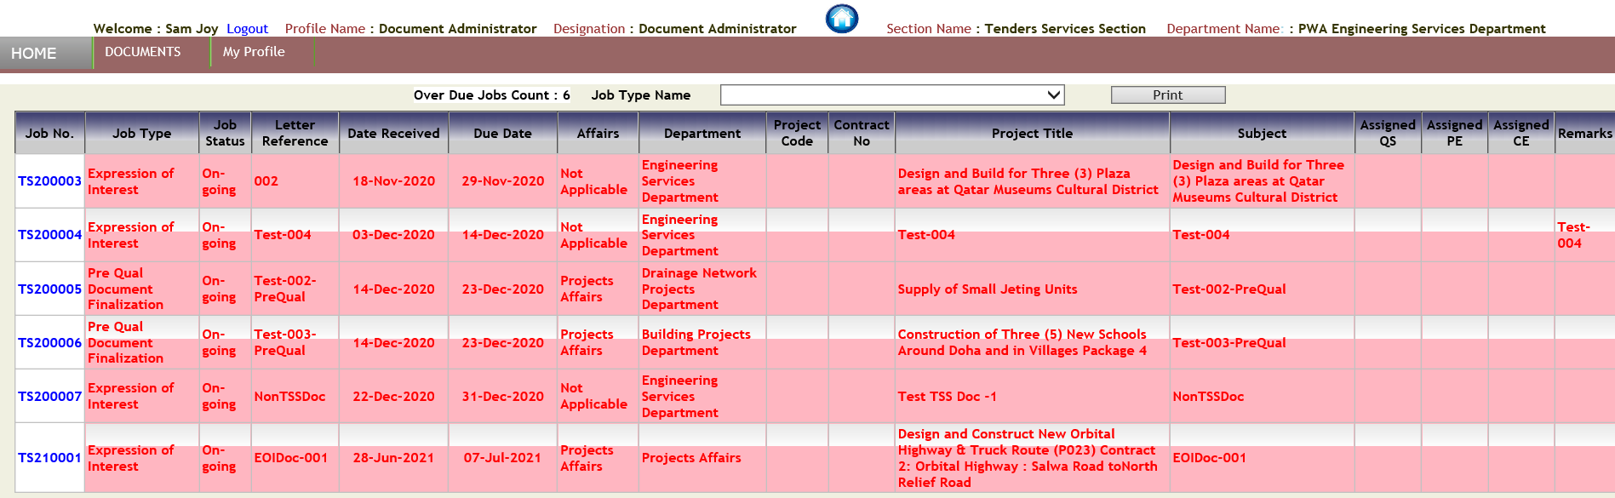

1. On the dashboard user clicks on “Overdue Tenders” services Jobs bar graph.



The EBook web application will open the following web page:-

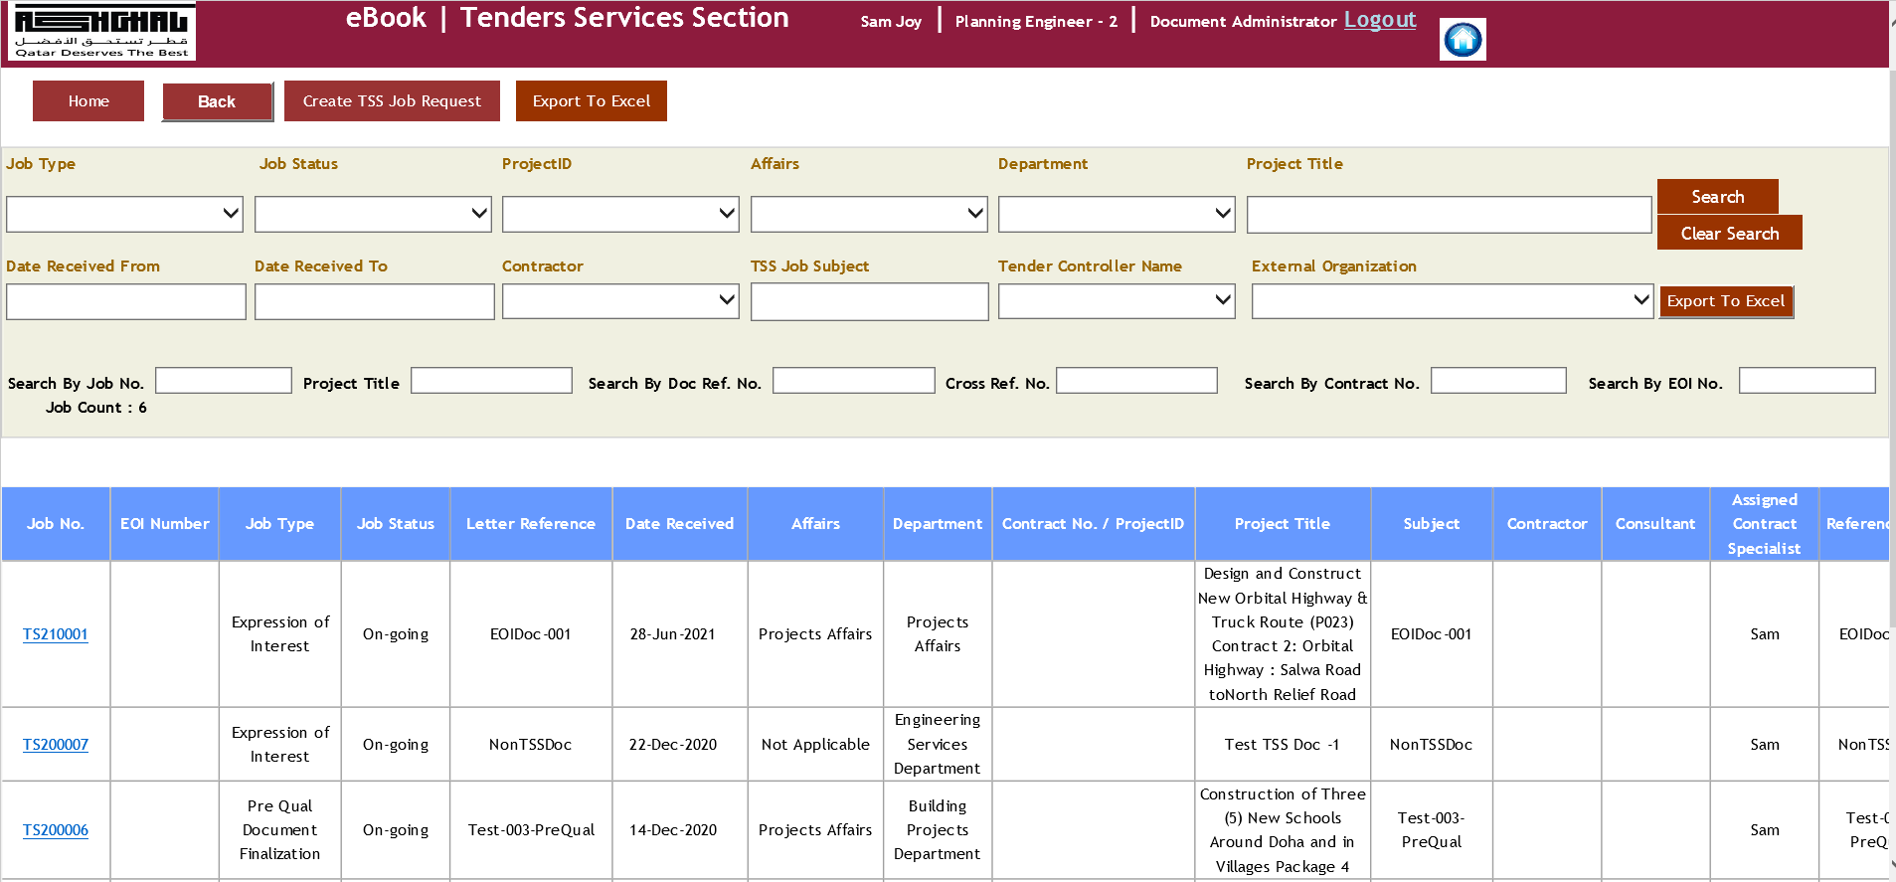

1. On the dashboard user clicks on “Ongoing Tender Services Job” My Ongoing Tasks services Jobs bar graph. The EBook web application will open the following web page:-

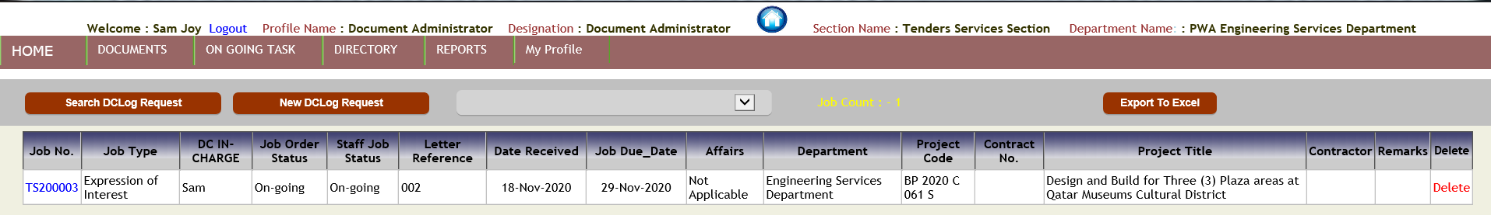

1. The user clicks on the following bars in the chart :-

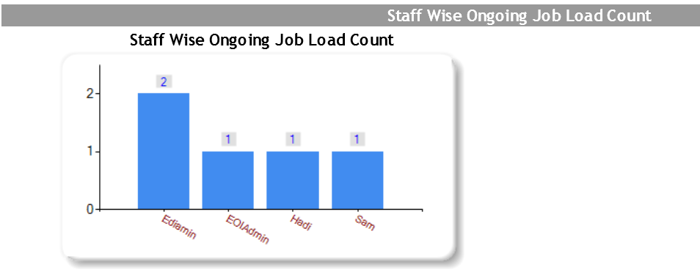

1. On the click of first bar in the above chart the following web page will open :-

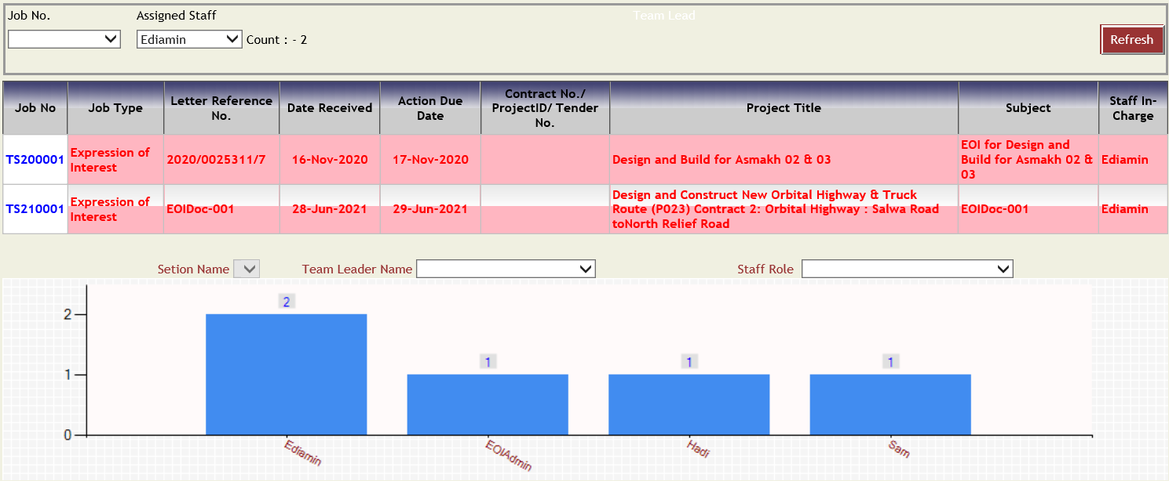

1. On the click of second bar in the above chart the following web page will open :-

