Design Report

In this visualization project, we would like to design a visualization system to visualization on mutual-funds dataset.

1. Design Tasks:
2. To explore the correlation between 3MO, 1YR, 3YR.
3. To find clusters on 3MO, 1YR, 3YR,
4. To find clusters on 3MO, 1YR, 3YR and its category and give investors some suggestion.
5. Visualization system:

This visualization system has four representations on our Dashboard:

1. Matrix scatterplots: This is used to mine the correlation between each of the dimensions:

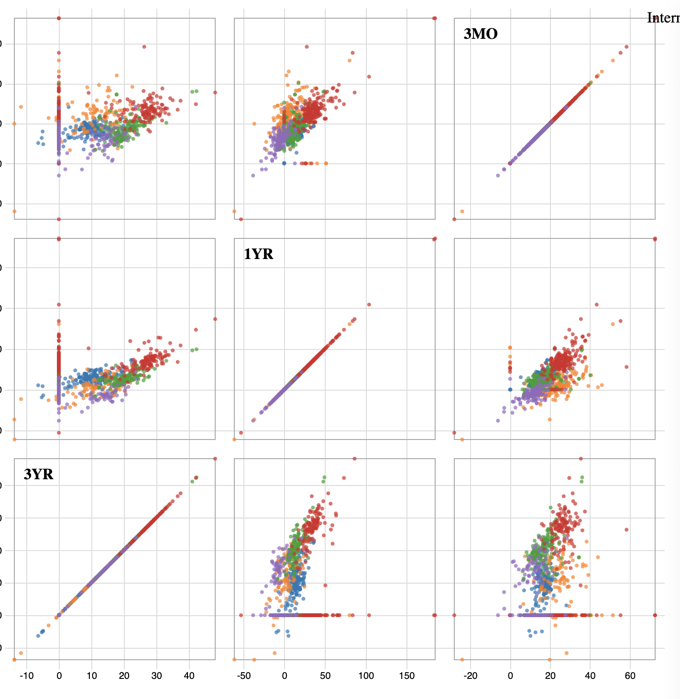

1. Pie chart to indicate the aggregation distribution on different categories:

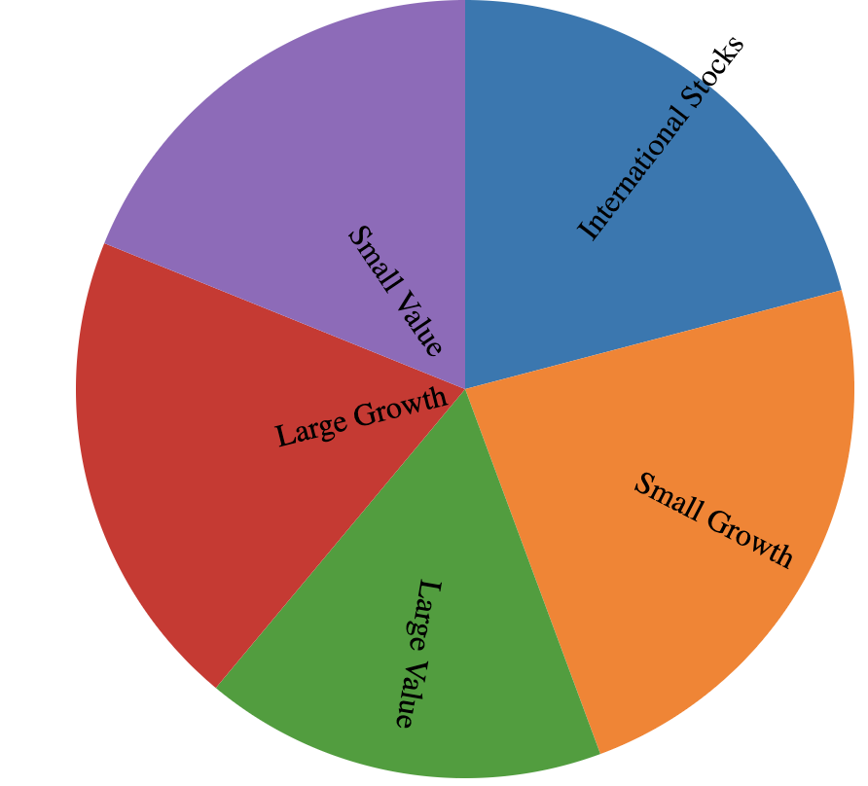

1. A zoom-in detailed scatter plot for lasso area details and to mine out clustters

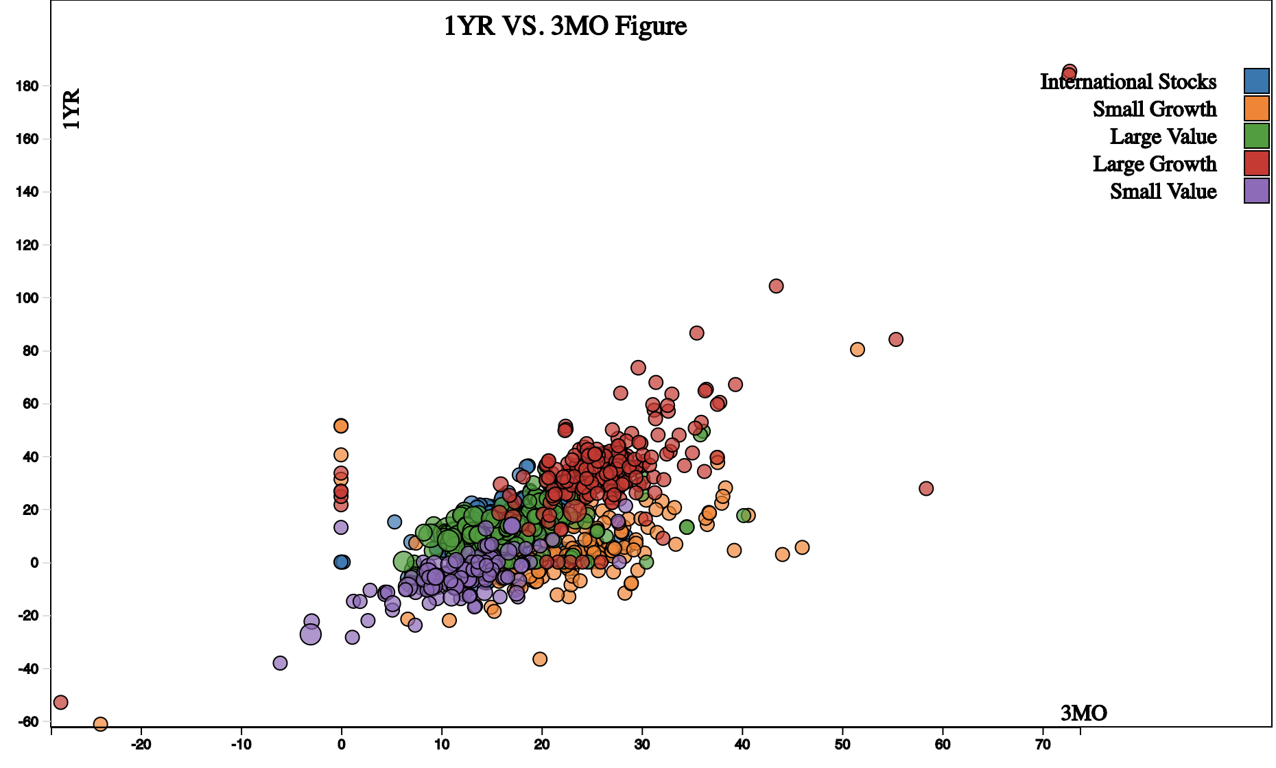

1. A table to show lasso-area details:

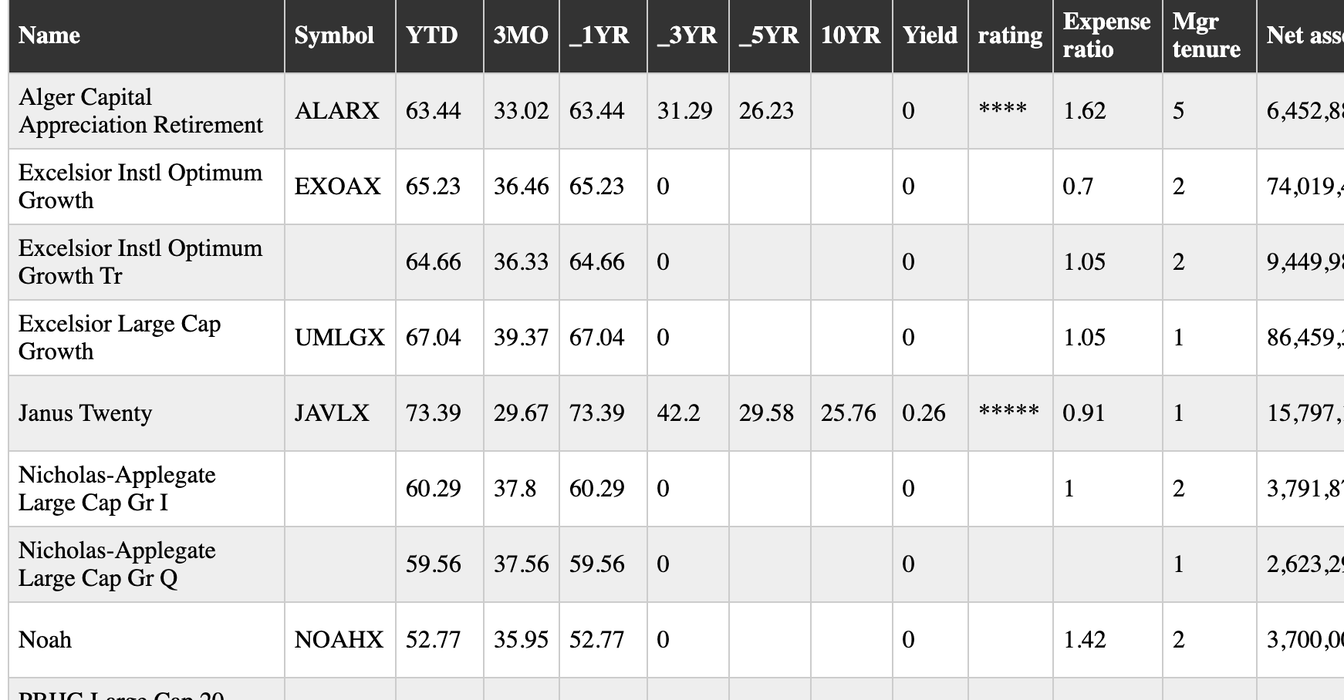

1. Interactions:
2. Dashboard is a matrix-scatterplot in which you could hover over your mouse and it will turn “grey” and click it to see details:

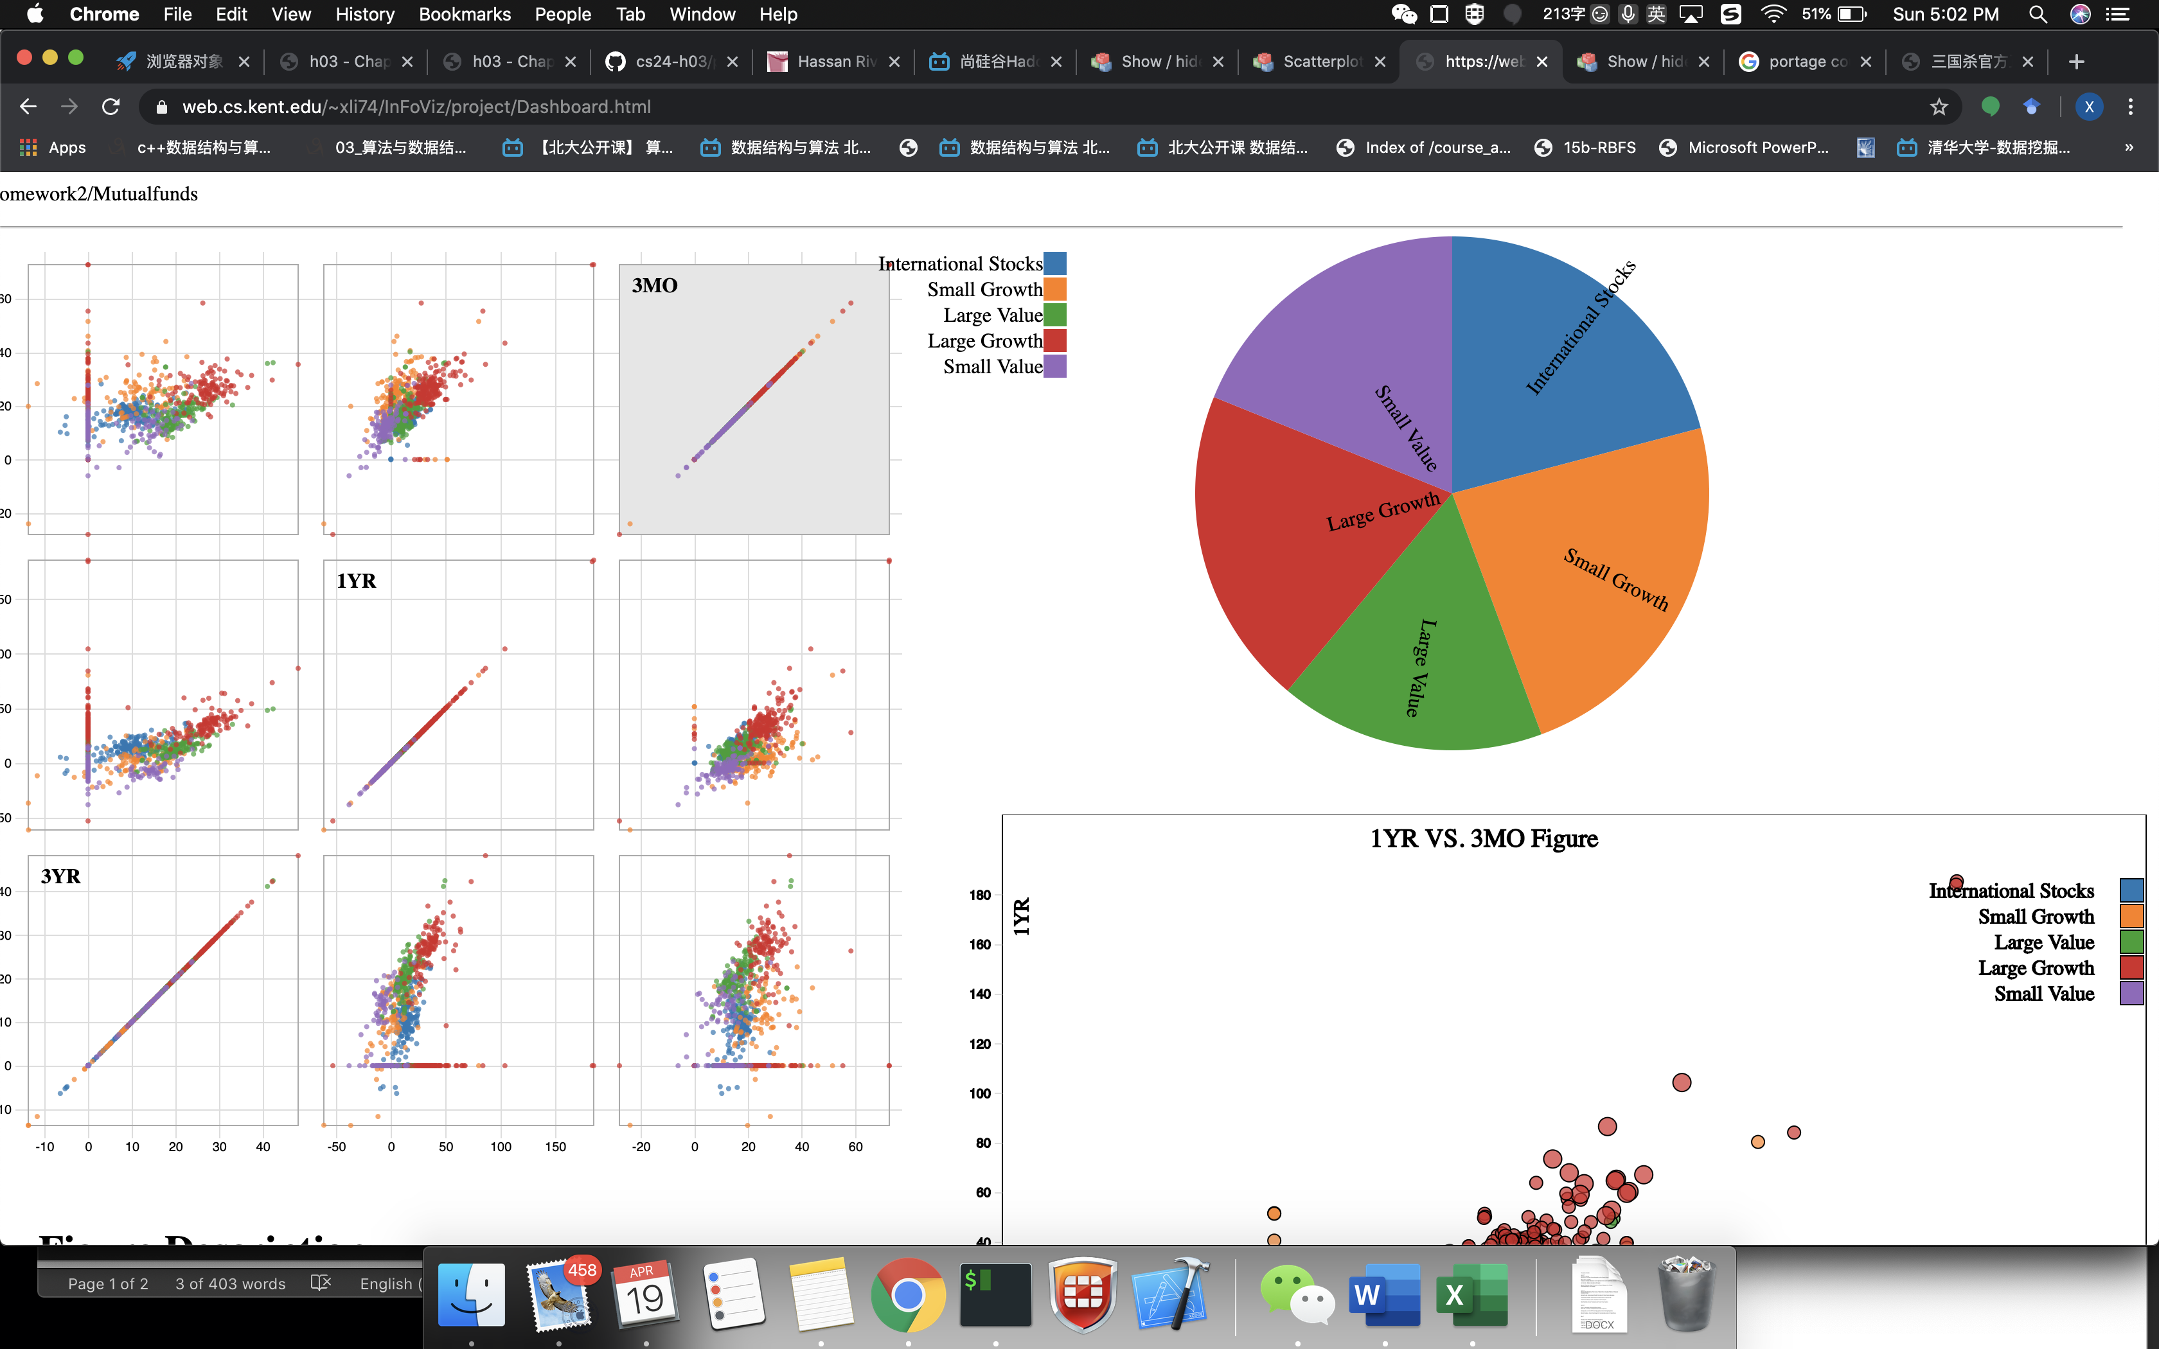

1. Then it will pop up a lasso detail scatter plot in which you could lasso an area and see details:

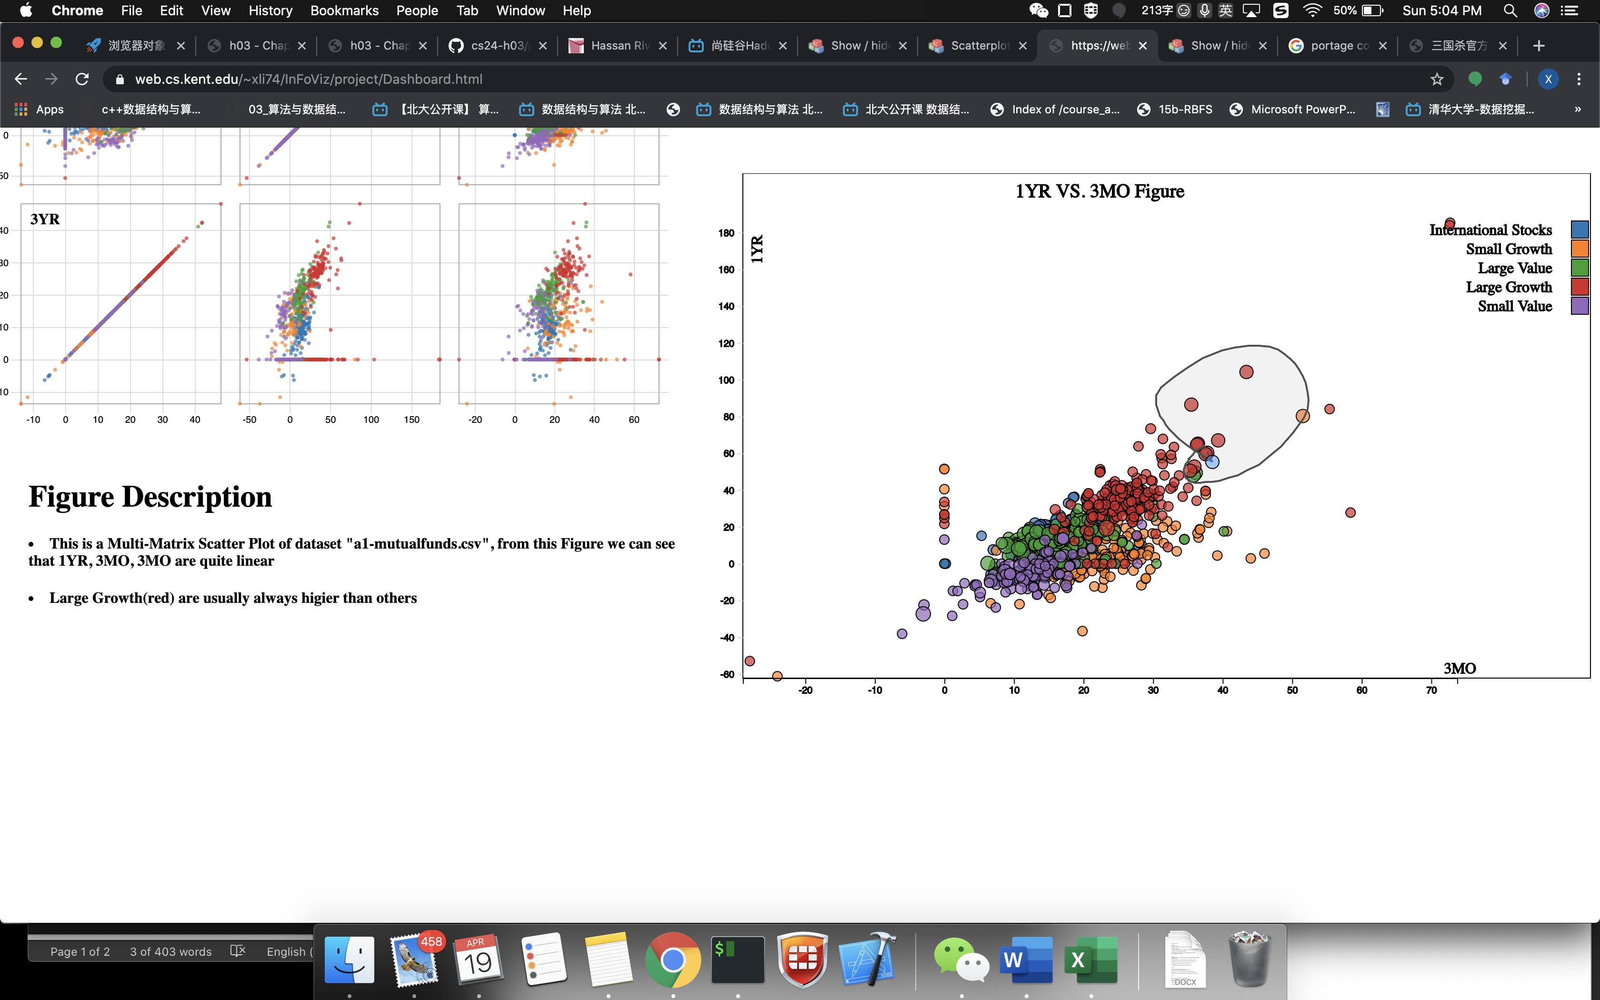

1. Then it will pop up the lassoed area detail table:

