NUTRISCAN

An AI-Powered System for Packaged Food Label Analysis, Nutritional Assessment and Legal Metrology Compliance

A Synopsis for
Project-1
BACHELOR OF TECHNOLOGY in COMPUTER SCIENCE & ENGINEERING
BY
Aashay Jain
EN23CS301020

Under the Guidance of

Prof. Dr. Safdar Sardar Khan



Department of Computer Science & Engineering Faculty of Engineering
MEDICAPS UNIVERSITY, INDORE- 453331

August-December 2026

1. Introduction
Packaged food products are widely sold through retail stores, supermarkets and e-commerce platforms. The information printed on their labels is important for regulatory compliance as well as for enabling consumers to make informed purchasing decisions. Under the Legal Metrology Act, 2009 and the Legal Metrology (Packaged Commodities) Rules, 2011, packaged commodities are required to carry prescribed declarations such as the name and address of the manufacturer, packer or importer, net quantity, Maximum Retail Price (MRP), date-related declarations and consumer care details [1].
Food labels also contain ingredient lists and nutritional information that can be used to provide a consumer-oriented assessment of a product's nutritional profile. Manual inspection of a large number of products is time-consuming and may lead to inconsistent extraction and comparison of label information. NutriScan is proposed as an intelligent web-based system that scans images of packaged food labels, extracts relevant information using Optical Character Recognition (OCR), processes the extracted text and evaluates it using configurable compliance and nutritional rules.
The proposed system combines computer vision, OCR, text processing and a rule-based decision engine. It will identify mandatory declarations, detect potentially missing or unclear information, extract ingredients and nutrition values, and present the findings through a dashboard. The system will generate evidence-based reports containing the scanned image, extracted information, detected issues and assessment scores. The nutritional module will be presented as an informational assessment and not as a medical diagnosis.
2. Literature Review
Research in document image analysis and Optical Character Recognition demonstrates that text can be automatically detected and extracted from complex visual documents. OCR systems can convert printed label content into machine-readable text, while computer vision techniques can improve recognition through image enhancement, cropping, perspective correction and noise removal [2].
Food-label analysis systems have explored the extraction of nutrition facts, ingredients and product attributes from package images. These approaches demonstrate the usefulness of combining OCR with structured information extraction for food-related applications [3]. However, OCR alone cannot determine whether a package satisfies regulatory requirements. A rule-based layer is therefore required to compare extracted declarations with a defined set of applicable requirements.
NutriScan integrates these approaches into a single platform. AI and OCR are primarily used for information extraction, while configurable rules are used for compliance assessment. This separation improves explainability because each finding can be linked to extracted label information and the corresponding rule.

3. Problem Definition
Manual verification of packaged food labels requires inspectors or users to locate and read multiple declarations and then compare them with applicable requirements. The process becomes difficult when labels contain small text, multiple languages, complex layouts or low-quality photographs. In addition, consumers may find it difficult to interpret long ingredient lists and nutrition tables.
Therefore, there is a need for an integrated software system that can accept product or label images, automatically extract relevant text and structured information, assess mandatory declarations against configurable Legal Metrology requirements, analyze ingredients and nutrition information, and generate a clear report with supporting evidence.
4. Objectives
• To develop a user-friendly web application for scanning and analyzing packaged food product labels.
• To extract text and relevant declarations from package images using OCR and image-processing techniques.
• To detect and validate important Legal Metrology declarations such as product identification, manufacturer/packer/importer details, net quantity, MRP, applicable date-related information and consumer care details.
• To identify potentially missing, unclear or non-standard declarations and provide explainable compliance findings.
• To support readability and declaration-presentation analysis, subject to image quality and available physical-scale information.
• To extract ingredient lists and nutritional values such as energy, sugar, fat, saturated fat, protein and sodium where available.
• To provide an ingredient and nutritional assessment using configurable thresholds and transparent rules, without presenting the result as a medical diagnosis.
• To maintain a searchable repository of scanned products, inspection records, findings and compliance history.
• To generate digital compliance and food-analysis reports in PDF and editable/exportable formats.
• To provide role-based access and a dashboard for monitoring scans, compliance status, violations and product trends.
5. Methodology
The proposed system will follow a modular architecture consisting of a frontend application, backend REST APIs, OCR and computer-vision services, a rule engine, database services and a reporting module.
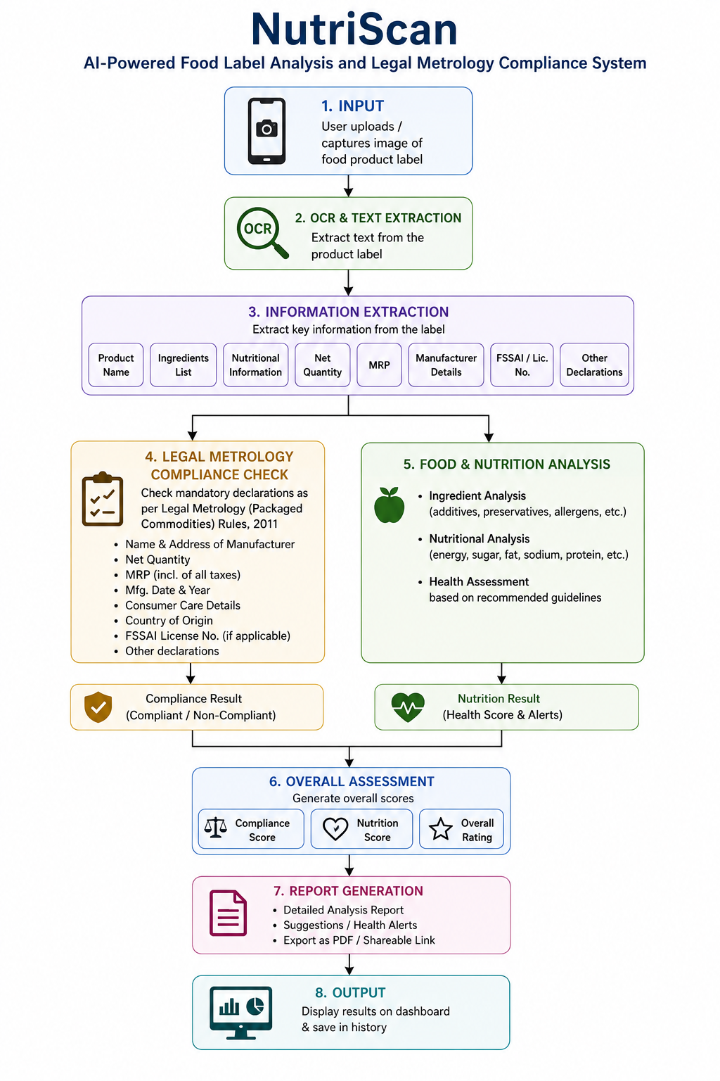

5.1 System Workflow
• Image Acquisition: The user uploads a product/package image or captures an image using a camera-enabled interface.
• Image Pre-processing: OpenCV-based processing will be used for resizing, grayscale conversion, contrast enhancement, noise reduction and, where required, perspective correction.
• OCR and Text Extraction: Tesseract OCR or a comparable OCR engine will convert visible label text into machine-readable text.
• Information Extraction: The backend will identify product name, manufacturer/packer/importer, net quantity, MRP, dates, consumer care information, ingredients and nutrition values using text-processing and pattern-based techniques.
• Legal Metrology Rule Engine: Extracted declarations will be compared with a configurable repository of applicable requirements. Findings will be marked as compliant, potentially non-compliant, missing or requiring manual verification.
• Ingredient and Nutrition Analysis: Ingredient names and nutrition values will be normalized and evaluated using transparent rules. Selected ingredients or nutrients that exceed configured reference levels may be highlighted.
• Assessment: Separate regulatory compliance and nutritional-profile scores will be generated so the two assessments are not confused.
• Evidence and Reporting: The original image, relevant extracted text, detected fields, findings and scores will be stored and used to generate a digital report.
• Dashboard and Repository: Authorized users will be able to search previous scans, inspect product histories, review violations and view aggregate statistics.
5.2 Technology Stack
• Frontend: React.js with Tailwind CSS for responsive interfaces and dashboards.
• Backend: Python FastAPI for REST APIs, authentication, processing orchestration and rule-engine integration.
• Computer Vision: OpenCV for image preprocessing and text-region/readability-related analysis.
• OCR: Tesseract OCR initially, with the architecture allowing replacement or comparison with other OCR engines.
• Text Processing: Python-based parsing and normalization of declarations, ingredients and nutrition values.
• Database: PostgreSQL for users, products, scans, extracted declarations, rules, violations and reports.
• Authentication: JWT-based authentication with role-based access control.
• Reporting: ReportLab and export tools for PDF and editable/tabular outputs.
• Deployment: Docker-based deployment, with cloud hosting considered for final demonstration.
5.3 Major Modules
• User Authentication and Role Management
• Product Image Scanning and Upload
• OCR and Label Information Extraction
• Legal Metrology Compliance Rule Engine
• Ingredient and Nutritional Analysis
• Compliance Score and Violation Detection
• Product and Inspection Repository
• Dashboard and Analytics
• Evidence Management and Report Generation
6. References
[1]. Department of Consumer Affairs, Government of India, “Legal Metrology (Packaged Commodities) Rules, 2011.”
[2]. Smith R., “An Overview of the Tesseract OCR Engine,” Proceedings of the Ninth International Conference on Document Analysis and Recognition (ICDAR), 2007.
[3]. Min W., Jiang S., Liu L., Rui Y., Jain R., “A Survey on Food Computing,” ACM Computing Surveys, Volume 52, Issue 5, 2019.

