Kpdfsync reads the ‘My Clippings.txt’ text file for the highlights and notes and then applies them in the correct place on a PDF file.

It is easy to use. There are only 4 steps:

Step 1: Open Clipping file and select a book
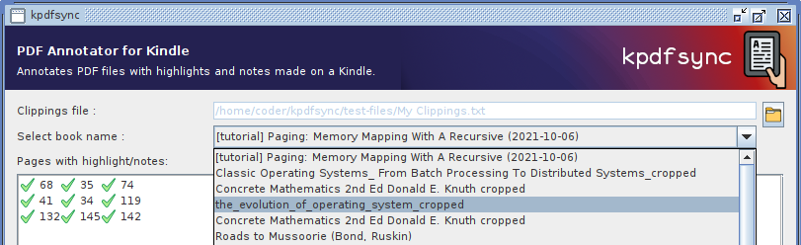Figure 1: Opening Clipping file and selecting a book
 | Prerequisite: Download ‘My Clippings.txt’ file from your Kindle and copy it locally.

Description
Clippings file: | Open the My Clippings.txt file.
Select book name: | Select name of the PDF book/document you want to read the highlights for.

Step 2: Pair Highlights with notes
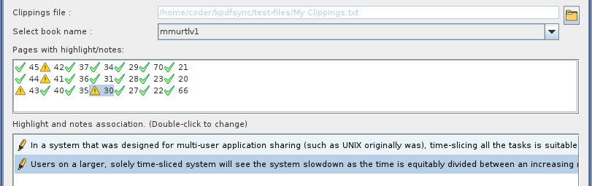Figure 2: Pairing of Highlights with notes
There are no unpaired notes in the page. This can occur when a page has
- no notes only highlights (no mapping is required) or
- has exactly one highlight and note (automatic mapping) or
- all the notes where manually assigned to a highlight. (manual mapping)
There is one or more unpaired notes in the page. This occurs when a page has
- More than one highlight or note and manual mapping for every note is not yet provided.
As there is no way a computer to know which highlight belongs to which note, you need to provide the mappings manually.
This is an error condition. This occurs for pages with
- More notes than there are highlights.
Nothing can be done for these pages at this point of time.

Automatic mappings
Pages with exactly one highlight and note is automatically mapped. In this case page 22 has only one highlight and note, so they are paired automatically.. In the bottom list, the 1st line is the highlight and the 2nd line is the note.
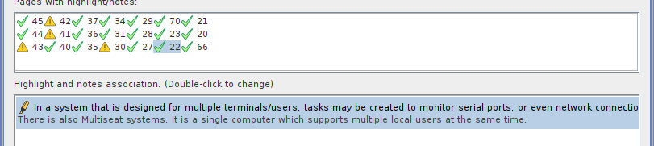Figure 3: Note was automatically paired with the only highlight on the page (Automatic mapping)

Manual mappings
Pages that have more than one highlight or note cannot be automatically mapped.
Figure 4: Pages more than one highlight or note need to manually mapped. (Manual mapping)
Here is an example. Page 30 has the icon which means it has one or more unpaired notes.
Steps to manually associate notes and highlights (For the above example)
● | Open ‘MMURTLv1.pdf’ document on your kindle.
● | Go to page 30.
● | Check highlights for notes. When one is found, go back to this software and double click on the same highlight.
● | A dialog window will open. Select note as shown on my Kindle for the highlight. Then click ‘Create mappings’ button.  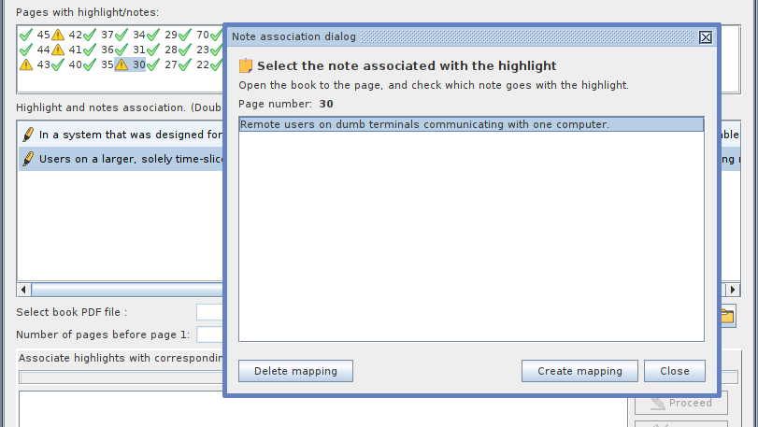Figure 5: Note association dialog box
After successful mapping, the note will be seen associated with the highlight. When there are no unpaired note, the icon for this page will change to .
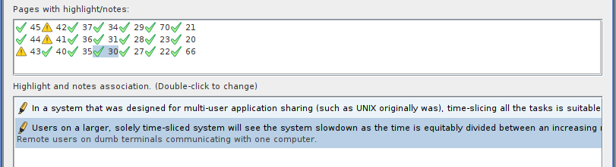Figure 6: Mapping manually provided for the highlight on page 30.
It is not necessary to map every note. Unmapped notes will not show up on the final PDF.

Remove mappings
Similar to creation of mappings, using the ‘Create mappings’ button, mappings can be removed using the ‘Delete mappings’ button.

Step 3: Select source PDF file
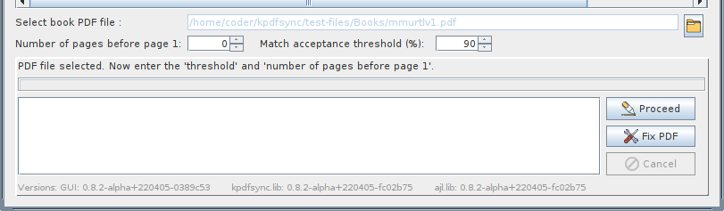Figure 7: Selection of source PDF file
Description
Select book PDF file: | Open the PDF file corresponding to the selected book.
Number of pages before page 1: | As this software deals with page numbers, it must know where ‘Page 1’ is in the above file. It may not always be the 1st page in the file.  Open the document in a PDF viewer, then go to page 1. You can see how many pages are before this. You need to enter this number.  More on Appendix 2
Match acceptance threshold: | Match tolerance. Text which matches more or equal to this percentage will be highlighted. Same value applies to every page in the book.
  If wrong text is getting highlighted, increase this value.
  If text is not found, then lower this value.

Step 4: Select destination PDF

Click the Proceed button to start the highlighting process.
Enter the output file name in the Save dialog window then click Save button.
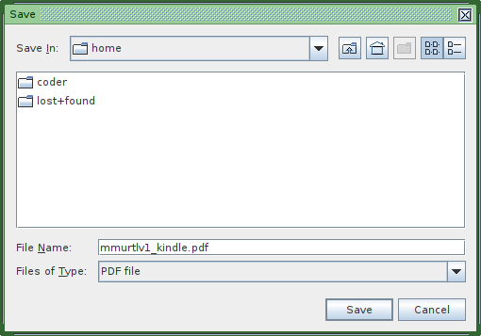Figure 8: Save dialog window for destination PDF file | If there are unpaired notes, then the ‘Continue?’ popup will come, click Yes button to continue.  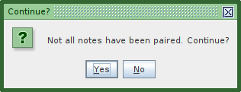Figure 9: Reminder for unpaired notes.
  The highlights must be saved on to a new file.
  Do not select the same output file as the input file.

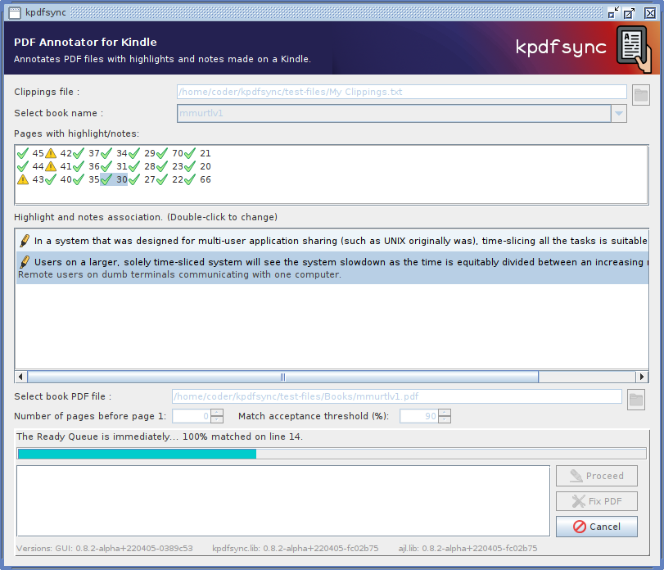Figure 10: Highlighting in progress | Any errors or warnings will show up in the list at the bottom. If you want to cancel the process, click Cancel button at the top.  That’s it. After the process has completed, the output file will have the highlights and associated notes in proper places.

Appendix 1: Fixing PDF errors
Fixing the PDF file can correct some types of highlighting error.
Figure 11: Fix button is enabled after source PDF is selected.
After selecting the source PDF file, click on the Fix button.
Fixing can take some time, depending of the size of the PDF and your computer. Please wait and let the process complete.
You cannot cancel this process, as this can cause corruption. For safety, we create a back of the original file.

Source PDF will be backup up in same path. For example, if source PDF is C:\Users\Bojra\BookDraft1.pdf then its backup will be C:\Users\Bojra\BookDraft1_original(0).pdf

After fixing has completed, try highlighting again, by pressing the Process button.

Not all PDF files adhere to the Adobe PDF Standard or has issue with embedded fonts. Even tough such PDF files will open in an PDF viewer, kpdfsync has trouble dealing with such files and can throw errors.

Appendix 2: Number of Pages before page 1 in a PDF.
Some of the PDFs are structured like a book, which means the page number 1, is not the 1st page in the book. In such books, the first new pages are paged differently. It is easy to know how many pages are before the page marked page number of 1.
● | Open the source pdf file in Firefox, or any other PDF reader.
Contents list is not present
● | Page number 1 is the 1st page. So there are no pages before it.  Set ‘Number of Pages before Page 1’ field to 0 (zero). | 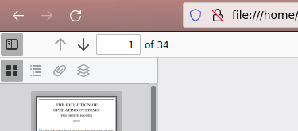Figure 12: Firefox showing that this PDF has no Contents.
Contents list is present
● | Go to page number 1 - Either manually, or entering 1, in the page number text box of the PDF viewer. | 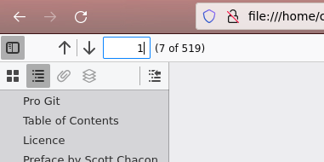Figure 13: Firefox showing that page number 1 is the 7th page in the file.
● | Then notice how many pages are before this one.  In the example page number 1 is actually the 7th page in the book. That means there are 6 pages before page 1.  Set ‘Number of Pages before Page 1’ field to 6.

Revision history
Initial release for 0.8.0-alpha | 31 March 2022
Update for 0.8.2-alpha | 07 April 2022

