**Project :** **BioArmory – Survive the Epidemic (BASE)**

**Team :**

Achal Jain

Akshar Agrawal

Sanket Ramteke

Adithya Raju Nair

Abhijith Raju Nair

Aritra Boral

**Introduction :**

The management of global pandemics poses significant challenges to public health systems and policymakers worldwide. The complexity of controlling the spread of infectious diseases, coupled with the socio-economic impacts they inflict, necessitates innovative approaches to understanding and addressing these crises. In response, the game "BASE" was developed as a simulation-based solution to provide players with an immersive experience in navigating the intricacies of pandemic management.

The objective of "BASE" is to provide an immersive and educational experience that highlights the intricacies and trade-offs involved in managing a global pandemic. By simulating the complexities of real-world scenarios, the game aims to enhance players' understanding of the challenges faced by epidemiologists, policymakers, and healthcare professionals. Additionally, the game encourages strategic thinking, decision-making skills, and an appreciation for the importance of collaboration and resource management in crisis situations.

**Premise :**

The world is in the grip of a deadly and rapidly spreading epidemic. As a brilliant scientist and renowned epidemiologist, you have been tasked with leading the global effort to find a cure and save humanity from the brink of disaster.

Your journey begins as you discover a new strain of virus, which reports a rising number of infections and increasing mortality rates. The world is in a state of panic, and public distrust is growing as misinformation spreads like wildfire.

Your mission is to obtain a complete cure for the virus, collaborating with local health agencies, governments, and research institutions to gather vital data and resources. Along the way, you must manage limited healthcare capacities, navigate economic challenges, and address public distrust.

Can you analyse the complex web of factors, maintain global stability, and ultimately find the cure to save humanity? The clock is ticking, and the world is looking to you for leadership.

**Features :**

Multiple Mini-Games that will be triggered by certain conditions to which you must respond or face consequences.

These will require the knowledge of certain concepts in probability and statistics field.

Public Distress, Infection Rate, economy are all interdependent parameters that will affect the gameplay.

Unpredictable behaviour of the virus as it will mutate unpredictably.

Detection of Virus through the symptoms.

Virus can spread through various methods.

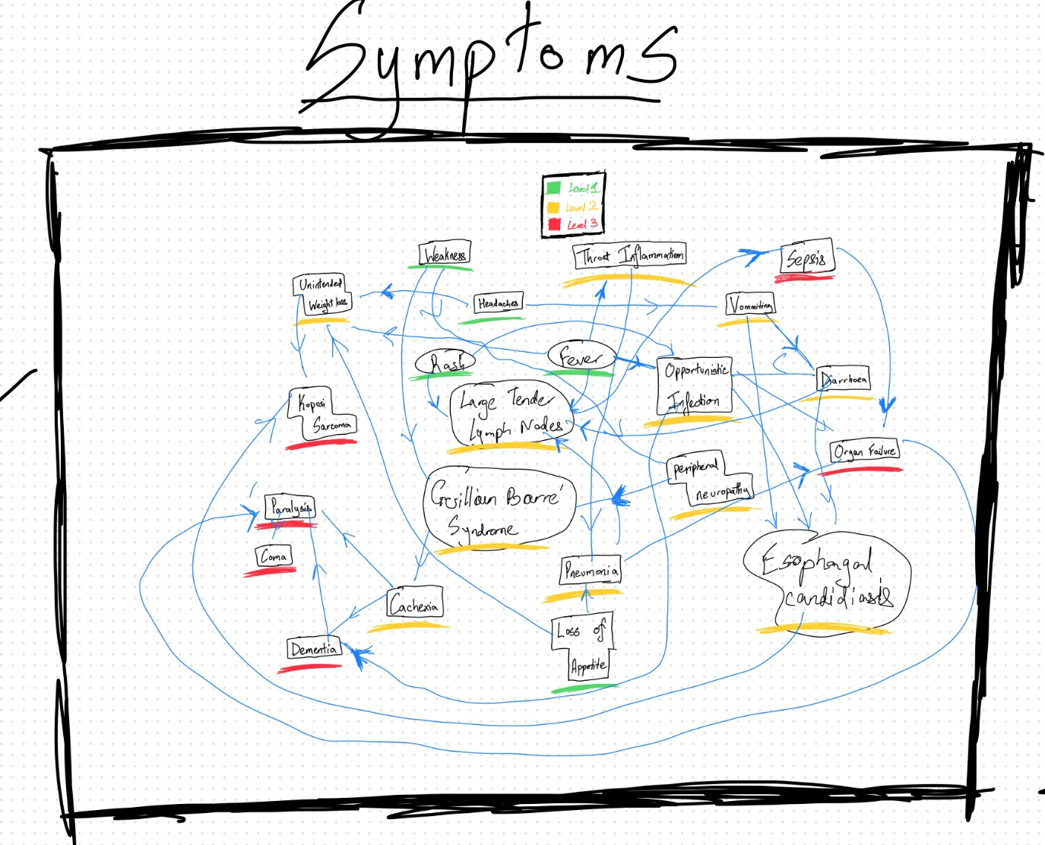

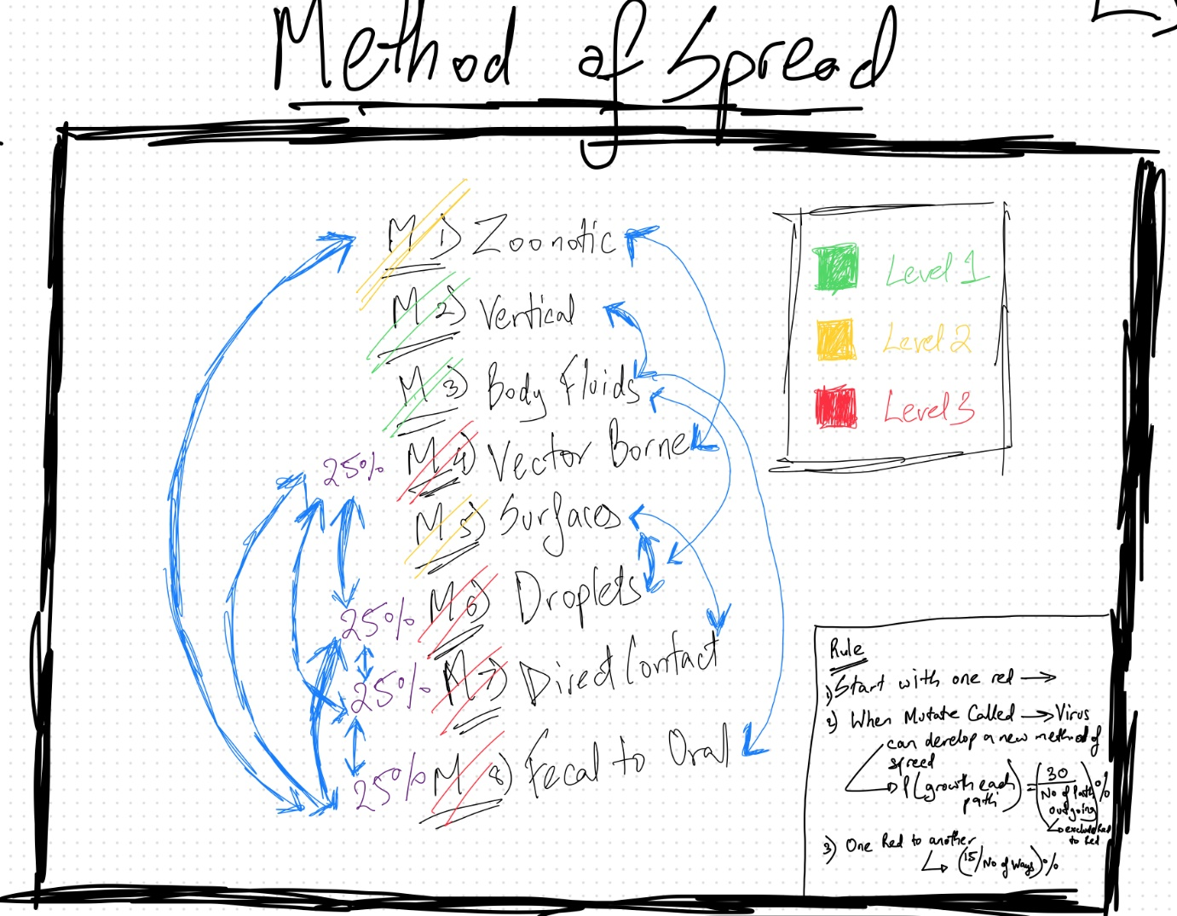

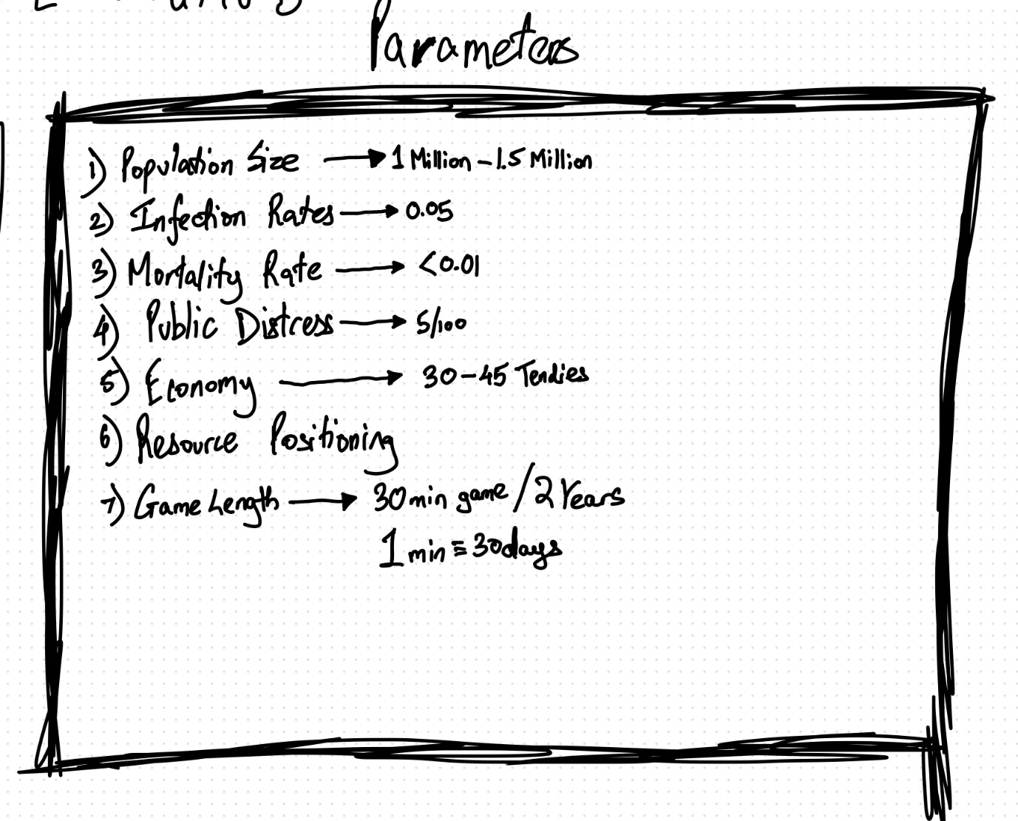

**Mathematical Model :**

SIR – compartmental model used for modelling the infection spread throughout the population.

Bayesian Network for parameter dependencies.

**Implementation** **:**

Python language

Modules used – pygame, numpy, random, sys, time, colorama

Data structures – graphs, csv for login info, dictionary to save state

**References:**

1. Correlation of tourism and cases: <https://www.mdpi.com/2571-9394/3/4/53>
2. Correlation of media perception and infection <https://www.ncbi.nlm.nih.gov/pmc/articles/PMC6361417/>
3. <https://en.wikipedia.org/wiki/Compartmental_models_in_epidemiology> //SIR model  for simulation.
4. <https://www.ncbi.nlm.nih.gov/pmc/articles/PMC8609511/>
5. <https://statisticstimes.com/economy/country/india-gdp-sectorwise.php#:~:text=Sector%2Dwise%20GDP%20of%20India&text=The%20services%20sector%20accounts%20for,and%20allied%20sector%20share%2020.19%25>.
6. <https://www.sciencedirect.com/topics/mathematics/bayesian-network#:~:text=and%20Markov%20models-,A%20Bayesian%20network%20(BN)%20is%20a%20probabilistic%20graphical%20model%20for,belief%20networks%20or%20Bayes%20nets>.