**WECHAT_BOT AUTOMATION BASIC MANUAL**

**\*Contact:** [**terrykim1211@naver.com**](mailto:terrykim1211@naver.com) **or ‘Terry Kim’ in the Coderbunker Group Chat if you really need help in the future**

1. **Basic Introduction on Development:**

This bot works with a python installed with a version of 3 or above

python --version to check your python version

Clone the repository somewhere

npm itchat

Install the itchat dependencies you need

itchat.auto_login(hotReload = True)

This saves the record, user does not have to login each time

**import** time, datetime, requests, itchat

**from** itchat.content **import** *

Now you can import and use it

‘hotReload = **True**’ inside the ‘itchat.auto_login(hotReload = **True**)’

this saves the memory of the user that logged in. So that the same user doesn’t have to login by scanning the QR code. If you want to aboard a new user, delete the pkl file or ‘hot reload=True’.

You also have to register certain keywords before defining the corresponding functions and parameters:

Ex)   
@itchat.msg_register(FRIENDS)

Ex)

@itchat.msg_register(TEXT,isGroupChat=**True**)  
**def** auto_reply(msg):  
 coming_from = msg.get(**'ActualNickName'**)  
 context = msg.text  
 friend = itchat.search_friends(name=coming_from)  
 print(**f'{coming_from}:{context}'**)

isGroupChat=**True allows it to only work when the message is sent from the group chat**

1. **RETREIVE INFORMATION FROM THE TEXT SENT:**

**Getting name of User that sends the message:**

msg.get(**'ActualNickName'**)

**The content of the message**

msg.text

ex)

@itchat.msg_register(TEXT,isGroupChat=**True**)  
**def** auto_reply(msg):  
 coming_from = msg.get(**'ActualNickName'**)  
 context = msg.text  
 friend = itchat.search_friends(name=coming_from)  
 print(**f'{coming_from}:{context}'**)

# now we can print who it is coming from and the content

# notice that we defined the

coming_from = msg.get(**'ActualNickName'**)

coming_from to be the user that sent the message

friend = itchat.search_friends(name=coming_from)

friend to be defined as a variable storing the friend with the ‘coming_from’. As a result friend is storing the user that sent the message.

1. **Sending Media Files**
2. **Sending Files for general (all pdf, jpg etc)**

itchat.send_file(**'File Path’**, friend[0][**'UserName'**])

friend[0][**'UserName'**]

* This part defines who is receiving the file or the message

**Ex)**

**Windows:**

itchat.send_file(**'C:\\Users\\user\\Desktop\\CODER BUNKERINTERN\\workspace\\chatbot\\images\\'**+ msg.text, friend[0][**'UserName'**])

**MAC:**

reply = itchat.send_file(

'/Users/suser/Desktop/store_file/Coderbunker collaboration model with clients.pdf',

friend[0]['UserName'])

*the only reason why ‘\\’ is used to separate is because it is for the windows

From the example above, friend = itchat.search_friends(name=coming_from)

* Since friend is already pre-defined as the user that is sending the message, the file will be sent to the person that is sending a message to the bot

1. **Sending Images Specifically**

This will allow us to send an image in a way that user can view it right away.

(What this means is that it won’t send the image in a way that the receiver has to download and then view the image like a pdf document)

reply = itchat.send_image(**'image path'**, receiving_friend[0][**'UserName'**])

Ex)

itchat.send_image(  
 **'C:\\Users\\user\\Desktop\\CODER BUNKER INTERN\\workspace\\chatbot\\images\\space.jpg'**,msg[**'RecommendInfo'**][**'UserName'**])

1. **Sending Files Dynamically: Application**

This allows us to send whatever file the user asks for. For example, if user sends ‘ricky.jpg’ or ‘coderbunkerfile.pdf’ the code will look for the corresponding file in the folder and send that file

itchat.send_file(**'File Path'**+ msg.text, friend[0][**'UserName'**])

by putting the msg.text after the **'File Path',** the file path will be composed of the message content that someone sends at the end.

For example, if someone sends the bot ‘ricky.jpg’, the file path will become

**'C:\\Users\\user\\Desktop\\CODER BUNKER INTERN** **\\workspace\\chatbot\\images\\****’ + ricky.jpg**

Resulting:

**'C:\\Users\\user\\Desktop\\CODER BUNKER INTERN** **\\workspace\\chatbot\\images\\****ricky.jpg**

1. **Auto_Accept Friend Request and Send Files:**

@itchat.msg_register(FRIENDS)  
**def** add_friend(msg):  
 print(**u'[ Terminal Info ] New Friend Request 新朋友的请求，自动通过验证添加加好友 From: %s'** % msg[**'RecommendInfo'**][**'UserName'**])  
 itchat.add_friend(**msg[**'Text'**]) *# This automatically adds the friend*

[**'RecommendInfo'**][**'UserName'**])

This portion is the user you are sending the message to, so in this case a newly added user

Ex) This sends all the corresponding files when a new user is added, as well as auto-accepting it

@itchat.msg_register(FRIENDS)  
**def** add_friend(msg):  
 print(**u'[ Terminal Info ] New Friend Request 新朋友的请求，自动通过验证添加加好友 From: %s'** % msg[**'RecommendInfo'**][**'UserName'**])  
 itchat.add_friend(**msg[**'Text'**]) *# 该操作会自动将新好友的消息录入，不需要重载通讯录* itchat.send_image(  
 **'C:\\Users\\user\\Desktop\\CODER BUNKER INTERN\\workspace\\chatbot\\images\\ricky.jpg'**,  
 msg[**'RecommendInfo'**][**'UserName'**])  
  
 itchat.send_image(  
 **'C:\\Users\\user\\Desktop\\CODER BUNKER INTERN\\workspace\\chatbot\\images\\fred.jpg'**,  
 msg[**'RecommendInfo'**][**'UserName'**])

1. **Combining Everything together:**

**Features that this current bot provides:**

* **Auto Accept and Send Files**

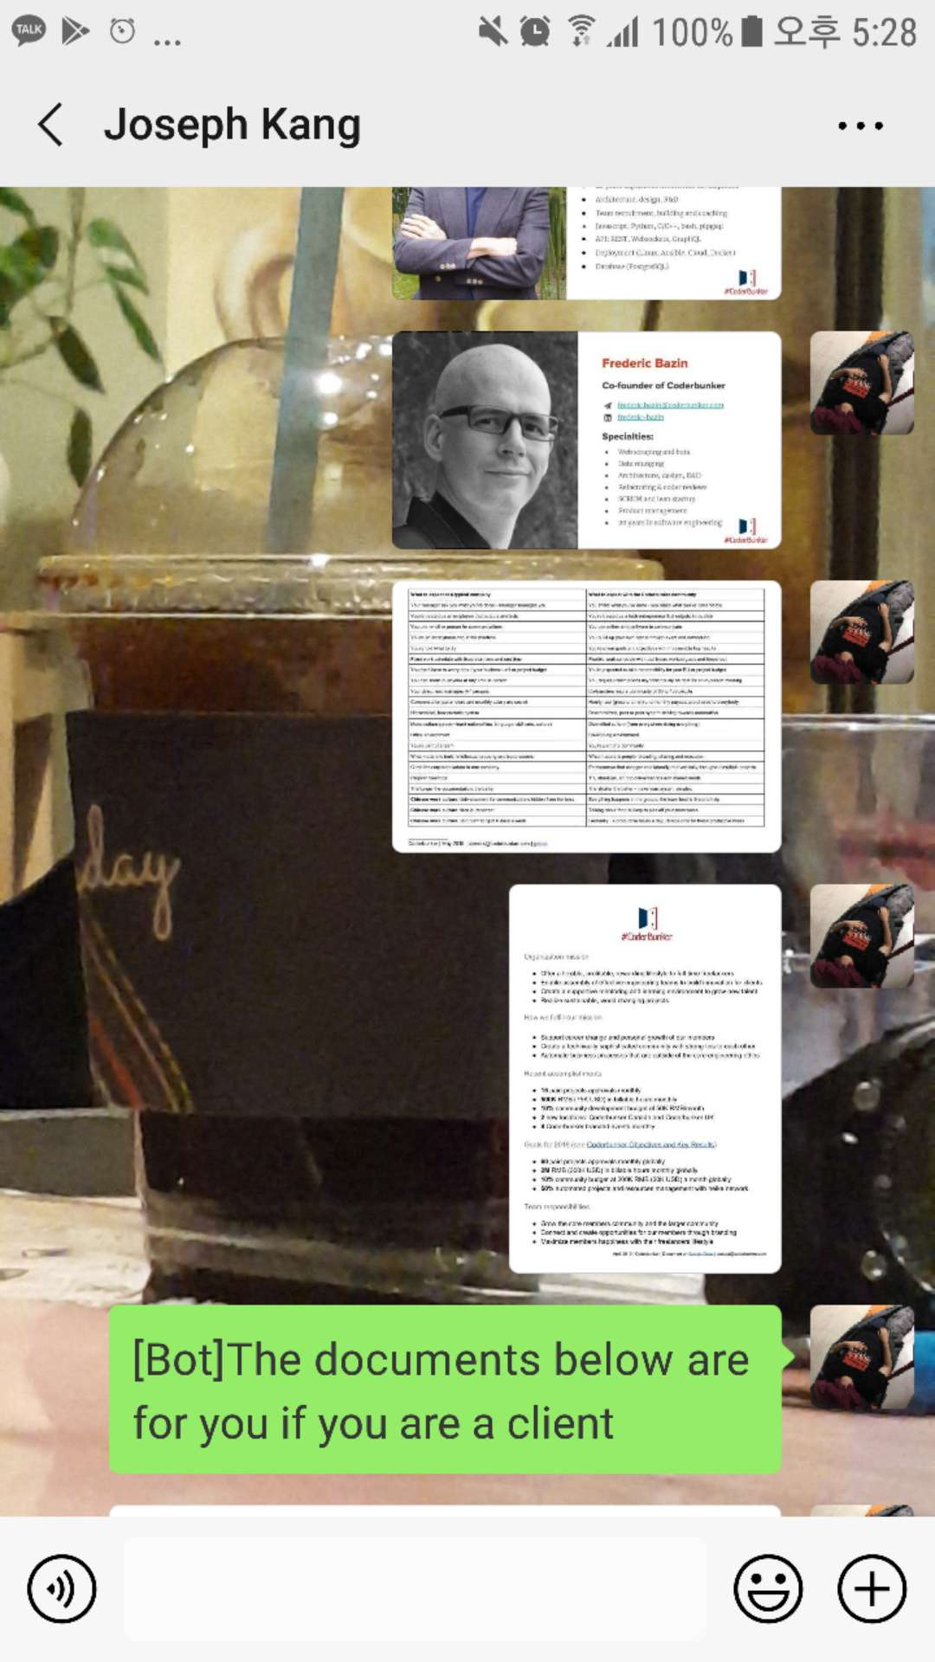

2. Responding to certain key words such as #freelancer #client #other

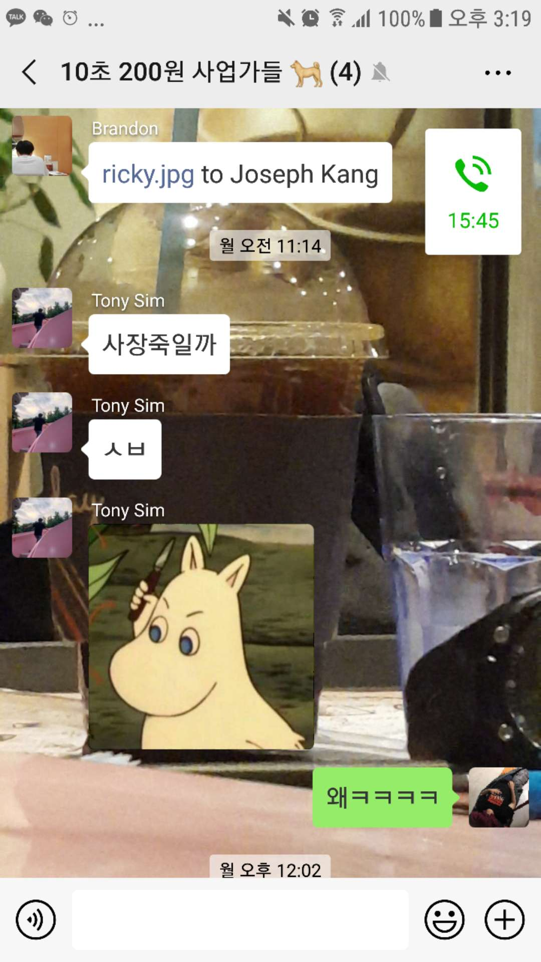3. We try to send the file to other user

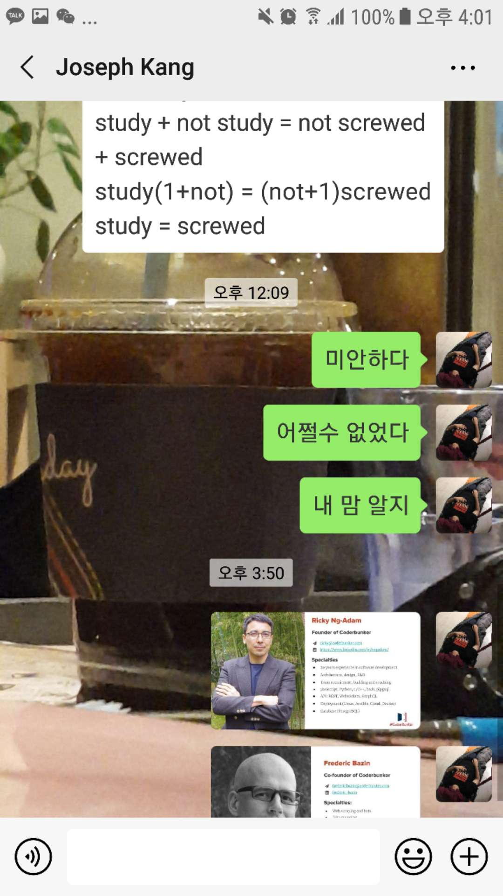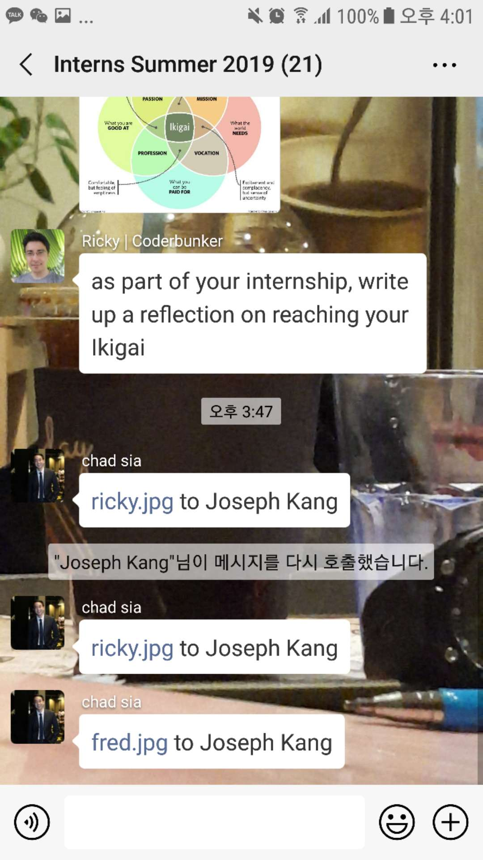

We try to achiever this by splicing the word and extracting the last two or one word at the user wants to another user that they want to

words = context.split(**" "**)  
file_name = words[0]  
receiving_name = words[-1]  
print(receiving_name)  
*# this gives ricky.jpg after @*receiving_friend= itchat.search_friends(name=receiving_name)  
  
**if** len(words)>1:  
 *#for two word names* receiving_name_two = words[-2] + **' '** + words[-1]  
 print(receiving_name_two)  
 receiving_friend_two = itchat.search_friends(name=receiving_name_two)