TBMI26 – Computer Assignment Reports  
Boosting

**Nour Elhouda Qweder (nouqw898)**

**Weng Hang Wong (wenwo535)**

1. **Plot how the classification accuracy on training data and test data depend on the number of weak classifiers (in the same plot). Be sure to include the number of training data (non-faces + faces), test-data (non-faces + faces), and the number of Haar-Features.**

**We investigate the parameters shown as below:**

Number of test data : 11788 (non-face + faces)

Number of training data : 1000 (non-face + faces)

Number of Haar-Features : 30

Number of week classifiers : 30

Strong classifier evaluation on both training data and test data:

training accuracy : 0.9380 ; test accuracy : 0.9

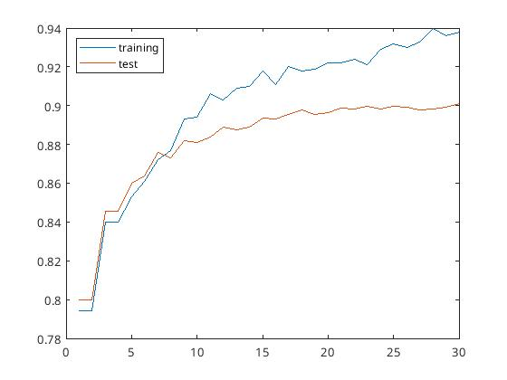

Number of test data : 11788 (non-face + faces)

Number of training data : 1000 (non-face + faces)

Number of Haar-Features : 100

Number of week classifiers : 50

Strong classifier evaluation on both training data and test data:

training accuracy : 0.9840 ; test accuracy : 0.9426

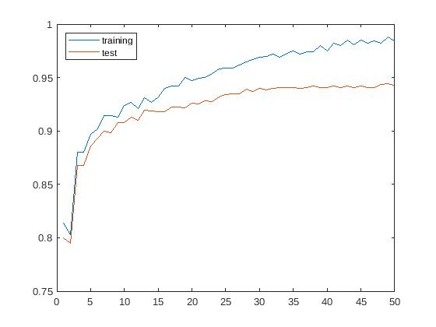

Number of test data : 11788 (non-face + faces)

Number of training data : 100 (non-face + faces)

Number of Haar-Features : 200

Number of week classifiers : 60

Strong classifier evaluation on both training data and test data:

training accuracy : 1 ; test accuracy : 0.9431

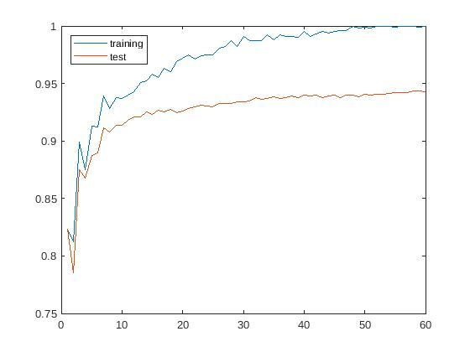

1. **How many weak classifiers did you use when training? How many of them did you use for the final strong classifier? Motivate your choices.**

There are 30,50,60 weak classifiers we used for training in the second case. By investigating the plot above, the accuracy keep increased when the weak classifers increased. However, the test accuarcy remains around 0.94 at 30-50 weak classifieres. Therefore, we would use 30-50 weak classifiers for the final strong classifier on the test dataset.

1. **What is the accuracy on the training data and test data after applying the optimized strong classifier? Discuss your choice of hyperparameters and how they influence the accuracies.**

From the first case, we used 30 classifiers and 30 haar features for the training and the test accuracy is only around 0.9. After applying the optimized strong classifier with 50 weak classifier and 100 Haar-features, the test accuarcy is increased to around 0.94 and the training accuracy is increased to 0.98. The performace is significantly improved with the increasing number of Haar features and weak classifiers.

However, the test performance remained when we increased both of the hyperparameters. In order to get even better performances on test data, we need to also increase the size of training data.

1. **Plot the Haar-features selected by your classifier (one for each weak classifier). If you have many weak classifiers, select some representative subset. Can you think of why they would be useful for classifying faces?**

The Haar-features are selected from 26 to 50 weak classifer. The position of the retangular filter inside the haar-features are the specific positions where human face can be detected. For example, the constrast part in the filter can mat the eyes or noses on human faces.

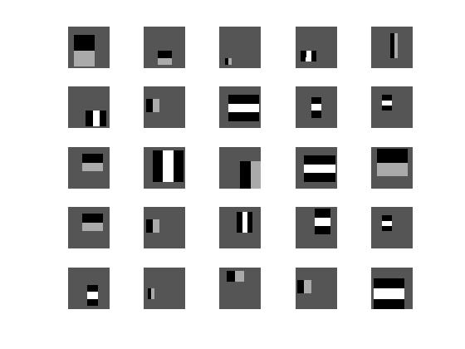

1. **Plot some of the misclassified faces and non-faces that seem hard to classify correctly. Why do you think they are difficult to classify?**

The misclassified faces images have low contrast on the faces, that could be one of the probelm that the classifiy couldn’t work properly.

The missclassifier non-faces images have the opposite problem that the constrast part might misled the filter classified them as human faces

. 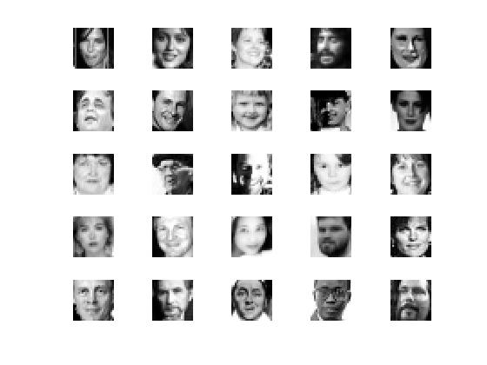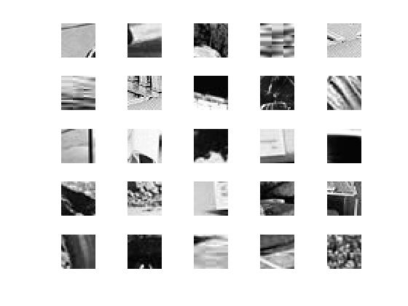

1. **Are your results reasonable? Can you think of any way to improve the results?**

The results seems quite reasonable considered we only used less than 10% on the data to train the classiifer, we still get over 94% accuracy on the test data. To improve the result, we can use a larger amount of data to train the model, so that it can reduce the generalization problem. Other than that, we can also test different number of Haar-feautures to improve the result.

1. **Can we expect perfect results? Motivate your answer.**

We can’t expect perfect results due to the limit of the training data and the cost of training time.

And the test images can be varied and contained noises, so that it will increase the difficulty to gain a perfect result here.