IS-F341 Software Engineering (II - 2019-20)

# T<*15*> & *<Travellite>*

<https://tranquil-oasis-05127.herokuapp.com/>

|  |
| --- |
|  |

|  |  |  |
| --- | --- | --- |
| Student ID | Name | Role (PO+DEV/SM+DEV/DEV) |
| 2017A7PS0108H | Dhruv Gupta | DEV |
| 2017A7PS0080H | Smit Shah | PO + DEV |
| 2017A7PS0049H | Shikhar Dhawale | SM + DEV |
| 2017A7PS0083H | Saarthak Jain | DEV |

**Section 1 – Project Overview**

BITS Pilani Hdyerabad Campus is situated on the outskirts of the city and travelling alone especially to the airport costs you a fortune! Travelling on bus with luggage is tiresome and inconvenient. It is therefore desired to find some people travelling to the same destination around the same time so that you could share a cab and hence save money. However finding the right people willing to share a cab with you is quite time consuming and requires a lot of coordination.

**Travel@BPHC** : a Facebook group is used for finding people to share a cab where people share their travelling details through a post expecting others to notice and reply.But these Facebook posts are bound to be mixed with other unimportant feed stuff,which often results in the person missing relevant posts regarding their journey. Also,most comments end up as spam in the comments section.Thus we aim at building an application where people can post their travelling details and others can search applying appropriate filters.

Users can create a new post or update an existing one. Other people can view this post along with others and can choose which group to join as per group member convenience. The post owner will be notified of joining requests from other members and can accept any one of his/her choice.Users can leave the group in case of schedule change and join another group without worrying about the hassle involved in informing the other members of this change.At the end of each ride the application will display the cab fare and the respective dues.Users can also view their previous rides and transaction history. This reduces the effort involved in finding the right cab sharing group and also removes the element of spam which is involved in the current situation.

**Section 2 – To-be Work System Snapshot**

|  |  |  |  |  |
| --- | --- | --- | --- | --- |
| Customers | | | Product/Services | |
| * Students * BITS (as an institution ) | | | * Cab Group Search. * Cab fare splitting. | |
| Major Activities and Processes | | | | |
| * User registers on the website by entering his details * The user can search for posts based on his preferred date,time and location * The user can join groups based on the search results obtained * The user can also add a new post with his travel details * The user who created the post is notified when a new member requests to join * The user can accept/ reject a member’s request to join * All members in a cab group are reminded via email one day before their journey. * The members are notified about their respective dues after each ride. | | | | |
| Participants | | Information | | Technologies |
|  | * Student * Faculty members * Staff members * Administration Office members | * User details * Location description * Time of visit * Cab Fare | | * Database software * Email * Client/Server model |

**Section 3 – Product Backlog**

<based on exported data from Pivotal Tracker>

Sprint 1 Tasks

|  |  |  |  |  |  |
| --- | --- | --- | --- | --- | --- |
| Id | Title | Labels | Iteration | Type | Estimate |
| 171085890 | Search Panel |  | 1 | feature | 4 |
| 171216966 | Login/Signup backend |  | 1 | feature | 4 |
| 171086401 | Plus Button |  | 1 | feature | 4 |
| 171085769 | Logout |  | 1 | chore |  |
| 171086013 | Search button functionality backend |  | 1 | feature | 4 |
| 171085427 | User navigation bar |  | 1 | feature | 2 |
| 171292371 | Add new post backend |  | 1 | feature | 4 |
| 171316742 | My profile button frontend |  | 1 | feature | 2 |
| 171316613 | Search button results frontend |  | 1 | feature | 2 |
| 171085290 | Start Page having 2 buttons:Signup &login |  | 1 | feature | 4 |
| 171085214 | User registration page |  | 1 | feature | 2 |
| 171316643 | Join button backend |  | 1 | feature | 2 |
| 171085721 | My Profile Button backend |  | 1 | feature | 2 |
| 171086621 | Accept Button |  |  | feature | 8 |
| 171085527 | Notification bell icon |  |  | feature | 4 |
| 171086596 | Request Button functionality |  |  | feature | 4 |

*Select the six columns (shown above) from the exported CSV file and paste the contents here to indicate the details of user stories (features, bugs, chores, etc.)*

**Section 4 - Use case diagram**

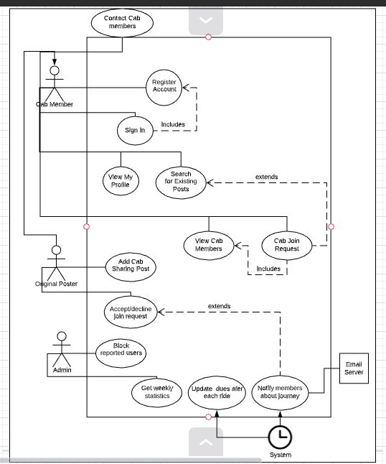

**Section 5 – User Personas**

*Student 1*

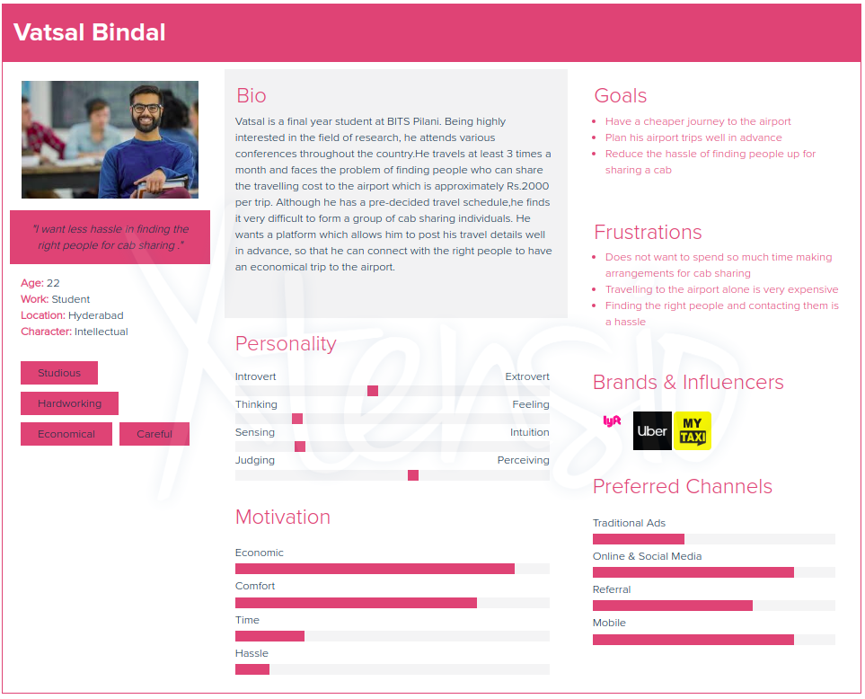

*Student 2*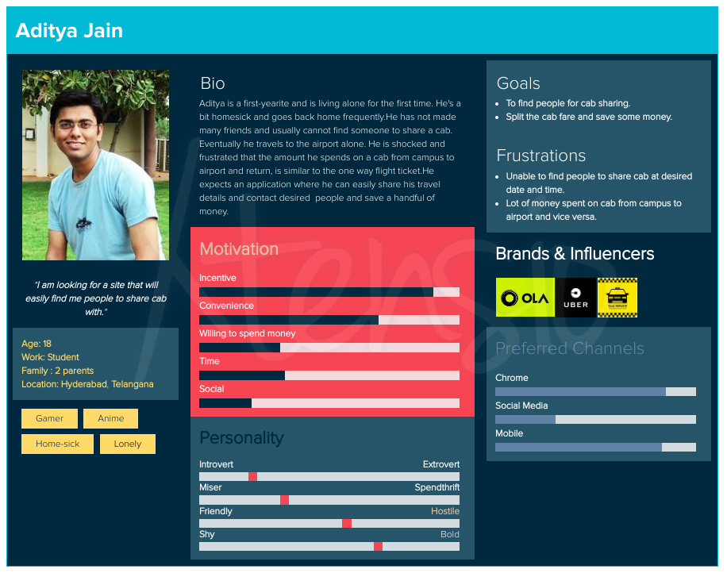

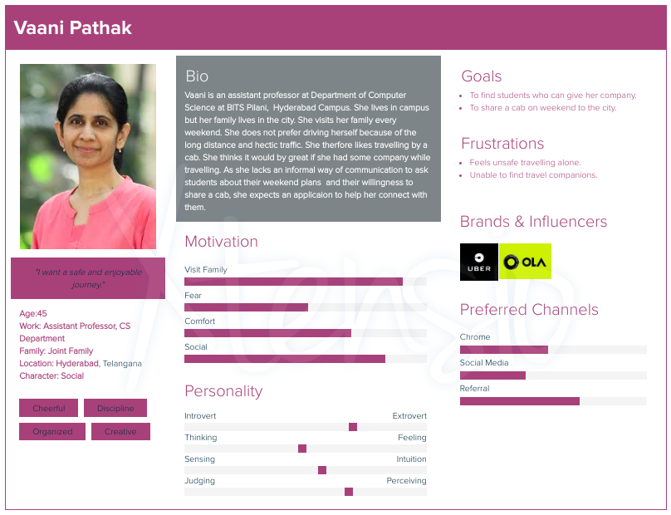

*Professor*

*Admin*

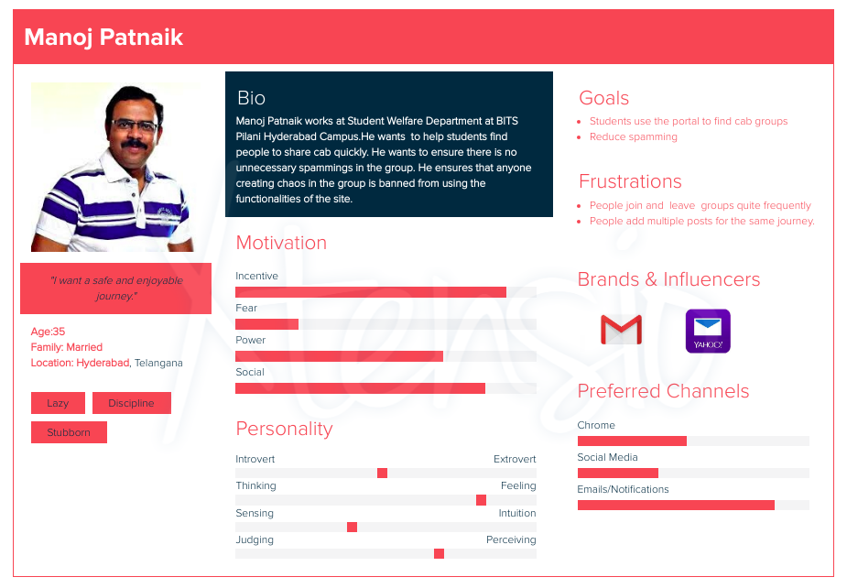

**Section 6 - Activity diagram**

< not required for Sprint 1>

**Section 7 - Mind maps for Personas**

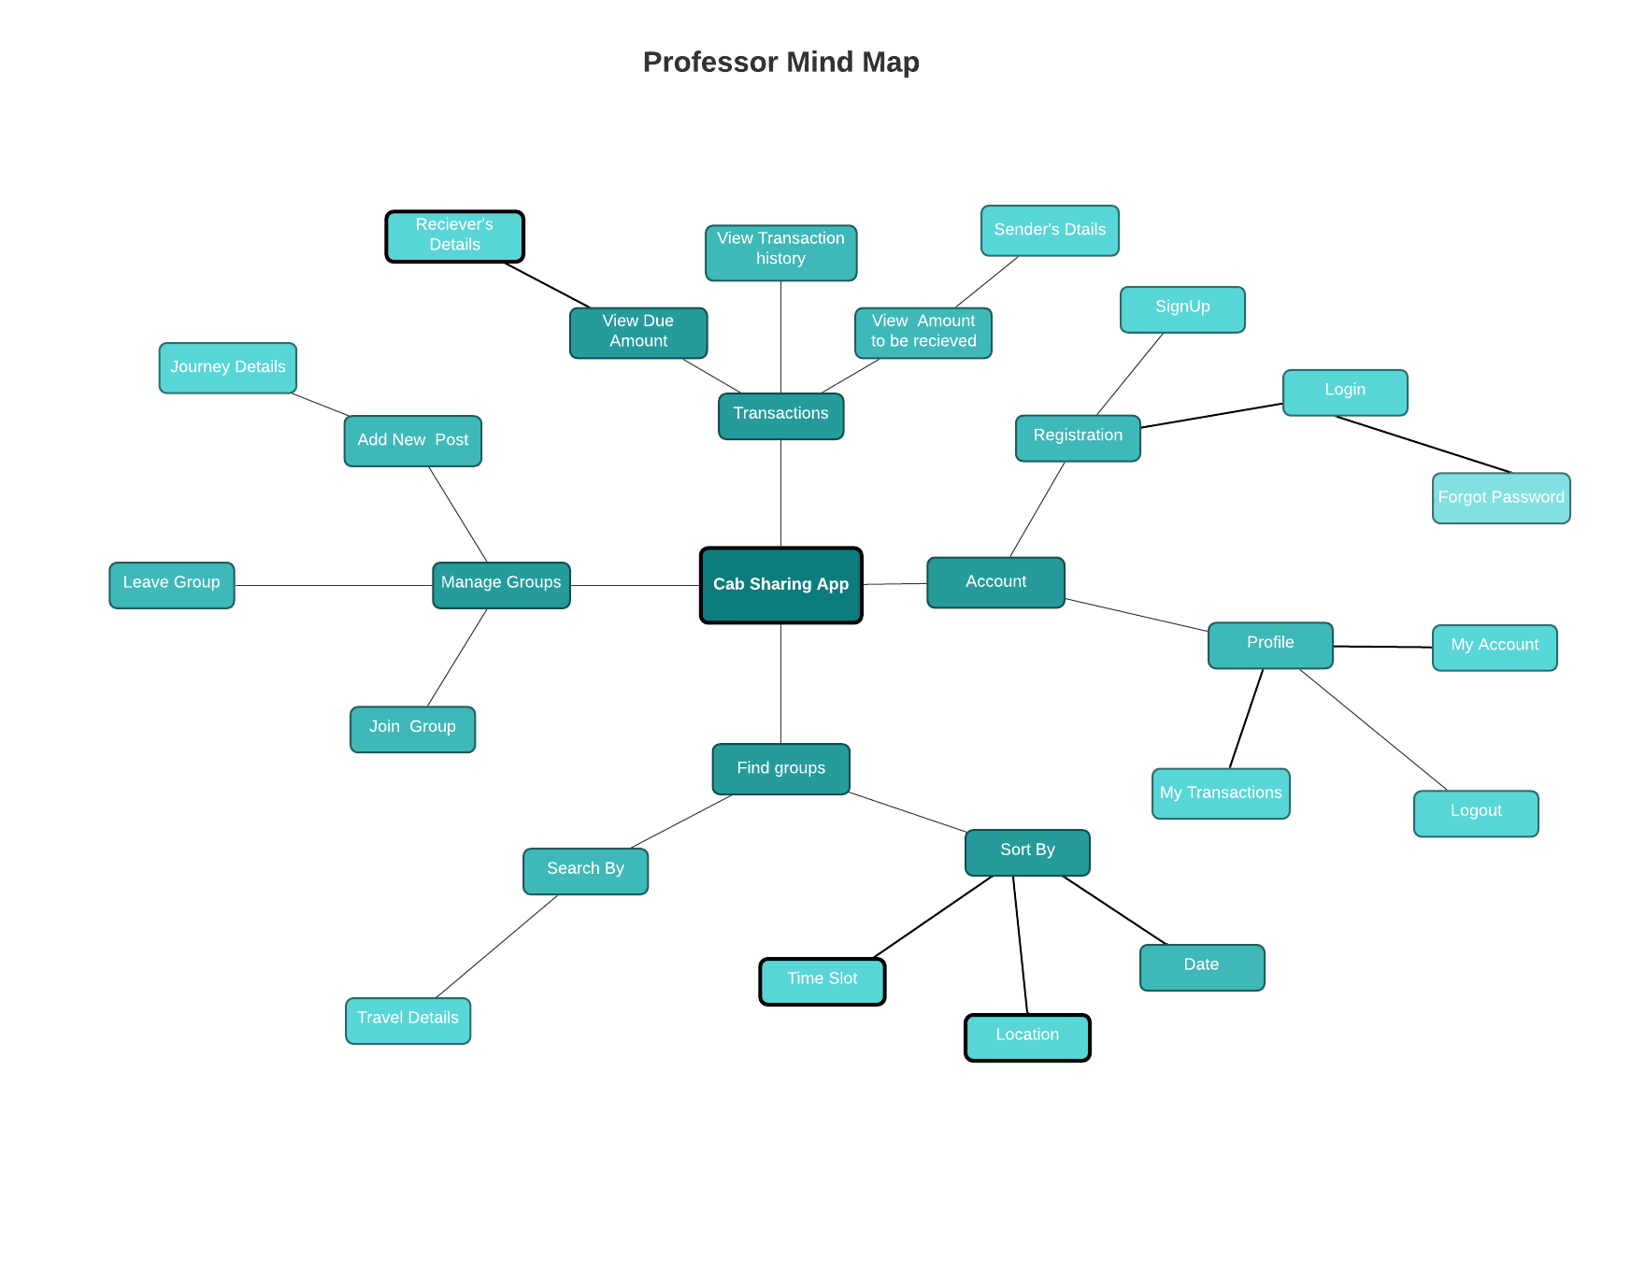

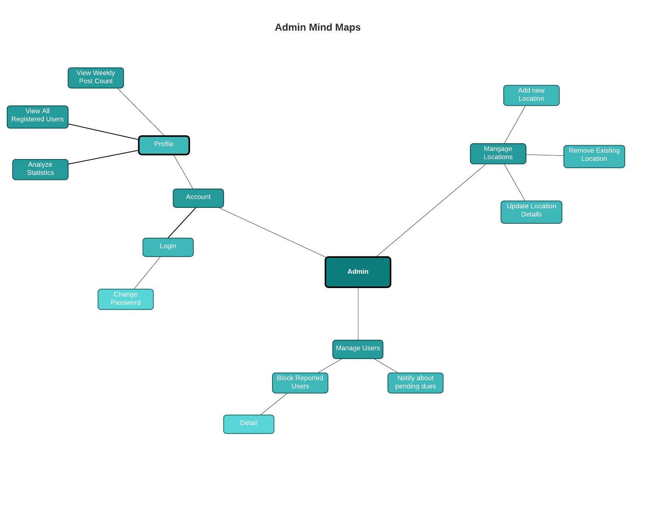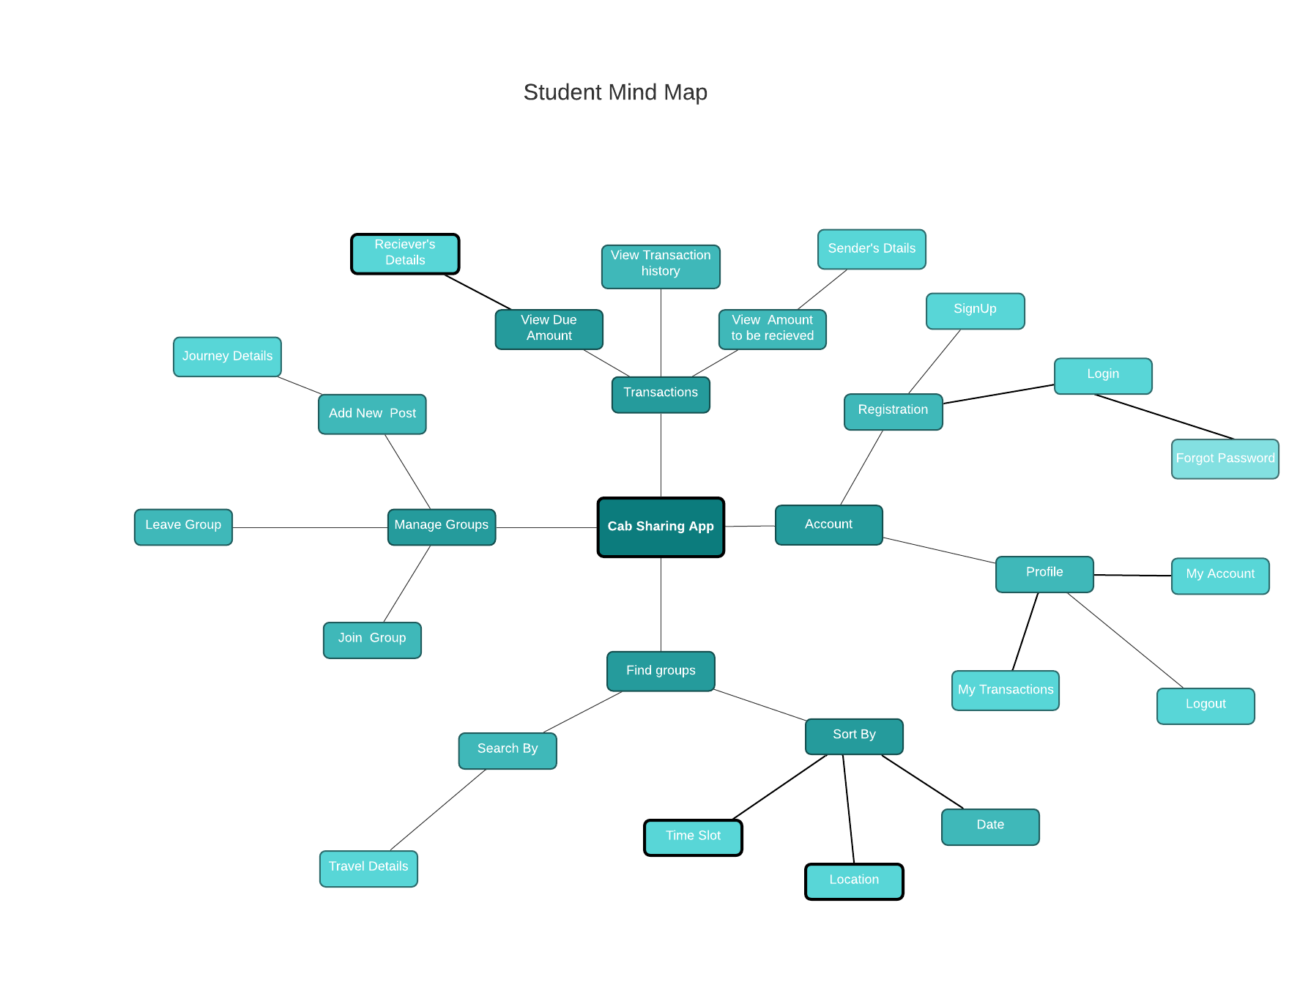

**Section 8**

**Wireframes**

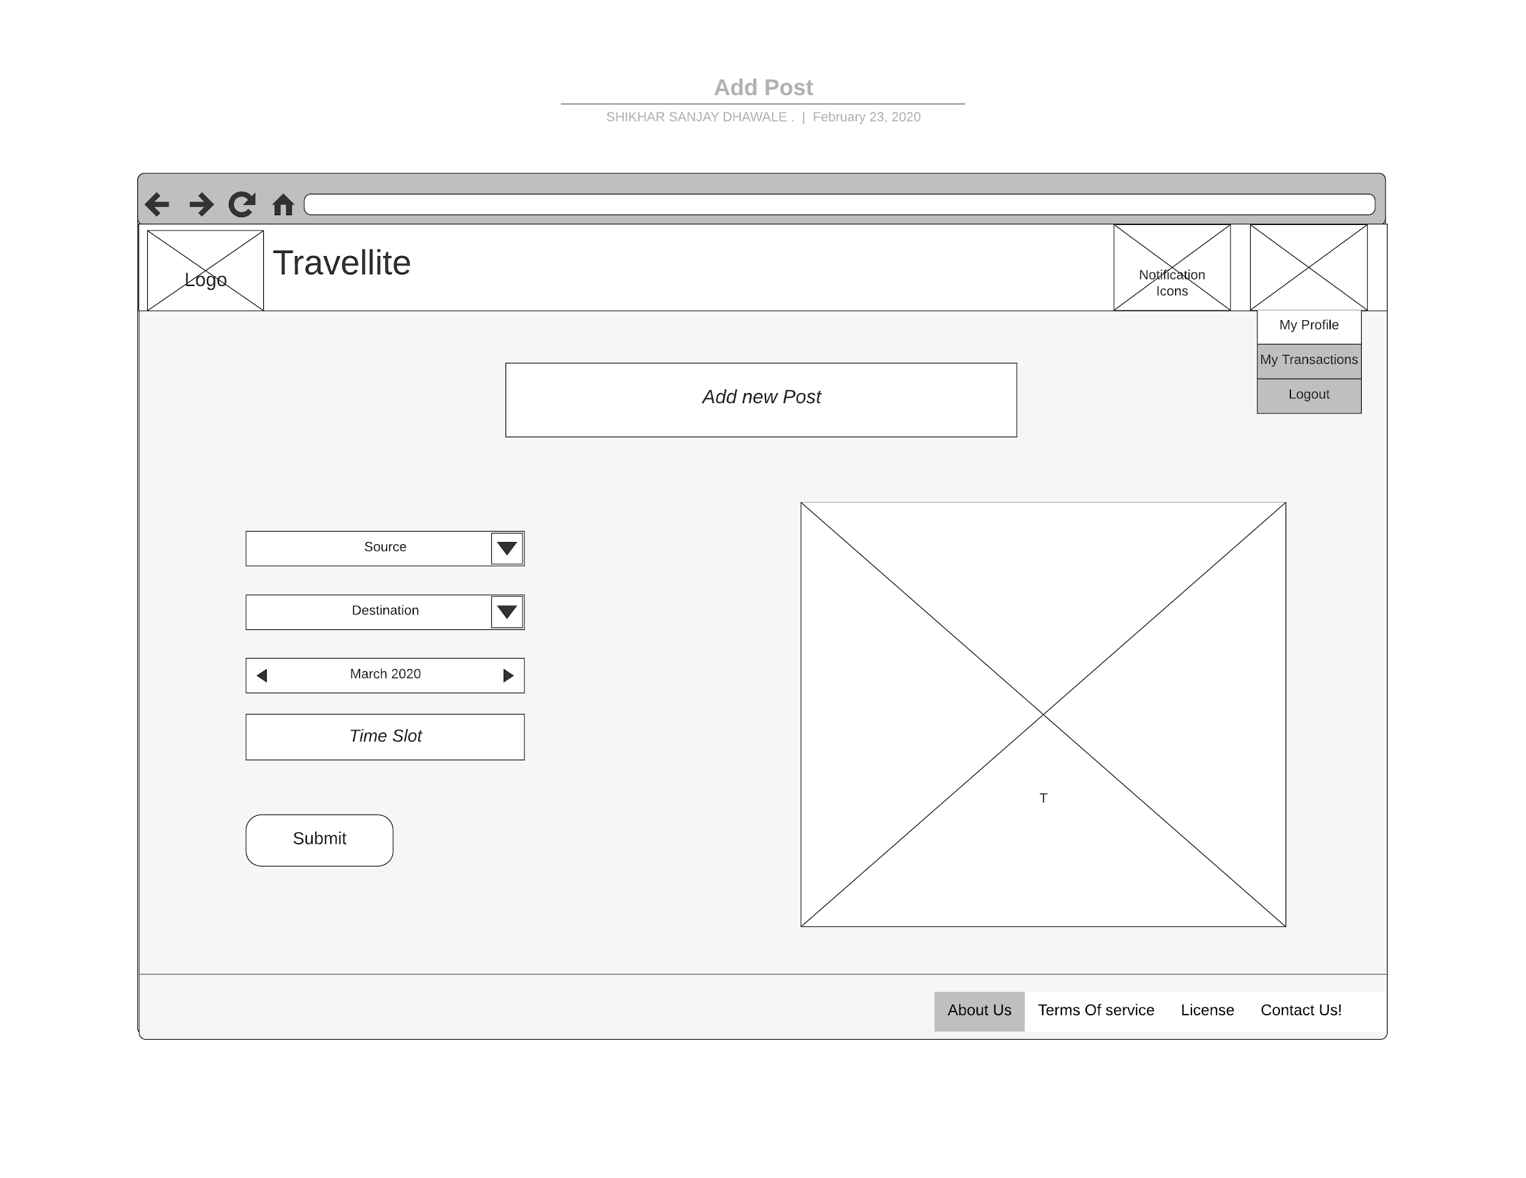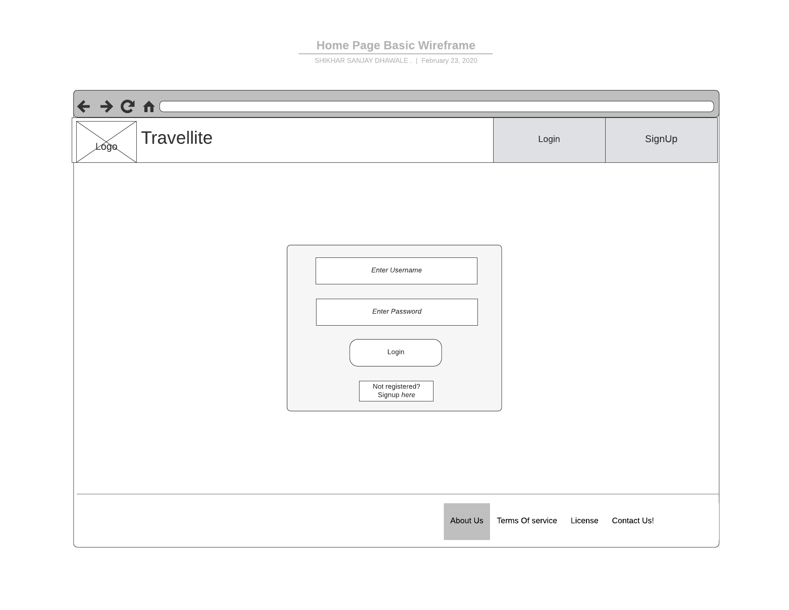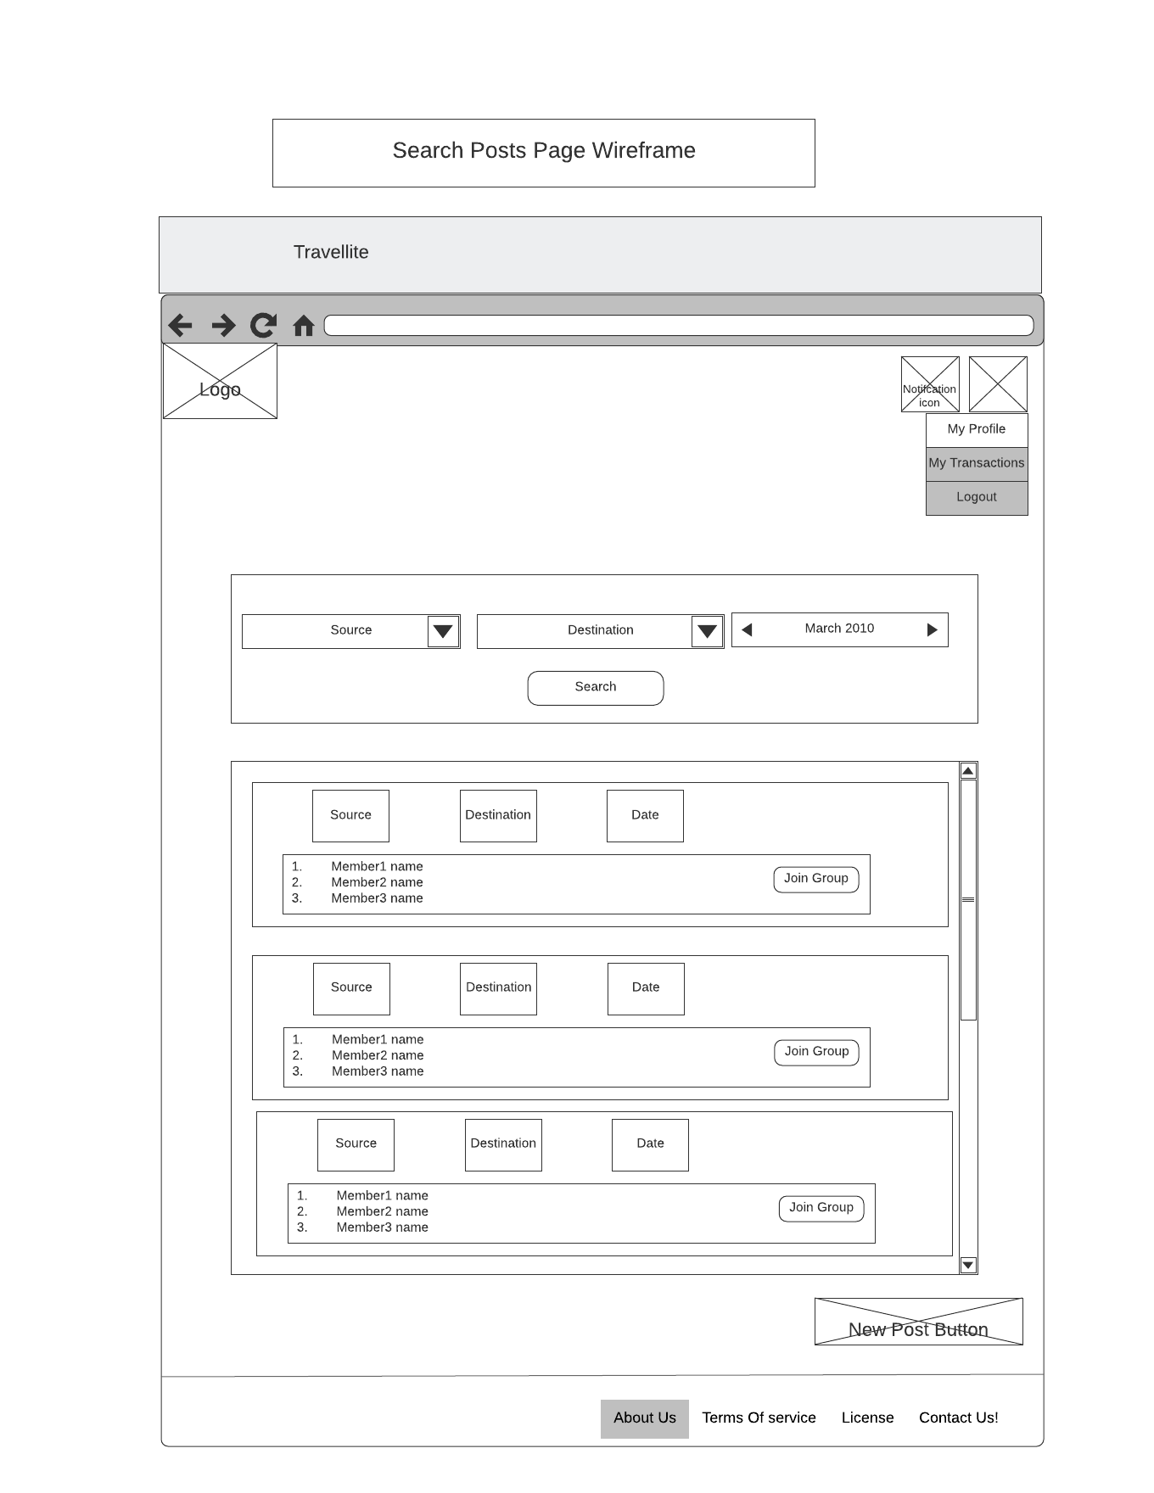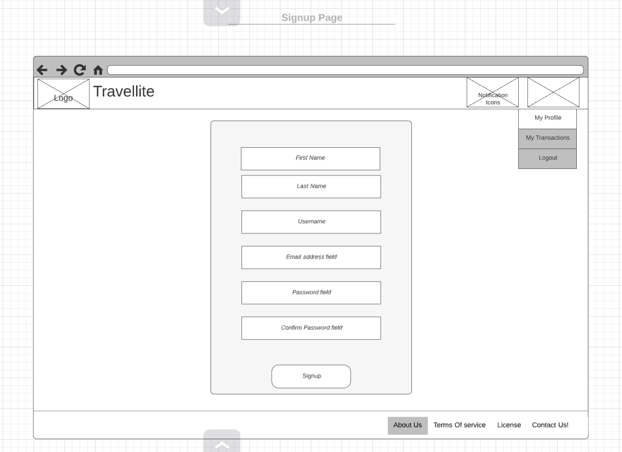

**Section 9 – Class diagram**

<attributes ~~and operations~~ should be listed on the following pages as a table; about 8 to 10 classes are expected with relationships>

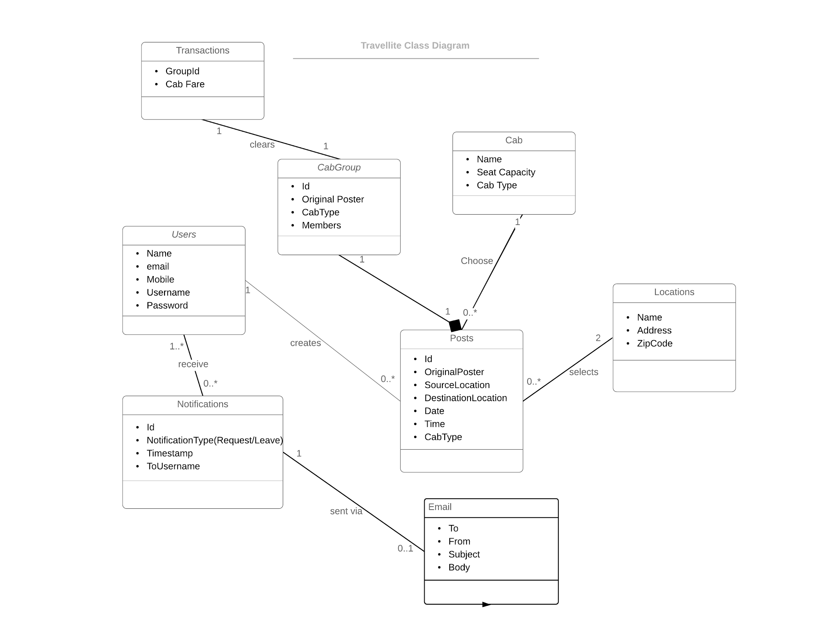

**Attributes ~~and operations~~**

<underline class attributes ~~and operations with underline~~>

|  |  |  |
| --- | --- | --- |
| Class name | Attributes | ~~Operations~~ |
| User | * Name * email * Mobile * Username * Password |  |
| CabGroup | * Id * Original Poster * CabType * Members |  |
| Posts | * Id * OriginalPoster * SourceLocation * DestinationLocation * Date * Time * CabType |  |
| Locations | * Name * Address * ZipCode |  |
| Cab | * Name * Seat Capacity * Cab Type |  |
| Transactions | * GroupId * Cab Fare |  |
| Email | * To * From * Subject * Body |  |
| Notifications | * Id * NotificationType(Request/Leave) * Timestamp * ToUsername |  |

**Section 10 – Project management**

**Project Overview**

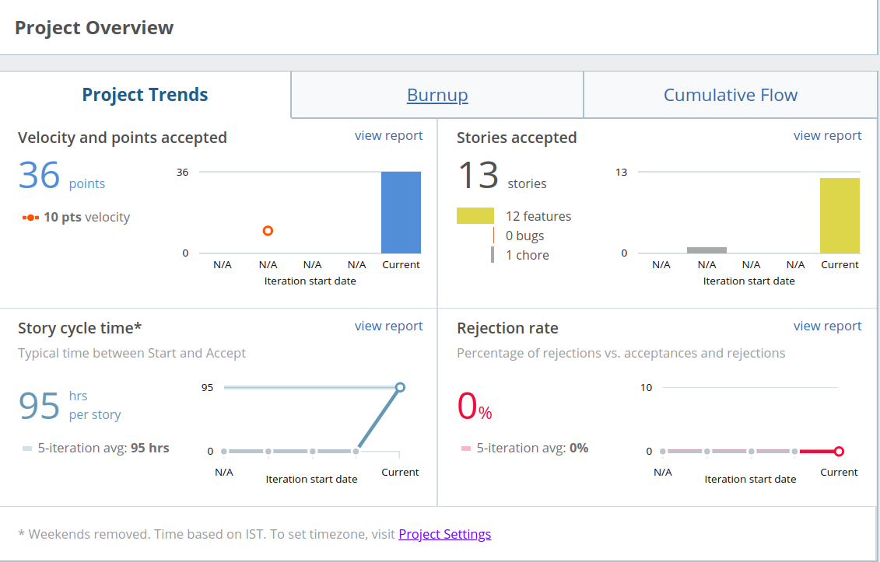

**Iteration Report**

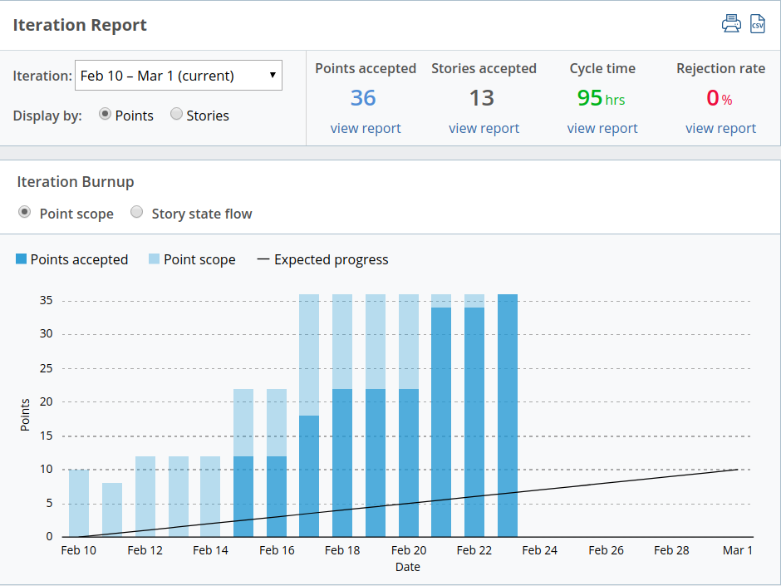

**Burnup Chart**

