

DPP XENON firmware for X724 family

Index

1 Quick overview between firmware features 3
1.1 Trigger Mode 3
1.1.1 EXTERNAL TRIGGER 3
2 Registers 4
2.1 Registers content 4
2.1.1 CONFIG 4
2.1.2 BUFF_ORG 4
2.1.3 INPUT_DELAY 4
2.1.4 PRE_TRG 5
2.1.5 CUST_SIZE 5
2.1.6 DPP_TRG_THRESHOLD (thr) 5
2.1.7 Ns_Under_Thr 5
2.1.8 DPP_CTRL 5
2.1.9 FRONT PANEL I/O CONTROL 6
2.2 Event Data Format 6
3 Quick start to software 7
3.1 DPP-NG parameter settings 7
3.2 Software command overview 8
3.3 Trigger Mode 8
3.3.1 EXTERNAL TRIGGER 8
3.3.2 SELF TRIGGER 9

Quick overview between firmware features
In the following we’ll have a look on the main changes and the new features introduced in the DPP-NG firmware:

Standard firmware:
- common trigger on all channels simultaneously;
- trigger is fired whenever the signal crosses the given absolute threshold;
- programmable record length and post trigger;

DPP-XENON firmware:
- channels can trigger independently;
- trigger is fired either when the signal crosses a given threshold which is absolute or relative to the signal baseline (user-configurable);
- acquisition window variable length in accordance with the pulse duration;
- programmable input delay (to compensate the delay of veto generation with respect to the input signal);
- programmable minimum record length;
- programmable pre-trigger;
- veto features;
- new memory management;

Trigger Mode
Two different Trigger Mode are available, namely:
- External Trigger
- Self Trigger

EXTERNAL TRIGGER
WhenIn this mode the channel self trigger channel is disabled, all channels enabled triggerano together following a SW_TRG (software trigger) or a trigger sent via the connector TRGIN.

Registers
We report here only the registers related with the DPP-NG firmware. For the other board registers refers to the X724 manual

Registers content

CONFIG
Address: 0x8000, 0x8004 (BitSet), 0x8008 (BitClear)
Bits: [31:0]
Access Mode: Read and Write

[0] | Must be 0
[1] | Must be 0
[2] | Not Used
[3] | Test Mode: when the test pattern is enabled the input signal samples are replaced by a sawtooth test signal.  0: Test mode disabled  1: Test mode enabled
[4] | Must be 1
[7:5] | Must be 0
[8]  0x00000100  Default: 0 | Individual trigger: N:B: This bit must be set to 1 to work properly with independent trigger for each channel because the default value is 0
[9]  0x00000200  Default: 0 | Pulse Polarity :  0: The input signals pulse are positive with respect to the baseline  1: The input signals pulse are negative with respect to the baseline  This bit affects all channels. If you want to choose the polarity for each channel individually, set “positive” and then use bit[16] of DPP_CTRL Register (see 2.1.8)
[10] | Must be 0
[11] | Not Used
[12]  0x00001000  Default: 0 | Trgin_disable:  0: TRGIN signal used as COMMON TRIGGER  1: TRGIN signal used as VETO
[13]  0x00002000  Default: 0 | Veto polarity:  0: Veto Signal Active Low  1: Veto Signal Active High
[31:24] | Reserved

BUFF_ORG
Address: 0x800C
Bits: [3:0]
Access Mode: Read and Write
This register allows to set the maximum number of events acceptable for the board.
The memory are not managed in pages, but this value must be set to the maximum value (1024) so you have to set 0xA (that is the default value.)

INPUT_DELAY
Address: 0x1n34 (channel n), 0x8034 (all channels)
Bits: [8:0]
Access Mode: Read and Write
[8:0]  0x000001FF  Default: 10 | Input_Del: Defines the delay added to the input waveform : DELAY= NS_{DEL}*10 nsec= INPUT_DEL * 2 * 10 nsec. (Max INPUT_DEL = 511).
[31:9] | Reserved

PRE_TRG
Address: 0x1n38 (channel n), 0x8038 (all channels)
Bits: [8:0]
Access Mode: Read and Write
[8:0]  0x000001FF  Default:6 | Pre_Trg: Defines the number of samples of the pre trigger: NS_{PRE} = PRE_TRG * 2. (Max PRE_TRG = 511).
[31:9] | Reserved

CUST_SIZE
Address: 0x1n20 (channel n), 0x8020 (all channels)
Bits: [20:0]
Access Mode: Read and Write
[20:0]  0x001FFFFF  Default: 100 | CUST_SIZE: This register allows the user to set the minimum waveform length, the minimum number samples in the waveform is Ns = CustSize; Custom size must be multiple of 2.  WARNING: unlike standard FW, in the DPP XENON FW the number of samples is only decided by this register and it cannot be zero, otherwise no sample will be saved.
[31:21] | Reserved

DPP_TRG_THRESHOLD (thr)
Address: 0x1n60 (channel n), 0x8060 (all channels)
Bits: [13:0]
Access Mode: Read and Write
[13:0]  0x00003FFF  Default: 0 | Trigger Threshold (thr): when the input signal crosses the trigger threshold value, the trigger signal is given and the wave storage starts. The threshold can be relative to the baseline calculated by the FW or absolute (if the number of samples for the baseline calculation is 0).
[31:14] | Reserved

Ns_Under_Thr
Address: 0x1n78 (channel n), 0x8078 (all channels)
Bits: [20:0]
Access Mode: Read and Write
[20:0]  0x001FFFFF  Default: 4 | Ns_UndThr: This register allows the user to set the number of samples below the threshold before closing the acquisition (when autotrigger is enabled and Stored Samples >= CUST_SIZE): Ns = Ns_UndThr * 2.
[31:21] | Reserved

DPP_CTRL
Address: 0x1n80 (channel n), 0x8080 (all channels)
Bits: [31:0]
Access Mode: Read and Write
[15:0] | Not Used
[16]  0x00010000  Default: 0 | Individual Pulse Polatiry:  0: The input signal pulse is positive with respect to the baseline  1: The input signal pulse is negative with respect to the baseline
[19:17] | Not Used
[22:20] 0x00700000  Default: 0 | Baseline averaging window: number of samples to calculate the baseline.  000: 0 sample : Baseline is not calculate and Trigger Threshold (see 2.1.6) is absolute  001: 16 samples  010: 32 samples  011: 64 samples  100: 28 samples  101: 256 samples  110: 512 samples  111: 1024 samples
[23] | Not Used
[24] 0x01000000  Default: 0 | Self Trigger Disable: This parameter disable/enable the self trigger (auto trigger)  1: Disabled;  0: Enabled;

FRONT PANEL I/O CONTROL
Address: 0x811C
Bits: [31:0]
Access Mode: Read and Write
Bit 11 of this register allows to configure the board to send the TRGIN signal directly to the channels without processing.
N.B: This bit must be set to 1 when you want to use the TRGIN signal as VETO.

[0:10] | See V1724 User's Manual for
[11] | TRGIN_DIRECT2PB:  0: TRGIN signal processing by the motherboard  1: TRGIN signal sent directly to channels
[12:31] | See V1724 User's Manual for

Event Data Format

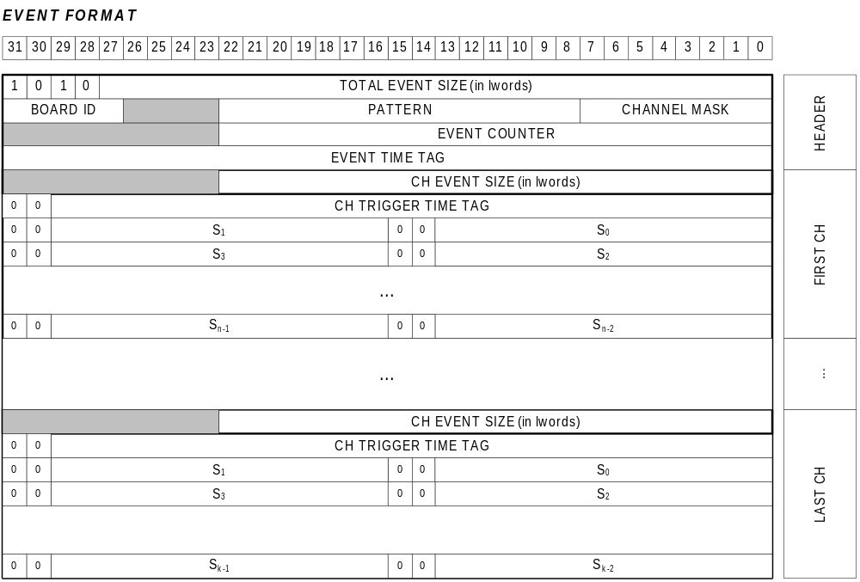
An event from the board is composed of a header and one event for each channel that has triggered.

The HEADER format is the same as the standard FW, but the “EVENT TIME TAG” field represents the time in which the motherboard starts to read data from channels to compose the event itself: as the channels acquire with individual trigger this field loses physical significance.
The “CHANNEL MASK” field is the pattern of the channels that compose the event and is therefore a non-null subset of enabled channels, while in the standard FW coincides with the “channel enable mask”.

For each channel present in the event:
- first word is the EVENT SIZE (in 32bit words), is inclusive of the size word itself and of the Trigger Time Tag word, so EVENT SIZE= (DATA SIZE + 2).
- second word is the TRIGGER TIME TAG:
- bit [30:0], it is a 31-bit counter that indicates the start time of the acquisition window, ie the time of the first sample of the event
- bit 31: indicates the event type:
0 = complete event;
1 = truncated event (with “pretrigger” less than the set value);

- (EVENT SIZE-2) data words, each containing 2 samples of the input signal.

Quick start to software
This simple software is a demo to show how to configure the digitizer , read and analyze the data produced by the XENON_CUSTOM firmware. In the following we will see how to configure the XENON_CUSTOM parameters and how to launch an acquisition.
In the ../bin project folder there is the WaveCut.exe file that launches the software and the relevant file WaveCat_Config_Common.txt for settings the acquisition parameters common for all channels (and all boards), and the files WaveCat_Config_b.txt (for the board “b”).
To perform any acquisition, do the following two steps:
- configure the “configuration files”, that is, setting the XENON_CUSTOM parameters like the input delay, the trigger mode, the veto mode, pretrigger, record length, nsamples_under_thr, Ns_baseline, etc.
- execute the software and analyze the data.

DPP-NG parameter settings
The user can configure the XENON_CUSTOM parameter within the permitted value range (always refer to the registers description) or at least create it’s own configuration file.
The main parameters are:

- INPUT_DELAY [integer (1÷511)]: defines the delay added to the input signals to compensate for any delay of veto signal. DELAY = INPUT_DELAY*2*10 nsec;

- RECORD_LENGTH [integer (2÷(MemorySize-2))]: defines the acquisition window size that is the minimum number of samples contained in one event for each channel. This number must be multiple of 2. MemorySize is: 512K samples for V1724 models A,C,G and 4Msamples for others models.

- PRE_TRIGGER [integer (1÷511)]: define the number of samples for the pre-trigger (NS_{PRE_TRIGGER} =PRE_TRIGGER*2);

- TRIGGER_THRESHOLD [integer (1÷16383)]: defines the threshold for the self trigger generation; this threshold can be relative to the baseline calculated by the FW or absolute (if the number of samples for the baseline calculation is 0);

- NS_UNDTHR [integer (1÷1023)]: define the number of samples under threshold for closing acquisition (when self trigger is enabled): NS_UnderThreshold=NS_UNDTHR*2;

- NS_BASELINE [integer (0÷7)]: define the number of samples for baseline calculation:
0: 0 sample : Baseline is not calculate and Trigger Threshold is absolute
1: 16 samples
2: 32 samples
3: 64 samples
4: 128 samples
5: 256 samples
6: 512 samples
7: 1024 samples

Note: In this software DC_OFFSET, TRIGGER_THRESHOLD, NS_UNDTHR, NS_BASELINE, can be set individually for each channel; all others parameter are common for all the channels

Software command overview
Once launch the software, make sure the XENON_CUSTOM firmware release is the correct one (AMC FPGA Release 139.xx). To view the bind key help within the cmd window, press the space key. A list with all the software option will appear:

[s] Start acquisition
[S] Stop acquisition
[t] Send software trigger (one shot)
[T] Enable/Disable continuous software trigger
[W] Enable/Disable continuous waveforms saving to file
[b] Choose board on the plot
[c] Choose channel on the plot
[w] Enable/Disable continuous plot
[i] Save Registers Image
[q] Quit
[space] Print Menu

Start the acquisition pressing the “s” key. For the graphic interface, this software relies to the “gnuplot” which is a power graphic software (open source software). If any graph is displayed or “no data…” message is given on the cmd window, be sure that:

- check if you have enabled at least one channel within file WaveCat_Config_0.txt (for the board “0”) file,
- make sure to put the input signal to the correct enabled channel;
- set properly the PULSE_POLARITY parameter (see PULSE_POLARITY parameter description);
- make sure to set a significant value for the DPP_THRESHOLD
- if you are working with the baseline calculation, try to use absolute TRIGGER THRESHOLD (NS_BASELINE=0).

Trigger Mode
Two different Trigger Mode are available, namely:
- External Trigger
- Self Trigger

EXTERNAL TRIGGER
When EXTERNAL TRIGGER mode is selected, channel self trigger is disabled and the duration of the acquisition is fixed (one set as RecordLength).
All enabled channels start acquisition together following a software trigger (SW_TRG) or a trigger sent via the TRGIN connector.
Also you can not send a veto signal.

SELF TRIGGER
When SELF TRIGGER mode is selected, channel self trigger is enabled,while software trigger and TRGIN are disabled .
The duration of the acquisition is variable in accordance with the pulse duration:if after “RecordLength” samples, the signal is still above threshold, the acquisition is prolonged and is closed when the signal falls below the threshold for a programmable number (see 2.1.7 :Ns_Under_Thr) of samples.
When SELF TRIGGER mode is selected, it is possible to send a VETO signal to the TRGIN connector and configure the board to use this veto.

