Python Pi Project #6: Photo Booth
Level: Middling
One of the cool things you can get for the Pi is the Pi Camera. Let's take the Big Red Button example from the last project and turn it into a photo booth. You know the thing – you pop in your money (we'll press the button), it counts down for a moment (we'll flash the LED) and then takes your photograph (and we'll put it on a web page).
Hacking skills needed
- More GPIO
- Using the Pi Camera
We don't need any changes to the wiring on our breadboard since the last Project:
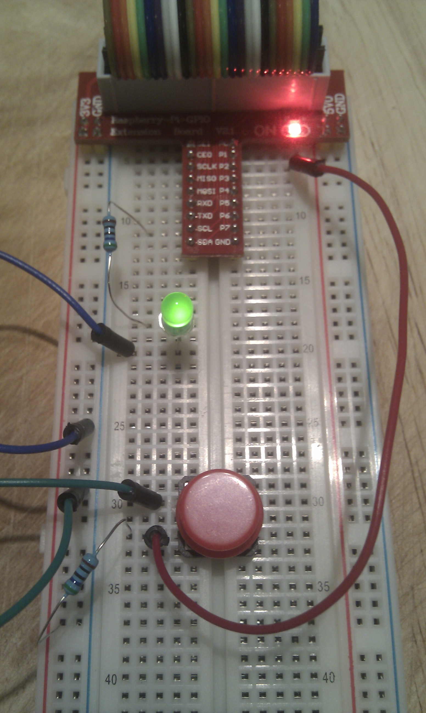
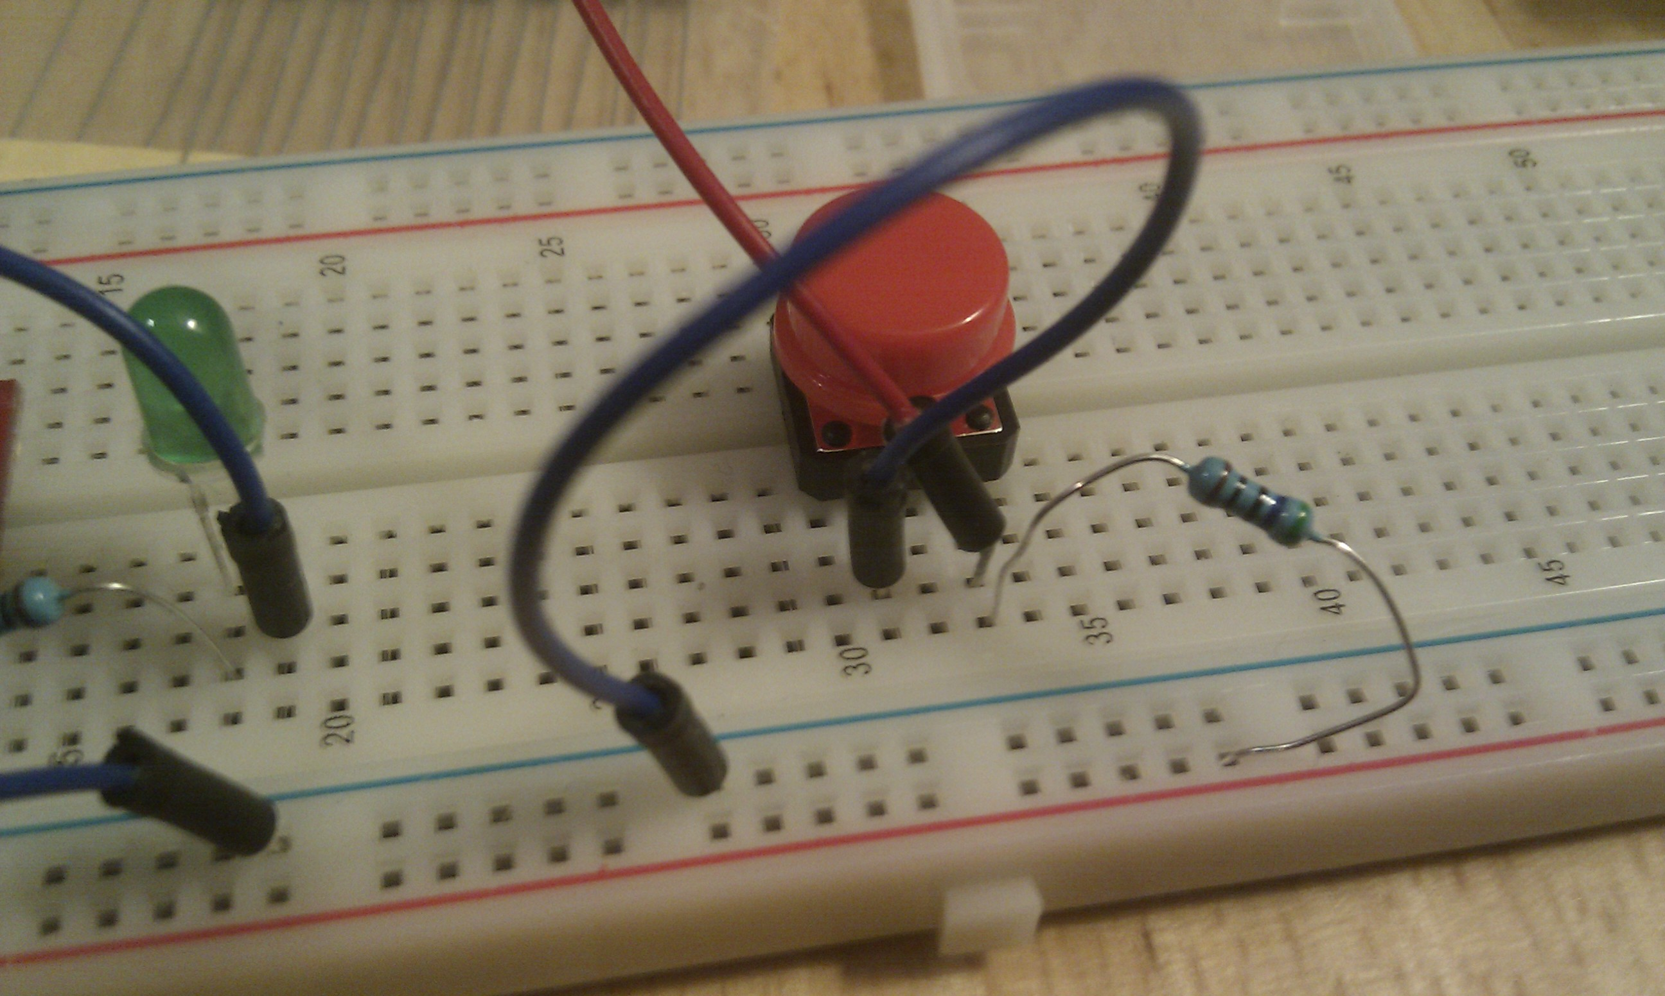

To take photos we'll plug in the Pi Camera to our Pi. The camera can be controlled from Python. There's a lot it can do, and we'll barely scratch the surface. For more extensive examples try http://www.raspberrypi.org/learning/python-picamera-setup/

You'll see that the code in our program has a lot that looks like Project 5, to manage the button pressing.
The difference now is that instead of just toggling the LED when the button is pressed, we take a photograph using a function called 'click':
def click():
snap('pic.png')
This just uses another function called 'snap' to do the work, but gives that function as its input the name of the file to save the photo in.
So the real work is done in 'snap':
def snap(name):
with picamera.PiCamera() as camera:
camera.resolution = (1024, 768)
camera.start_preview()
countDown(3, 1) # slow blink for 3
countDown(1, 0.1) # fast blink for 1
camera.capture(name)
This shows just a couple of the things you can do with the Pi Camera controls - setting the resolution:
camera.resolution = (1024, 768)
Then the start_preview will pop up a window on the screen that shows you what the camera is viewing. Smile!
camera.start_preview()
While you're smiling, we'll make the LED blink, with a little 'countDown' function.
We'll call it twice – once to make it blink slowly for three seconds, then again to make it blink quickly for one last second – still smiling? - and lastly we'll take your photo! -
camera.capture(name)
To show the picture you just took on a web page, put the file booth.html in the same directory as your python program and double click it in your file manager, to launch the web browser. To avoid having to introduce too many ideas all at once, we've kept the web page just about as simple as you can.
The Python bit - photoBooth.py
#!/usr/bin/env python

import RPi.GPIO as GPIO
import time
import picamera

# Constants
ON = True
OFF = False
pin_button = 12
pin_led = 8

# Functions
def snap(name):
with picamera.PiCamera() as camera:
camera.resolution = (1024, 768)
camera.start_preview()
countDown(3, 1) # slow blink for 3
countDown(1, 0.1) # fast blink for 1
camera.capture(name)

def getLed():
return GPIO.input(pin_led)

def getButton():
return GPIO.input(pin_button)

def setLed(state):
GPIO.output(pin_led, state)

def toggle():
setLed(not(getLed()))

def countDown(seconds, interval):
for n in range(seconds):
for t in range(int(1/interval)):
toggle()
time.sleep(interval)

def setupGPIO():
GPIO.setwarnings(False)
GPIO.setmode(GPIO.BOARD)
GPIO.setup(pin_button, GPIO.IN)
GPIO.setup(pin_led, GPIO.OUT)
setLed(OFF)

def click():
snap('pic.png')

# Do the main work of the program
try:
setupGPIO()
prev = -1
while True:
state = getButton()
if (0 == prev) and (1 == state) :
click()
prev = state
time.sleep(0.1)
except KeyboardInterrupt:
print("\nDone")

The Web Page bit – booth.html
<head>
<meta http-equiv="refresh" content="1" />
<style>
img {
height: 400;
}
</style>
</head>
<body>
<h1>Snap!</h1>
<img alt="picture" src="pic.png" />
</body>
</html>

Dojo Challenge:

Read up more online about the Pi Camera:

- What effects can you apply to the picture?
- Can you record a video instead of taking a picture?

