PAPER
Study on Ranking Improvement Method for Patent Publications Using Classification Code Similarity
Kenji AKIYAMA†, member, Takafumi SAITO†, member

† The author is with Tokyo University of Agriculture and Technology, Koganei-shi, 184-8588 Japan.
SUMMARY
In a patent infringement avoidance survey, it is necessary to check a large number of publications retrieved with classification codes and/or keywords determined by the search theme, which requires a lot of manpower and time. If publications can be ordered according to their importance determined from their relationship with own products, work efficiency can be expected to improve. In this study, we examined the ranking method based on the relevance of the products using the patent classification codes appearing in the past patent survey data. Although effective ranking was difficult with the conventional method for survey cases which has different survey viewpoints from past cases, we propose an improvement method for such case. In the verification experiment, a ranking evaluation index (REI) is defined, and it is confirmed how much the ranking by this method matches the result of the actual infringement avoidance survey conducted manually beforehand.
key words: Infringement avoidance survey, Patent classification code, Machine learning
1. Introduction
Companies involved in the manufacturing industry cannot continue corporate activities without knowing the patents of other companies. They have to conduct various surveys related to patents, not just patent applications. There are several types of patent surveys; “Technology Trend Survey” to investigate industry trends and “Prior Art Search” to confirm that there are no similar publications prior to patent application. Furthermore, when developing a new product, the company conducts an “Infringement Avoidance Survey” to confirm that the new product does not infringe on other company's patent. If all the technical elements described in the claims of the patent are implemented in the product, the possibility of infringement is high. (Product is related to the patent) Conversely, if even one technical element unrelated to the product is included, it is determined to be non-infringing. (Product is not related to the patent) This judgement can only be done by product technology specialists and requires a lot of manpower and time.
In this study, we considered about the publication ranking improvement in infringement avoidance survey. If the ranking is reliable, the check person can concentrate on the most important part within the limited development time. For this objective, we performed ranking based on the international patent classification code assigned to the patent. And we defined importance index of publication and compared the ranking with the actual infringement avoidance search results.
There are two survey ways in actual infringement avoidance surveys. The first survey way is conducted regularly and continuously, such as monthly. Publications in the same technical field as the company's products are retrieved from the newly published publications, and the researcher roughly extracts those likely to be related to the company's products. And the staffs in the individual specialized departments confirm that the shipped product or the product under development does not infringe the extracted patent.
The second survey way is conducted when a new technologies are installed in a newly released product, and it is checked that these technologies infringe on another company's patent or not.
Since the first survey way is conducted continuously, a lot of results may be accumulated in the company. Therefore, a method of ranking using these as training data is considered to be effective, and the possibility is confirmed.
On the other hand, in the second survey way, the new survey theme is different each time, so conduct ranking using past case data is difficult. The difference is that the first search method does not focus on a specific theme, whereas the second search collects publications on a specific theme. However, the criteria for determining whether there is infringement in relation to their products are the same. Therefore, we also verified how to rank the second survey more efficiently using the first survey data.
2. Related Works
The determination of a new case based on past cases is regarded as a classification problem. However, it is possible to perform a regression analysis and perform ranking based on the certainty of the determination even for a problem in which the determination is represented by binary values on a relationship. A lot of methods of regression analysis are known, such as simple linear regression, kernel ridge regression that determines a kernel function in consideration of nonlinearity, and regression analysis using a support vector machine.
On the other viewpoint, “Relevance Feedback” is known as a method for improving the efficiency of document searches using machine learning. In a system using this method, the researcher selects some documents that match the purpose of the survey from the retrieved documents and feeds it back to the system. The system can display the documents that meet to the purpose of survey at the top order by re-searching the documents that are close to the fed-backed documents. Although the concept of relevance feedback is not new [1], improvement proposals are still reported. Ruthven et al. have proposed an interactive technology for realizing feedback that meets the user's information needs [2]. Harashima et al. have proposed a feedback method characterized by language processing that uses not only surface words but also latent word information for reranking [3]. Hatakenaka et al. have proposed a method to extract the knowledge from multiple categories of training data, and build topic features to implement a search that reflects the topic [4].
Relevance feedback can collect many other publications that are close to the feedback publication. In an infringement avoidance survey, however, it is not easy to provide feedback on all technical elements because the products related to a wide range of technology, and we might miss related publications unexpectedly.
Ranking method based on the citation relationships for documents or web pages is also well known [5]. However, it is difficult to rank in the order of relation with product technology.
As a related work on patent survey, Bergmann et al evaluated similarities between patent documents on the basis of semantic patent analysis to detect the risks of the patent infringement [6]. However, this method is not suitable for selecting important publications from many publications.
With regard to the problem of infringement avoidance survey, Ando points out as follows [7]. Although it is possible to extract and prioritize a publication containing the component of interest using keywords, it is not possible to prove that the component described in the claim of the publication is not included in the product. In other words, it has been considered difficult to rank publications based on its low likelihood of being used as elements of a product.
3. Conventional Ranking
First, we confirm the ranking performance of the conventional method using specific survey examples.
3.1 Outline of Survey Case
We use a data set of an infringement investigation survey in a communication device developing company as data of the first survey way. This survey was conducted continuously over five years from 2013 to 2017. This data set has 26,353 retrieved publication, and 2,781 of these are labeled by humans to be "close to their products". To be clear, this judgment means that the technology described in the patent publication is very close to the technical elements of the product, not that the product infringes the patent. Hereinafter, this is referred to as a “past case”.
The same company requested an external searcher to search for a patent when developing a new product and received 352 publications of search results. They were checked manually and 58 cases were judged to close to new product mounting technology. We use this data as the second survey way data. Hereinafter, this case is referred to as “new case”.
3.2 Ranking Metrics
“Ranking Evaluation Index (REI)" is introduced as an evaluation scale that indicates the implemented ranking is close to the relationship given by humans.
Z is the total number of publications to be surveyed, and X is the number of target publications that humans have selected to be relevant to own product. Fig. 1 shows the relationship between the number of checks and the cover rate of the target publication when the publications are checked in the ranking order. If the publications are ranked at random, the cover rate increases proportionally as the check progresses, as shown in the blue graph. On the other hand, if the ideal ranking method can be attached the target publication is ranked at the top, so the coverage rate is 100% when X publications are checked as shown in the green graph. When ranked by actual ranking method, the cover rate curve passes between the two lines like a red curve. The area S₀ surrounded by the green and blue graphs represents the ideal improvement, and the area S_{a} surrounded by the red and blue graphs represents the actual improvement. Therefore, REI is defined as the ratio of S_{a} and S₀.
$$REI=\frac{S_{a}}{S_{0}} (1)$$
This index value ranges from 0 to 1. The closer to 1, the more ideal the ranking is, and the closer to 0, the more random the ranking is. The receiver operating characteristics (ROC) used in the field of signal processing have similar meanings. ROC ranges from -1 to 1. ROC = 0.5 corresponds to REI = 0. However, in this study, the ratio of work improvement can be expressed by REI, so we discuss with this index. In addition, REI is affected by the ratio of Z and X, and this ratio appears on the green line of Fig.1. REI has an advantage that this effect can be intuitively grasped.

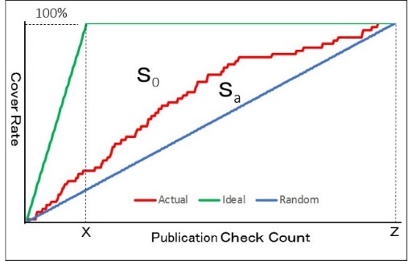
Fig.1 Target Publication Cover Rate and Check Count

3.3 Cross-validation of Past Case Ranking
The past case has M number of publication data, and is divided into N number of training data and M-N number of test data. Each data has plurality of IPC codes such as “G08B 13/18, H04W 76/50, - - -” and $A_{i}$ refers to code set of i-th publication data. Assuming that the set of all IPC code is C and each IPC code is $c^{(j)}∈C$, the IPC code contained in each publication is represented as |C| dimensional vector $x_{i}$.
$x_{i}^{}=\left( x_{i}^{\left(j\right)}\right){\left|C\right| \atop j=1}$
As for each element $x_{i}^{(j)}$, the portion corresponding to the IPC code included in the publication is 1 as described below.
$x_{i}^{(j)}=\left\{\begin{aligned}1, &c^{\left(j\right)}∈A_{i} \\ 0, else \end{aligned}\right.$
Also, as a result of the human judgment, 1 is given to yi if the publication is close to the product, and 0 is given otherwise. $y_{i}∈\{1,0\}$
These data are fitted to a linear model.
$y_{i}=β_{0}+β_{1}x_{i}^{1}+⋯+β_{\left|C\right|}x_{i}^{\left|C\right|}$ (2)
The regression analysis is a problem of finding $\tilde{β}$ satisfying next equation by N training data.
$$\tilde{β}=\min_{β}{\sum_{i=1}^{N}{\left(y_{i}-\sum_{j=1}^{\left|C\right|}{β_{j}x_{i}^{(j)}}\right)}} (3)$$
Regression for test data is performed by calculating $\tilde{β}x_{i} \left(i=N+1 \sim M\right)$. A publication having a larger calculation result has a higher relationship with a product, and ranking can be performed based on this. We conduct k-fold cross-validation to confirm whether the judgment of humans given in the past case can be regression-analyzed.
Fold number is 10. Validation result shows in Fig.2. In addition to the results of linear regression (a), rankings are also performed in polynomial Kernel Ridge regression (b) and in support vector machine regression model results (c) to support nonlinear models. REI values between 0.614 and 0.755 were obtained, and Kernel Ridge shows the best ranking performance. This result shows that survey work can be improved to the extent of the REI value for next case of regular surveys of first survey way.

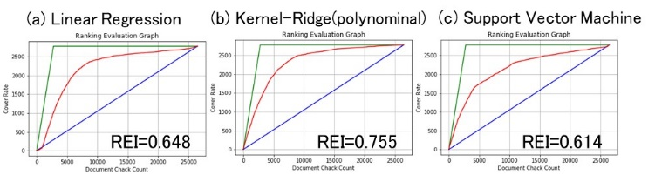
Fig.2 Cross-validation of Past Case Ranking by Conventional Method
3.4 New Case Ranking using Past Case
Correlation between past cases confirmed that regression analysis was effective for publication ranking. Therefore, we confirm whether or not an effective ranking can be made using past cases as training data and new cases as test data. This result shows in Fig.3. For all regression methods, the REI shows a value of almost 0, indicating that it cannot be applied to new cases retrieved for individual themes.

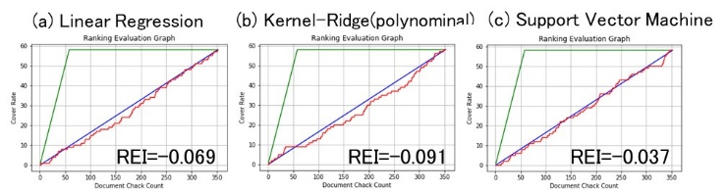
Fig.3 New Case Ranking by Conventional Method
4. Proposed Method
First, we consider how the IPC code is involved in the nature of the infringement avoidance survey.
4.1 Determining the Relevance of a Publication and Own Products
Fig. 3 shows the relationship between the IPC codes related to own products and the IPC codes tagged to the retrieved publications. Cp indicates the IPC code related to own product. However, the investigator does not clearly understand the relationship between products and more than 60,000 IPC codes but recognizes it as an image. Cr represents a set of IPC codes that appear in publications retrieved from patent databases in past infringement avoidance surveys. Cs represents a set of IPC codes that have been determined to be deeply related to the product from Cr. Cs is included in Cp, but it does not cover all of Cp. And Ce represents the set of IPC codes that appear in the publications for a new survey to be carried out.
In patent infringement avoidance surveys, the relationship between a patent and its own product determines whether the company's product contains technical elements that constitute patented technology. In this report, we discuss the assumption that technical elements are expressed in the IPC codes.

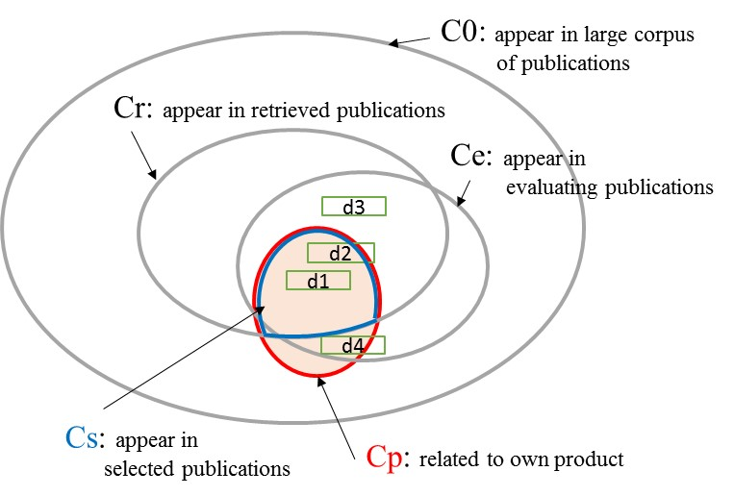
Fig.3 Range of IPC Codes Included in Patent Survey

The rectangles d1 through d4 represent the IPC code set of some publications included in Ce. The publication d1 in which all IPC codes are included in Cp, has a strong relationship with its products, and it is highly likely that its products infringe on the patented technology of d1. On the other hand, d2 that contains part of the IPC codes that are not included in Cp and d3 that does not contain any Cp elements are not related to their products. The judgment of the relationship between the publications and own products is carried out based on the same concept by humans.
Using the IPC code information contained in Cs that was determined to be relevant in the previous infringement avoidance surveys for each IPC code would help determine the new survey. However, even taking into account the appearance of past IPC codes, there are cases such as d4 that are not included in the search results Cr. Using a large publication corpus C0 that covers more IPC codes, the relevance of non-appearing IPC codes can be evaluated from code similarities.
4.2 Concept of Proposed Ranking Method
Fig. 4 shows a conceptual diagram of the proposed ranking method. In this paper, “IPC Relevance (IPCR)” is defined that quantifies the likelihood that each IPC code will be included in Cs. The calculation of this value is a preparation process for ranking. The improvement process at the upper right in the figure is to be introduced in Section 5.
And “Importance Index (IX)” is calculated as publication relevance, using IPCR with multiple IPC codes included in a publication that is subject to the survey. If the publications are ranked in the order of IX, it can be expected that the publications selected by human judgment can be ranked higher.

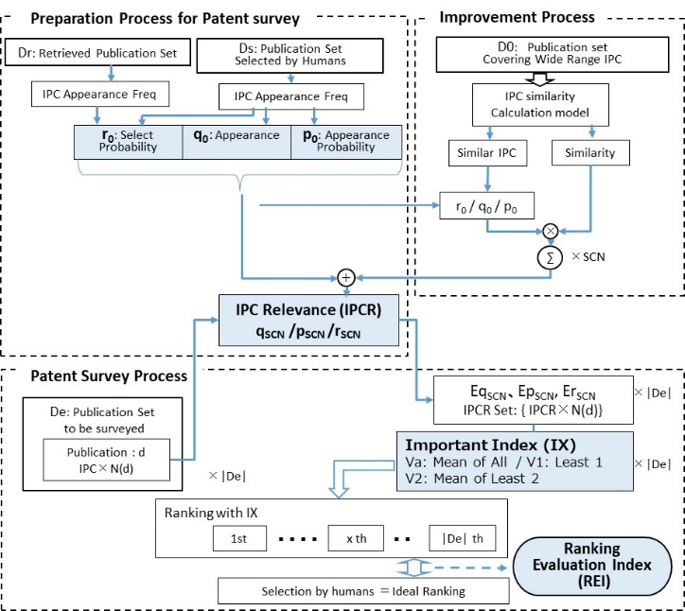
Fig4. Block Diagram of Proposed Method

The concept of calculating IPCR and IX are described. In the preparation process for the patent survey, IPCR is calculated using past infringement avoidance survey data. In this step, the appearance frequency of the IPC code is calculated which is included in the publication set Dr retrieved in past patent surveys and the publication set Ds selected by the humans from Dr as having a relationship with their products. And calculate 3 types of IPC relevance values (Appearance: q₀, Appearance Probability: p₀, Select Probability: r₀) from appearance frequency.
“q0” is information indicating whether or not an IPC code has appeared in Ds, “p0” is probability information obtained by dividing the number of IPC code appearance in Ds by the number of publications in Ds and “r0” is the ratio of the appearance probability of the IPC code in Ds and IPC code in Dr. These three values show the probability that humans selected the IPC code in past surveys.
In the actual patent survey process, IPCR sets (Eq_{SCN}, Ep_{SCN}, Er_{SCN}) are calculated by obtained IPCR from N(d) IPC codes which tagged to the publication (d) included in the publication set De to be surveyed. The Importance index (IX) of the publication is calculated by one of the following three calculation methods, and ranking is performed based on it. The first method (Va) takes the average IPCR, and the second method (V1) uses the lowest IPCR, and the third method (v2) takes the lower two averages.
Generally, if all IPC codes in a publication are included in Cs, Va (average of IPCR) is considered to be high. On the other hand, if only one IPC code in a publication is out of Cs, the humans judge that the publication is unrelated to the product however, Va is not so low compare to Va mentioned above. Va is insensitive to a small number of unrelated IPC codes, because of average calculation. Conversely, V1 and V2 are sensitive to less related IPC codes, because they are calculated with the lower IPCR. If IPCR can be estimated accurately, the ranking using V1 or V2 is expected to be close to human evaluation. EpSCN
4.3 Calculation of IPCR
The set of publications retrieved from the database in past infringement avoidance surveys is Dr, and the set of publications that humans have selected to be judged to related to own products from Dr is Ds. Ds is described as follows.
Ds = {ds¹, ds², ds³, ･･･, ds^{|Ds|}}
Each publication in Ds is assigned code set Cs⁽¹⁾, Cs⁽²⁾, Cs⁽³⁾ , ･･･, Cs^{(|Ds|)} , and each code set Cs^{(ds)} contains of N(ds) of different IPC codes.
Cs^{(ds)} = {c^{(ds,1)}, c^{(ds,2)}, c^{(ds,3)}, ･･･, c^{(ds,N(ds))} }
c ∈ IPC c : c₁, c₂, c₃, , ･･･, c _{|IPC|}
Here, “c” represents an IPC code such as “A01A__10 / 23”, and “IPC” represents the code set composed of all IPC codes. The past appearance frequency of each IPC code can be calculated as follows.
$$f\left(c_{i}\right)=\sum_{ds∈Ds}{\sum_{n=1}^{N(ds)}{δ\left(c_{i}.c^{\left(ds,n\right)}\right) }} (4)$$

Where δ (a, b) is a function that output 1 when a = b and 0 when a ≠ b. The above equation means counting the number of c_{i} appearing in each Cs and summing it up for all publications in Ds. Appearance q₀(c_{i}) and appearance probability p₀(c_{i}) are calculated by the following equations.

$$q_{0}\left(c_{i}\right)=\left\{\begin{aligned}1, &f\left(c_{i}\right)≥1 \\ 0, f\left(c_{i}\right)=0\end{aligned} (5)\right.$$

$$p_{0}\left(c_{i}\right)=\frac{f\left(c_{i}\right)}{|D_{s}|} (6)$$

The selection probability r₀(c_{i}) is calculated based on the ratio of the appearance frequency of the IPC code in Ds and the IPC code in Dr.

$$r_{0}\left(c_{i}\right)= \frac{\sum_{ds∈Ds}{\sum_{n=1}^{N(ds)}{δ\left(c_{i}.c^{\left(ds,n\right)}\right)}}}{\sum_{dr∈Dr}{\sum_{n=1}^{N(dr)}{δ\left(c_{i}.c^{\left(dr,n\right)}\right)}}} (7)$$

4.4 Calculation of Importance Index (IX)
This section shows how to calculate the importance index (IX) for ranking. The publication set for the patent survey is De.
De = {de¹, de², de³, ･･･, de^{|De|}}
Each publication in De is given a code set like Ce⁽¹⁾, Ce⁽²⁾, Ce⁽³⁾ , ･･･, Ce^{(|De|)} , and each Ce contains N(de) number of IPC cords.
Ce^{(de)} = {c^{(de,1)}, c^{(de,2)}, c^{(de,3)}, ･･･, c^{(de,N(de))} }
Ce ^{(de)} is converted into three types of IPCR sets Eh using the calculation formulas (5) through (7). Where h() represents q_{SCN}(), p_{SCN}() or r_{SCN}(), Eh can be expressed as follows.
Eh^{(de)} = {e^{(de,1)}, e^{(de,2)}, e^{(de,3)}, ･･･, e^{(de,N(de)} }
e^{(de,n)} = h(c^{(de,n)})

Ehs is an IPC relevance set that sorts Ed in ascending order.
Ehs^{(de)}＝ {e₁^{(de)}, e₂^{(de)}, e₃^{(de)}, ･･･, e_{N(de)}^{(de)} }
The relationship between the elements by sorting is as follows.
e_{k} ≦ e_{k+1} ( k = 1 〜 N(de) -1 )

Three methods are defined as the importance index (IX). Va is the average of IPCR include in Ehs, V1 is the lowest IPCR in Ehs, and V2 is the average of the lowest two IPCR include in Ehs. These are expressed as follows.
$$Va\left(de\right)={\sum_{e_{}^{\left(de\right)} ∈ {Ehs}^{(de)}}{e_{}^{(de)}}}/{N\left(de\right) (8) }$$

$V1\left(de\right)=e_{1}^{(de)}$(9)

$$V2\left(de\right)=\left\{\begin{aligned} (e_{1}^{(de)}+e_{2}^{(de)})/2, &N\left(de\right)≥2 \\ e_{1}^{(de)}, N\left(de\right)=1\end{aligned} (10)\right.$$

4.5 Past Case Ranking by Proposed Method
In order to confirm the effectiveness of the proposed method, rankings that combine the calculation method of IPC relevance and the calculation method of importance index were performed on past cases, and verified by k-split cross validation. Figure 5 shows the experimental results with k = 10. The best performance was obtained when the ranking was calculated by the importance index of Va using the selection probability for IPCR, and REI = 0.774 was obtained, which was higher than the conventional method.
Even when the appearance probability is used to IPCR, REI = 0.688 was obtained. This indicates that the ranking is valid even if the ranking is obtained based on the training data obtained only from the positive examples, which is a feature not found in the conventional method. When appearance of binary information is used to IPCR, the performance is lower than others.

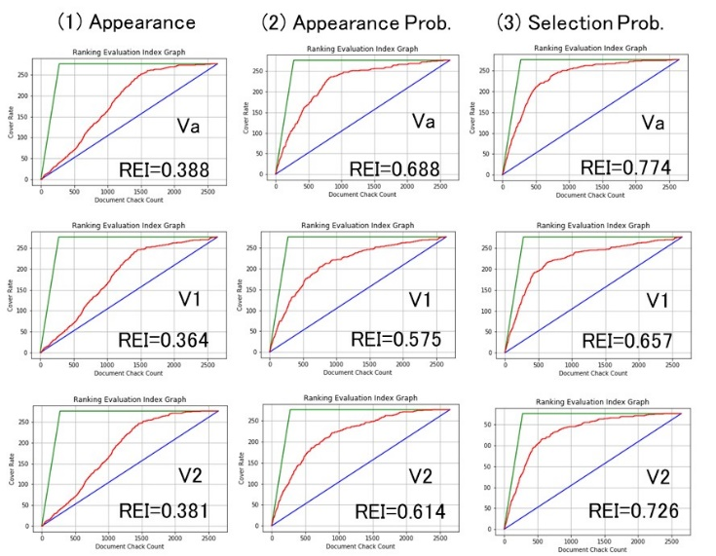
Fig5. Cross-validation of Past Case Ranking
by Proposed Method

Further, even when V2 or V1 is used as the importance index, similar accuracy is obtained as compared with Va. Even if ranking is performed on the basis of information evaluated as having the lowest relevance in one publication, the same level of accuracy is obtained, so it is considered that the evaluation is close to human judgment.
4.6 New Case Ranking using Past Cases with Proposed Method
Using the IPCR calculated in the previous section, new cases ranking using past cases was conducted in the same way as the conventional method. The result shows the Fig.6. Although there is a slight improvement trend compared to the conventional method, the ranking is hardly expected to improve work.
One of the reasons is that the appearance of the IPC code used in the evaluation is expected to be quite different between the past case and the new case. New cases include many IPC codes that do not appear in past cases, which is another reason why accuracy is not improved.

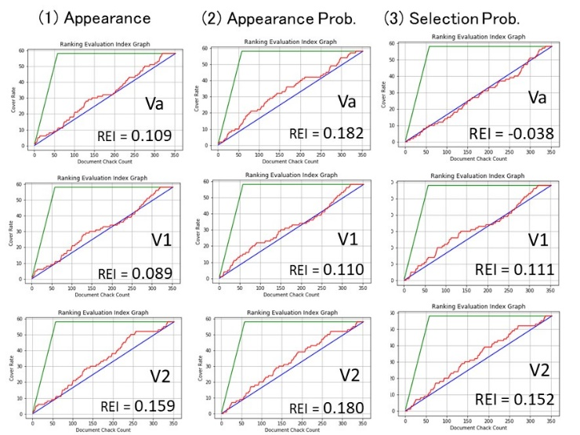
Fig6. New Case Ranking by Proposed Method
5. Improvement of Proposed Method
In order to improve the problem in the previous section, we tried to calculate the relevance of the product from the similarity with the included IPC code even if it was not included in the past case.
5.1 IPC Relevance Calculation using IPC Similarity
In Fig. 4, IPC relevance cannot be calculated for IPC codes that appear only in De and do not appear in Ds. In order to avoid this, the similarity between IPC codes is considered using a larger set of patent publications as training data, so that IPC relevance can be assigned to IPC codes that cannot be obtained from past data alone. The IPC relevance is calculated by adding q0, p0, r0 of a certain IPC code and q0, p0, r0 of the IPC with higher similarity to the IPC code with a similarity weight.
The similarity between IPC codes was calculated by the IPC similarity calculation model using about 2,000,000 publication sets (D0) published in Japan during the six years from April 2012 to March 2018. Words and IPC codes appearing in D0 are treated as vectors, and vectors are aggregated across D0 and dimensionally compressed. Where two IPC codes are c_{i} and c_{j}, corresponding vectors are v_{i} and v_{j}, the similarity between c_{i} and c_{j} is calculated by cosine similarity between vectors vi and v_{j}.

$$s\left(c_{i}{,c}_{j}\right)=\left|\frac{\left(v_{i} ･ v_{i}\right)}{\left|v_{i}\right||v_{j}|}\right| (11)$$
The similarity between a specific IPC code (c_{i}) and all IPC codes is calculated, and a code set arranged in descending order of similarity is defined as M.
M = {c⁽⁰⁾, c⁽¹⁾, c⁽²⁾, ･･･, c^{(|IPC|-1)} }
Elements of the set M satisfy the following relationship:
s(c_{i}, c^{(k-1)} ) ≧ s (c_{i}, c^{(k)} ) ( k = 1〜 |IPC| - 1 )
The code c⁽⁰⁾ with the highest similarity is c_{i} itself and its similarity is 1.
c⁽⁰⁾ = c_{i} s(c_{i}, c⁽⁰⁾ ) = 1
Using this code set M, IPCR considered similarity (q_{SCN}, p_{SCN}, r_{SCN}) are calculated as follows. SCN is the number of similarity calculations.
$$q_{SCN}\left(c_{i}\right)=\sum_{k=0}^{SCN}{q_{0}\left(c_{k}\right)∙} s\left(c_{i},c^{\left(k\right)}\right) (12)$$

$$p_{SCN}\left(c_{i}\right)=\sum_{k=0 }^{SCN}{p_{0}\left(c_{k}\right)∙} s\left(c_{i},c^{\left(k\right)}\right) (13)$$

$$r_{SCN}\left(c_{i}\right)=\sum_{k=0}^{SCN}{r_{0}\left(c_{k}\right)∙} s\left(c_{i},c^{\left(k\right)}\right) (14)$$

SCN = 0 means that the IPCR is calculated from q₀, p₀ or r₀ without calculating the similarity.

6. Experiments of Improvement Method
In order to confirm the effect of the improvement method, IPCR was calculated in consideration of the similarity between IPC codes, and the ranking of new cases was conducted. Fig.7 shows the results of confirming how REI changes by changing the value of SCN from 0 to 400. (1), (2), and (3) show the calculation method of the importance index using (q_{SCN}), the appearance probability (p_{SCN}), and the selection probability (r_{SCN}), respectively. The horizontal axis of each graph is a similarity calculation number (SCN), and a point on the horizontal axis 0 indicates the IPCR evaluation without calculating the similarity. The three curves in each figure show the difference in the method of calculating IX, where blue corresponds to Va, orange corresponds to V1, and red corresponds to V2.

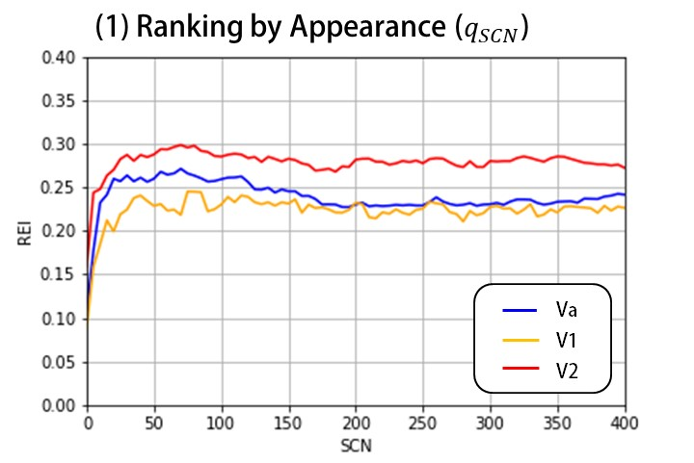
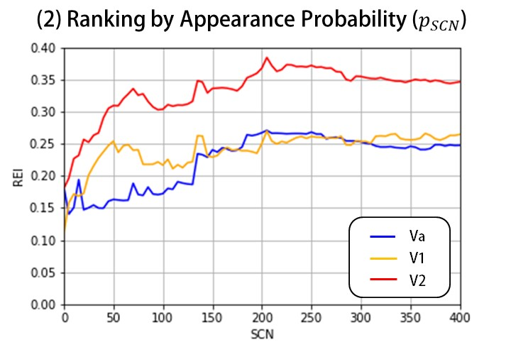
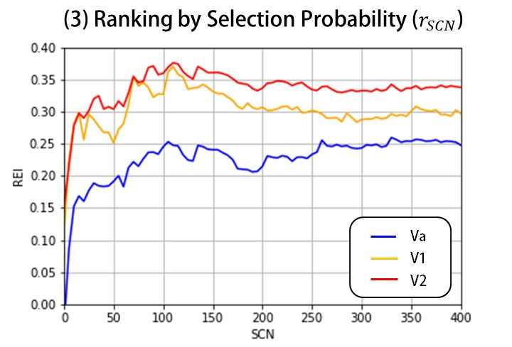
Fig.7 Ranking Evaluation Index vs SCN

In this graph, when SCN = 0, it represents the REI value before applying the improvement method. In the three methods of calculating the importance index, it is confirmed that the REI tended to improve when the SCN became larger than when the SCN is 0. REI tended to be high when the SCN is between 50 and 150, and for higher SCN, the REI tends to decrease gradually. From the above, it is confirmed that REI was improved by calculating IPCR using the similarity between past research results and IPC.
Next, we focus on the difference in the method of calculating the importance index.
In the ranking of appearance, V2 is the best and Va and V1 tended to be lower. When SCN is 70, Va has the maximum value of 0.298.
Also in the ranking by the appearance probability, V2 shows a tendency to be higher than others. When the SCN is increased, the improvement effect is large, and when the SCN is 205, the maximum value of V2 of 0.384 is obtained.
In the ranking by selection probability, V1 shows a large REI value after V2. When the SCN is 110, a maximum value of V1 of 0.370 and a maximum value of V2 of 0.376 are obtained.
By the improvement method, V2 shows a better ranking than Va. This indicates that an appropriate value has been assigned to the relevance value of the IPC code with a low frequency of appearance.
6. Conclusion
When using the survey results of the same theme as training data, it was found that the proposed method can achieve the same or better ranking performance than the conventional method.
Furthermore, by using the improvement method of the proposed method, it was confirmed that the patent search data of past cases can be effective even for the ranking of new cases with different themes.
Obtaining the above-mentioned effects is based on the premise that the survey is for a similar product of the same company. So improvement method may not be effective for the survey with extremely different themes. It will be a future task to quantitatively measure the differences between the themes and clarify the applicable range of the proposed method.
In this report, the ranking evaluation index was highest when the SCN was in the range of 50 to 150, but the suitable SCN value depending on the theme is not known. We will clarify these issues in the future.

Furthermore, we plan to conduct the following items as future works.
The best ranking was achieved by V2 which calculate the average of the two lowest IPCRs, but this is a workaround for the poor accuracy of IPCR estimation. In this experiment, the ranking was based only on past survey data of own company. However, patent surveys are conducted to develop new products and should incorporate new functions and mechanisms not found in conventional products. This part is not considered in this report. Therefore, the IPCR estimation accuracy may be insufficient. We plan to improve REI by incorporating the IPC code used in the search into the ranking as information representing a new function.
In addition to past infringement avoidance surveys, the company's patent application data are considered to reflect the information of its products, so we plan to verify the ranking by patent application data.
In this report, the ranking was conducted with the help of the IPC code assigned by the Japan Patent Office. However, there is a possibility that technical documents other than patent publications can be ranked by analyzing and ranking words appearing in the documents. We also plan to examine rankings that focus on words for efficient collection of technical documents.

Appendix: Similarity calculation between IPC codes
The similarity between PC codes was calculated using a paragraph embedding model called Doc2Vec in a natural language processing library called Gensim [8].
We used approximately 2 million publications as training data, which published from the Japan Patent Office for six year from April 2012 to March 2018. By using larger data, the IPC codes covered as much as possible, and the similarity can be calculated.
The summary data contained in the publications is morphologically decomposed to extract only the nouns excluding numbers and symbols as word data, and the IPC codes given in the publications are combined with tags into training data, and about 2 million training data are learned by Doc2Vec. Doc2Vec transforms the input words and tags to vector data, aggregates as feature vectors, and conducts dimension-compression. This makes it possible to estimate the similarity between words and tags that do not co-occur. The similarity between IPC codes is calculated by calculating the cosine similarity between the vectors. Since the degree of similarity is given as a value between -1 and 1, when calculating the IPC relationship, the absolute value of similarity is used. Doc2Vec settings used in this experiment are as follows.
vector_size = 300: Dimension of compression
window=8: Maximum distance between words
determined to co-occur in the same document
min_count=10: Threshold for ignoring infrequent words
For morphological decomposition, we used “Sudachi”, a Japanese morphological analyzer developed by Works Applications Inc [9]. And we used the default dictionary data containing the basic vocabulary, and the word division model was C mode, which divides the word into units as large as possible.
References
[1] J.J. Rocchio: Relevance Feedback in Information Retrieval,
ISR-9 (August 1965)
[2] Ian Ruthven, Mounia Lalmas: A survey on the use of relevance feedback for information ac-cess systems． The Knowledge Engineering Review archive Volume 18 Issue 2, June 2003
[3] Jun Harashima, Sadao Kurohashi: Relevance Feedback using Surface and Latent Infor-mation in Texts． Journal of Natural Language Processing Vol．21 No．2, 2014
[4] Shota HATAKENAKA and Satoshi SHIMADA and Takao MIURA:
Ranking Documents with Query-Topic Sensitivity, International
Workshop on Web Information Retrieval Sup-port Systems in IEEE/WIC/ACM International Conference on Web Intelligence and Intelli-gent Agent Technology, 2012.
[5] Langville, A.N. and Meyer, C.D.: Google's PageRank and Beyond:
The Science of Search Engine Rankings, Princeton University
Press, 2006
[6] Bergmann, I., Butzke, D., Walrter, L., Fuerste, J. P., Moehrle, M. G.
and Erdmann, V. A.: Evaluating the risk of patent infringement by
means of semantic patent analysis: The case of DNA chips. R&D
Management, 38: 550–62. 2008.
[7] Toshiyuki Ando: Efficient Patent Search Method using Text Mining,
Japio year book 230-237, 2015 (in Japanese)

Kenji Akiyama received the M.S. degrees in Tohoku University in 1984. He studied information visualization , in TUAT doctorial course form 2017, and also belong to intellectual property section of Fujitsu and Fujitsu Connected Technologies limited during 2010-2020.

Takafumi Saito

To Be Filled

