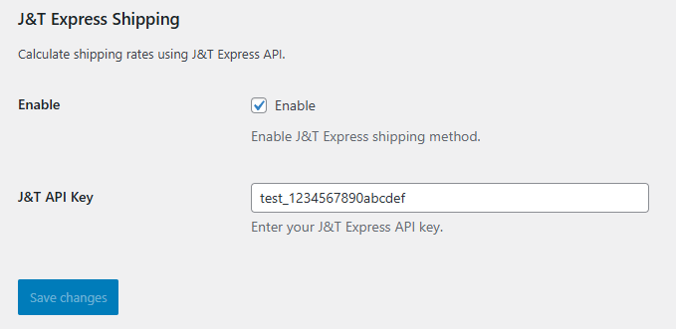

**J&T Express Shipping Plugin for WooCommerce**

**Problem: No Dedicated J&T Express Plugin for the Philippines**

While setting up an e-commerce website for a local business, I encountered a significant limitation—there was no official J&T Express shipping plugin for WooCommerce that catered specifically to the Philippines. Many online sellers rely on J&T Express for deliveries, but without a direct integration, they had to manually calculate shipping rates and generate waybills, leading to inefficiencies and potential errors.

**Approach: Building a Custom J&T Express Shipping Plugin**

To solve this problem, I developed a custom WordPress plugin that seamlessly integrates J&T Express with WooCommerce. The goal was to automate shipping rate calculations and waybill generation, allowing store owners to focus on their business instead of manually handling logistics. Using J&T Express' API, I created a plugin that dynamically retrieves shipping rates and provides tracking details directly within WooCommerce.

**Integration with WooCommerce**

The J&T Express Shipping Plugin integrates with WooCommerce in the following ways:

1. **Shipping Method Configuration:** The plugin registers "J&T Express" as a shipping method in WooCommerce, allowing store owners to enable or disable it from the admin panel.
2. **Real-Time Shipping Rates:** When a customer enters their shipping details at checkout, the plugin communicates with the J&T Express API to fetch the accurate shipping cost based on the destination postal code.
3. **Automatic Waybill Generation:** Once an order is placed, the plugin generates a waybill (tracking number) using the API and attaches it to the order details.
4. **Tracking Number Display:** The tracking number is automatically stored and displayed in the WooCommerce order details, making it accessible to both admins and customers.
5. **Scalability for Local Businesses:** The plugin is designed to work across the Philippines, ensuring that businesses in different regions can use J&T Express as a reliable shipping option.

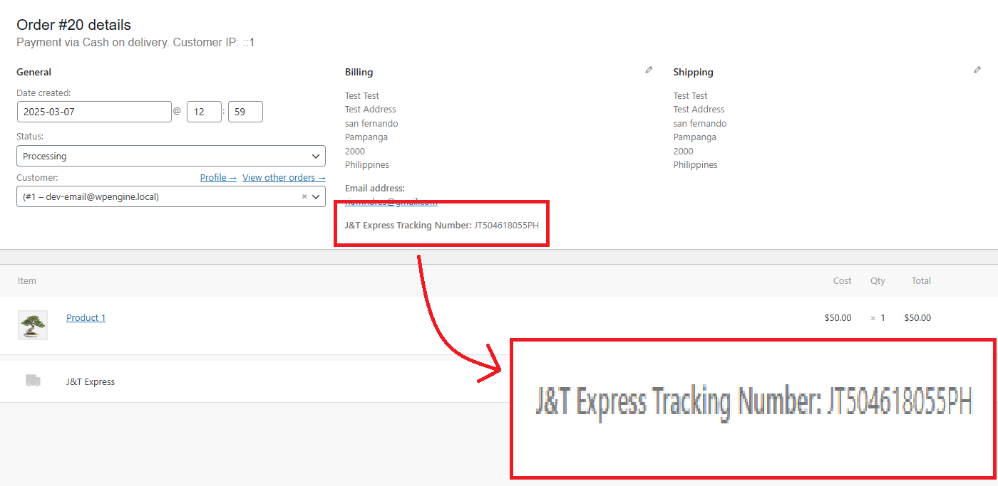

**Key Features**

* **WooCommerce Integration:** Adds J&T Express as a shipping method in the WooCommerce settings.
* **Dynamic Shipping Rate Calculation:** Automatically retrieves J&T Express shipping rates based on the customer’s location.
* **Automatic Waybill Generation:** Generates a tracking number when an order is confirmed.
* **Order Tracking Support:** Displays tracking numbers in WooCommerce order details for easy reference.
* **Admin-Friendly Settings:** Store owners can configure the API key and enable/disable the shipping method through the WooCommerce dashboard.

**Impact**

This plugin eliminates the need for manual shipping calculations and waybill generation, streamlining order fulfillment for WooCommerce store owners in the Philippines. By integrating directly with J&T Express, businesses can offer a more seamless checkout experience, improving customer satisfaction and operational efficiency.

This project highlights my ability to develop practical solutions that address real-world problems. If you’re interested in using this plugin or need a custom WordPress integration, feel free to reach out!

@codereeyo