The Wastena Retreat — readings to check
Two kinds of question, in two parts. Part one is the handful of passages the scanner could not read at all, where a retyping would recover text that is currently lost. Part two is single words where the scan could be read either way. In both, please write what you see on the line marked On the page:. Where what the site prints is already right, "ok" is enough.

Part one — passages to retype
13 passages, on pages 55, 78, 99, 101, 149, 182, 203, 205, 211. These are the only places in the whole retreat where the text is not readable, so they are worth the most.

1. scan page 205 · 44% of this passage is unreadable
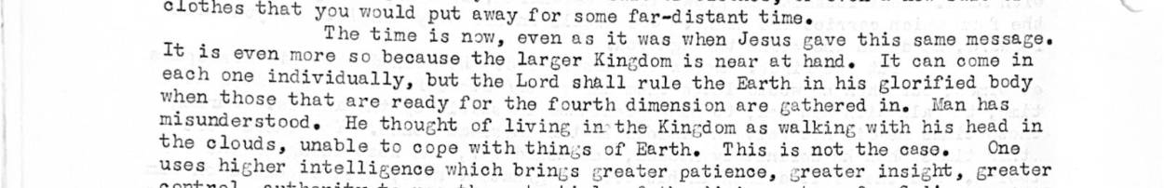
Site now: Tt Agi oyensasisiesc pace aa cathe SMe a3 pfouse when Jesus gave this same MOSSAECe each one individually, but the Lord’ cee sate knee Pi ane at rif 9d. body when those that are ready for the f th di i : 2 etre ean "
On the page: __________________________________________________________________________
____________________________________________________________________________________________
____________________________________________________________________________________________

2. scan page 203 · 40% of this passage is unreadable
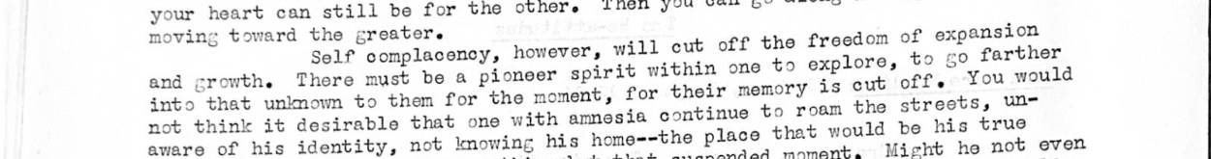
Site now: Self complacency, however, will cut off the freedom of si ageinon
On the page: __________________________________________________________________________
____________________________________________________________________________________________
____________________________________________________________________________________________

3. scan page 205 · 40% of this passage is unreadable
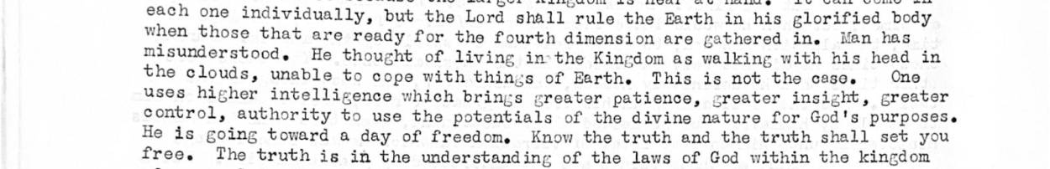
Site now: misunderstood He the bd ‘i tee our imension are gathered in. Men has :
On the page: __________________________________________________________________________
____________________________________________________________________________________________
____________________________________________________________________________________________

4. scan page 205 · 32% of this passage is unreadable
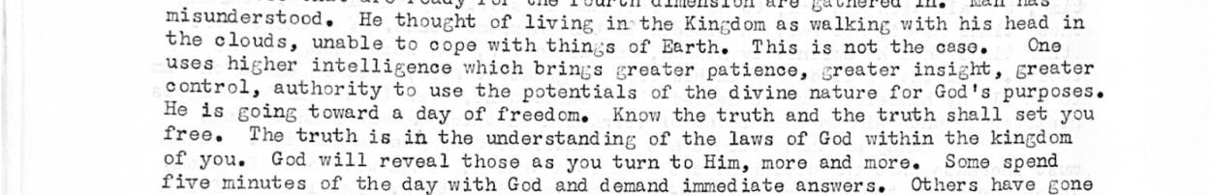
Site now: bare eae ney bring creator patience, greater insight, greater He deveouns Been ee potentials of the divine nature for God's purposes.
On the page: __________________________________________________________________________
____________________________________________________________________________________________
____________________________________________________________________________________________

5. scan page 211 · 26% of this passage is unreadable
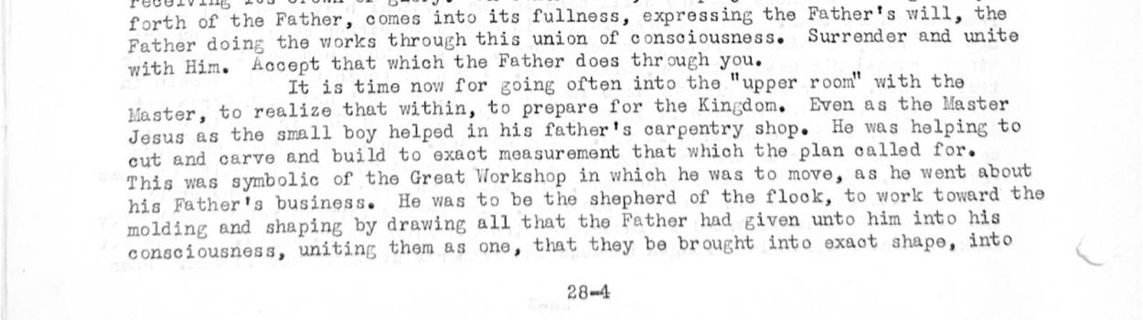
Site now: Master, to realize that within, to prepare for the Kingdom. Even as the Master CE a oe ee ae ea cra Gp alek ape glen celied fexeg cut and car x measur emen at whic e plan called for. This was symbolic of the Great Workshop in which he was to move, as he went about hae, Pen er OP past nenle a was uo Re ave ehepoere of the flock, to work toward the molding and shaping by drawing a na ho Father had given unto him into h
On the page: __________________________________________________________________________
____________________________________________________________________________________________
____________________________________________________________________________________________

6. scan page 99 · 25% of this passage is unreadable
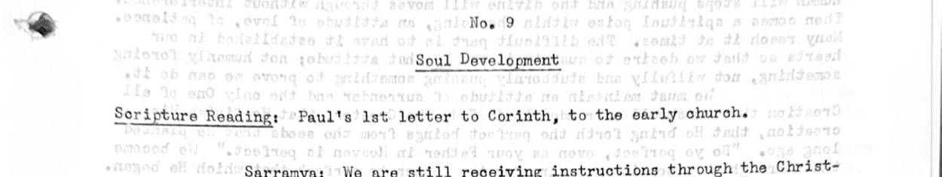
Site now: Scripture Reading: ‘Paul's lst letter to Corinth, to the early church.
On the page: __________________________________________________________________________
____________________________________________________________________________________________
____________________________________________________________________________________________

7. scan page 149 · 24% of this passage is unreadable

Site now: eet ee ee eae, My children, I shall lead you through the green pastures and beside the cool waters. « . » Drink
On the page: __________________________________________________________________________
____________________________________________________________________________________________
____________________________________________________________________________________________

8. scan page 78 · 23% of this passage is unreadable
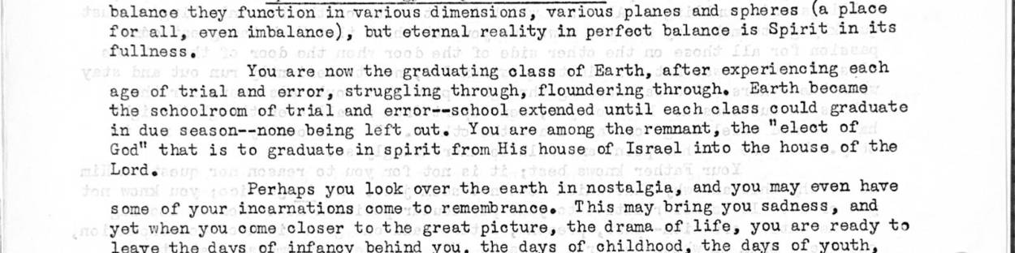
Site now: You are now the graduating class of Earth, after experiencing each age of trial and error, struggling through, floundering through. Earth became the schoolroom of trial and error--school extended until each class could graduate in due season--none being left out. You are among the remnant, the "elect of God" that is to graduate in spirit from His house of Israel into the house of the Lord.
On the page: __________________________________________________________________________
____________________________________________________________________________________________
____________________________________________________________________________________________

9. scan page 211 · 23% of this passage is unreadable
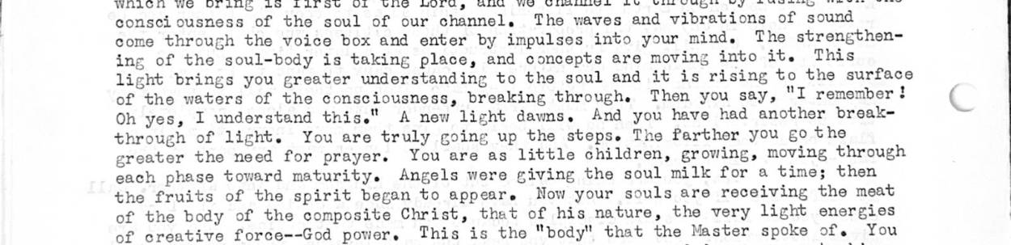
Site now: : ; - > place, and concepts are moving into it. is aes eee yon grease under stand ing to the soul and it is rising to the surface oF = a fo) e Congo Lousness, breaking through. Then you say, "I remember? yes, understand thise’ A new light dawns. And you have had another breakbeen ks trees é You are uy going up the steps. The Farther you 6° the a shane tonerd Pa . ie as little reac. enoneeee moving through
On the page: __________________________________________________________________________
____________________________________________________________________________________________
____________________________________________________________________________________________

10. scan page 55 · 22% of this passage is unreadable
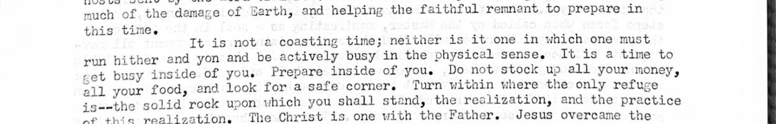
Site now: you must and tide paration within. only the cleansing
On the page: __________________________________________________________________________
____________________________________________________________________________________________
____________________________________________________________________________________________

11. scan page 211 · 22% of this passage is unreadable
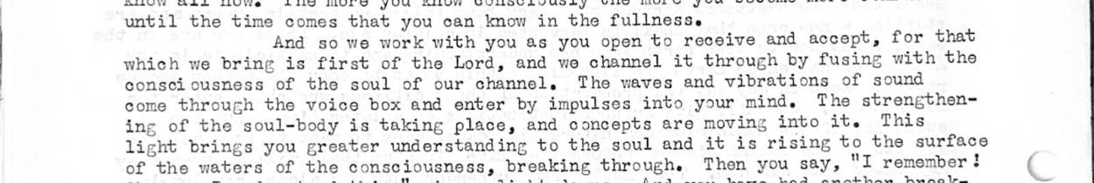
Site now: ; : And so we work with you as you open to receive and accept, for that which we bring is first of the Lord, and we channel it through by fusing with the consci ousness of the soul of our channel. The waves and vibrations of sound Se eed ulead ta eaeaiie ities Tat emede ard making Geodts Teac,
On the page: __________________________________________________________________________
____________________________________________________________________________________________
____________________________________________________________________________________________

12. scan page 101 · 20% of this passage is unreadable
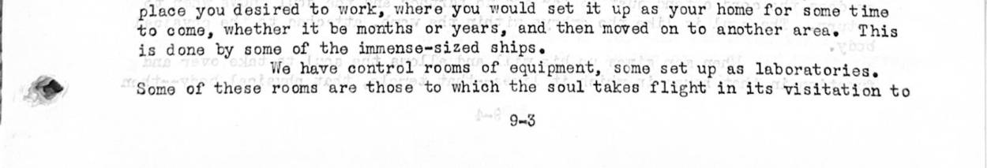
Site now: We have control rooms of equipment, some set up as laboratories. Some of these rooms are those to which the soul takes flight in its visitation to
On the page: __________________________________________________________________________
____________________________________________________________________________________________
____________________________________________________________________________________________

13. scan page 182 · 20% of this passage is unreadable
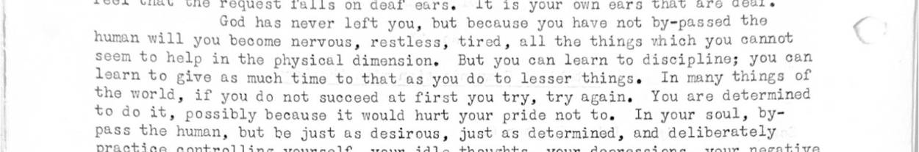
Site now: feel that the request falls on deaf ears. It is your own ears that are deaf.
On the page: __________________________________________________________________________
____________________________________________________________________________________________
____________________________________________________________________________________________

Part two — single words
45 of 172 words that are real words in their own right, so only the page can settle them. Most are probably right as they stand.

1. "calf" · scan page 72
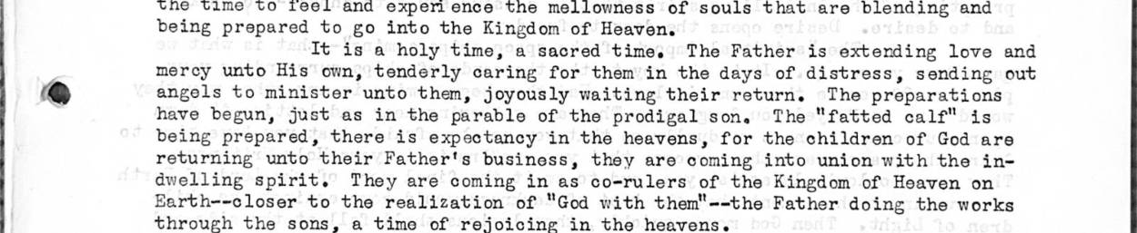
Site now: er unto them, joyously waiting their return. The preparations have begun, just as in the parable of the prodigal son. The “fatted calf" is being prepared, there is expectancy in the heavens, for the children of God are returning unto their Father's business, they
Or could be: call
On the page: __________________________________________________________________________

2. "cases" · scan page 80
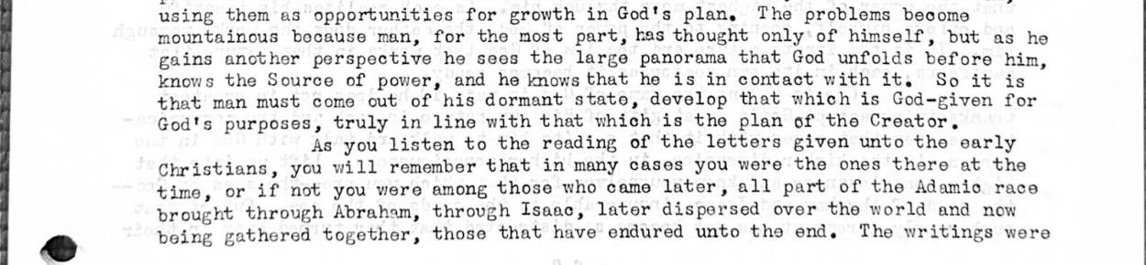
Site now: plan of the Creator, As you listen to the reading of the letters given unto tho early Christians, you will remember that in many cases you were the ones there at the time, or if not you were among those who came later, all part of the Adamic race brought through A
Or could be: cares
On the page: __________________________________________________________________________

3. "certainty" · scan page 168
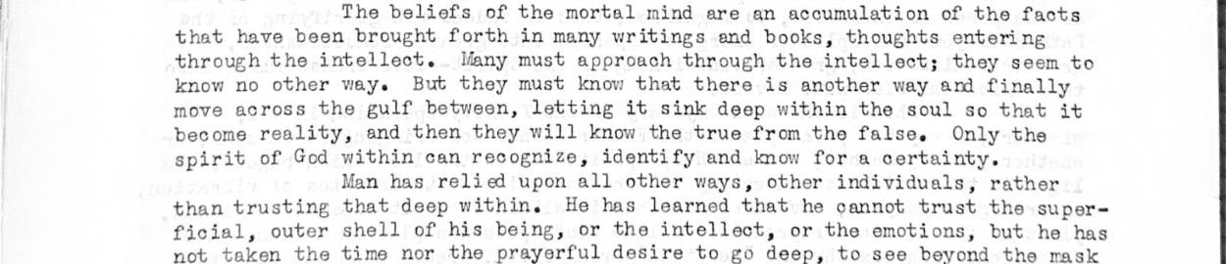
Site now: me reality, and then they will know the true from the false. Only the spirit of God within can recognize, identify and know for a certainty. Man has relied upon all other ways, other individuals, rather than trusting that deep within. He has learned that he cannot tru
Or could be: certainly
On the page: __________________________________________________________________________

4. "charges" · scan page 136
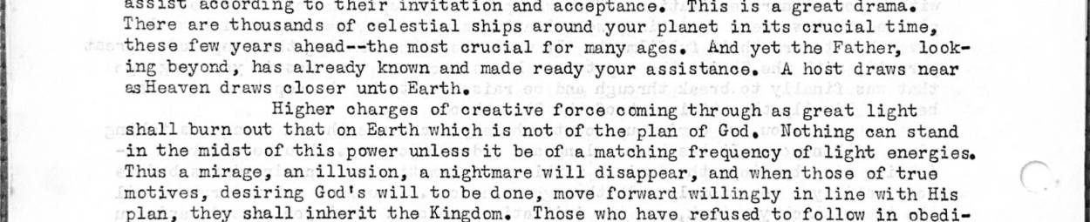
Site now: r, looking beyond, has already known and made ready your assistance. <A host draws near esHeaven draws closer unto Earthe Higher charges of creative force coming through as great light shall burn out that on Earth which is not of the plan of God, Nothing can stand i
Or could be: changes
On the page: __________________________________________________________________________

5. "charging" · scan page 14
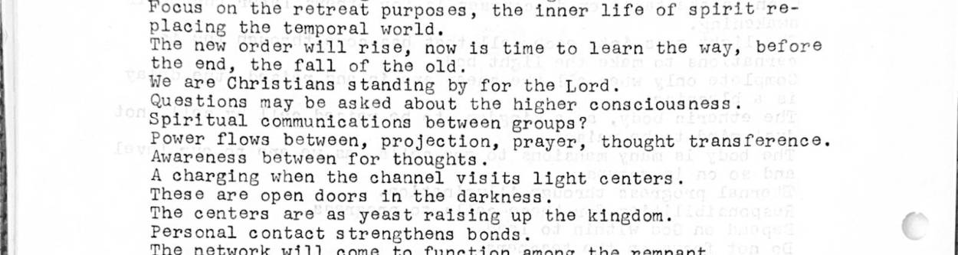
Site now: rough our channel, whether she be conscious or unconscious. We have come, as foreordained, into this available vortex for greater charging of heavenly powers. It is easy to move into the midst of you who come together to enter into the Christ consciousness, but the Sp
Or could be: changing
On the page: __________________________________________________________________________

6. "closed" · scan page 77
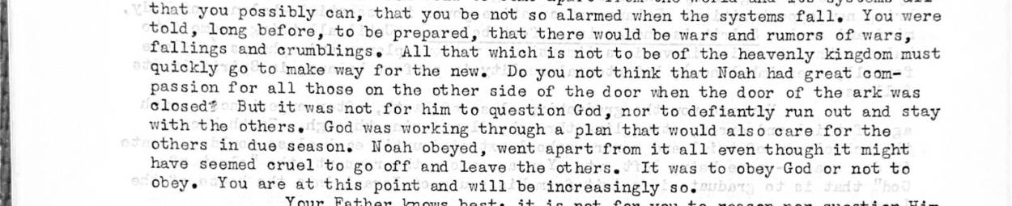
Site now: the new. Do you not think that Noah had great compassion for all those on the other side of the door when the door of the ark was closed? But it was not for him to question God, nor to defiantly run out and stay with the others. God was working through a plen that w
Or could be: closer
On the page: __________________________________________________________________________

7. "closet" · scan page 139

Site now: iction of the soul. From now on take more time to enter into the upper room, whether it be in your home or a retreat. Go into the closet within you and commune with your Lord. In reality, not in imagination, in true reality of purpose in the higher consciousness. Fu
Or could be: closer
On the page: __________________________________________________________________________

8. "comet" · scan page 16
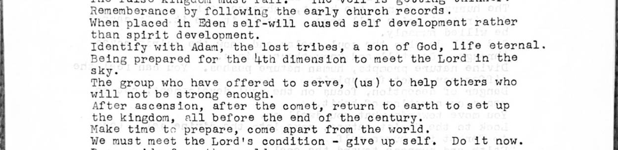
Site now: of the Earth upon his shoulders. He shall lead the way, bringing you back to Earth when the stabilizing has taken place after the comet side-swipes the planet, shifting the poles and burning one-third of the Eerth's surface. After this the Lord shall return with hi
Or could be: comes
On the page: __________________________________________________________________________

9. "conceit" · scan page 82
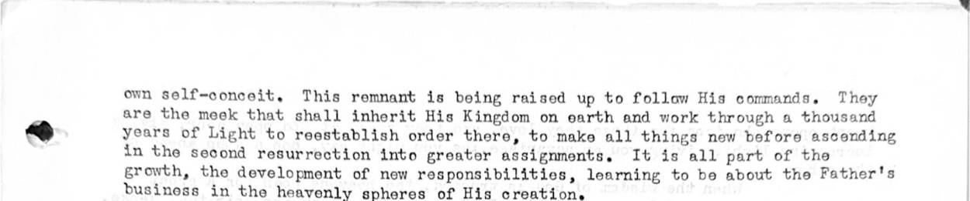
Site now: ds of tho sea, Out of that number only a remnant has not become so distracted that they turned away in their [page 82] own self-conceit, This remnant is boing raised up to follow His commands, They are the meek that shall inherit His Kingdom on earth and work throu
Or could be: concept
On the page: __________________________________________________________________________

10. "dare" · scan page 103
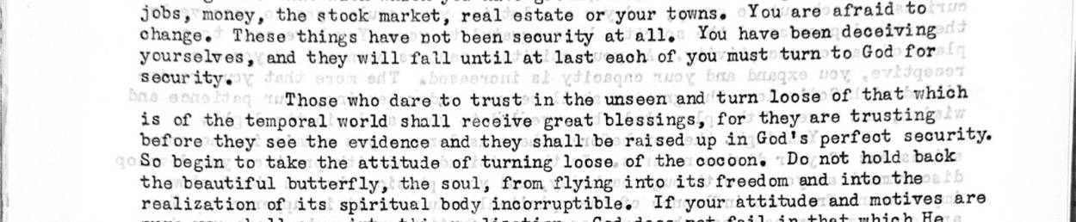
Site now: ll. You have been deceiving yourselves, and they will fail until at last’ each of you must turn to God for security. } Those who dare +o trust’in the unseen and turn loose of that which is of the temporal world’ shall receive great blessings, for they are trustin
Or could be: care
On the page: __________________________________________________________________________

11. "dead" · scan page 127

Site now: ose who are now coming forth in great riots and all forms of rebellion, refusing to go along with authority, claiming that God is dead--that there is no proof of anything--these have made their choice. Come apart from them. Remember your Master said that if he cam
Or could be: read, lead
On the page: __________________________________________________________________________

12. "dealing" · scan page 39
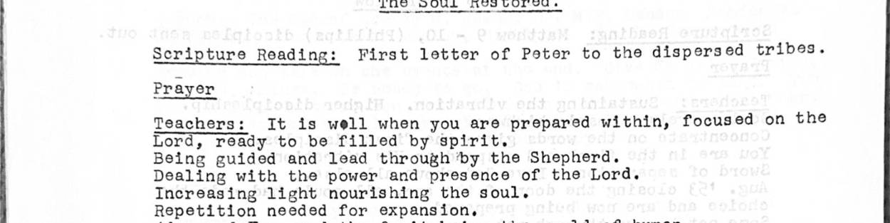
Site now: flocks. And it has taken a long time to help you to come into position, into the realization that you are, even on this very day, dealing with the presence, the power of your Lord. It should not be surprising, for it was promised by the Father, but the words have fal
Or could be: healing
On the page: __________________________________________________________________________

13. "deceiving" · scan page 100
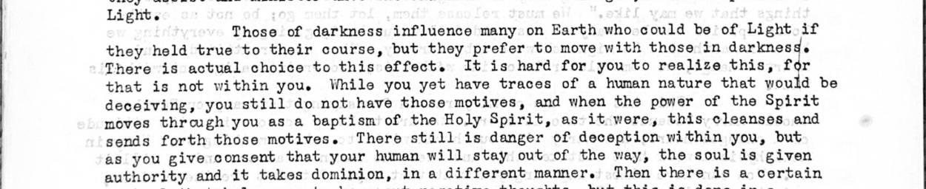
Site now: effect. It is hard for you to realize this, for that is not within you. While you yet have traces of a human nature that would be deceiving, you still do not have those motives, and when the power of the Spirit moves thragh you as a baptism of the Holy Spirit, as it we
Or could be: receiving
On the page: __________________________________________________________________________

14. "establishes" · scan page 68
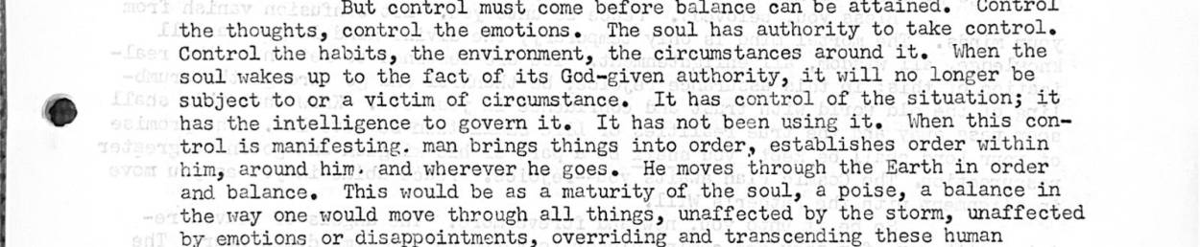
Site now: ; it has the intelligence to govern it. It has not been using it. When this control is manifesting. man brings things into order, establishes order within him, around him. and wherever he goes. He moves through the Earth in order and balance. This would be as a maturity
Or could be: established
On the page: __________________________________________________________________________

15. "ethers" · scan page 197
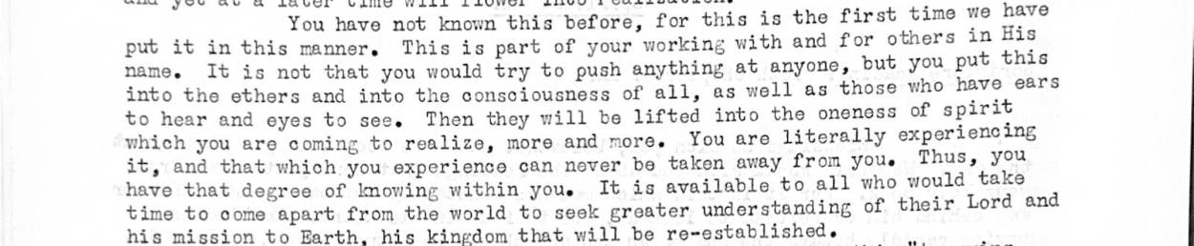
Site now: your working with and for others in His name. It is not that you would try to push anything at anyone, but you put this into the ethers and into the consciousness of all, as well as those who have ears to hear and eyes to see. Then they will be lifted into the onen
Or could be: others
On the page: __________________________________________________________________________

16. "expert" · scan page 164
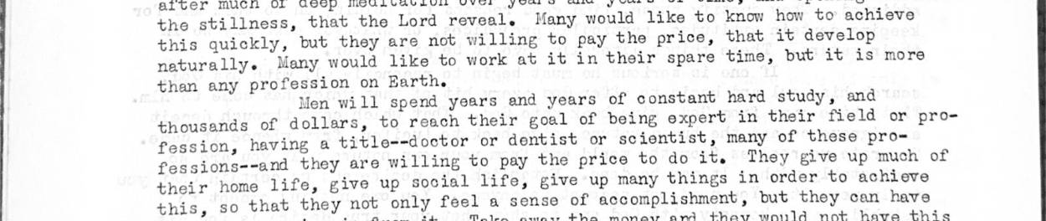
Site now: ofession on Earth. Men will spend years and years of constant hard study, and thousands of dollars, to reach their goal of being expert in their field or profession, having a title--doctor or dentist or scientist, many of these pro-sessions--and they are willing to
Or could be: expect
On the page: __________________________________________________________________________

17. "fade" · scan page 131
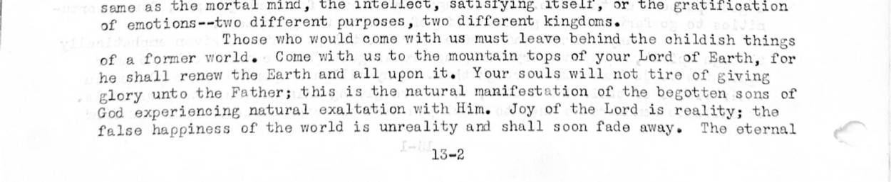
Site now: xperiencing natural exaltation with Him. Joy of the Lord is reality; the false happiness of the world is unreality and shall soon fade away. The eternal [page 132] verities are those with which you must deal The call goes forth to all those being gathered toget
Or could be: face, made
On the page: __________________________________________________________________________

18. "faster" · scan page 90
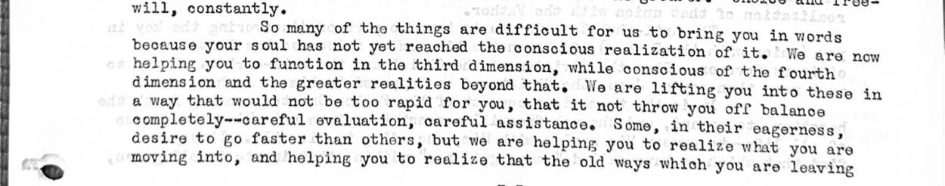
Site now: you, that it not throw you off balance completely--careful evaluation, careful assistance. Some, in their eagerness, desire to go faster than others, but we are helping you to realize what you are ring you in words on of it. We are now moving into, and helping you t
Or could be: master
On the page: __________________________________________________________________________

19. "five" · scan page 44
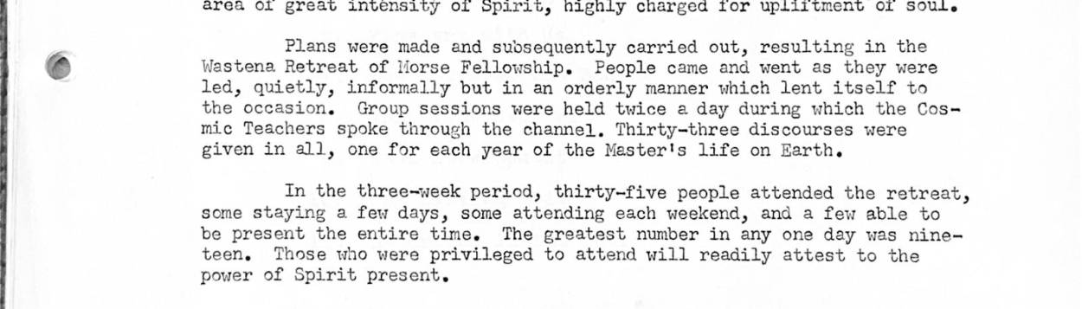
Site now: hat we speak of is your rising above into your higher nature. You will gain this strength through practice. Even if you only have five minutes, come apart in consciousness, aside from distraction, and speak to the Father within--a constant companion. In addition
Or could be: give, live
On the page: __________________________________________________________________________

20. "four" · scan page 44

Site now: ook up i and to desire. Desire opens the door to freedom. The "spiritual import of the space ships coming"--that is what we gave four years ago. It is the key to the thousands of ships surrounding your planet. Of course they come in love. Had they been coming in
Or could be: your
On the page: __________________________________________________________________________

21. "fret" · scan page 194
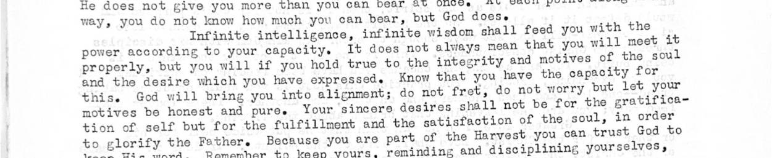
Site now: soul and the desire which you have expressed. Know that you have the capacity for this. God will bring you into alignment; do not fret, do not worry but let your motives be honest and pure. Your sincere desires shall not be for the gratificaI tion of self but for
Or could be: free
On the page: __________________________________________________________________________

22. "heed" · scan page 91
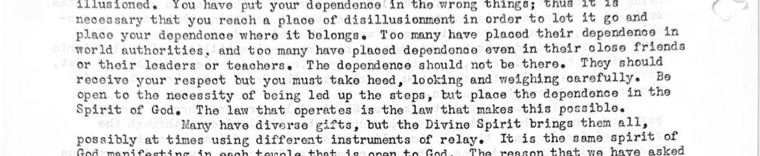
Site now: lose friends or their leaders or teachers. The dependence should not be there. They should receive your respect but you must take heed, looking and weighing carefully. Be open to the necessity of being led up the steps, tut place the dependence in the Spirit of Go
Or could be: need, feed
On the page: __________________________________________________________________________

23. "heeded" · scan page 54
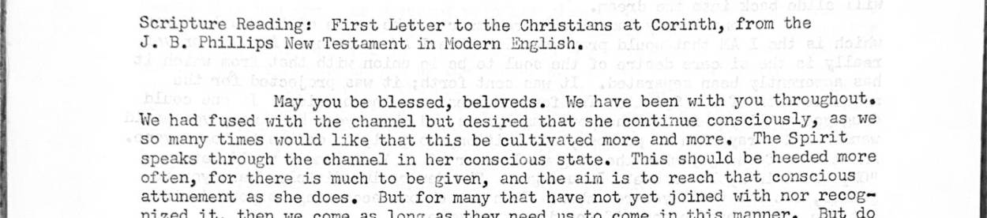
Site now: es would like that this be cultivated more and more. The Spirit speaks through the channel in her conscious state. This should be heeded more often, for there is much to be given, and the aim is to reach that conscious attunement as she does. But for many that have
Or could be: needed
On the page: __________________________________________________________________________

24. "hide" · scan page 56
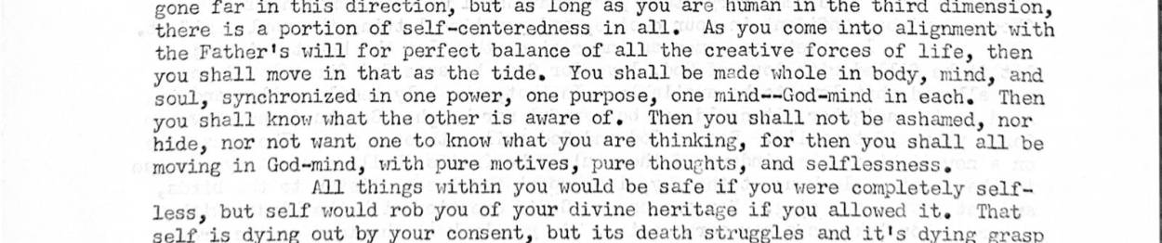
Site now: ower, one purpose, one mind--God-mind in each. Then you shall know what the other is aware of, Then you shall not be ashamed, nor hide, nor not want one to mow what you are thinking, for then you shall all be moving in God-mind, with pure motives, pure thoughts, a
Or could be: tide, side
On the page: __________________________________________________________________________

25. "hither" · scan page 47
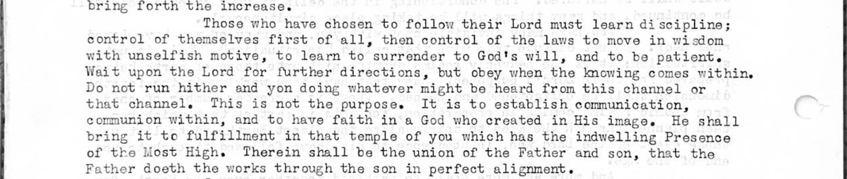
Site now: r to God's will, and to be patient. Wait upon the Lord for further directions, but obey when the knowing comes within. Do not run hither and yon doing whatever might be heard from this channel or that channel, This is not the purpose. It is to establish communicatio
Or could be: higher, either
On the page: __________________________________________________________________________

26. "infinity" · scan page 170
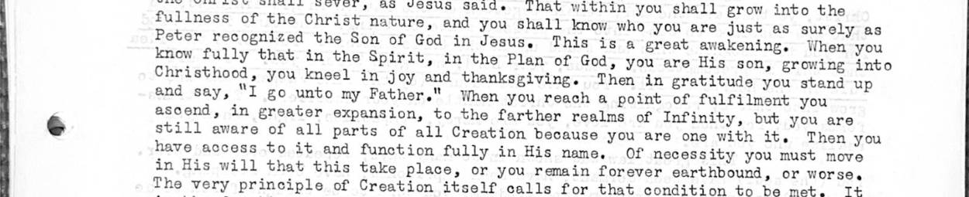
Site now: nd say, “I go unto my Father." When you reach a point of fulfilment you : ascend, in greater expansion, to the farther realms of Infinity, but you are ry still aware of all parts of all Creation because you are one with it. Then you have access to it and function ful
Or could be: infinite
On the page: __________________________________________________________________________

27. "intend" · scan page 202
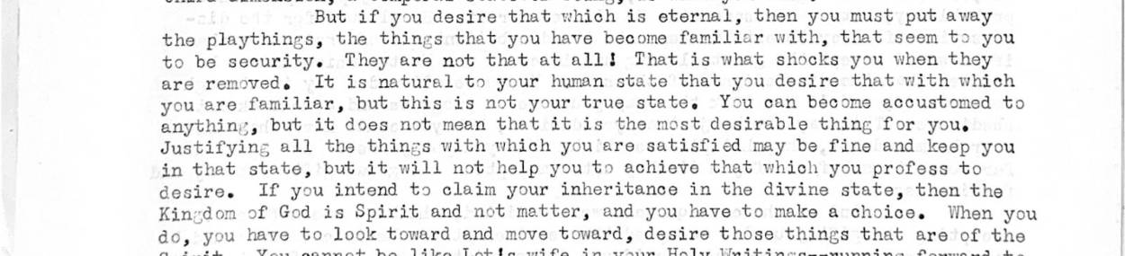
Site now: re satisfied may be.fine and keep you in that state, but it will not help you to achieve that which you profess to desire. If you intend to claim your inheritance in the divine state, then the Kingdom of God is Spirit and not matter, and you have to make a choice. W
Or could be: intent
On the page: __________________________________________________________________________

28. "latter" · scan page 12
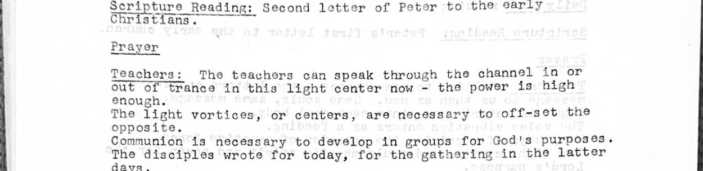
Site now: Earth taking the government upon his shoulders. Is that not far more hopeful than your next election? All the prophecies of the latter days that are given in your Holy Writings shall take place in the next few years. It is a time of fulfilment. It was a time of f
Or could be: matter, letter
On the page: __________________________________________________________________________

29. "lends" · scan page 44

Site now: is and take no credit unto yourselves. Your conscious voluntary choice, to cooperate while you are in this dimension, is good and lends support to the commitment of the soul. It shows that your desire is great and you are chosen, then, to follow through with this b
Or could be: leads, sends
On the page: __________________________________________________________________________

30. "lines" · scan page 97
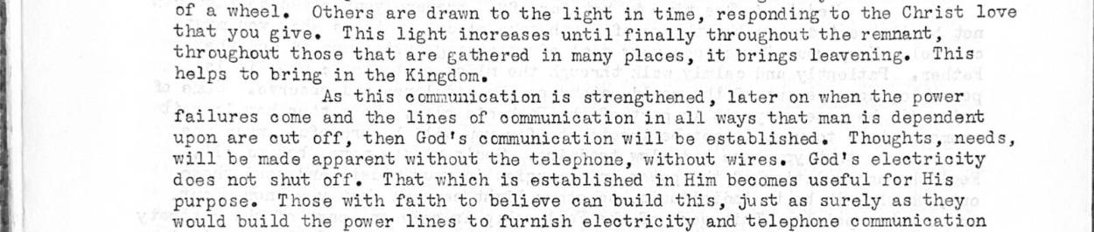
Site now: vening. This helps to bring in the Kingdom. As this communication is strengthened, later on when the power failures come and the lines of communication in all ways that man is dependent upon are cut off, then God's communication will be established. Thoughts, need
Or could be: lives
On the page: __________________________________________________________________________

31. "rain" · scan page 97
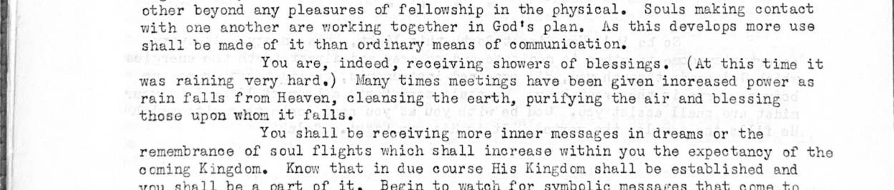
Site now: , receiving showers of blessings. (At this time it was raining very hard.) Many times meetings have been given increased power as rain falls from Heaven, cleansing the earth, purifying the air and blessing those upon whom it falls. You shall be receiving more inn
Or could be: vain, pain
On the page: __________________________________________________________________________

32. "reap" · scan page 127
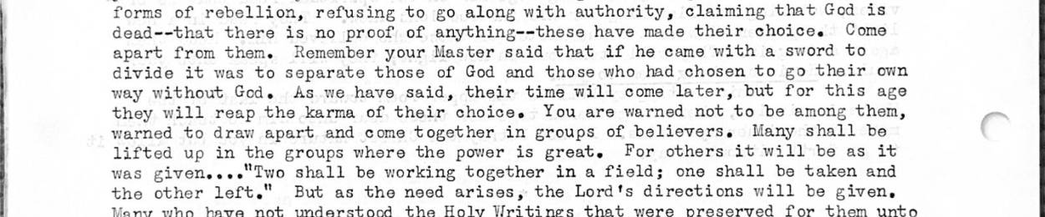
Site now: and those who had chosen to go their own way without God. As we have said, their time will come later, but for this age they will reap the karma of their choice. You are warned not to be among them, warned to draw apart and come together in groups of believers. Ma
Or could be: read, real
On the page: __________________________________________________________________________

33. "regain" · scan page 17
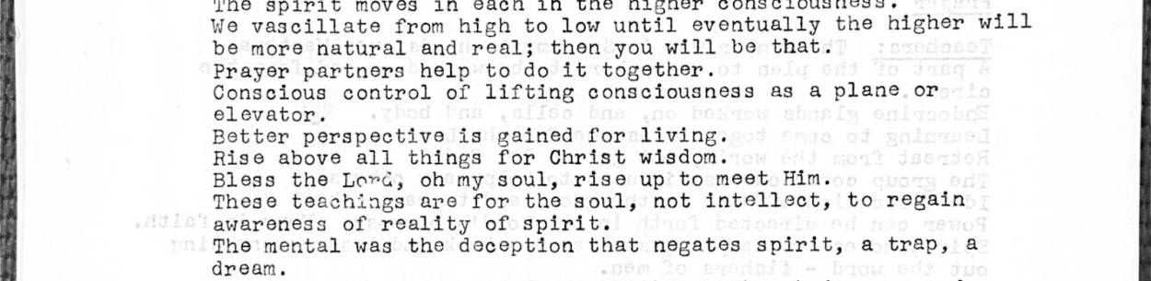
Site now: anxious about what you will wear or eat. Open instead to receive inner guidance. Many are trying to find right foods so they may regain their youth and live long lives. This is all right as a temporary measure, but it is only [page 79] God within that shall be th
Or could be: remain
On the page: __________________________________________________________________________

34. "relay" · scan page 88
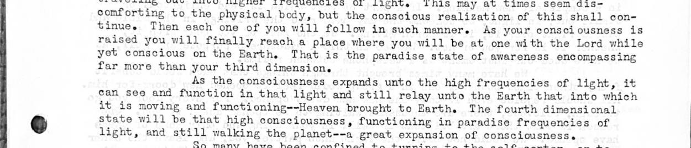
Site now: hird dimension. As the consciousness expands unto the high frequencies of light, it can see and function in that light and still relay unto the Earth that into which it is moving and functioning--Heaven brought to Earth. The fourth dimensional state will be that h
Or could be: relax, delay
On the page: __________________________________________________________________________

35. "retain" · scan page 216
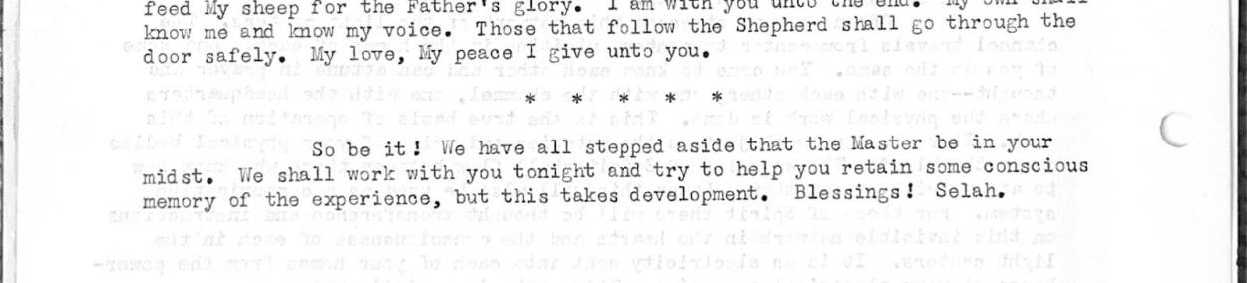
Site now: you. So be it! We have all stepped aside that the Master be in your C midst. We shall work with you tonight and try to help you retain some conscious memory of the experience, but this takes development. Blessings! Selah.
Or could be: remain
On the page: __________________________________________________________________________

36. "seeks" · scan page 156
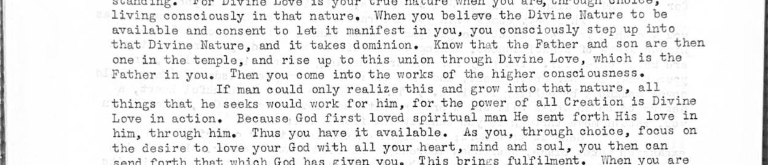
Site now: ou come into the works of the higher consciousness. If man could only realize this and grow into that nature, all things that he seeks would work for him, for the power of all Creation is Divine Love in action. Because God first loved spiritual man He sent forth H
Or could be: seems
On the page: __________________________________________________________________________

37. "sifting" · scan page 110
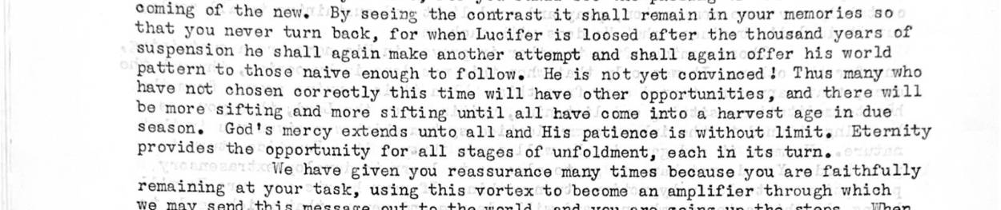
Site now: He is not yet convinced! Thus many who have not chosen correctly this time will have other opportunities, and there will be more sifting and more sifting until.all have come into a harvest age in due Season. God's mercy extends unto all and His patience is without l
Or could be: lifting
On the page: __________________________________________________________________________

38. "stem" · scan page 95
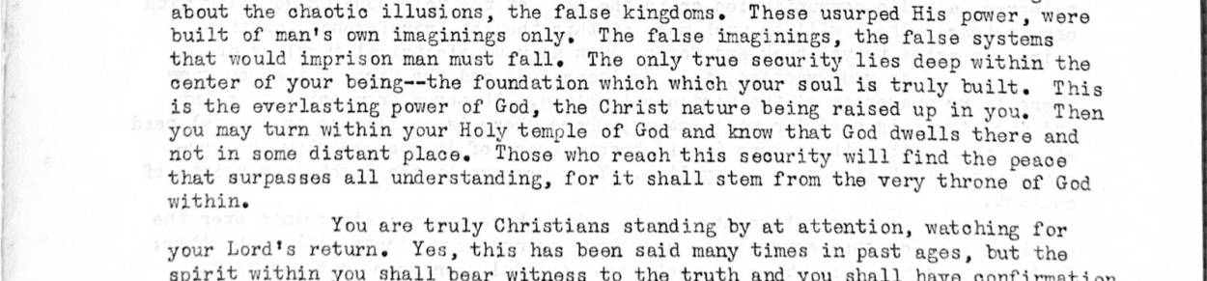
Site now: e and not in some distant places Those who reach this security will find the peace that surpasses all understanding, for it shall stem from the very throne of God within. You are truly Christians standing by at attention, watching for your Lord's return. Yes, thi
Or could be: seem, step
On the page: __________________________________________________________________________

39. "sweeping" · scan page 21
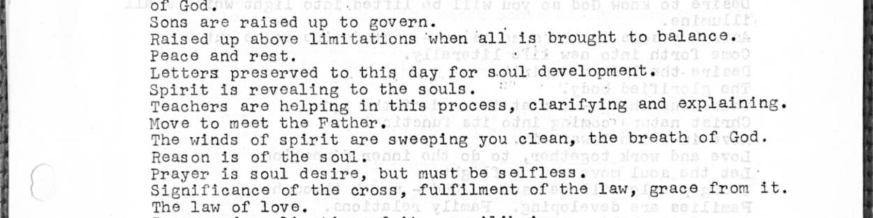
Site now: ly as you hear the winds blowing through the trees here by this lake, you shall feel the winds of the Holy Spirit moving through, sweeping you clean, raising you into the higher purposes of the cosmic realm of God's creation. Mighty is the breath of the Lord--the win
Or could be: sleeping
On the page: __________________________________________________________________________

40. "tales" · scan page 205
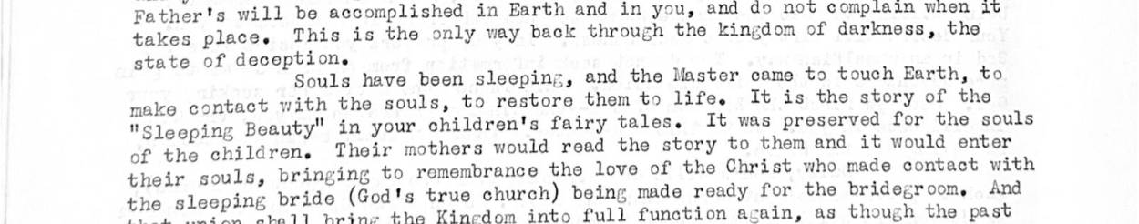
Site now: came to touch Earth, to It is the story of the make contact with the souls, to restore them to life. " in your children's fairy tales. It was preserved for the souls "Sleeping Beauty of the children. Their mothers would read the story to them and it would enter
Or could be: takes, tapes
On the page: __________________________________________________________________________

41. "tense" · scan page 152
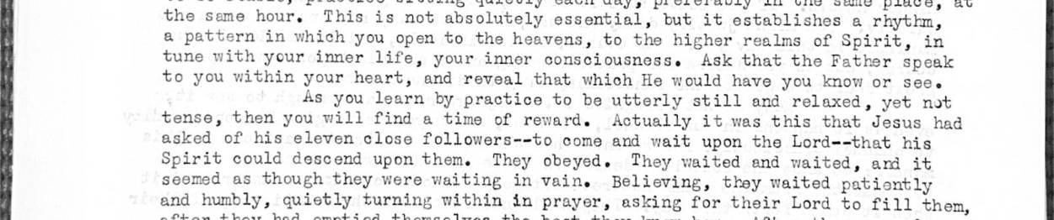
Site now: ur heart, and reveal that which He would have you know or see. As you learn by practice to be utterly still and relaxed, yet not tense, then you will find a time of reward. Actually it was this that Jesus had asked of his eleven close followers--to come and wait u
Or could be: sense
On the page: __________________________________________________________________________

42. "thin" · scan page 12
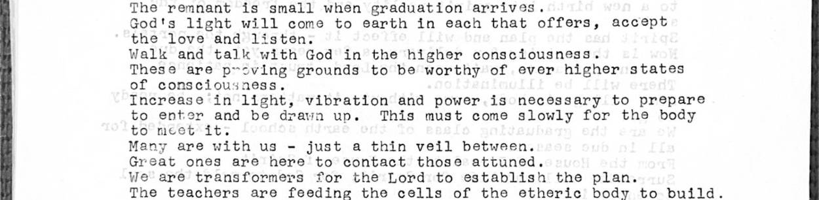
Site now: and they are one in that God-consciousness, desiring to join hands with you as you enter into it in the fullness. There is just a thin veil between; it is you who are yet blind. It will open suddenly and you shall know that you have been with them very closely, pa
Or could be: this, then
On the page: __________________________________________________________________________

43. "torn" · scan page 189
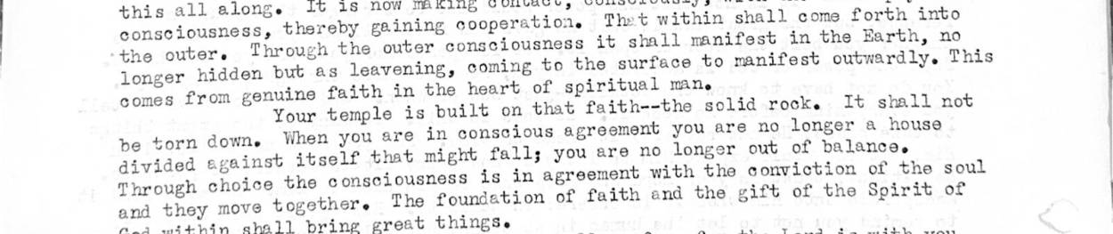
Site now: This comes from genuine faith in the heart of spiritual man. Your temple is built on that faith--the solid rock. It shall not be torn down. When you are in conscious agreement you are no longer a house divided against itself that might falls you are no longer out
Or could be: born, turn
On the page: __________________________________________________________________________

44. "tree" · scan page 57
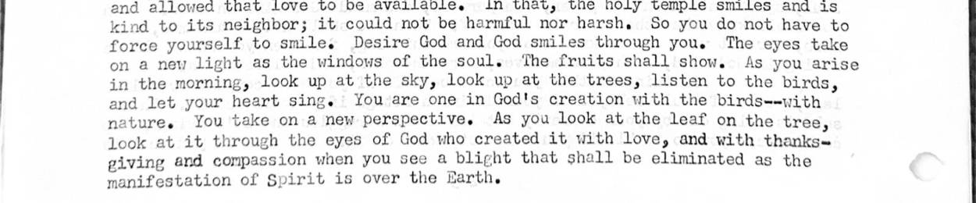
Site now: rt sing. You are one in God's creation with the birds--with nature. You take on a new perspective. As you look at the leaf on the tree, look at it through the eyes of God who created it with love, and with thanksgiving and compassion when you see a blight that sha
Or could be: true, free
On the page: __________________________________________________________________________

45. "tries" · scan page 165
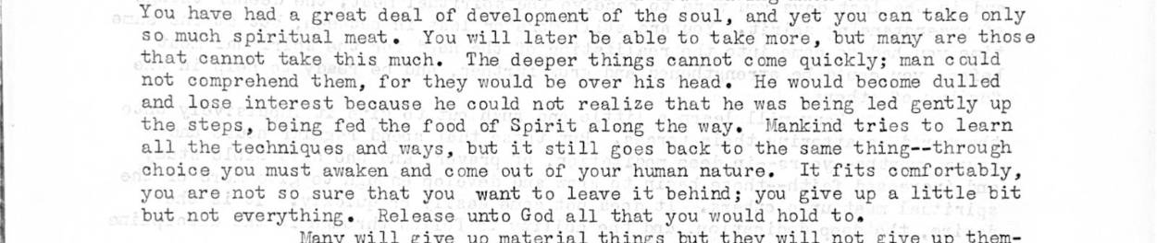
Site now: erest because he could not realize that he was being led gently up the steps, being fed the food of Spirit along the ways Mankind tries to learn all the techniques and ways, but it still goes back to the same thing--through choice you must awaken and come out of yo
Or could be: tried
On the page: __________________________________________________________________________

