The Wastena Retreat — readings to check
Each entry below shows the strip of the scan a doubtful word sits on. Underneath is what the site currently prints, and what the alternative would be. Please write what you actually see on the line marked On the page: — a few words either side is plenty. Where the current reading is already right, just write "ok".
Entries 1 to 3 of 196.

1. "affect" · scan page 82
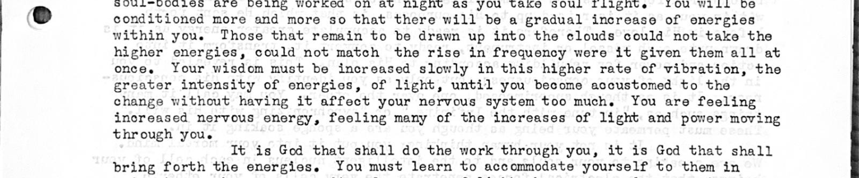
Site now: igher rate of vibration, the greater intensity of energies, of light, until you become accustomed to the change without having it affect your nervous system too much. You are feeling increased nervous energy, feeling many of the increases of light and power moving t
Could be: effect
On the page: __________________________________________________________________________

2. "alter" · scan page 51
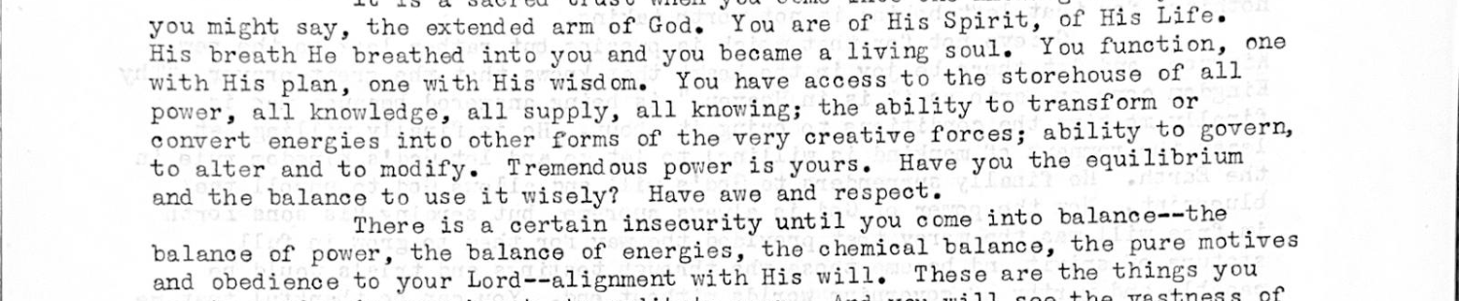
Site now: ly, all knowing; the ability to transform or convert energies into other forms of the very creative forces; ability to govern, to alter and to modify. Tremendous power is yours. Have you the equilibrium and the balance to use it wisely? Have awe and respect. There
Could be: after
On the page: __________________________________________________________________________

3. "altitudes" · scan page 47
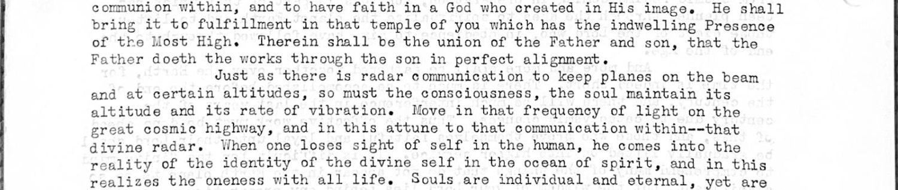
Site now: h the works through the son in perfect alignment. Just as there is radar communication to keep planes on the beam and at certain altitudes, so must the consciousness, the soul maintain its altitude and its rate of vibration. Move in that frequency of light on the grea
Could be: attitudes
On the page: __________________________________________________________________________

