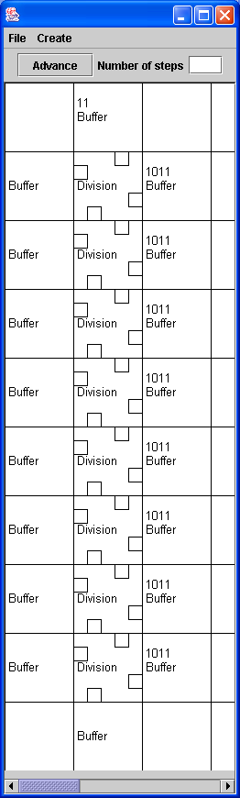
This is an example of how to fill the division sample with bits. This is done with “make cell” from the command line.

