**PROJECT – 4 Comcast Telecom Consumer Complaints**

Step 1: Import the relevant data set and read the data and find out the column of the dataset to analyse.

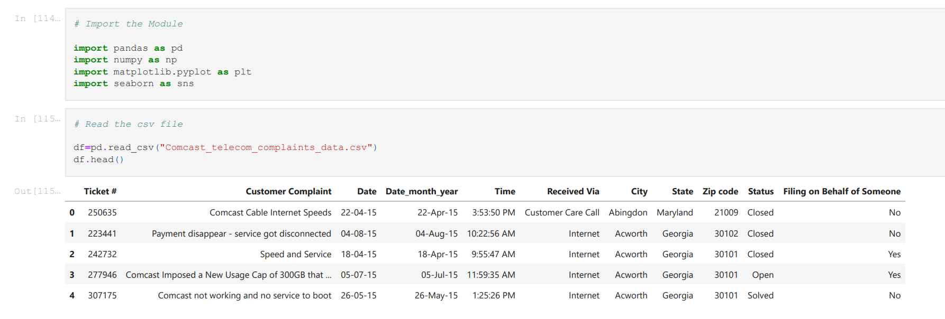

Step 2: Obseving the data column information

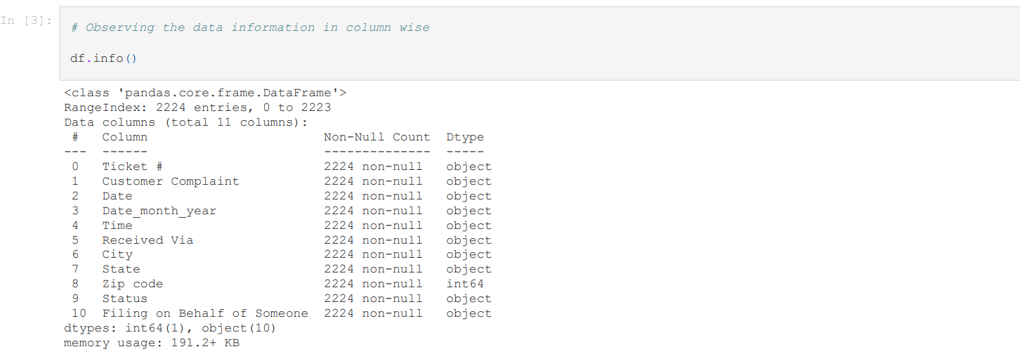

Step 3:Converting date column from object to datetime format by using predefined function

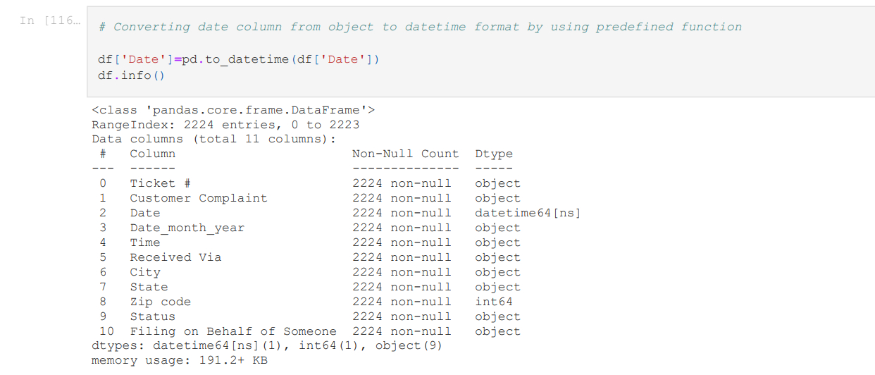

Step 4: Adding New Column of “month” to find out the Complaint on month wise.

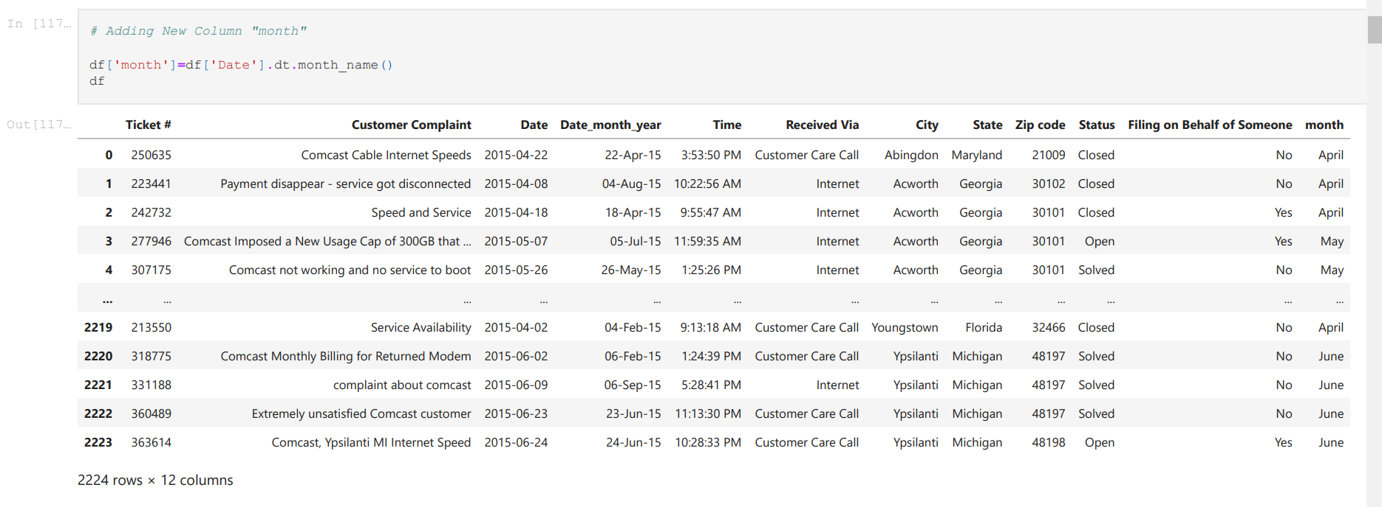

Step 5: Grouping the list of complaint by using date column and it clearly shown 24thJune was the most complaints recorded as per the data.

Step 6:



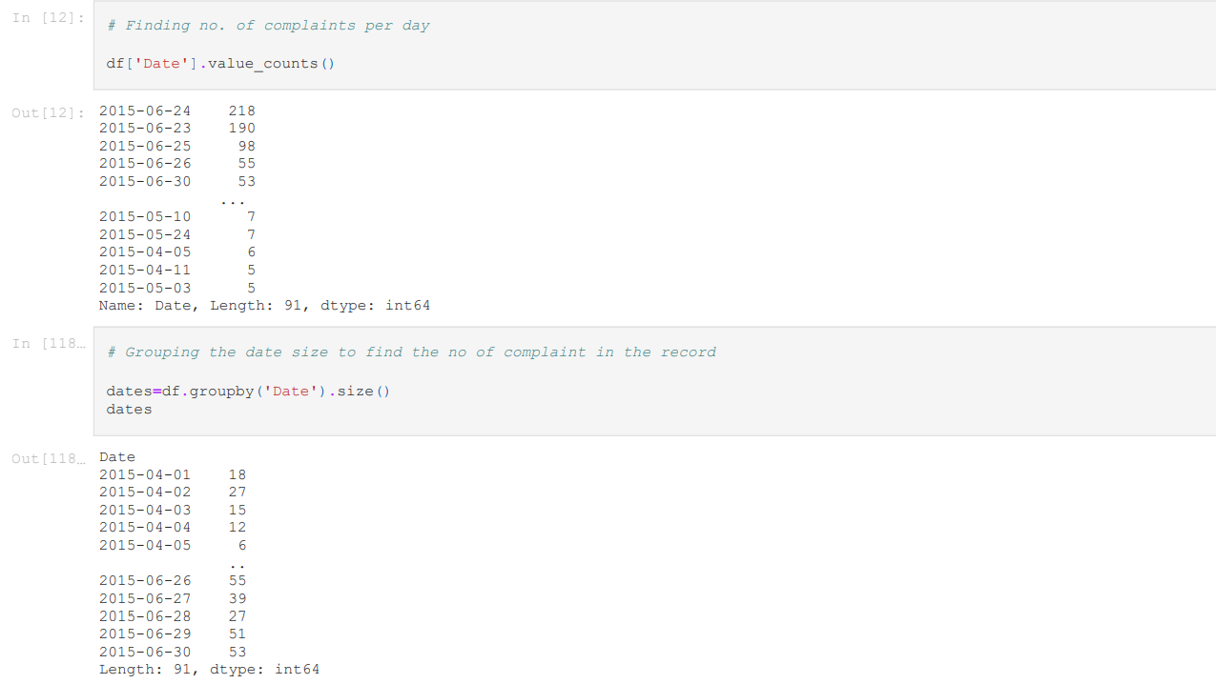

Step 6: Reset and Renaming the dates column name to find the count of complaints

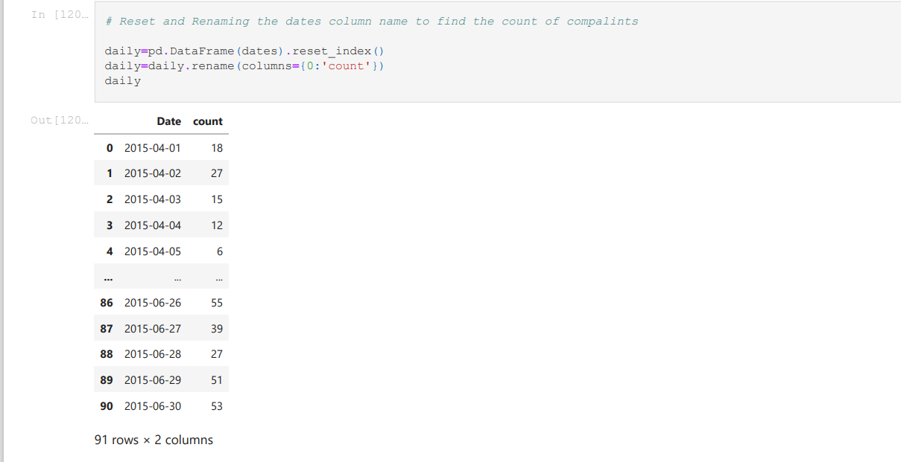

Step 7: For the better understanding, we use plot line graph to identify the month and datecolumn.

After grouping the month column we could find the June month complaint is around 1280.

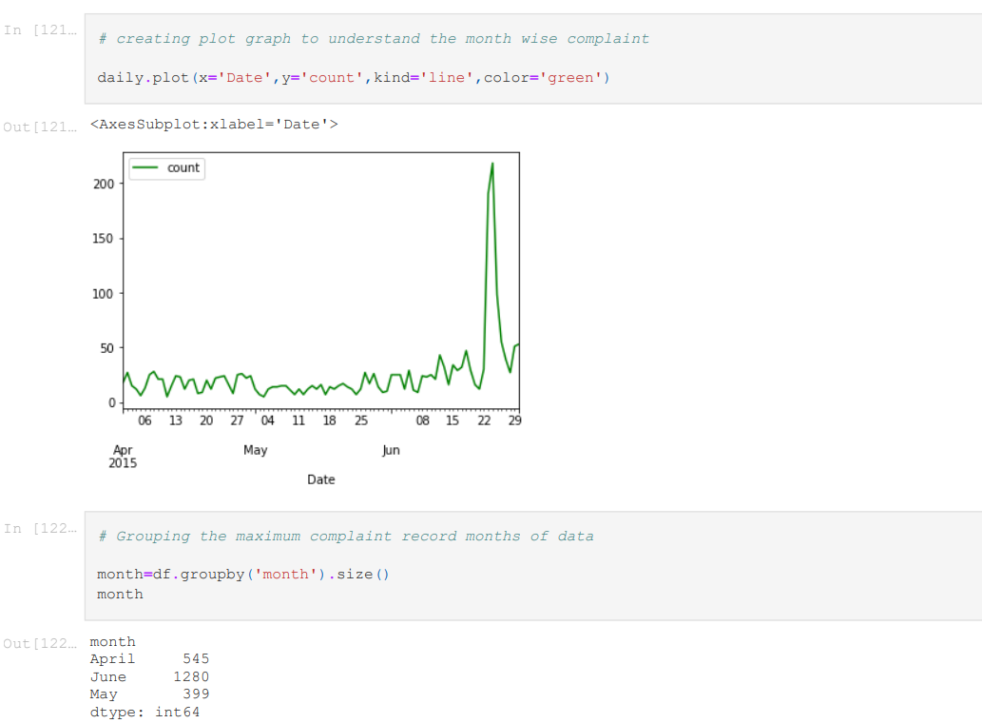



Step 8: Reset and Renaming the month column name to find the count of compalints

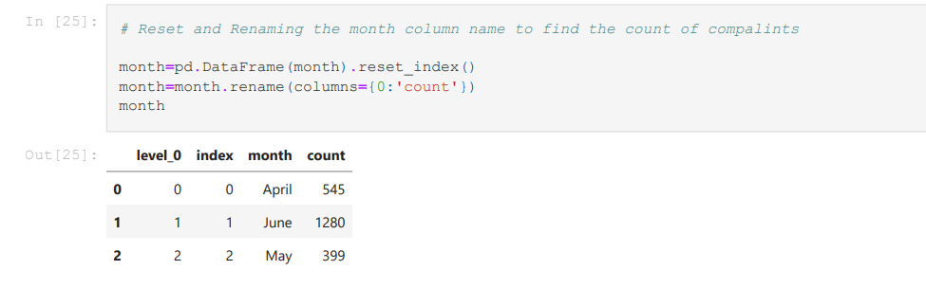

Step 9: Using Bar graph for month column to identify the no. of complaint records on the month.

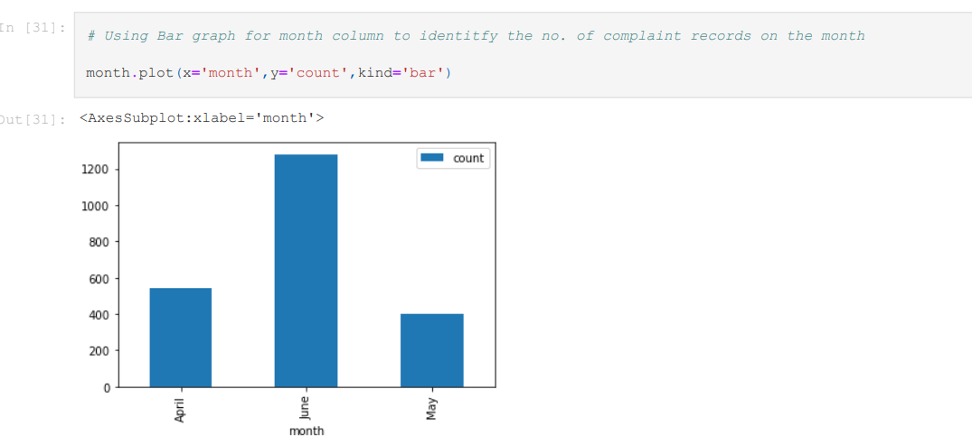

Step 10: Identify the complaint category by using value_counts function. Using Lambda function to changing the string items upper case in each words

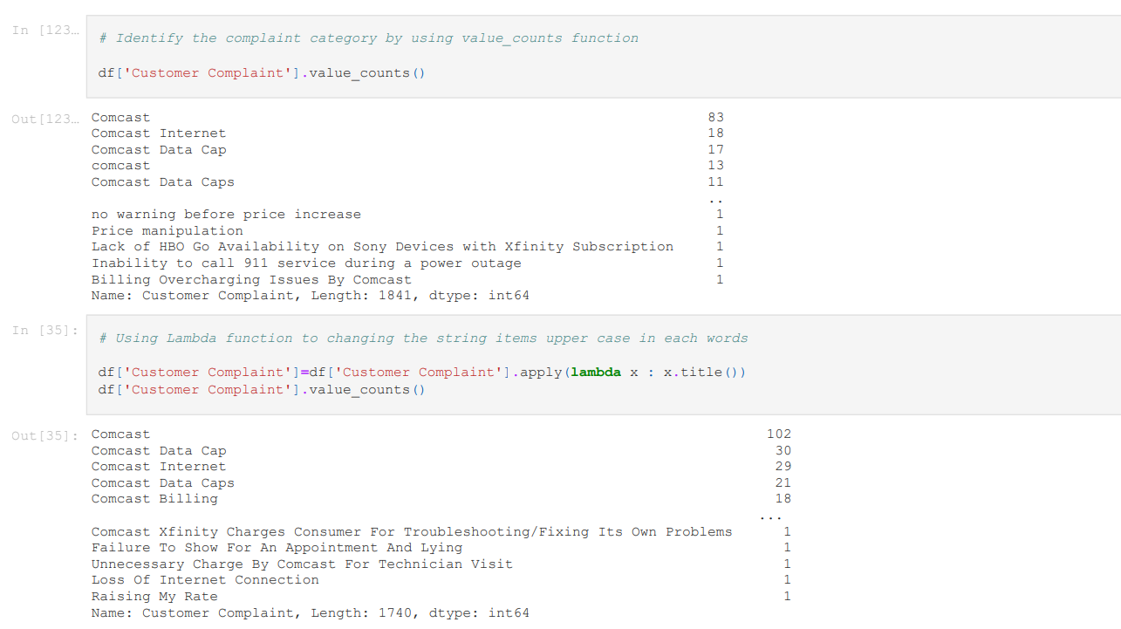

Step 11: For better understanding we would go for bar graph to verify the most category of customer complaint is “comcast” as per the graph

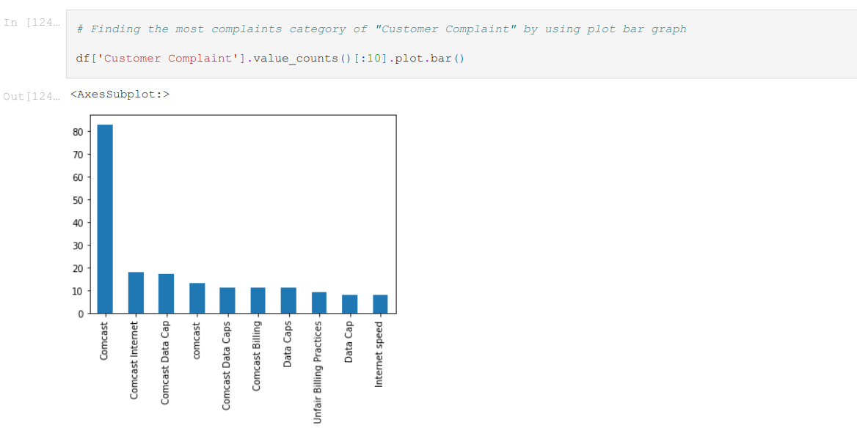Step 12: Recall the Data set

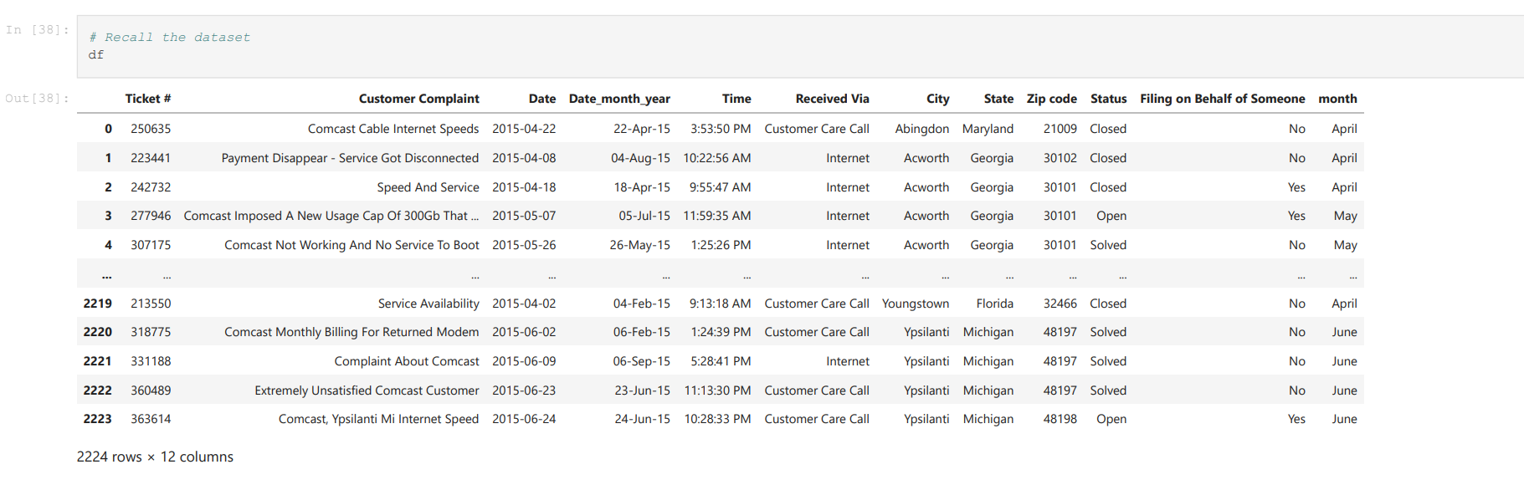

Step 13: Identify the complaints by using string contains by keywords

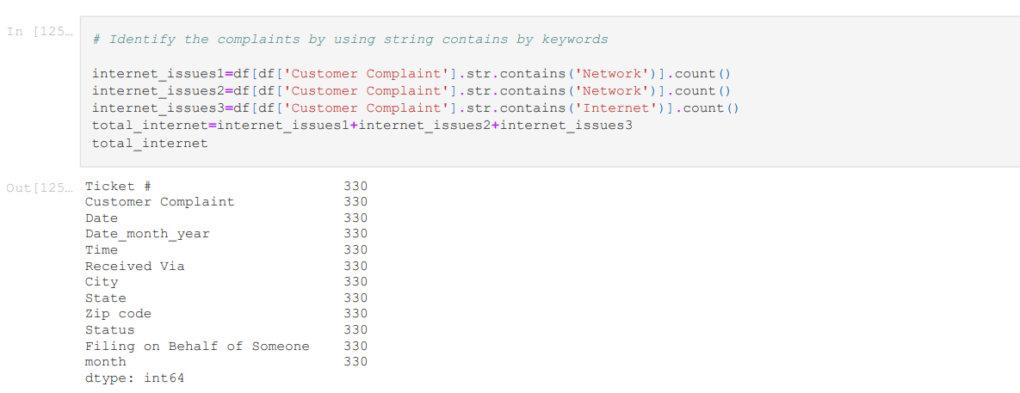

Step 14: Identify the complaints by using string contains by keywords

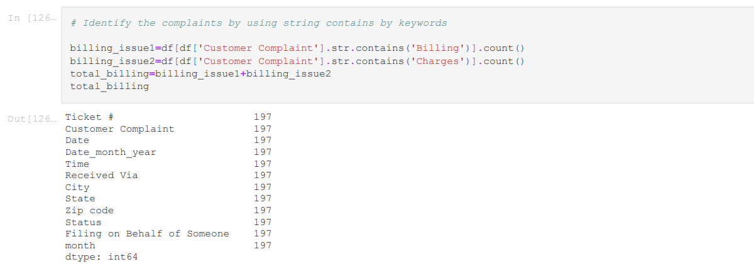

Step 15: Identify the complaints by using string contains by keywords

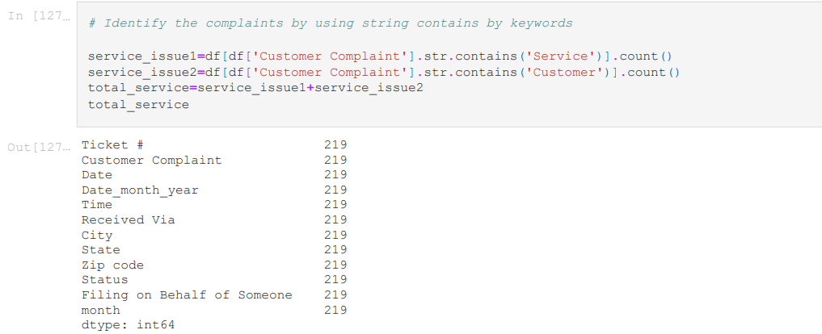

Step 16: Identify the other complaints by using string contains by keywords.

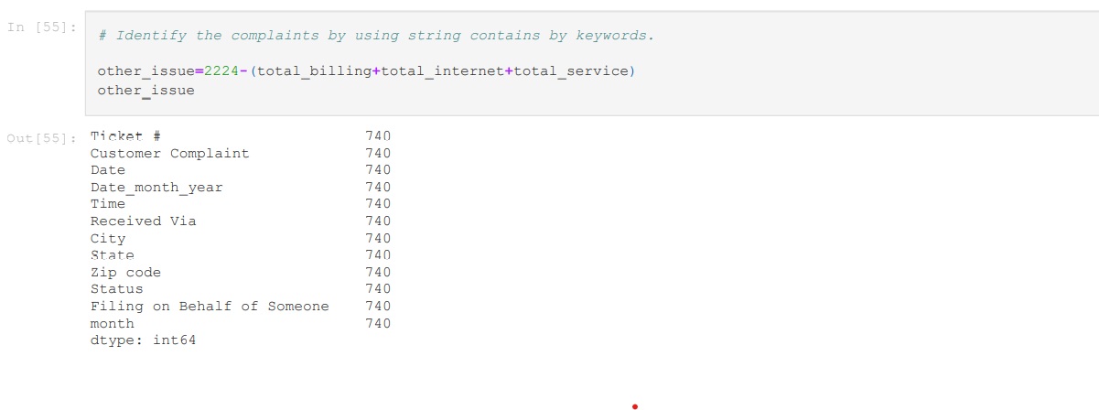

Step 17: Identify the “status” column unique values.

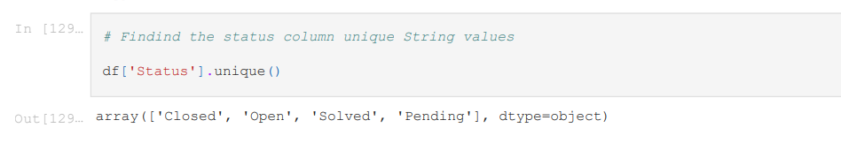

Step 18: Modifying the status column by using if else condition.

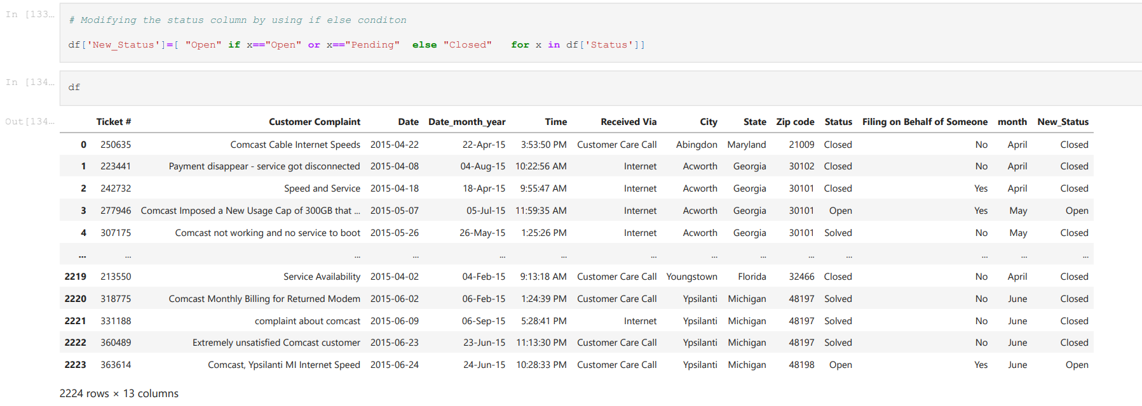

Step 19: Finding the status of complaint by state wise and fill the NaN by using fillna()

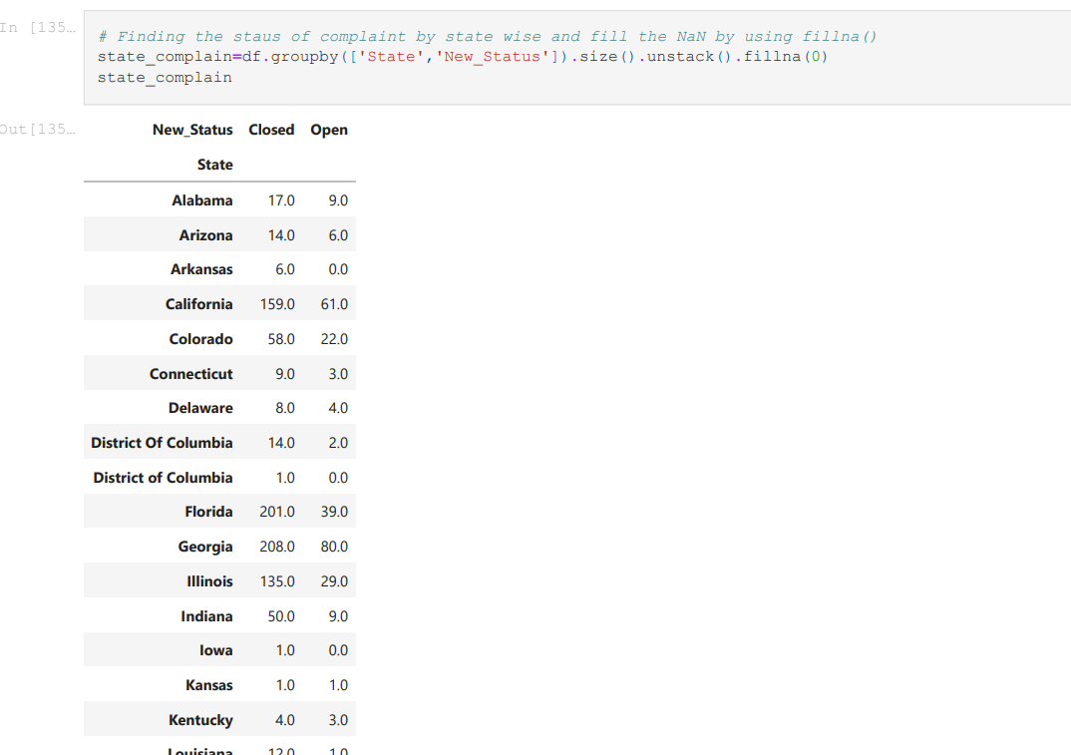

Step 20: Using Bar plot to find the most of the complaint are closed state is Georgia as per the bar graph.

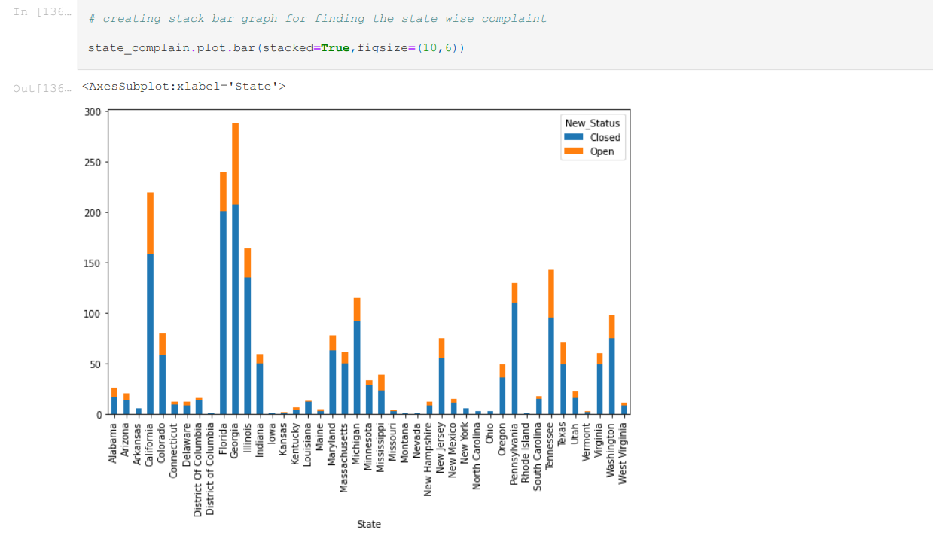

Step 21: Findly the top complaint states by using value count function

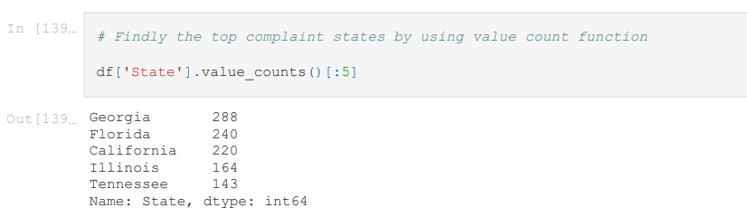

Step 22: Identify the most unresolved complaint state is Georgia.

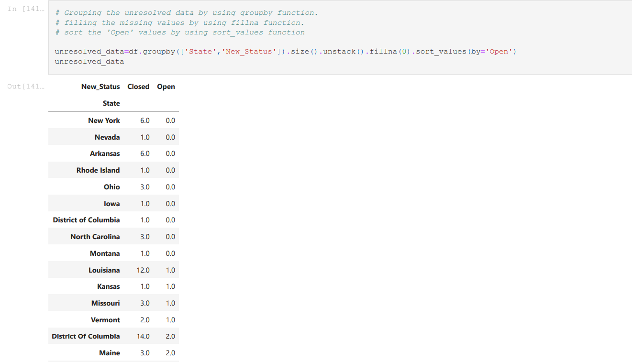

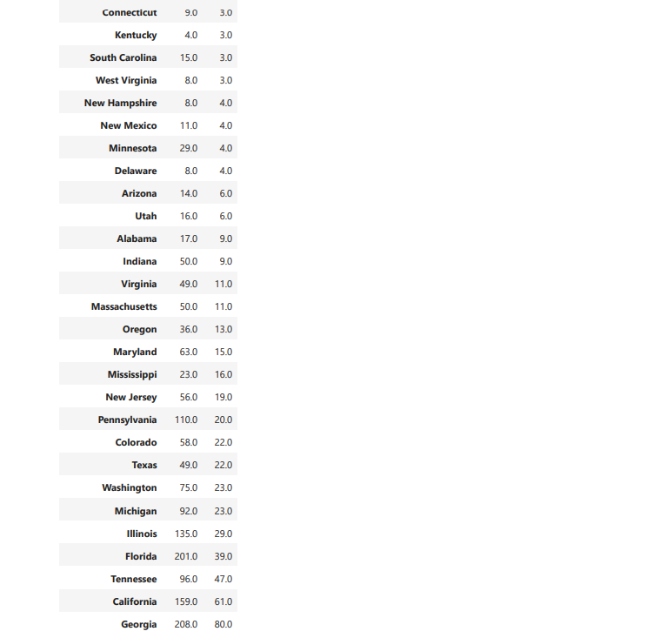

Step 23: By using percentage Georgia has a highest number of unresolved compalints.

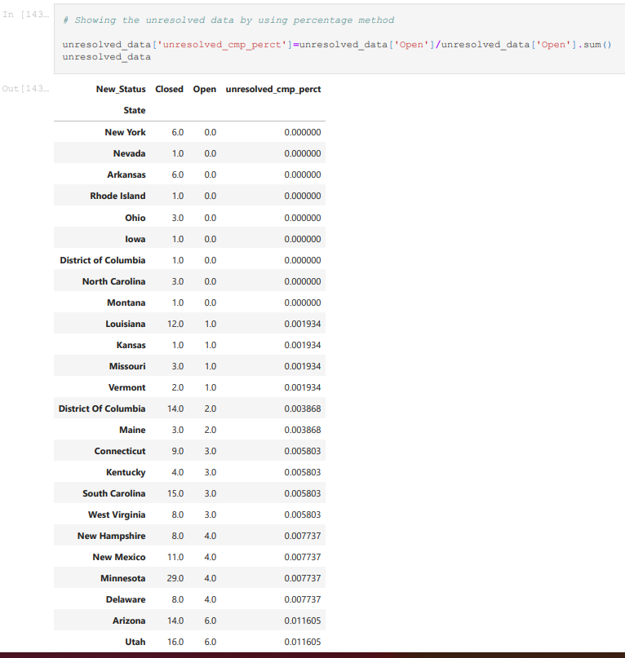

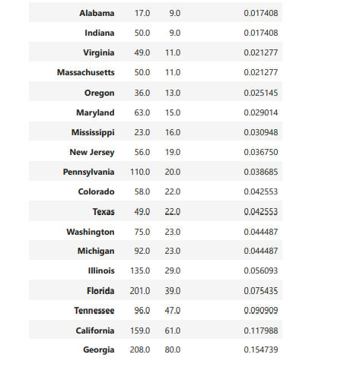

Step 24: Identifying the resolved status, Grouping the data by using “Received Via” and “New_Status” Column to find the percentage and Received Via input.

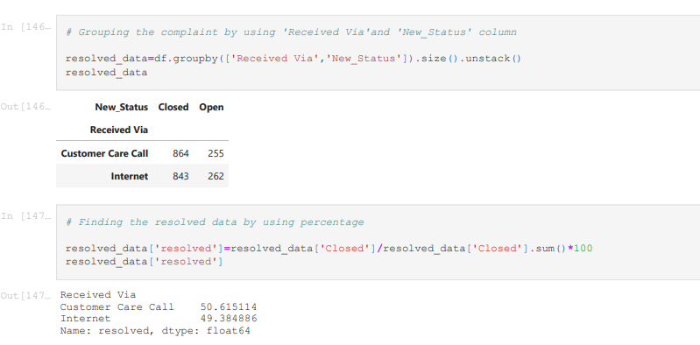

Conclusion:

Therefore, the Total percentage of Complaint have been resolved via “customer care call” and the percentage of resolved is 50.615114%.