1. Listing all the files that is already exists in the root directory.

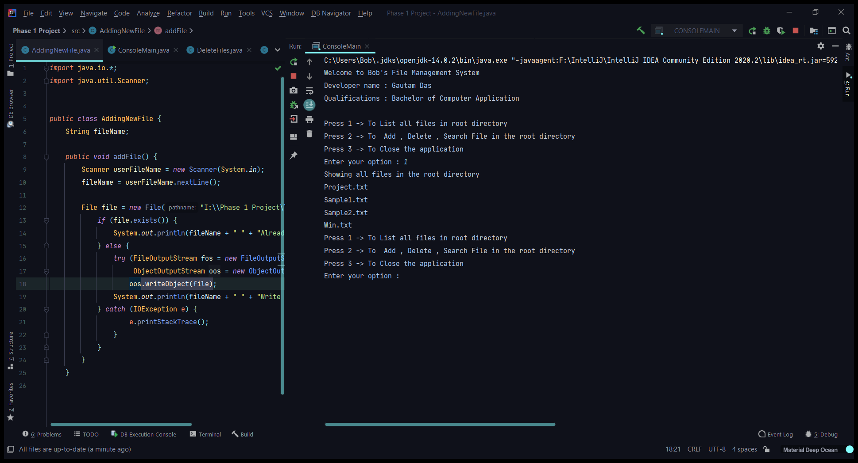

1. Adding a new file in the root directory.

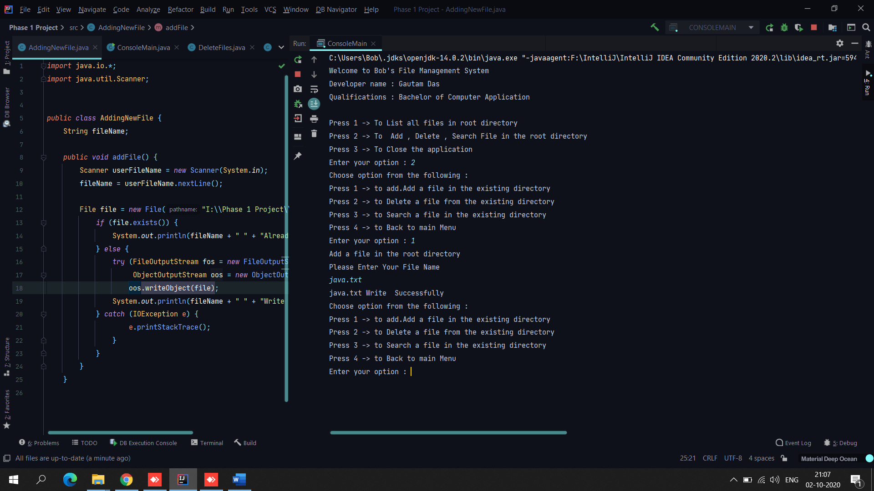

1. Deleting a file from root directory.

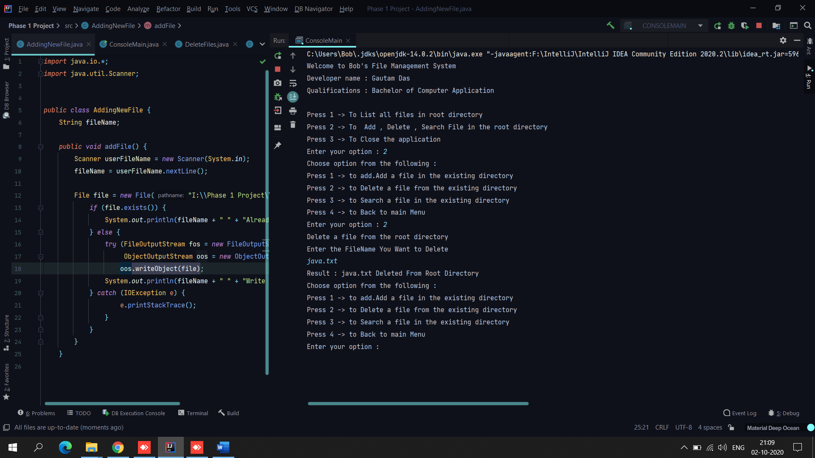

1. Searching a file in the root directory.

