**Kapcher Development Brief**

Kapcher one-pager marketing website + blog

Requirements:

* Responsive
* WordPress
* Cross browser compatible for all major web browsers
* W3C valid
* HTML5/CSS3
* Javascript animations (see below)
* Web fonts (use Mark in Fonts folder)
* Retina optimised

**1. Landing Page**

**Responsive**

The website needs to be responsive. I have designed the desktop size. For framework/ example of how this should scale for mobile refer to <http://www.elegantthemes.com/demo/?theme=Divi>. We are happy for you to use this theme. Please advise if you’d like us to purchase this and provide the files.

**Sections**

This is a one-pager marketing website (+blog) that needs to be broken up into 5 key sections – Home, About, Features, Discover, Join. The website should detect the users screen size and display each section full screen, like <http://www.invisionapp.com/> or <http://format.com/>

**Images**

On all images there is a gradient overlay, which creates a darker shadow on the bottom. This needs to be applied in CSS for all images.

**Navigation**

As you scroll down the top navigation should animate the same as <http://www.invisionapp.com/>

‘…header-default.jpg’ is the default state

‘…header-scroll.jpg’ replaces the default state as you scroll down the site the same way as <http://www.invisionapp.com/>

**Section 1 - Home**

The background will be an image to start with but we also need the ability to make this a video, e.g. <http://designlab.co/demo/template/kane/layout-style-two/light/video-bg/index.html>

The background image/video should also stay in the same position as the user scrolls down the page like the above example (not scroll with the page).

Button hover state - 20% white overlay.

**Section 2 – About**

The ‘Your Brand’ text needs to animate. Your should remain in the same place and the word ‘Brand’ should cycle between these three words – ‘Brand’, ‘Story’, ‘Way’. An example of the animation is <http://codepen.io/RichardBray/pen/julhw> when you hover over the button. But this should happen automatically and loop on our website.

Nice, simple animation on the icons as they are revealed. An example is on <http://www.elegantthemes.com/demo/?theme=Divi>. Refer to how the icons animate in on the ‘Divi’s Core Features’ section.

**Section 3 – Features**

Nice, simple animation on the screenshots. An example is on <https://www.storehouse.co/ipad>. Refer to how the screenshots scroll down on the ‘Beautiful stories everywhere’ section.

There are 4 different key features that need to be displayed. Refer to the PSD for content.

On mobile this should be a single image with the arrows on the left and right like the header on <http://www.elegantthemes.com/demo/?theme=Divi>.

Button hover state - 20% white overlay.

We’d like to see two options here. One of the above and one without the arrows on the side and each feature simply stacked like on <http://format.com/>.

**Section 4 – Discover**

This is the blog. The feature image from blog posts will be displayed here. On hover the red overlay will fade in along with the text. For the animation/ hover state please refer to <http://www.elegantthemes.com/demo/?theme=Divi> in the section below.

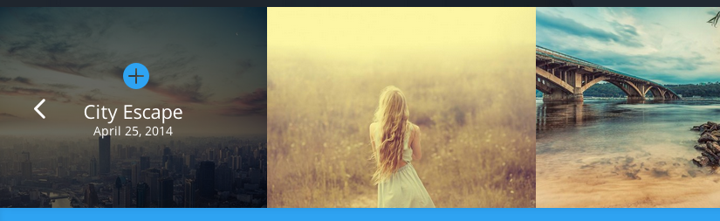

On mobile this should be a single image with the arrows on the left and right.

On click it should take you to the post on the blog page.

**Section 5 – Join**

Mailchimp integration required here.

Button hover state - 20% white overlay.

**2. Discover**

Only accessed by url /discover

Use same template as ‘Section 4 – Discover’

**3. Discover - Post**

Blog post template.

Use same header section/ animation as on homepage.