

AGENTFLOW
The Next Generation Multi-Agent Task Automation System

Requirement and Design Document (RDD)

Submitted by:
Mridul Dhamija
2310990741
Web Programming Project

Problem Statement :-
Modern productivity and task management systems primarily rely on single-agent architectures or manual user input, which limits their effectiveness in handling complex and multi-step goals. While these systems are useful for basic task tracking, they often fail to support users in managing broader objectives that require planning, coordination, and adaptability.
In real-world scenarios, users frequently deal with multiple tasks across different domains at the same time. However, existing tools provide limited assistance in structuring these tasks, leading to inefficiencies and increased cognitive effort.
Some key challenges in current systems include:
- Difficulty in breaking down high-level goals into smaller, actionable tasks
- Lack of intelligent coordination between dependent tasks
- Inability to adapt to changing priorities and dynamic requirements
- Absence of real-time feedback and performance-based optimization
- Over-reliance on manual intervention for tracking and decision-making
Due to these limitations, users often spend more time organizing and managing tasks rather than executing them effectively. This reduces overall productivity and makes it harder to maintain consistency in workflows.
Therefore, there is a need for an advanced system that can overcome these challenges by leveraging multiple specialized agents working collaboratively. Such a system should be capable of:
- Automatically decomposing complex goals into structured workflows
- Coordinating tasks intelligently across different stages
- Adapting dynamically to changes in user requirements
- Providing continuous feedback and optimizing performance over time
By integrating multi-agent collaboration with intelligent automation, the proposed solution aims to create a more efficient, scalable, and user-friendly approach to task management.

Objectives :-
The primary objective of the proposed system is to enhance productivity and task management by leveraging a multi-agent approach that can intelligently assist users in planning, executing, and optimizing their workflows. The system aims to reduce manual effort, improve efficiency, and provide a more structured approach to handling complex tasks.
To achieve this, the key objectives of the system are:
- To develop a system capable of breaking down high-level goals into smaller, actionable tasks
- To enable intelligent coordination between multiple tasks and agents
- To design a workflow that can adapt dynamically to changing user requirements and priorities
- To provide real-time feedback and insights to improve task execution
- To minimize manual intervention through automation of repetitive processes
- To ensure scalability so the system can handle tasks across multiple domains effectively
Additionally, the system aims to create a user-friendly and efficient environment where users can focus more on execution rather than planning and management. By integrating intelligent automation with multi-agent collaboration, the solution seeks to deliver a more reliable and optimized approach to modern task management.
Scope of the System :-
The proposed system focuses on developing a multi-agent task automation platform that assists users in planning, organizing, and executing tasks efficiently. The system is designed to simplify the process of managing complex goals by breaking them down into structured workflows and enabling intelligent coordination between different components.
The scope of the system includes:
- Providing a user interface to input high-level goals or tasks
- Automatically decomposing goals into smaller, manageable tasks
- Managing task execution using multiple specialized agents
- Tracking task progress and maintaining workflow status
- Adapting to changes in user requirements dynamically
- Storing task-related data for better organization and retrieval
The system is intended to support productivity across various domains such as academic work, personal projects, and basic professional tasks. It aims to improve efficiency by reducing manual effort and providing a structured approach to task management.
However, the scope of the system is limited to:
- A prototype-level implementation of multi-agent coordination
- Basic automation and task execution without deep domain-specific intelligence
- Limited integration with external platforms or third-party services
The system does not aim to replace fully specialized project management tools but rather to provide an intelligent and scalable solution for improving everyday task management and workflow efficiency.

System Overview :-
The proposed system, AgentFlow, is a multi-agent task automation platform designed to handle complex workflows through intelligent coordination of specialized AI agents. Unlike traditional task management systems or single-agent chatbots, the system distributes tasks across multiple agents, each responsible for a specific role within the workflow.
The system operates by accepting a high-level goal from the user and transforming it into a structured execution plan. This process is managed by a central orchestration layer that coordinates communication between agents and ensures smooth task execution.
The key components of the system include:
- Orchestrator: Acts as the central control unit that analyzes user input, distributes tasks, and manages overall workflow
- Planner Agent: Breaks down complex goals into smaller, structured tasks
- Research Agent: Gathers relevant information and context required for task execution
- Execution Agent: Performs the core task operations such as code generation or content creation
- Quality Assurance Agent: Validates outputs and ensures correctness and reliability
- Reporting Agent: Compiles results and presents them in a structured format
The workflow of the system can be described as follows:
- The user submits a high-level task through the interface
- The Orchestrator processes the input and assigns it to the Planner Agent
- The Planner Agent decomposes the task into multiple subtasks
- Subtasks are distributed among specialized agents for parallel or sequential execution
- Agents communicate through a shared memory system to maintain context and consistency
- The Quality Assurance Agent verifies outputs before final delivery
- The Reporting Agent compiles and delivers the final result to the user
The system incorporates shared memory and context management to ensure that all agents operate with consistent information. This allows agents to build upon each other's outputs and avoid redundancy.
The platform is built using a MERN-based frontend-backend architecture, combined with AI model integration for intelligent processing. The modular design enables easy addition of new agents and supports scalability for handling more complex tasks in the future.
By leveraging multi-agent collaboration, intelligent orchestration, and real-time coordination, AgentFlow provides a scalable and efficient solution for modern task automation and productivity management.

Requirements :-

A. Functional Requirements :
1. User Goal Input
The system should allow users to input high-level goals or tasks through an intuitive interface. These goals act as the starting point for task planning and execution.
- Accept user input in text form
- Validate and process the input
- Forward the input to the orchestrator

2. Task Decomposition (Planner Agent)
The system should break down complex user goals into smaller, structured, and manageable tasks using a planning mechanism.
- Analyze the user goal
- Generate a sequence of subtasks
- Organize tasks in a logical order

3. Agent Coordination (Orchestrator)
The system should coordinate multiple agents and manage task distribution efficiently.
- Assign tasks to appropriate agents
- Manage execution flow (sequential/parallel)
- Handle communication between agents

4. Task Execution (Executor Agents)
The system should execute tasks using specialized agents powered by AI tools.
- Generate outputs (code, content, analysis, etc.)
- Process tasks based on assigned roles
- Return results to the system

5. Context and Memory Management
The system should maintain a shared memory to ensure consistency and context across all agents.
- Store task data and intermediate results
- Allow agents to access shared context
- Maintain workflow state

6. Task Monitoring and Feedback
The system should monitor task progress and provide feedback to improve execution quality.
- Track task status (pending, in-progress, completed)
- Validate outputs using feedback mechanisms
- Suggest improvements if needed

7. Output Generation and Presentation
The system should compile results and present them in a structured and user-friendly format.
- Aggregate outputs from multiple agents
- Format results clearly
- Display final output to the user

8. Task History and Storage
The system should store completed tasks and workflows for future reference.
- Save user goals and results
- Maintain history of executions
- Allow retrieval of past tasks

B. Non-Functional Requirements :-

1. Scalability
The system should support increasing workloads and allow the addition of new agents without major architectural changes.
- Modular agent-based design
- Support horizontal scaling
- Easy integration of new agents

2. Performance
The system should provide efficient and timely responses during task execution.
- Support parallel task processing
- Minimize response latency
- Optimize resource usage

3. Reliability
The system should ensure consistent and accurate performance under different conditions.
- Handle failures gracefully
- Ensure correctness of outputs
- Maintain system stability

4. Usability
The system should provide a simple and intuitive user interface.
- Easy navigation
- Clear task visualization
- Minimal learning curve

5. Security
The system should ensure protection of user data and system resources.
- Secure data storage
- Controlled access to system components
- Safe handling of API keys and integrations

6. Maintainability
The system should be easy to update, debug, and extend.
- Clean and modular code structure
- Easy debugging and monitoring
- Support future enhancements

7. Availability
The system should remain accessible with minimal downtime.
- High uptime
- Reliable deployment infrastructure
- Continuous system monitoring

8. Extensibility
The system should allow integration with additional AI tools and external services.
- Plug-and-play agent architecture
- Support for third-party APIs
- Flexible system expansion

The above requirements ensure that the system delivers both functional capabilities and high-quality performance, making it suitable for real-world applications and scalable deployment.

System Design and Architecture :-
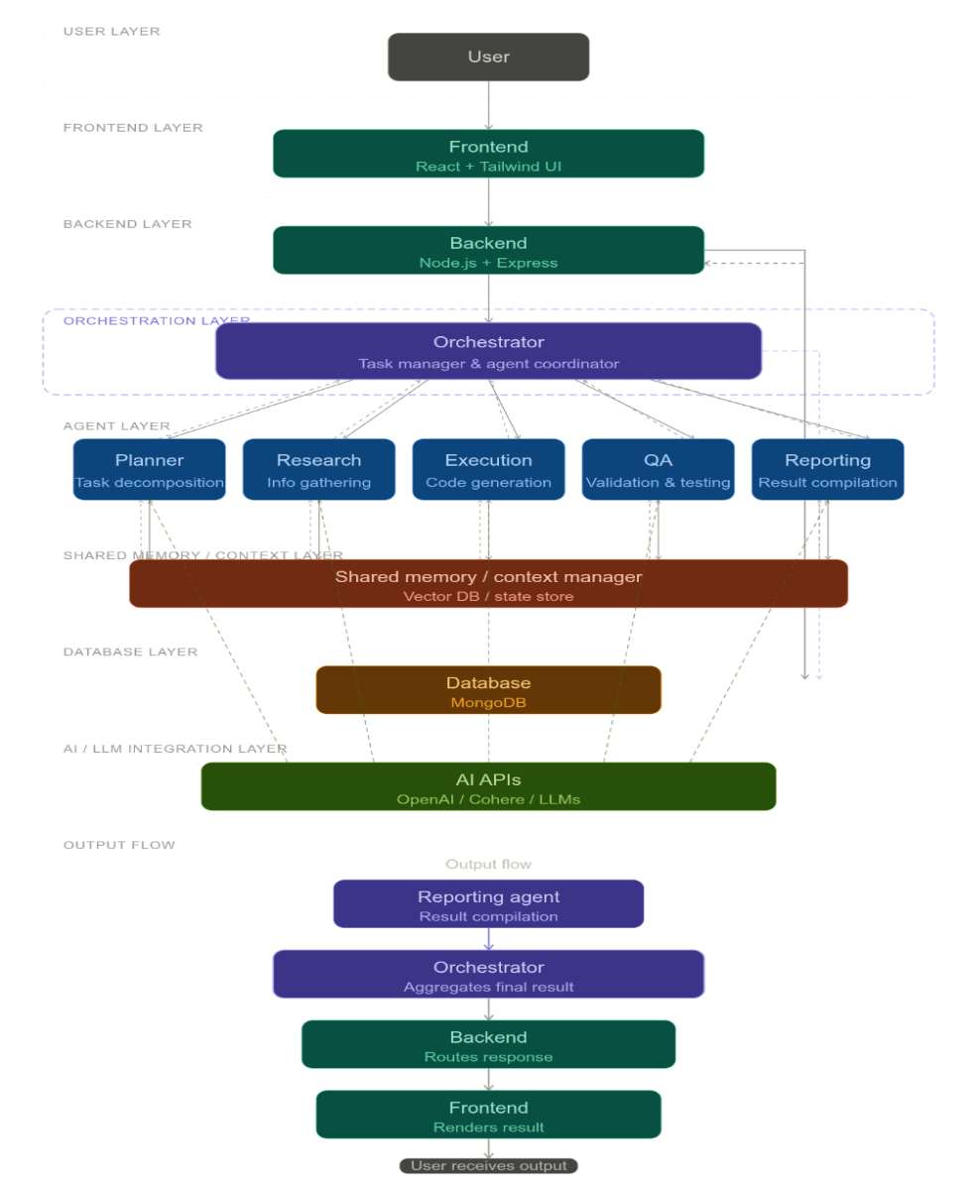
Workflow :-
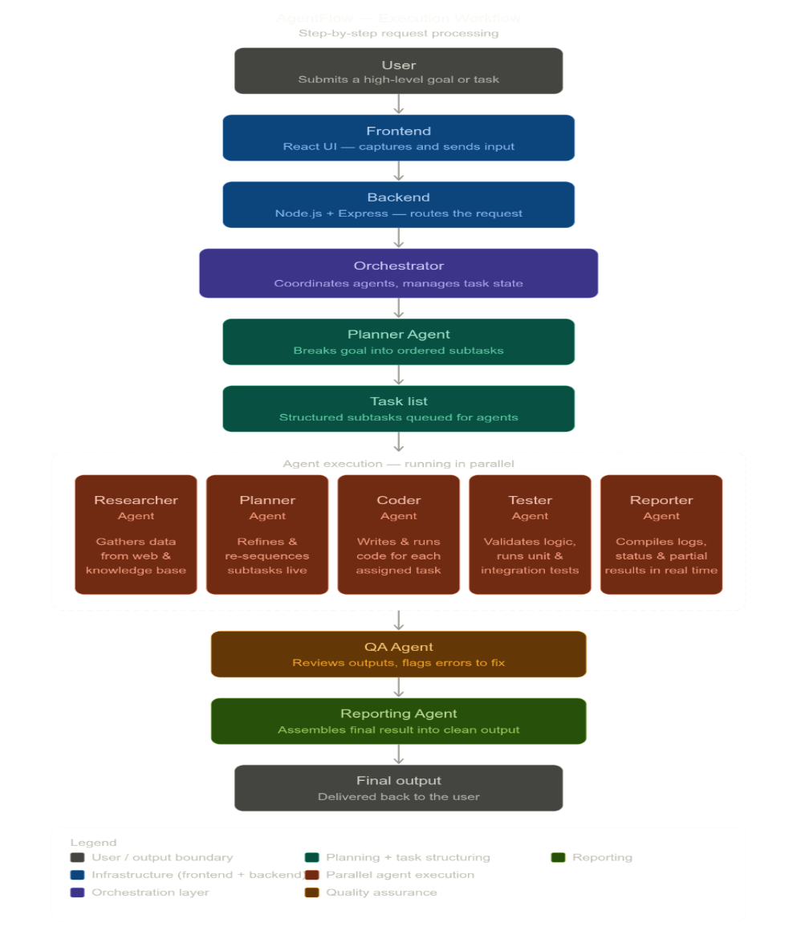
Agents Interaction :-

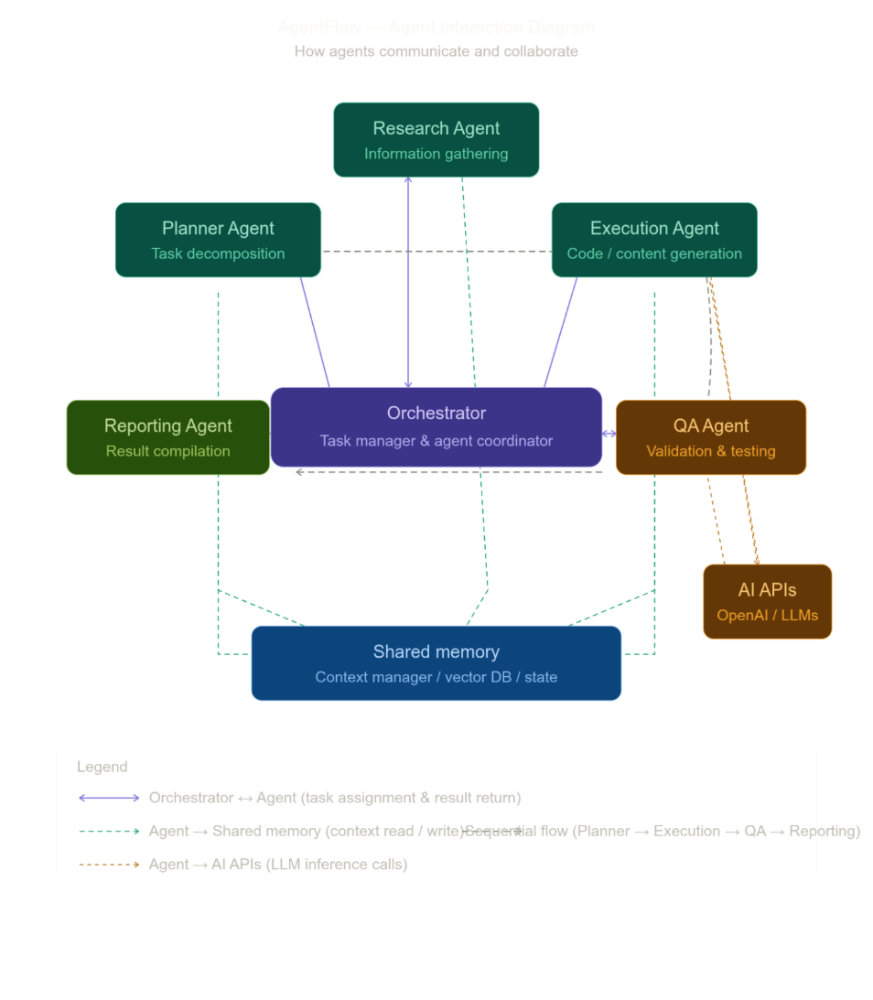
Conclusion :-
The proposed system, AgentFlow, introduces an advanced and structured approach to modern task management by leveraging a multi-agent architecture for intelligent automation. Unlike traditional systems that rely on manual input or single-agent responses, AgentFlow distributes tasks across multiple specialized agents, enabling efficient handling of complex and multi-step workflows.
The system demonstrates how high-level user goals can be transformed into structured execution plans through the use of a Planner Agent, followed by coordinated task execution using multiple agents. The inclusion of components such as shared memory, orchestration mechanisms, and quality assurance ensures consistency, reliability, and improved overall performance.
By integrating AI-driven capabilities, the system enhances its ability to generate meaningful outputs, adapt to dynamic requirements, and optimize workflows over time. This reduces the cognitive load on users and allows them to focus more on execution rather than planning and management.
Furthermore, the modular design of the system ensures scalability and flexibility, making it suitable for applications across multiple domains such as software development, research, content creation, and productivity management. The architecture also supports easy extension, allowing new agents and functionalities to be added without major system changes.
In conclusion, AgentFlow provides a scalable, efficient, and intelligent solution for task automation, addressing the limitations of traditional systems and demonstrating strong potential for real-world implementation.

Future Scope :-
The proposed system can be further enhanced by incorporating advanced features and expanding its capabilities to support a wider range of real-world applications. With continuous improvements in AI technologies, the system has significant potential for growth and scalability.
Some key areas for future development include:
- Integration with external platforms such as GitHub, Google Workspace, and project management tools to enable seamless workflow automation
- Implementation of more advanced AI models and fine-tuned agents for improved accuracy, decision-making, and domain-specific performance
- Support for real-time collaboration, allowing multiple users to interact with the system simultaneously
- Enhancement of memory systems using vector databases for long-term context retention and improved personalization
- Development of autonomous agents capable of making independent decisions with minimal human intervention
- Deployment of the system as a cloud-based platform to support large-scale enterprise applications
- Incorporation of monitoring and analytics features to track performance, efficiency, and user behavior
These enhancements will not only improve the functionality and usability of the system but also enable it to evolve into a comprehensive and scalable solution for intelligent task automation across various domains.

