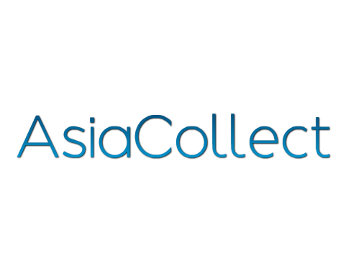**Head of Operations**

Philippines

**Company**

* AsiaCollect is the first pan-Asian professional consumer credit collection services company. The Company seeks to bring world-class outsourced collection practices and efficiency to the South East Asian consumer finance market. Established in 2015, AsiaCollect is headquartered in Singapore and is backed by Forum Capital, a global Emerging Markets investment firm with deep expertise in the consumer finance industry.

**Why to apply?**

* Exciting entrepreneurial opportunity to join a fast growing business across ASEAN
* Work with proven global entrepreneurs who have created significant companies and wealth
* Be part of the early team that is creates a new market leader

**What’s exciting about the opportunity?**

* Reporting directly to the CEO of AsiaCollect, the Head of Operations will be responsible for managing the consumer credit collection operations, including the call center, field collections, and legal collections.
* Utilise your manager`s experience and the drive to develop the young team of professionals.
* Influence the strategy and direction of AsiaCollect through your feedback and knowledge from the “front line”.
* Work with a group of smart, fun and successful entrepreneurs and help establish the AsiaCollect culture.

**Is this you?**

* Passionate about, and have 5+ years of experience of operations in outsourced services, preferably to the financial services sector.
* Excellent people management and leadership skills.
* Strong written and verbal communication skills.
* High level of responsibility and self-motivation.
* Have a bachelors degree in business/commerce, science, engineering or equivalent