Assignment 1

# **Lab Assignment 1 : Develop an object oriented program in C++ to create a database of student information system containing the following information: Name, Roll number, Class, division, Date of Birth, Blood group, Contact address, telephone number, driving license no. etc Construct the database with suitable member functions viz, static member functions, friend class/ friend function, this pointer, inline code and dynamic memory allocation operators-new and delete. Implement all the keywords as mentioned in the problem statement.**

Aim: To create student database & use C++ concepts in it.

Description:   
 Student database is created with c++ which includes option to Create and Display the student data with the help of C++ concepts like class, constructor, static members, friend function etc.

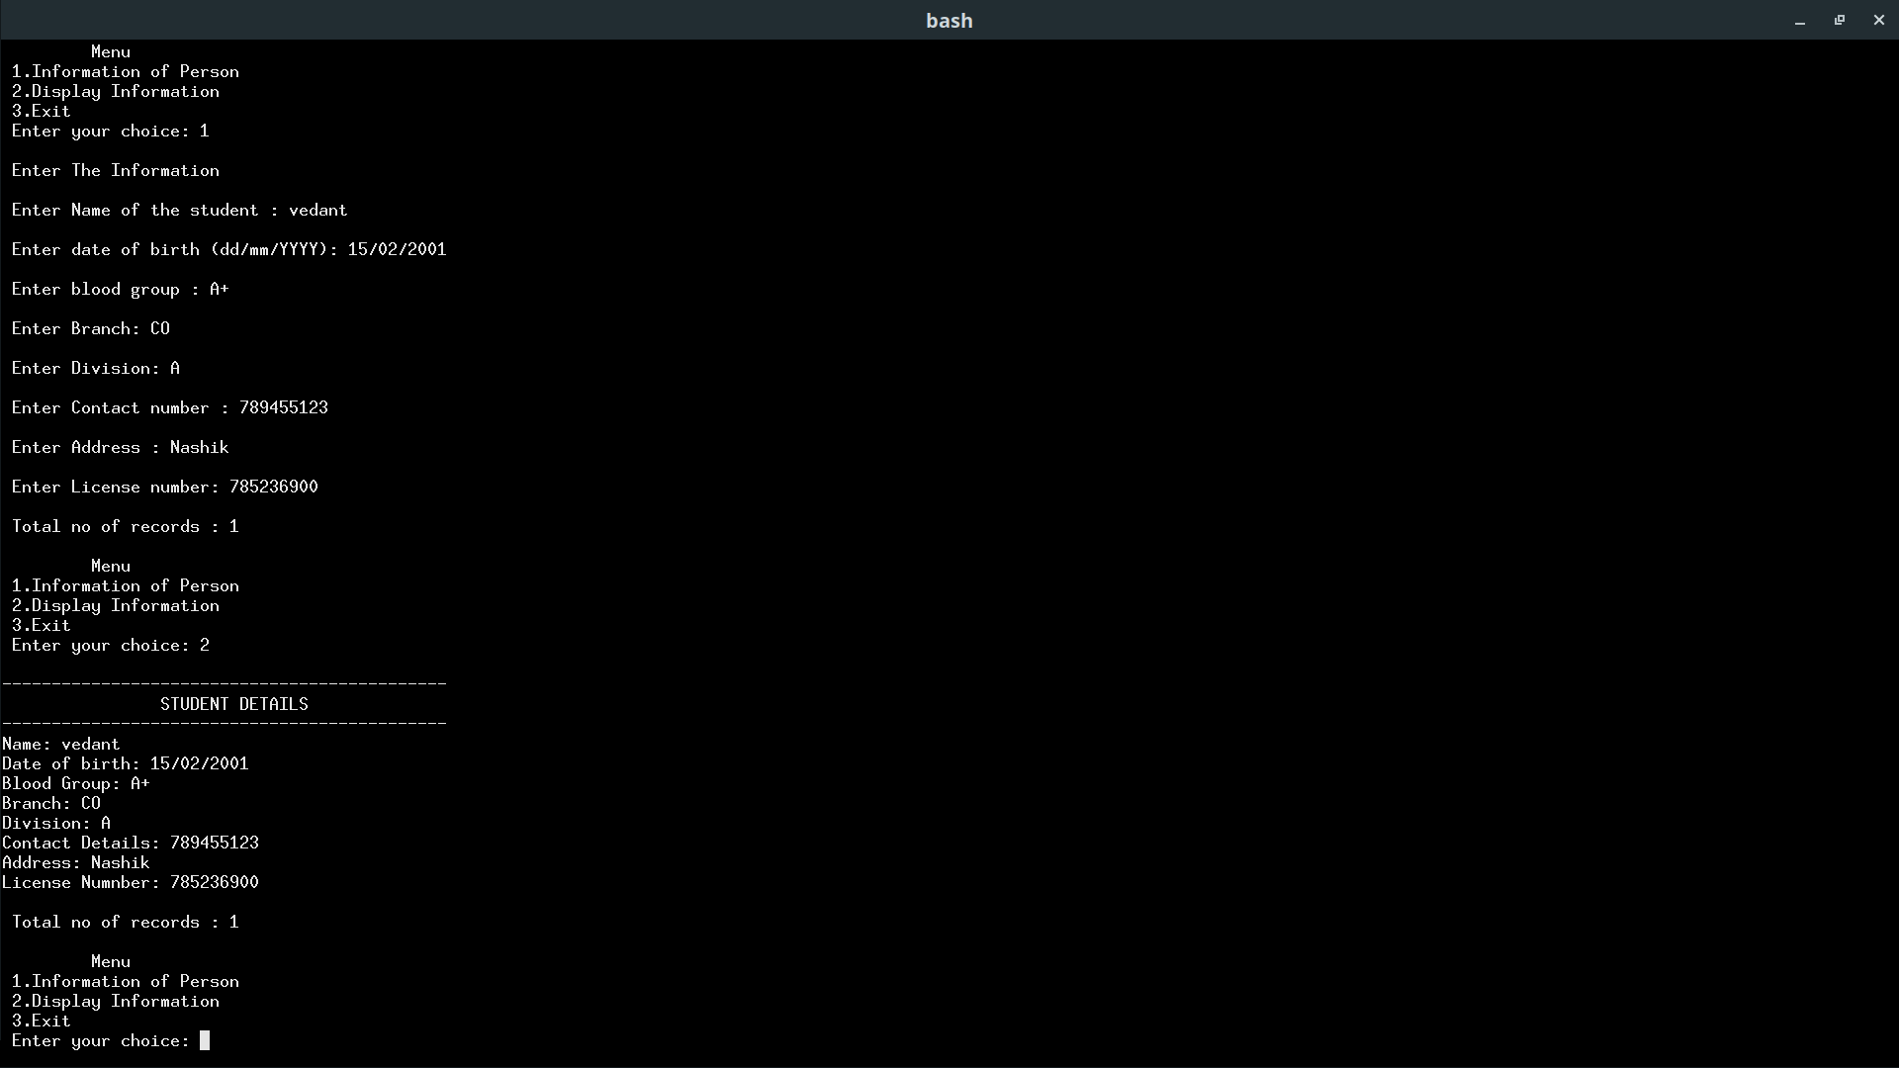  
 Output: Student Database

OOP Concepts Used:

1. A static member function is a special member function, which is used to access only static data members, any other normal data member cannot be accessed through static member function. Just like static data member, static member function is also a class function, it is not associated with any class object.
2. C++ Friend Functions.: A friend function of a class is defined outside that class' scope but it has the right to access all private and protected members of the class. Even though the prototypes for friend functions appear in the class definition, friends are not member functions.
3. this pointer in C++ Programming: In C++, this pointer is used to represent the address of an object inside a member function. For example, consider an object obj calling one of its member function say method() as obj.method(). Then, this pointer will hold the address of object obj inside the member function method().
4. C++ inline function is powerful concept that is commonly used with classes. If a function is inline, the compiler places a copy of the code of that function at each point where the function is called at compile time.
5. Dynamic memory allocation in C/C++ refers to performing memory allocation manually by programmer. Dynamically allocated memory is allocated on Heap and non-static and local variables get memory allocated on Stack.
6. De-allocation: Deallocation is the "clean-up" of space being used for variables or other data storage. Compile time variables are automatically deallocated based on their known extent

Conclusion: We created student database & used all cpp concepts mentioned in the problem description.