Assignment 2

**Aim**: Implement C++/Java/Python program to create a base class called shape. Use this class to store two double type values that could be used to compute the area of figures. Derive two specific classes called function get_data() to initialize base class data members and another member function display_area() to compute and display the area of figures. Make classes to suit their requirements. Using these three classes, design a program that will accept dimension of a triangle or a rectangle interactively, and display the area. Remember the two values given as input will be treated as lengths of two sides in the case of rectangles, and as base and height in the case of triangles, and used as follows:

# Area of rectangle= x*y Area of triangle =1/2*x*y

**Description**: this program calculates area for rectangle and triangle. We

We have implemented area calculator program for rectangle and triangle. We implemented concept of multiple inheritance and function overloading for performing calculations. Program performs calculation of area according to user choice I.e either rectangle or triangle.

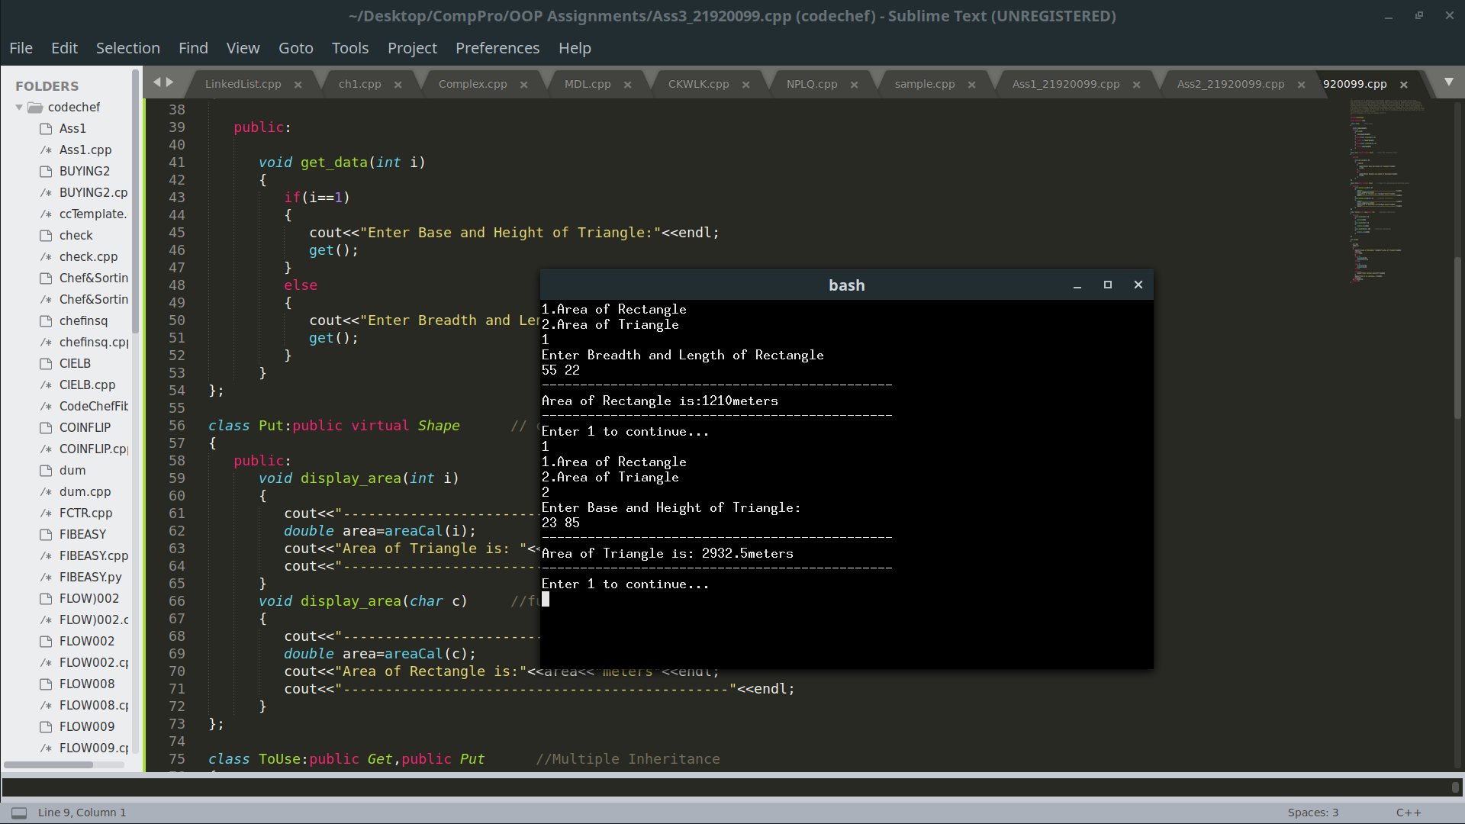  
Output

**OOPConcepts Used:**

**1) Function Overloading:**

Function overloading is a feature in C++ where two or more functions can have the same name but different parameters.

Function overloading can be considered as an example of polymorphism feature in C++.

## Function Overloading and Ambiguity

When the compiler is unable to decide which function is to be invoked among the overloaded function, this situation is known as function overloading.

When the compiler shows the ambiguity error, the compiler does not run the program.

Example:

int overloaded() { }

int overloaded (int g){ }

int overloaded (float g){ }

int overloaded (int g, double s){ }

int overloaded (float s, int g, double k){ }

# **2) Multiple Inheritance in C++**

Multiple Inheritance is a feature of C++ where a class can inherit from more than one classes.

The constructors of inherited classes are called in the same order in which they are inherited. For example, in the following program, B’s constructor is called before A’s constructor.

**Conclusion:** We have successfully implemented program to calculate the area of a rectangle and triangle and learned about inheritance and overloading