Build Your Own Coding Agent
by Alexey Grigorev
This is a part of the "AI Engineering Buildcamp: From RAG to Agents" course.
If you’d like to follow along in video format, you can watch the workshop here. The accompanying code and examples are available here.

In this tutorial, we will build our own agent — something similar to Lovable.dev or Bolt.new. We will create a simple Django application with just one prompt.
For that, we need:
- OpenAI key (it will cost less than $1)
- Python and Jupyter
- Make (optional)
We assume that you already know how to get the OpenAI key and configure the Python library to use it. (If you don’t, ask ChatGPT.)
Many code snippets in this tutorial are generated using ChatGPT (as demonstrated in the course).

Function Calling
The core distinction between a “usual” chatbot and a conversational agent lies in the agent's capacity to utilize tools for various actions.
- A text-only chatbot responds using the information it has been trained on and a prompt. It cannot take actions in the outside world.
- A conversational agent can use tools like APIs or local functions you expose to it to perform actions and bring results back into the conversation. That ability to act is the key difference.
Here are some typical tools and concrete examples:
- Search: call a search API to look up facts and return sources.
- Calendar: create or edit events via a calendar API.
- File I/O: read and write files. We’ll use this in the workshop.
- Code execution: run short scripts or functions on a controlled runtime and capture stdout/return values. We’ll do this in the workshop too.
- Anything else you implement: email sending, database queries, etc.
The LLM never executes code directly. It proposes calls; your system runs them. And this is what’s called “function calling”.

Example Conversation
Let’s review an example conversation flow between the user and the assistant (LLM). In the first column, we show whether it is a request or a response.
- → means request (we send a request to the LLM provider)
- ← means response (we get a response back from the LLM provider)
- Bold content = what the end user sees (UI text). System prompts, tool call decisions, and raw tool outputs are not shown to the user.
 | Role | Content | Explanation
→ | System prompt | You’re a helpful assistant and you can perform these functions:  - search(query) — perform a search in the web using the provided query  - joke(name) — tell a joke about the provided name | We give the LLM some instructions — what it should do and what kind of tools it can use to help the user
→ | User | tell me a joke | The user asks for a joke
← | Assistant | what’s your name? | The LLM realizes that in order to invoke the “joke” function, it needs the “name” parameter, and the name is not provided anywhere, so it asks for it
→ | User | Alexey | The user replies
← | function_call, call_id: ‘0xcafebabe’ | execute joke(“Alexey”) | Now the LLM has all the context to invoke the joke function, so it wants us (the system) to execute the “joke” function.
→ | function_call_output, call_id ‘0xcafebabe’ | “Why did Alexey bring a ladder to the bar? Because he thought the drinks were on the house.” | We (the system) execute the function and send back the result to the LLM
← | Assistant | Here’s a joke for you:  Why did Alexey bring a ladder to the bar? Because he thought the drinks were on the house. | The LLM presents the results from the function to the user
→ | User | lol | The user is satisfied with the joke

- Only the assistant and user lines are marked with bold font. The users don’t see the rest, which is your system prompt, the model’s internal decision to invoke a tool, or the raw tool output.
- But LLM sees everything, including your tool descriptions, the tool call, and the tool’s returned data.

No function calling
Without tools/function calling, you only exchange plain chat messages and ask the model to generate a joke directly:
Using gpt-4o-mini without function calling
system_prompt = "You can make funny and original jokes."
user_prompt = "Tell me a joke about Alexey."

chat_messages = [
{"role": "developer", "content": system_prompt},
{"role": "user", "content": user_prompt}
]

response = openai_client.responses.create(
model='gpt-4o-mini',
input=chat_messages,
)

print(response.output_text)

Here, the model generates the joke itself, and there’s no external function call.

Adding Function Calling
But if we want to use a special function for making jokes, we transform our chatbot into “an agent.” In that case, our agent can then leverage tools to perform specific tasks rather than handling them directly.
Let’s define a function for generating jokes:
The “joke” function
import random

def make_joke(name):
jokes = [
f"Why did {name} bring a pencil to the party? Because he wanted to draw some attention!",
f"Did you hear about {name}'s bakery? Business is on a roll!",
f"{name} walked into a library and asked for a burger. The librarian said, 'This is a library.' So {name} whispered, 'Can I get a burger?'",
f"When {name} does push-ups, the Earth moves down.",
f"{name} told a chemistry joke... but there was no reaction.",
]
return random.choice(jokes)

# Example usage:
print(make_joke("Alexey"))

The LLM needs to know what this function can do and how to use it. For that, we need to describe this function. In particular, we need to specify the function’s name, what it does, and what kind of arguments it has.
Schema for describing functions
{
"type": "function",
"name": "<function_name>",
"description": "<Brief explanation of what the function does>",
"parameters": {
"type": "object",
"properties": {
"<parameter_name>": {
"type": "<data_type>", // e.g., "string", "number", "boolean", "array", "object"
"description": "<Description of the parameter's purpose>"
}
// Additional parameters can be added here
},
"required": ["<param1>", "<param2>"], // List all required parameters here
"additionalProperties": false
}
}

This schema is language-agnostic: it can be used with any programming language, such as Python, JavaScript, or others. Internally — it’s not visible for us — the OpenAI API incorporates these schemas into the system prompt, allowing the model to understand which tools it can use.
In our case, the description of our joke function in Python will look like this:
Schema of the joke function in Python
make_joke_description = {
"type": "function",
"name": "make_joke",
"description": "Generates a random personalized joke using the provided name.",
"parameters": {
"type": "object",
"properties": {
"name": {
"type": "string",
"description": "The name to insert into the joke, personalizing the output."
}
},
"required": ["name"],
"additionalProperties": False
}
}

To use it, we provide it in the list of tools:
Using gpt-4o-mini with function calling
system_prompt = "You can make funny and original jokes. Find out the user's name to make the joke personalized."

user_prompt = "Tell me a joke about Alexey."

chat_messages = [
{"role": "developer", "content": system_prompt},
{"role": "user", "content": user_prompt}
]

response = openai_client.responses.create(
model='gpt-4o-mini',
input=chat_messages,
tools=[make_joke_description]
)

When we execute it and the model decides to call your tool, you’ll receive a tool call response. It looks like this:
LLM’s response with the decision to invoke a tool
[ResponseFunctionToolCall(arguments='{"name":"Alexey"}', call_id='call_7hX94T60RCVYUDxIR4XTRVTE', name='make_joke', type='function_call', id='fc_6888c3ed8c44819e83405e5c069fa48c096e19ff95bea46b', status='completed')]

So, the LLM tells us to execute the function “make_joke” with arguments name="Alexey".
Now we execute it:
Function execution
arguments = json.loads(call.arguments)
f_name = call.name

f = globals()[f_name] # trick to invoke a function by its name
result = f(**arguments)

call_output = {
"type": "function_call_output",
"call_id": call.call_id,
"output": result,
}

We send the results back to the model and add both call and call_output to the chat history. We do this because LLMs are stateless: they don’t “remember” previous conversations. OpenAI doesn’t know that we previously asked it to give us a joke; it saw a function called “make_joke” and decided to invoke it. So we need to “remind” GPT-4o-mini about it.
In practical terms, it means sending the entire conversation history every time we make a follow-up request to the API.
Sending the results back to the model
chat_messages.append(call)
chat_messages.append(call_output)

response = openai_client.responses.create(
model='gpt-4o-mini',
input=chat_messages,
tools=[make_joke_description]
)

print(response.output_text)

When a model can invoke tools, it stops being just a chatbot. It becomes an agent, delegating specific actions to external functions (e.g., search, code execution, file I/O) and integrating the results into its reasoning and replies. This enables tasks beyond conversation.

Toy AI Kit
There’s a lot of boilerplate code we need to write to use the agents: define the tools, maintain the conversation history, handle tool invocation and things like that.
We have implemented everything we needed from scratch in this and this workshops.
You don’t need to rewatch these workshops, because I put all the code into the toyaikit library. But you can, if you want to know more about lower-level implementation details.
Note: This library is not for production use, but it’s good for education. For now, we will use toyaikit because it’s simpler and follows closely the raw OpenAI API. In production, you can use libraries like OpenAI Agents SDK, PydanticAI, or something similar.
Let’s install it:
pip install -U toyaikit

And import the classes we’re going to use:
from toyaikit.tools import Tools
from toyaikit.chat import IPythonChatInterface
from toyaikit.llm import OpenAIClient
from toyaikit.chat.runners import OpenAIResponsesRunner

Let’s define our tools. With toyaikit, we don’t need to specify the schema for functions, it can create them automatically. But we do need to provide the docstrings: the library uses them for generating the function description.
Updated make_joke function with docstrings and type hints
def make_joke(name: str) -> str:
"""
Generates a personalized joke using the provided name.

Parameters:
name (str): The name to insert into the joke.

Returns:
str: A joke with the name included.
"""
jokes = [
f"Why did {name} bring a pencil to the party? Because he wanted to draw some attention!",
f"Did you hear about {name}'s bakery? Business is on a roll!",
f"{name} walked into a library and asked for a burger. The librarian said, 'This is a library.' So {name} whispered, 'Can I get a burger?'",
f"When {name} does push-ups, the Earth moves down.",
f"{name} told a chemistry joke... but there was no reaction.",
]
return random.choice(jokes)

Note that we also added the type hints: it’s also needed for describing the function arguments.
Let’s use the Tools class to specify the tools we want to use:
tools = Tools()
tools.add_tool(make_joke)
tools.get_tools()

We can see the function description — it creates it automatically.
Let’s define the rest and run it:
Using toyaikit for creating a simple chat application
system_prompt = "You can make funny and original jokes. Find out the user's name to make the joke personalized."

chat_interface = IPythonChatInterface()
llm_client = OpenAIClient(client=OpenAI())

chat_assistant = OpenAIResponsesRunner(
tools=tools_obj,
developer_prompt=system_prompt,
chat_interface=chat_interface,
llm_client=llm_client
)

chat_assistant.run()

Now you can interact with it:
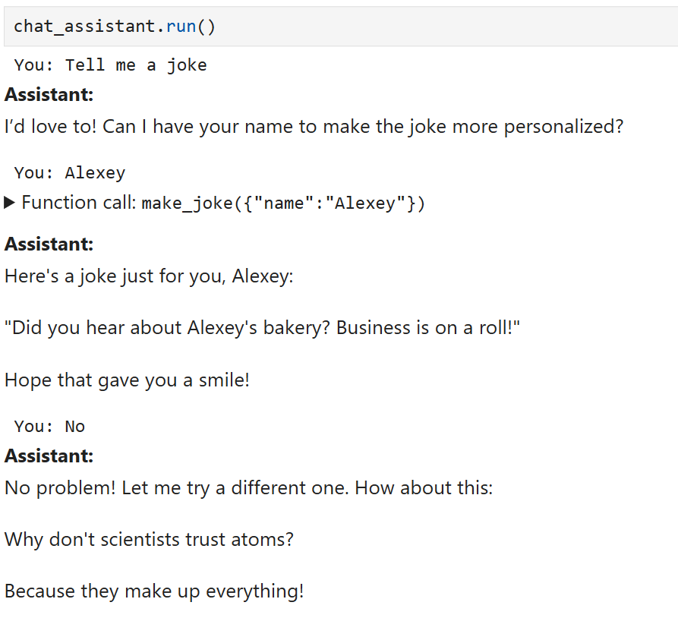
Type “stop” to exit the loop.
We have discussed the agents: they are conversational systems that can invoke functions. With this we can now implement an AI coding assistant. For that, the coding agent will need to be able to modify files and perform other I/O operations.
But for our coding assistant, we first want to create a template for scaffolding new projects. Let’s do it now.

Django template project
In this tutorial, we want to create a coding assistant that can make simple Django applications. For that, we first will need a template that will serve as the basis for all Django projects. This template will contain the simplest working code: the basic structure upon which we can build.
When we start a new conversation, we first make a copy of the template into a new folder and let our agent update it.
I have already created the template, so you can just clone it:
Cloning and preparing the existing Django template
git clone https://github.com/alexeygrigorev/django_template.git
cd django_template

uv sync

make migrate
make run

We also need a function for making the copy of this folder:
Copying the template into a new folder
import os
import shutil

def start(project_name):
if not project_name:
print("Project name cannot be empty.")
return False

if os.path.exists(project_name):
print(f"Directory '{project_name}' already exists. Please choose a different name or remove the existing directory.")
return False

shutil.copytree('django_template', project_name)
print(f"Django template copied to '{project_name}' directory.")

return True

Now let’s use it:
project_name = input("Enter the new Django project name: ").strip()
start(project_name)

Now we’re ready to define the tools for our agent.

Tools for editing the project
We have the template ready, and we already copied it to a folder. Now let’s create a collection of functions for creating and modifying the files in the project directory.

This is how I created these functions:
- First, I asked ChatGPT what functions I needed for a coding assistant. It came up with these functions
  - read_file(filename),
  - write_file(filename, content),
  - see_file_tree(folder),
  - execute_bash_command(workdir, command), and
  - search_in_files(folder, content)
- Then I asked it to group all these functions in a class, and also restrict it only to the files within the project directory — so it can’t see arbitrary files on our computer. I called it AgentTools
- Lastly, I asked it to add docstrings to the functions, so we could get the description for these functions easily.
- I iterated on these functions, and after using it for some time, I noticed that we need to make a few modifications:
  - When getting the list of files, it was returning a lot of stuff because it was listing the content of .venv and all the pycache files — I asked ChatGPT to filter it out
  - It would attempt to run a Django project, and it would cause the system to hang, so I asked ChatGPT to forbid it
In the end, this is the code I got (you can also see it here):
The functions for the agent in tools.py
from pathlib import Path
import os
import subprocess

class AgentTools:
# Directories to skip when building file tree
SKIP_DIRS = {'.venv', '__pycache__', '.git', '.pytest_cache', '.mypy_cache', '.coverage', 'node_modules', '.DS_Store'}

def __init__(self, project_dir: Path):
"""
Initialize AgentTools with the given project directory.

Parameters:
project_dir (Path): The root directory of the project.
"""
self.project_dir = project_dir

def read_file(self, filepath: str) -> None:
"""
Read and return the contents of a file at the given relative filepath.

Parameters:
filepath (str): Path to the file, relative to the project directory.
Returns:
str: Contents of the file.
"""
abs_path = self.project_dir / filepath
with open(abs_path, 'r', encoding='utf-8') as f:
return f.read()

def write_file(self, filepath: str, content: str) -> None:
"""
Write the given content to a file at the given relative filepath, creating directories as needed.

Parameters:
filepath (str): Path to the file, relative to the project directory.
content (str): Content to write to the file.
Returns:
None
"""
abs_path = self.project_dir / filepath
abs_path.parent.mkdir(parents=True, exist_ok=True)
with open(abs_path, 'w', encoding='utf-8') as f:
f.write(content)

def see_file_tree(self, root_dir: str = ".") -> list[str]:
"""
Return a list of all files and directories under the given root directory,
relative to the project directory.

Parameters:
root_dir (str): Root directory to list from, relative to the project directory.
Defaults to ".".
Returns:
list[str]: List of relative paths for all files and directories.
"""
abs_root = self.project_dir / root_dir
tree = []

for dirpath, dirnames, filenames in os.walk(abs_root):
# Remove blacklisted directories from dirnames to prevent os.walk from entering them
for skip_dir in list(dirnames):
if skip_dir in self.SKIP_DIRS:
dirnames.remove(skip_dir)

for name in dirnames + filenames:
full_path = os.path.join(dirpath, name)
rel_path = os.path.relpath(full_path, self.project_dir)
tree.append(rel_path)

return tree

def execute_bash_command(self, command: str, cwd: str = None) -> tuple[str, str, int]:
"""
Execute a bash command in the shell and return its output, error, and exit code. Blocks running the Django development server (runserver).

Parameters:
command (str): The bash command to execute.
cwd (str, optional): Working directory to run the command in, relative to the project directory. Defaults to None.
Returns:
tuple: (stdout (str), stderr (str), returncode (int))
"""
# Block running the Django development server
if 'runserver' in command:
return (
'',
'Error: Running the Django development server (runserver) is not allowed through this tool.',
1
)
abs_cwd = (self.project_dir / cwd) if cwd else self.project_dir
result = subprocess.run(command, shell=True, capture_output=True, text=True, cwd=abs_cwd)
return result.stdout, result.stderr, result.returncode

def search_in_files(self, pattern: str, root_dir: str = ".") -> list[tuple[str, int, str]]:
"""
Search for a pattern in all files under the given root directory and return a list of matches as (relative path, line number, line content).

Parameters:
pattern (str): Pattern to search for in files.
root_dir (str): Root directory to search from, relative to the project directory. Defaults to ".".
Returns:
list[tuple]: List of (relative path, line number, line content) for each match.
"""
abs_root = self.project_dir / root_dir
matches = []
for dirpath, _, filenames in os.walk(abs_root):
for filename in filenames:
filepath = os.path.join(dirpath, filename)
try:
with open(filepath, 'r', encoding='utf-8') as f:
for i, line in enumerate(f, 1):
if pattern in line:
rel_path = os.path.relpath(filepath, self.project_dir)
matches.append((rel_path, i, line.strip()))
except Exception:
continue
return matches

In Jupyter, let’s use it:
Importing the Tools class for our agent
from pathlib import Path
import tools

project_path = Path(project_name)
agent_tools = tools.AgentTools(project_path)

And add these tools to our Tools class:
tools_obj = Tools()
tools_obj.add_tools(agent_tools)

We can see the description of these functions if we invoke tools_obj.get_tools()
The tools for the agent are ready, now let’s create the agent itself!

The Coding Agent
The functions are ready, the only thing that we still need to do is to define the system prompt. Here we tell the LLM what exactly we expect from it.
I started with a simple prompt like this:
System prompt, initial version
DEVELOPER_PROMPT = """
You are a coding agent. Your task is to modify the provided Django project template
according to user instructions. You don't tell the user what to do; you do it yourself using the
available tools. First, think about the sequence of steps you will do, and then
execute the sequence.
Always ensure changes are consistent with Django best practices and the project’s structure.
"""

But after a few iterations (also with help of ChatGPT), I ended up with the following prompt:
System prompt, final version
DEVELOPER_PROMPT = """
You are a coding agent. Your task is to modify the provided Django project template according to user instructions. You don't tell the user what to do; you do it yourself using the available tools. First, think about the sequence of steps you will do, and then execute the sequence.
Always ensure changes are consistent with Django best practices and the project’s structure.

## Project Overview

The project is a Django 5.2.4 web application scaffolded with standard best practices. It uses:
- Python 3.8+
- Django 5.2.4 (as specified in pyproject.toml)
- uv for Python environment and dependency management
- SQLite as the default database (see settings.py)
- Standard Django apps and a custom app called myapp
- HTML templates for rendering views
- TailwindCSS for styling

## File Tree

├── .python-version
├── README.md
├── manage.py
├── pyproject.toml
├── uv.lock
├── myapp/
│ ├── __init__.py
│ ├── admin.py
│ ├── apps.py
│ ├── migrations/
│ │ └── __init__.py
│ ├── models.py
│ ├── templates/
│ │ └── home.html
│ ├── tests.py
│ └── views.py
├── myproject/
│ ├── __init__.py
│ ├── asgi.py
│ ├── settings.py
│ ├── urls.py
│ └── wsgi.py
└── templates/
└── base.html

## Content Description

- manage.py: Standard Django management script for running commands.
- README.md: Setup and run instructions, including use of uv for dependency management.
- pyproject.toml: Project metadata and dependencies (Django 5.2.4).
- uv.lock: Lock file for reproducible Python environments.
- .python-version: Specifies the Python version for the project.
- myapp/: Custom Django app with models, views, admin, tests, and a template (home.html).
- migrations/: Contains migration files for database schema.
- myproject/: Django project configuration (settings, URLs, WSGI/ASGI entrypoints).
- settings.py: Configures installed apps, middleware, database (SQLite), templates, etc.
- templates/: Project-level templates, including base.html.

You have full access to modify, add, or remove files and code within this structure using your available tools.

## Additional instructions

- Don't execute "runproject", but you can execute other commands to check if the project is working.
- Make sure you use Tailwind styles for making the result look beautiful
- Use pictograms and emojis when possible. Font-awesome is available
- Avoid putting complex logic to templates - do it on the server side when possible
"""

When defining the system prompt, you want to be very precise. Being verbose is fine, and helps the assistant to behave the way we want.
The prompt is ready, so let’s put everything together:
Using toyaikit for orchestrating the interaction with the agent
chat_interface = IPythonChatInterface()
llm_client = OpenAIClient(client=OpenAI())

runner = OpenAIResponsesRunner(
tools=tools_obj,
developer_prompt=DEVELOPER_PROMPT,
chat_interface=chat_interface,
llm_client=llm_client
)

And run it:
runner.run()

All you need is to give it a single prompt. For example, write “todo list”. It will proceed with planning and executing some of the functions:
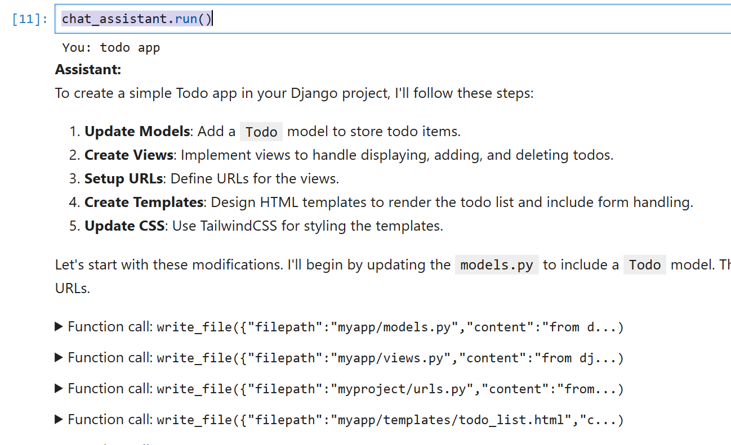
It may ask you a follow up question, but most likely it will finish after one iteration. You will see something like that:

Assistant:
The Todo app has been successfully implemented with the following features:
- Model: A Todo model to store todo items.
- Views:
- todo_list: Displays all todos.
- add_todo: Handles adding a new todo.
- delete_todo: Handles deleting a todo.
- URLs: Defined for the app's functionalities.
- Templates:
- todo_list.html: Displays the list of todos and a form to add new ones.
- add_todo.html: Provides a form to input new todos.
- Database: Migrations for the Todo model have been created and applied.
Next Steps
To see the Todo app in action, you can run the Django development server using:
python manage.py runserver
After that, navigate to http://127.0.0.1:8000/ to interact with your Todo app!

So let’s run it! Navigate to the project directory and execute
make run

After that, open http://localhost:8000. Ideally, you will see something like that:
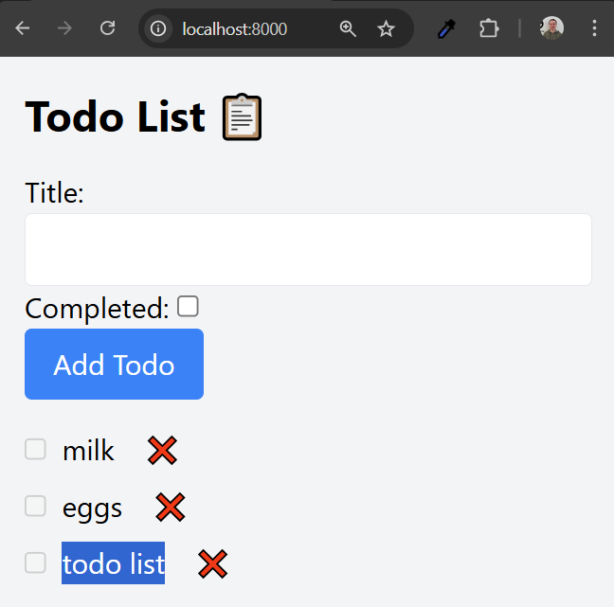

If it doesn’t run, you can copy the error message into the input prompt and let the agent fix it.
You can also ask it to modify some of the behavior:
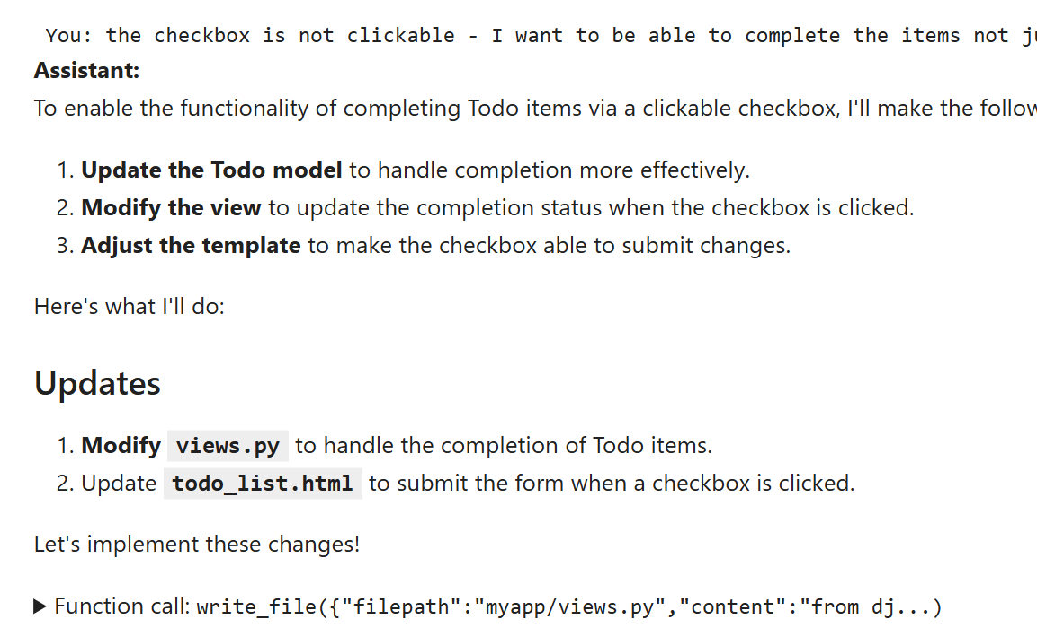
Once you finish interacting with the agent, type “stop”.
If you want to make further edits, you can start the conversation again. You can mention in the prompt, that it’s an existing project, so it will first analyze it before making any changes.

Further steps
There are many ways you can improve this project:
- Try using a model with reasoning capabilities
- Try using a model from Anthropic — Claude Sonnet is quite good at coding tasks
- Try PydanticAI, OpenAI Agents SDK, Langchain or any other agents library

Summary
In this tutorial, we took a look at agentic conversational systems and implemented one ourselves. The main difference between a “usual” chatbot and an agentic one is the ability of an agent to use tools — that is, invoke different functions.
We illustrated it by creating a coding agent. Our system scaffolds a project from a template and then uses an LLM to modify the project according to the prompt from the user.
You can find all the code here: https://github.com/alexeygrigorev/workshops/tree/main/coding-agent.

AI Bootcamp — from RAG to Agents
Did you like this content? Sign up for the “AI Bootcamp — from RAG to Agents” course here: https://maven.com/alexey-grigorev/from-rag-to-agents.
Use code “CODEAGENT” at the checkout to get 15% off.

