WEEK-1

MODULE 4 - Test driven development and Logging framework
[ SLF4J LOGGING FRAMEWORK ]

NAME : LOKESHWARAN S
SUPERSET ID : 6742729

Exercise 1: Logging Error Messages and Warning Levels
Main.java
package com.example;
import org.slf4j.Logger;
import org.slf4j.LoggerFactory;
public class Main{
private static final Logger logger = LoggerFactory.getLogger(Main.class);
public static void main(String[] args) {
logger.error("This is an error message");
logger.warn("This is a warning message");
}
}
Output:
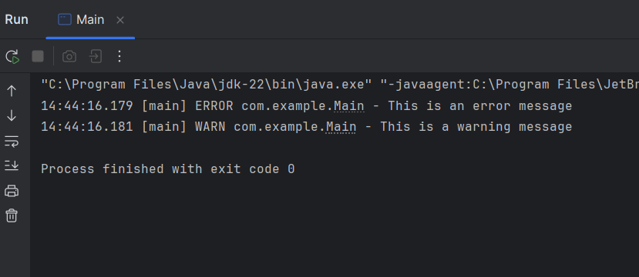

Exercise 2: Parameterized Logging
Main.java
package com.example;
import org.slf4j.Logger;
import org.slf4j.LoggerFactory;
public class Main {
private static final Logger logger = LoggerFactory.getLogger(Main.class);
public static void main(String[] args) {
String user = "Sid";
int age = 20;
logger.info("User {} has logged in.", user);
logger.warn("User {} is {} years old - verify age!", user, age);
logger.error("Login attempt failed for user: {}", user);
}
}

Output:


Exercise 3: Using Different Appenders
Main.java
package com.example;
import org.slf4j.Logger;
import org.slf4j.LoggerFactory;
public class Main {
private static final Logger logger = LoggerFactory.getLogger(Main.class);
public static void main(String[] args) {
logger.debug("Debugging application startup");
logger.info("App started successfully");
logger.warn("Disk space is running low");
logger.error("Unhandled exception occurred");
}
}
Output:
