CHESS MATCH MAKING PROJECT

Problems faced-
unreilable manual pairing
Rigid play format
tie breaking
informal
lack of knowledge of rules

Soln
An automated chess match making system

Features
Stores data of players
Helps in choosing among all the formats
tie break systems
Authorization and authentication:
provides interface to organizer and to the player as well
If separate categories exist can automatically find the optimal spread and ask for user input on that
Assigns table numbes to players with speciallly abled players having fixed spots(alllowing for custiomized inputs lie fixing tablle spots etc)
Could perhaps spread it to online chess in collaboration with chess.com
Provides an AI powerd assistant(RAG) mecahnism that contains FIDEs rule book that allows for thew arbiter to ask questions in case of discrepencies
could maybe use agentic architecture as a future upgrade to this architecture

HLD
DB-postgres(sql) to store pllayer info ...tournament standings .... etc
spring boot for the full stack
python for the vector db--langchain(gotta learn with it)
#need a translator that makes common ground bw java and python
Redis- Cache to store players who are currently playing
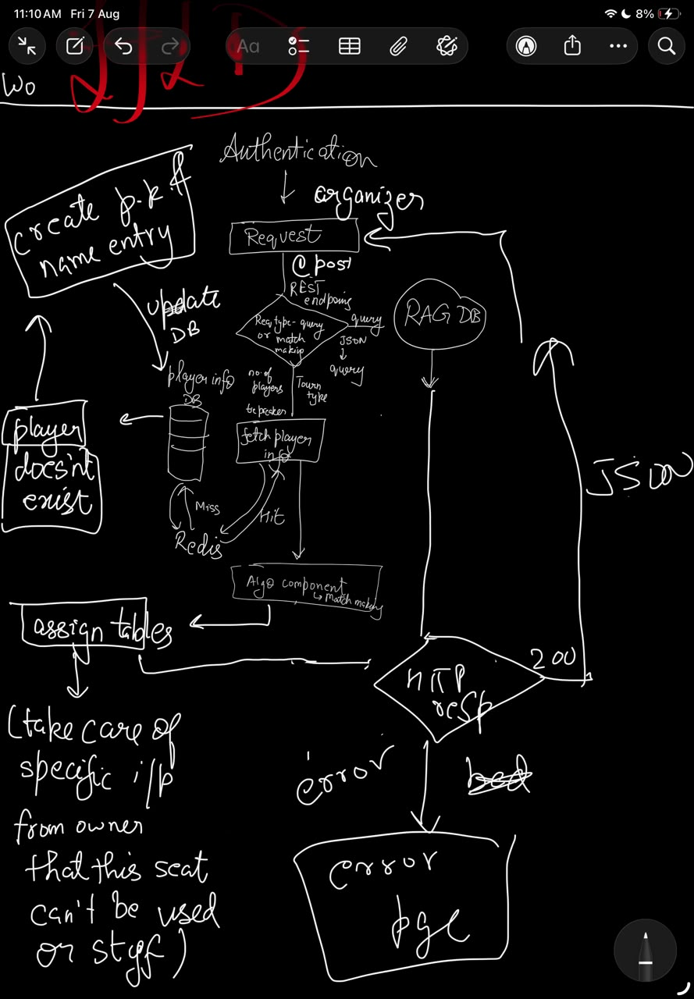

Pseudocode for swiss matchmaking
My pseudocode
FUNCTION PairRound(players):
// 1. Sort players deterministically
SORT players BY score DESCENDING, THEN BY rating DESCENDING

// 2. Make buckets of scores
buckets = GROUP players BY score

FOR EACH bucket IN buckets:
// Include any downfloaters from the previous bracket
ADD downfloater TO bucket

is_bracket_solved = FALSE

WHILE is_bracket_solved == FALSE:
// 3. Deterministic split
S1 = top half of bucket
S2 = bottom half of bucket

// 4. Try pairings by relaxing constraints strictly from Hard to Soft
FOR EACH constraint_level (from strict to relaxed):

// 5. Structured Swapping (No randomness allowed)
WHILE (swaps_are_available):
current_pairing = MATCH S1[i] WITH S2[i] sequentially

IF current_pairing obeys hard constraints AND current constraint_level:
is_bracket_solved = TRUE
SAVE current_pairing
BREAK // Exit the swapping loop

ELSE:
// Systematically alter the bracket to find a fit
IF more transpositions exist:
REORDER the players within S2 (Transposition)
ELSE IF more exchanges exist:
SWAP a player between S1 and S2 (Exchange)
RESET S2 to its original order
ELSE:
BREAK // Exhausted all possible deterministic swaps

IF is_bracket_solved == TRUE:
BREAK // Exit the constraint relaxation loop

// 6. The Backtrack
IF is_bracket_solved == FALSE:
UNDO pairing of the upper_bucket
FORCE upper_bucket to select its next-best valid pairing
GENERATE a different downfloater for the current bucket
RESTART current bucket loop

RETURN complete_round_pairing

Formal pseudo code
ALGORITHM FIDE_Dutch_Pairing(Tournament_Players):

// Step 1: Global Initialization
SORT Tournament_Players BY Score DESC, Rating DESC
Buckets = PARTITION Tournament_Players BY Score

// Step 2: Top-Down Processing
Current_Index = 0
WHILE Current_Index < LENGTH(Buckets):
Current_Bracket = Buckets[Current_Index]
Status = Solve_Bracket(Current_Bracket)
IF Status == SUCCESS:
Current_Index = Current_Index + 1
ELSE:
// Backtrack: Step up one bracket and force a new configuration
Current_Index = Current_Index - 1
IF Current_Index < 0:
THROW "Tournament Mathematically Unpairable"
FORCE_NEXT_BEST_PAIRING(Buckets[Current_Index])

RETURN ALL_PAIRED_MATCHES

// ---------------------------------------------------------

FUNCTION Solve_Bracket(Bracket):

// Establish Subgroups
S1 = TOP_HALF(Bracket)
S2 = BOTTOM_HALF(Bracket)

// Iterate through allowed tolerance levels
FOR Tolerance_Level IN [PERFECT_COLORS, RELAXED_COLORS, IGNORE_COLORS]:

// Attempt Transpositions (Reordering S2)
FOR EACH Transposed_S2 IN GENERATE_TRANSPOSITIONS(S2):
IF Is_Valid_Match(S1, Transposed_S2, Tolerance_Level):
SAVE_MATCH(S1, Transposed_S2)
RETURN SUCCESS

// Attempt Exchanges (Swapping S1 and S2 players)
FOR EACH Exchanged_State IN GENERATE_EXCHANGES(S1, S2):
S1_New = Exchanged_State.S1
S2_New = Exchanged_State.S2

FOR EACH Transposed_S2_New IN GENERATE_TRANSPOSITIONS(S2_New):
IF Is_Valid_Match(S1_New, Transposed_S2_New, Tolerance_Level):
SAVE_MATCH(S1_New, Transposed_S2_New)
RETURN SUCCESS

// If all swaps and tolerances fail, the bracket is deadlocked
RETURN FAILURE

// ---------------------------------------------------------

FUNCTION Is_Valid_Match(Subgroup1, Subgroup2, Tolerance):
FOR i = 0 TO LENGTH(Subgroup1) - 1:
P1 = Subgroup1[i]
P2 = Subgroup2[i]

// Hard Constraints (Unbreakable)
IF HAS_PLAYED_BEFORE(P1, P2): RETURN FALSE
IF FORCES_THIRD_SAME_COLOR(P1, P2): RETURN FALSE

// Soft Constraints (Evaluated based on current Tolerance level)
IF Tolerance == PERFECT_COLORS:
IF COLOR_PREFERENCE_CONFLICT(P1, P2): RETURN FALSE

RETURN TRUE

ER diagram

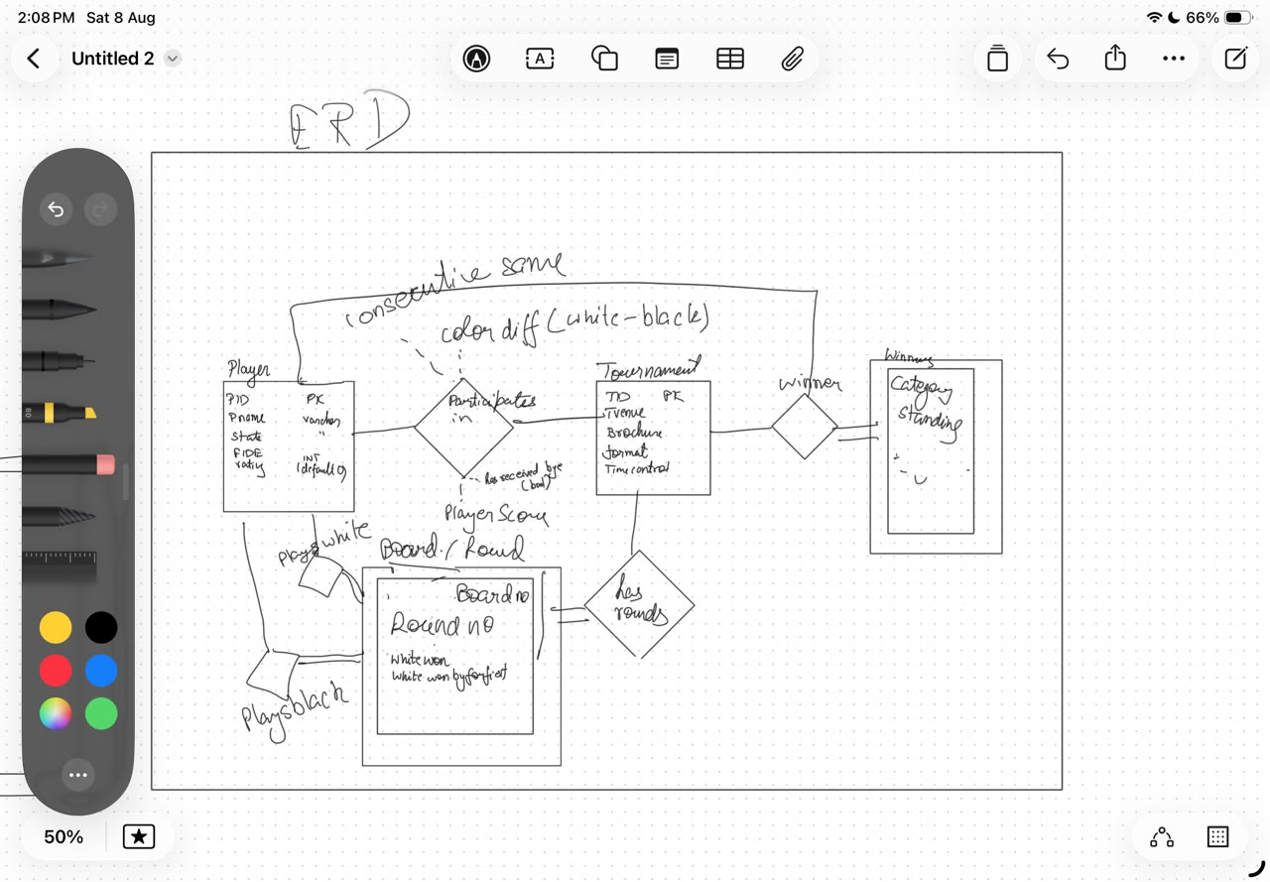

1. players Table
This table holds the static identity and global information for all players.
Column Name | Data Type | Constraints | Description
pid | VARCHAR / UUID | Primary Key | Unique identifier for the player.
p_name | VARCHAR(100) | Not Null | Full name of the player.
state | VARCHAR(50) | Nullable | Player's geographic state or region.
fide_rating | INT | Default 0 | Global FIDE rating.
2. tournaments Table
This table defines the overarching tournament instance and its static rules.
Column Name | Data Type | Constraints | Description
tid | VARCHAR / UUID | Primary Key | Unique identifier for the tournament.
t_venue | VARCHAR(255) | Not Null | Location of the tournament.
brochure | TEXT | Nullable | Link or text for tournament details.
t_format | VARCHAR(50) | Not Null | E.g., "Swiss", "Round Robin".
time_control | VARCHAR(50) | Not Null | E.g., "90+30", "15+10".
winner_pid | VARCHAR / UUID | Foreign Key, Nullable | Points to the pid in players (set when tournament ends).
3. tournament_players Table (The Junction / State Table)
This resolves the "Participates in" relationship. It is the most critical table for your FIDE algorithm, holding all the dynamic state for a player within a specific tournament.
Column Name | Data Type | Constraints | Description
tid | VARCHAR / UUID | Primary Key, Foreign Key | Refers to tournaments.tid.
pid | VARCHAR / UUID | Primary Key, Foreign Key | Refers to players.pid.
player_score | DECIMAL(4,1) | Default 0.0 | Cumulative points in this specific tournament.
color_diff | INT | Default 0 | White games minus Black games.
consecutive_same | INT | Default 0 | Tracks consecutive same colors (positive for White, negative for Black).
has_received_bye | BOOLEAN | Default FALSE | True if the player received a half or full-point bye.
4. matches Table (The Board / Round Weak Entity)
This table records every single game played. Consolidating the scores into an Enum ensures absolute data integrity.
Column Name | Data Type | Constraints | Description
match_id | VARCHAR / UUID | Primary Key | Unique identifier for the specific match.
tid | VARCHAR / UUID | Foreign Key, Not Null | Refers to tournaments.tid.
round_no | INT | Not Null | The round number (1, 2, 3...).
board_no | INT | Not Null | The physical board number.
white_pid | VARCHAR / UUID | Foreign Key, Not Null | Refers to players.pid playing White.
black_pid | VARCHAR / UUID | Foreign Key, Nullable | Refers to players.pid playing Black (Nullable for byes).
match_result | VARCHAR(50) | Not Null | Enum: WHITE_WIN_PLAYED, BLACK_WIN_PLAYED, DRAW, WHITE_WIN_FORFEIT, BLACK_WIN_FORFEIT, UNPLAYED.
5. tournament_awards Table (The Winners Category)
This handles the multi-category prize distributions (e.g., Under-18, Best Female, General Standings).
Column Name | Data Type | Constraints | Description
award_id | VARCHAR / UUID | Primary Key | Unique identifier for the award record.
tid | VARCHAR / UUID | Foreign Key, Not Null | Refers to tournaments.tid.
pid | VARCHAR / UUID | Foreign Key, Not Null | Refers to players.pid.
category | VARCHAR(100) | Not Null | E.g., "Overall", "U-18", "Unrated".
standing | INT | Not Null | The rank/position within that category (1st, 2nd, 3rd).

Spring API endpoints

src/main/java/com/yourdomain/tournamentengine/
├── TournamentEngineApplication.java
│
├── config/ # Security and global configurations
│ └── SecurityConfig.java # Role-based access (Arbiter vs Public)
│
├── controller/ # REST API Endpoints
│ ├── TournamentController.java
│ ├── PlayerController.java
│ └── MatchController.java # Handles the PUT request for results
│
├── dto/ # Data Transfer Objects (Payloads)
│ ├── request/
│ │ ├── MatchResultRequest.java
│ │ └── PlayerRegistrationRequest.java
│ └── response/
│ ├── RoundPairingsResponse.java
│ └── StandingsResponse.java
│
├── model/ # JPA Entities (Your finalized ERD)
│ ├── enums/
│ │ └── MatchResult.java # WHITE_WIN_PLAYED, DRAW, etc.
│ ├── Player.java
│ ├── Tournament.java
│ ├── TournamentPlayer.java # The Junction Entity
│ ├── TournamentPlayerId.java # Embedded composite key (TID, PID)
│ ├── Match.java # The Board/Round weak entity
│ └── TournamentAward.java
│
├── repository/ # Spring Data JPA Interfaces
│ ├── PlayerRepository.java
│ ├── TournamentRepository.java
│ ├── TournamentPlayerRepository.java
│ ├── MatchRepository.java
│ └── TournamentAwardRepository.java
│
├── service/ # Business Logic & Transactions
│ ├── TournamentService.java
│ ├── MatchService.java # Houses the @Transactional result update method
│ │
│ └── engine/ # The Matchmaking Core isolated
│ ├── FideDutchEngine.java # Bucketing and S1/S2 splitting logic
│ └── ValidationUtil.java # Helper to check 3-color rules, floaters, etc.
│
└── exception/ # Global Error Handling
├── GlobalExceptionHandler.java # Maps exceptions to HTTP 400/500 codes
├── TournamentUnpairableException.java # Thrown when backtrack fails
└── InvalidMatchStateException.java
System Architecture & Component Documentation
This document provides a detailed breakdown of each file and component within the Spring Boot architecture for the FIDE Swiss Matchmaking Engine.

1. Application Entry & Configuration
TournamentEngineApplication.java
Layer: Bootstrap / Core Application

Purpose: The main entry point for the Spring Boot application.

Responsibilities:

Annotated with @SpringBootApplication to trigger auto-configuration, component scanning, and property loading.

Contains the main(String[] args) method that executes SpringApplication.run(), starting the embedded Web Application Server (Tomcat).

config/SecurityConfig.java
Layer: Configuration / Security

Purpose: Configures Spring Security filter chains, authentication mechanisms, and authorization policies.

Responsibilities:

Defines public vs. secured endpoints using Role-Based Access Control (RBAC).

Allows unauthenticated access (permitALl()) to read-only endpoints like public standings and round pairings.

Secures state-modifying endpoints (POST, PUT) so that only authenticated users with ARBITER or ADMIN roles can generate rounds or enter scores.

Configures CORS, CSRF protection policies, and JWT validation filters.

2. Controller Layer (REST API Endpoints)
Controllers act as the HTTP layer. They catch incoming JSON requests, validate payloads, delegate work to the service layer, and return HTTP status codes and responses.

controller/TournamentController.java
Purpose: Exposes REST endpoints for managing tournament entities and player enrollments.

Responsibilities:

POST /api/v1/tournaments: Creates a new tournament instance.

GET /api/v1/tournaments/{tid}: Fetches tournament metadata.

POST /api/v1/tournaments/{tid}/players: Enrolls a player into a tournament (creating the initial state in the junction table).

GET /api/v1/tournaments/{tid}/standings: Returns the current leaderboard.

controller/PlayerController.java
Purpose: Manages the global registry of players independent of individual tournaments.

Responsibilities:

POST /api/v1/players: Registers a brand-new player with their global FIDE rating.

GET /api/v1/players/{pid}: Retrieves static profile information for a player.

controller/MatchController.java
Purpose: Manages match schedules and result submissions.

Responsibilities:

POST /api/v1/tournaments/{tid}/rounds/generate: Triggers the execution of the FIDE Dutch algorithm for a specific round.

GET /api/v1/tournaments/{tid}/rounds/{round_no}: Retrieves board assignments for a round.

PUT /api/v1/matches/{match_id}/result: Receives match scores and triggers state updates for both players.

3. Data Transfer Objects (DTOs)
DTOs decouple internal database structures from what is exposed over the network, ensuring controlled data input and clean API outputs.

Requests
dto/request/MatchResultRequest.java: Encapsulates the JSON payload sent by an arbiter when submitting a board result (e.g., {"result": "WHITE_WIN_PLAYED"}).

dto/request/PlayerRegistrationRequest.java: Encapsulates the JSON payload required to register a player into a specific tournament (e.g., {"playerId": "uuid"}).

Responses
dto/response/RoundPairingsResponse.java: Shapes the HTTP response returned when fetching or generating a round, mapping board numbers, player names, and ratings cleanly.

dto/response/StandingsResponse.java: Shapes the leaderboard data returned to clients, formatted with player rankings, points, and tie-breakers.

4. Model Layer (Entities & Enums)
This package translates the relational schema into Java objects managed by Object-Relational Mapping (ORM / JPA).

model/enums/MatchResult.java
Type: Enum

Purpose: Restricts valid game outcomes to a fixed set of constants:
WHITE_WIN_PLAYED, BLACK_WIN_PLAYED, DRAW, WHITE_WIN_FORFEIT, BLACK_WIN_FORFEIT, UNPLAYED.

model/Player.java
Type: @Entity

Purpose: Maps to the static players table containing unique global player details (pid, p_name, state, fide_rating).

model/Tournament.java
Type: @Entity

Purpose: Maps to the tournaments table storing tournament parameters (tid, t_venue, t_format, time_control, winner_pid).

model/TournamentPlayer.java
Type: @Entity (Junction Entity)

Purpose: Maps to the tournament_players table. Holds dynamic, tournament-specific state needed by the algorithm (player_score, color_diff, consecutive_same, has_received_bye).

model/TournamentPlayerId.java
Type: @Embeddable

Purpose: Represents the composite primary key (tid, pid) used by the TournamentPlayer entity.

model/Match.java
Type: @Entity

Purpose: Maps to the matches weak entity representing individual board assignments (match_id, tid, round_no, board_no, white_pid, black_pid, match_result).

model/TournamentAward.java
Type: @Entity

Purpose: Maps to the tournament_awards table for tracking placement outcomes across categories (award_id, tid, pid, category, standing).

5. Repository Layer (Data Access)
Interfaces extending JpaRepository that Spring Data converts into SQL execution methods at runtime.

repository/PlayerRepository.java: Executes SQL CRUD operations against the players table.

repository/TournamentRepository.java: Executes SQL CRUD operations against the tournaments table.

repository/TournamentPlayerRepository.java: Interacts with the tournament_players table. Features queries such as fetching players by tid sorted by player_score descending.

repository/MatchRepository.java: Performs database reads and writes on board matches, fetching all games for a particular round or player history.

repository/TournamentAwardRepository.java: Handles reading and writing category prize placements.

6. Service Layer (Business Logic & Engine)
This layer contains the execution logic of the application.

service/TournamentService.java
Purpose: Manages general tournament lifecycle procedures.

Responsibilities: Creating tournaments, fetching standings, validating registration constraints, and populating prize distributions.

service/MatchService.java
Purpose: Manages game operations and result updates.

Responsibilities: Contains the primary @Transactional method for updating match results. When a result is entered, it atomically updates the Match entity and recalculates scores, color differences, and consecutive color counters for both affected players in TournamentPlayer.

