Over five parts, you'll learn how to create a practical chatbot, BankerBot, that can help your imaginary bank's customers check their account balance and transfer money between accounts!

Search for Amazon Lex and then it lands you into creating a chatbot page.

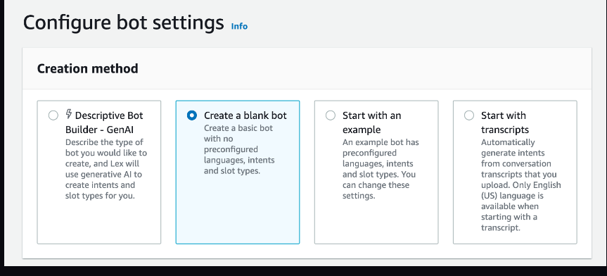

* enter **BankerBot**
* Enter Description

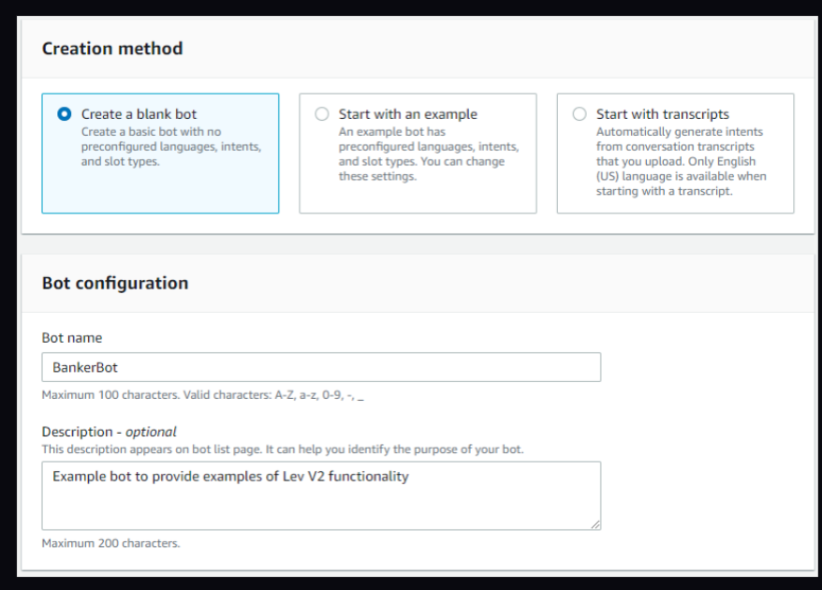

* Under IAM permissions, select **Create a role with basic Amazon Lex permissions.**

💡 This will create a policy (i.e. a rule) that gives Amazon Lex permissions to call other AWS services on your behalf, which is what we need for this workshop. We'll be using it to call another service called Lambda later!

* Under Children’s Online Privacy Protection Act (COPPA), select **No.**
* Under Idle session timeout, keep the default of 5 minute(s)

💡 Amazon Lex will only maintain a session for a set length of time. If the user is idle and does not provide any input for 5 minutes, their session will end.

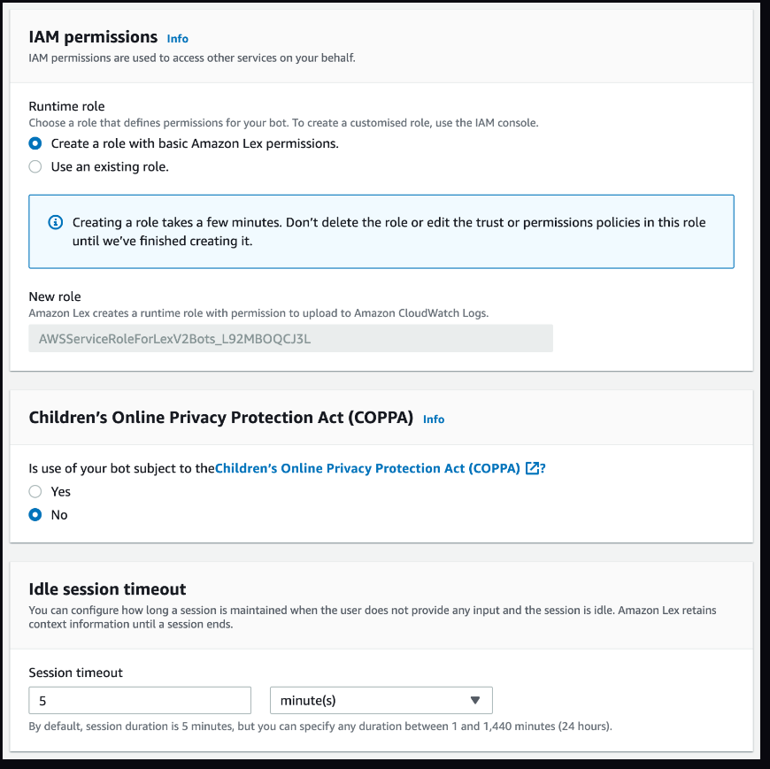

* Keep the language as **English** so you can explore the full features of Lex V2 in this project.
* Under Voice interaction, click on the dropdown and select one of the option.

 These voices are borrowed from Amazon Polly, which is another AWS service all about turning your text into speech!

* For **Intent classification confidence score threshold**, keep the default value of **0.40.**

💡 What does**intent classification confidence score threshold**mean?  
When you're using Amazon Lex to build a chatbot, this threshold is like a minimum score for your chatbot to confidently understand what the user is trying to say. Setting this to 0.4 means that your chatbot needs to be at least 40% confident that it understands what the user is asking to be able to give a response. So if a user's input is ambiguous and your chatbot's confidence score is below 0.4, it'll throw an error message. You'll see how this works in a bit!

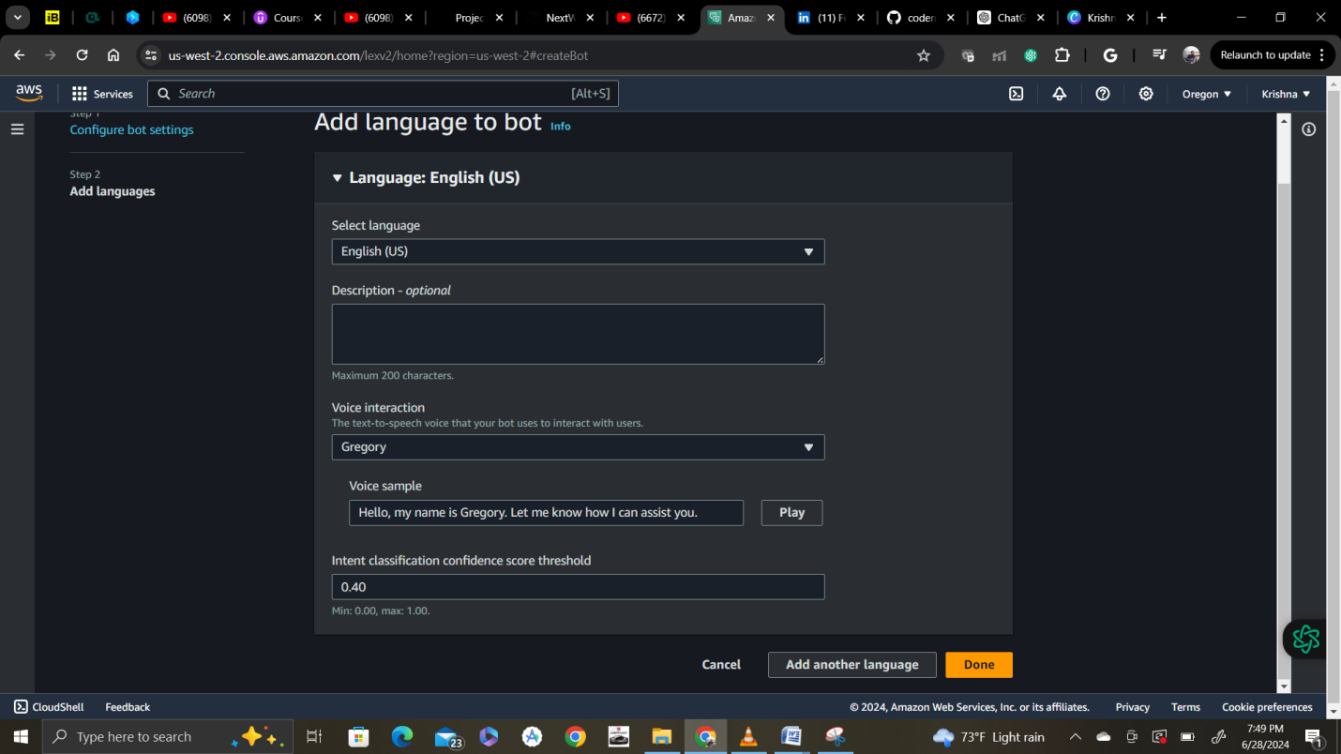

Click done and it will create a chatbot like below.

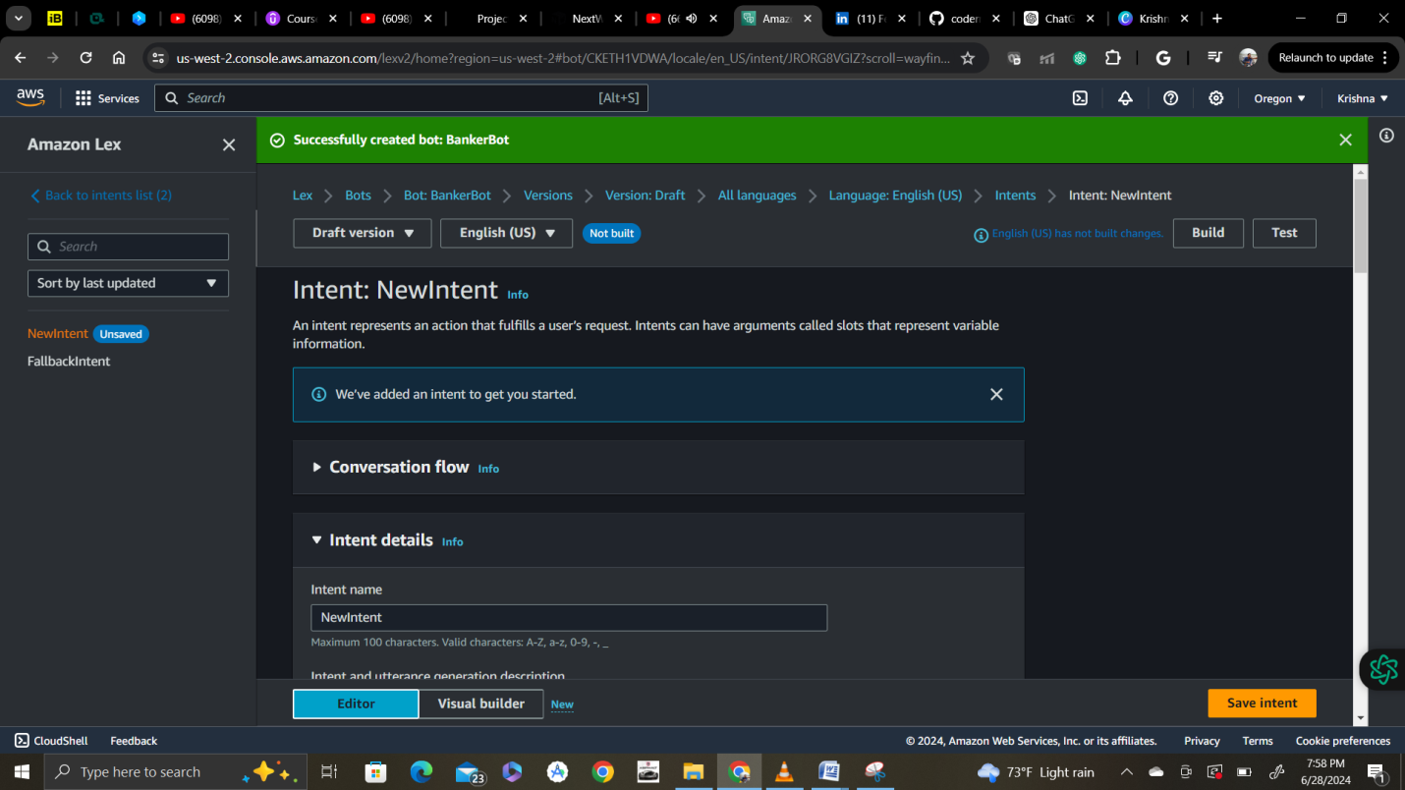

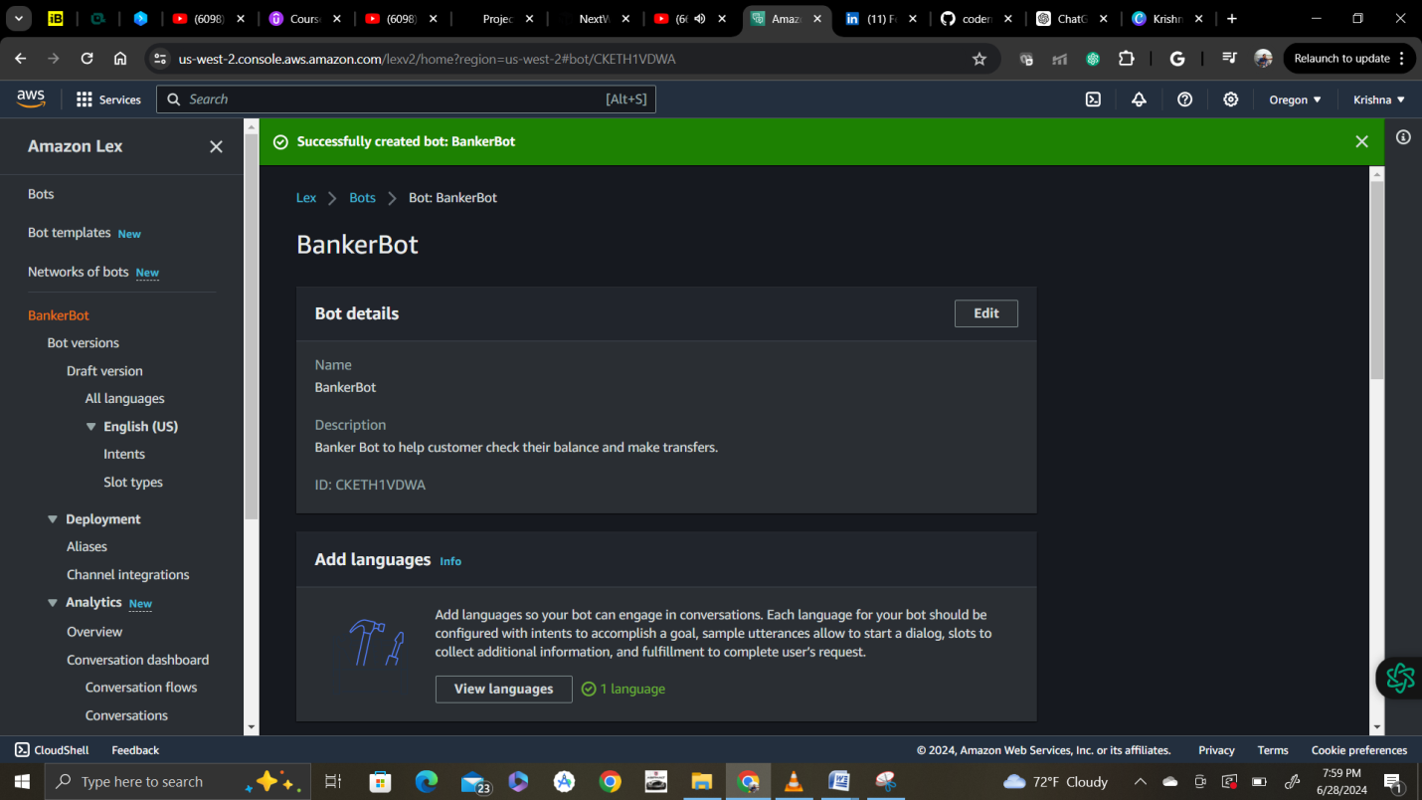

* When your bot is created, you will automatically see a page called Intent: NewIntent

* **What are intents?**  
An intent iswhat the user is trying to achieve in their conversation with the chatbot. For example, checking a bank account balance; booking a flight; ordering food. In Amazon Lex, you build your chatbot by defining and categorising different user actions/goals. If you set up different intents, one single chatbot can manage a variety of requests that are usually related to each other. You'll be creating different intents and will see how they're related in a minute!

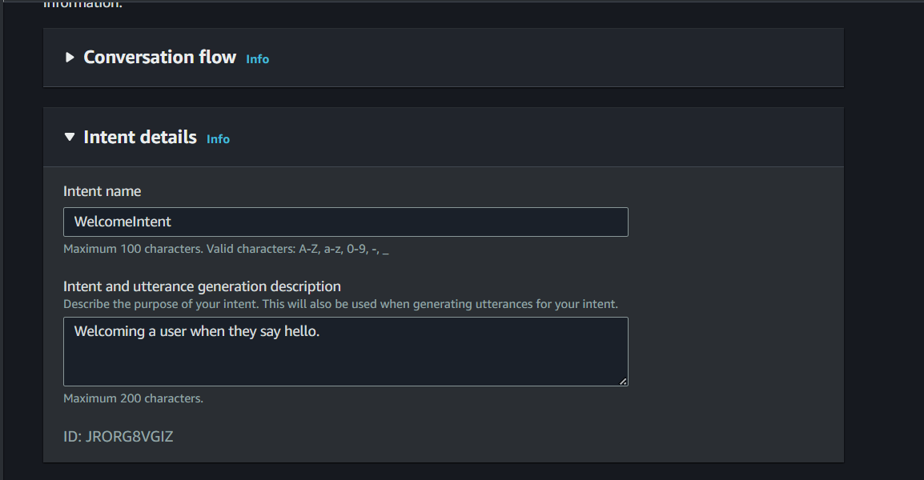

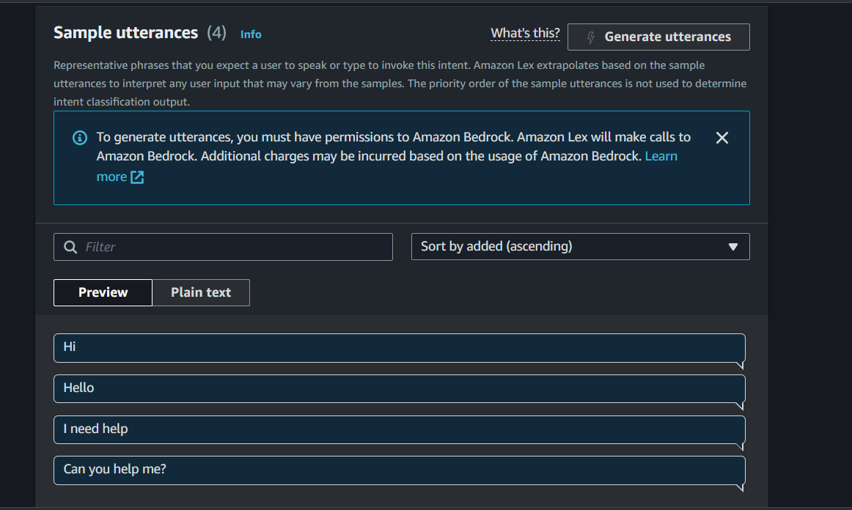

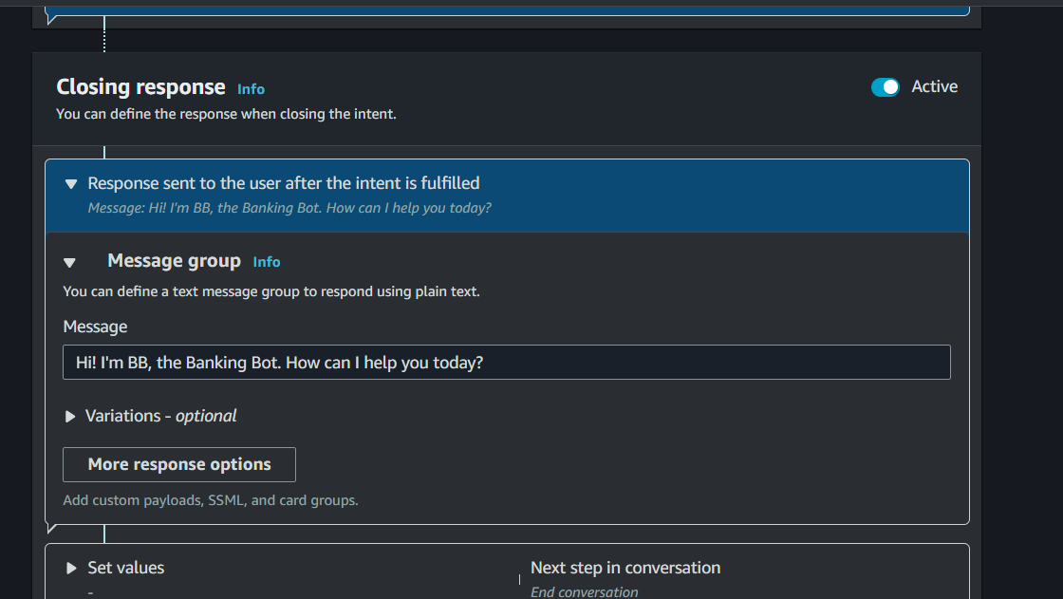

After saving intent choose build.

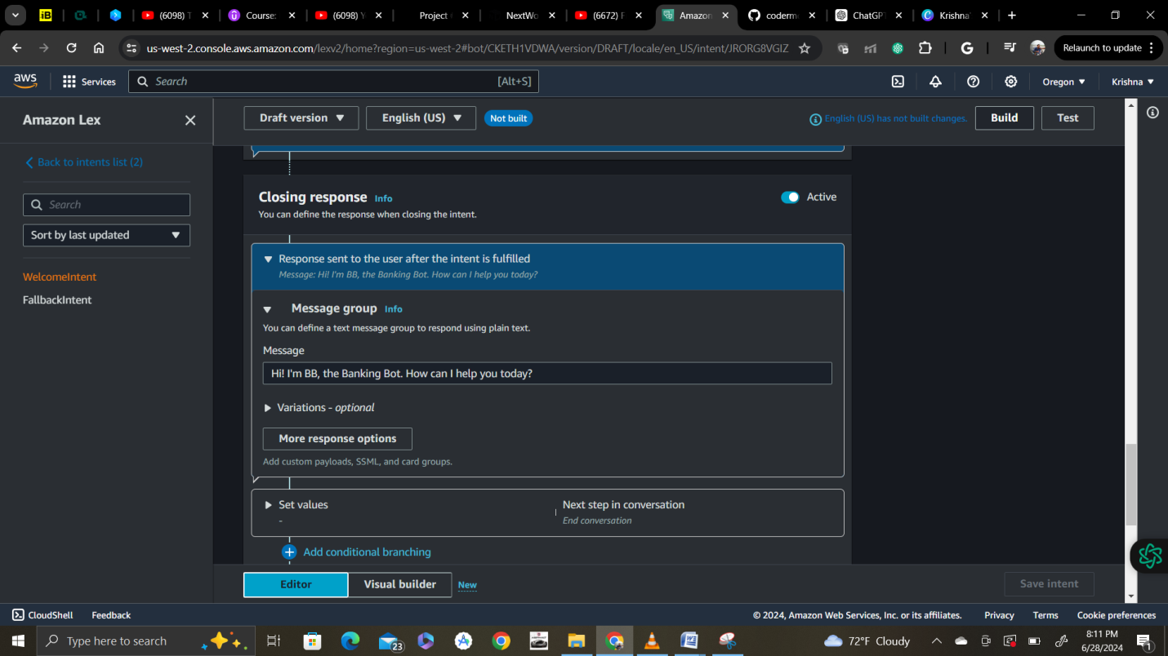

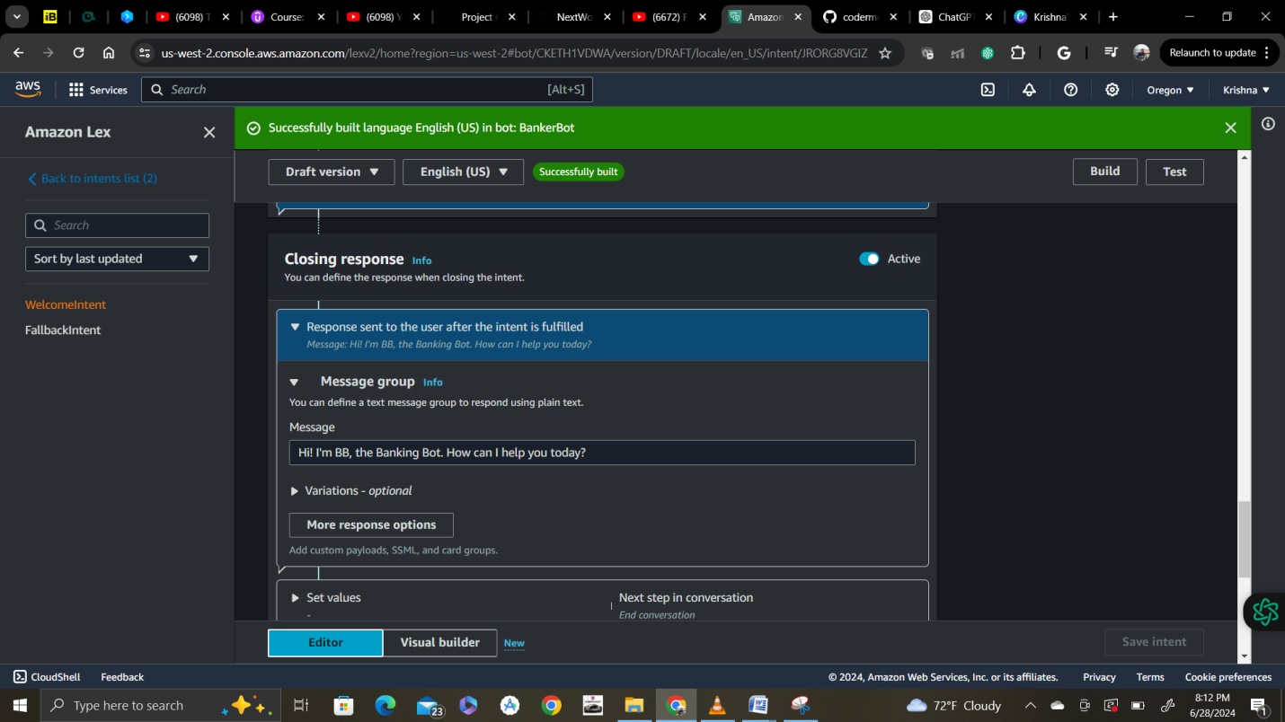

After building click on test and now bot will give you a interactive page like this

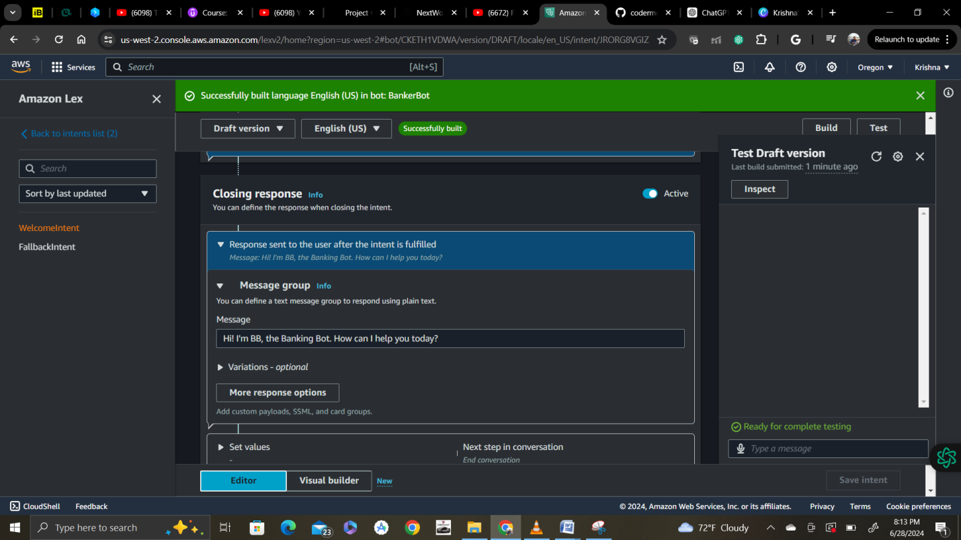

Now test it

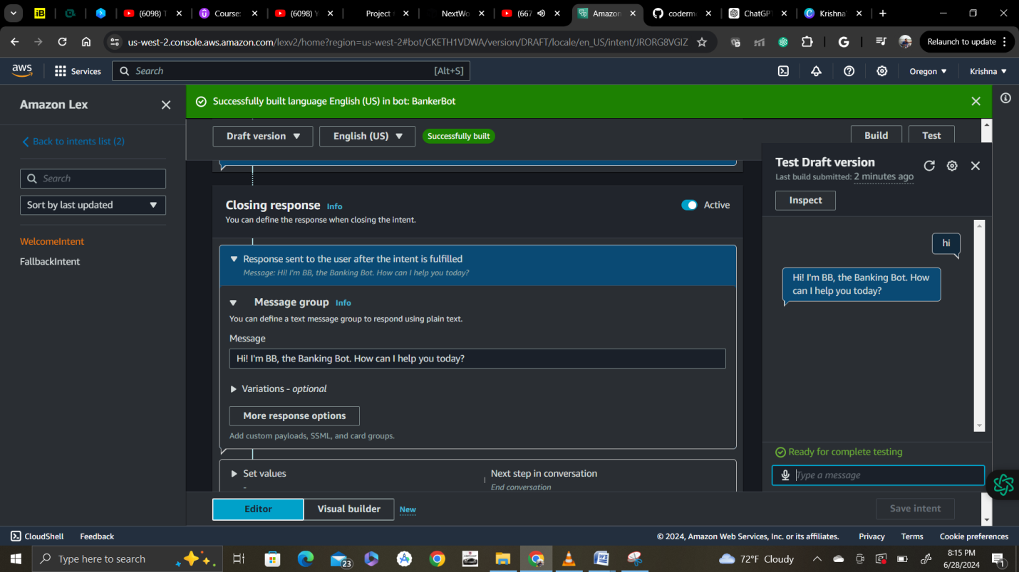

Test it different ways that you entered.

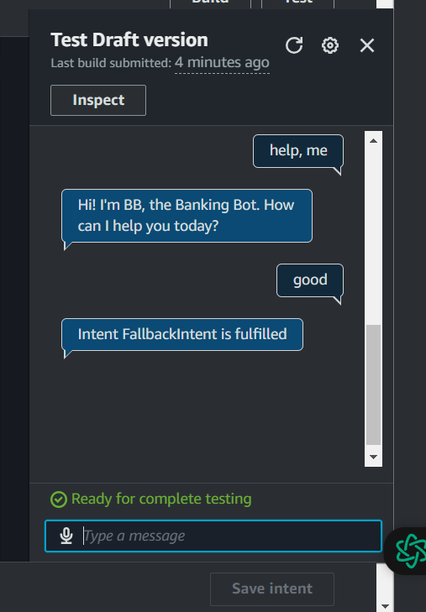

 The first three are successfully recognised - Amazon Lex is able to use its ML techniques to match what you have said against your utterances. But the last two fail, resulting in a **Intent FallbackIntent is fulfilled** response - meaning Amazon Lex doesn't quite recognise this utterance. We'll learn what **FallbackIntent**means in the next step.

Also try with microphone as above and it works. Now we are dealing with FallbackIntent select that,.

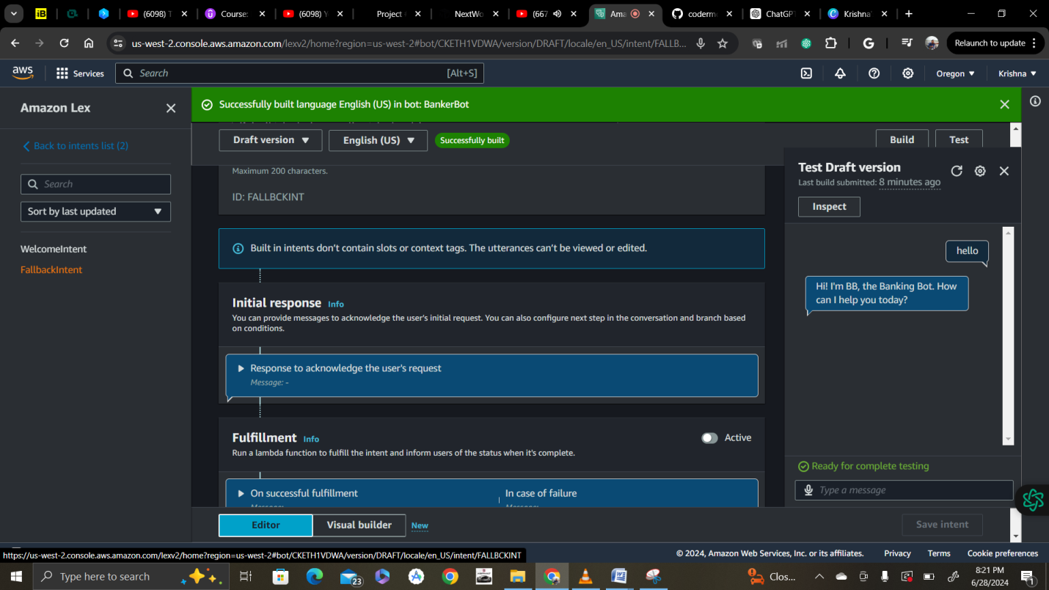

Now add a closing response in the fallback intent as below:

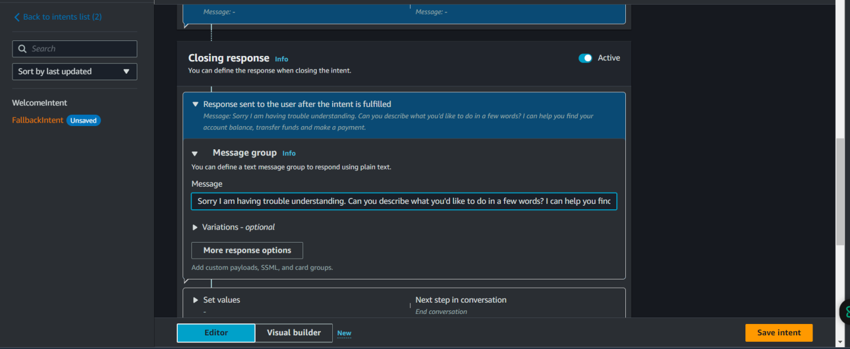

Enter message and also variations as below and save intent.

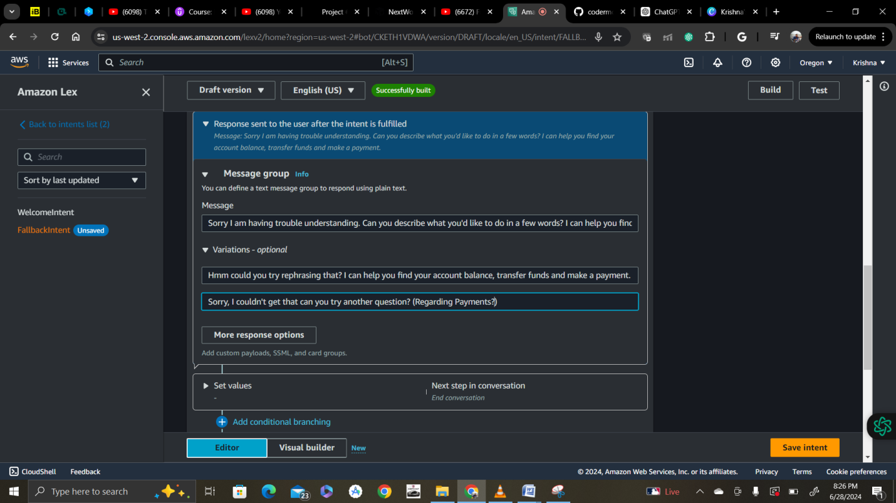

After saving intent again click on build to witness the changes that we made.

