EMR Instance Creation

1. VPC is created first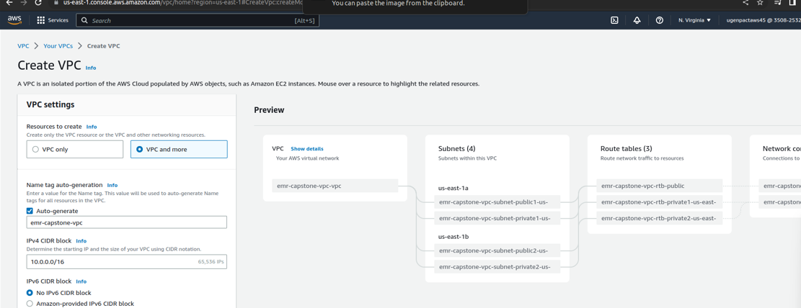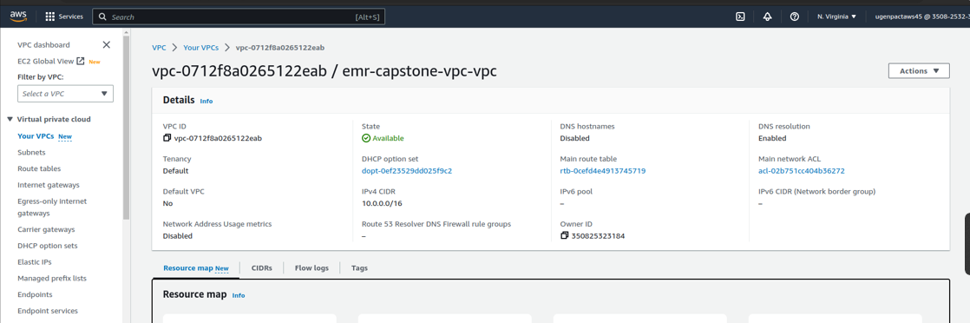
2. Cloud9 is setup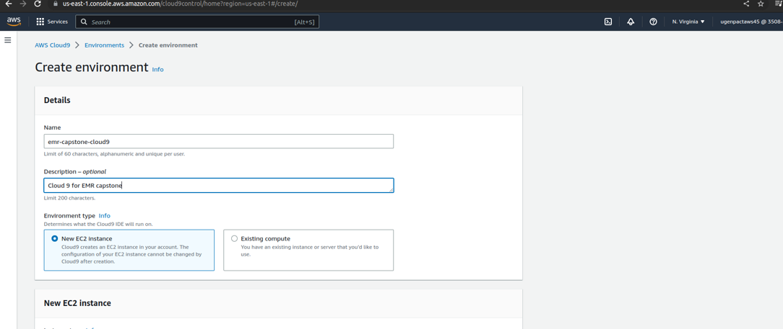

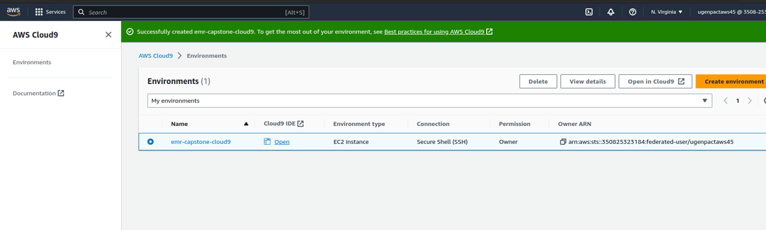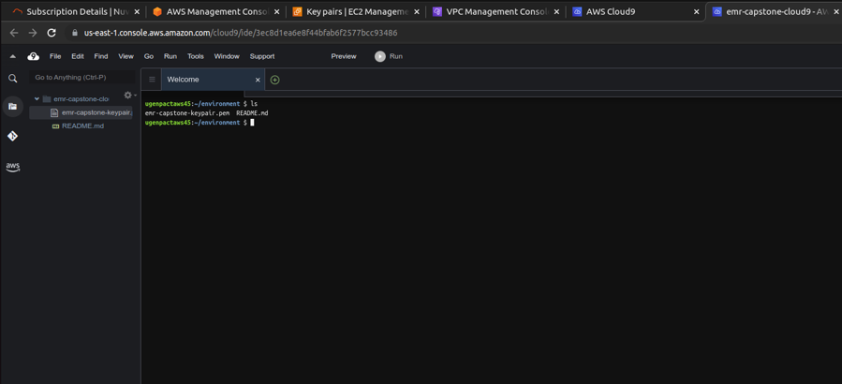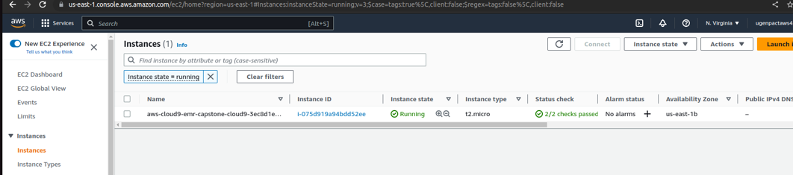

1. Key-Pair is created and pushed into cloud 9
2. S3 bucket is created and data is loaded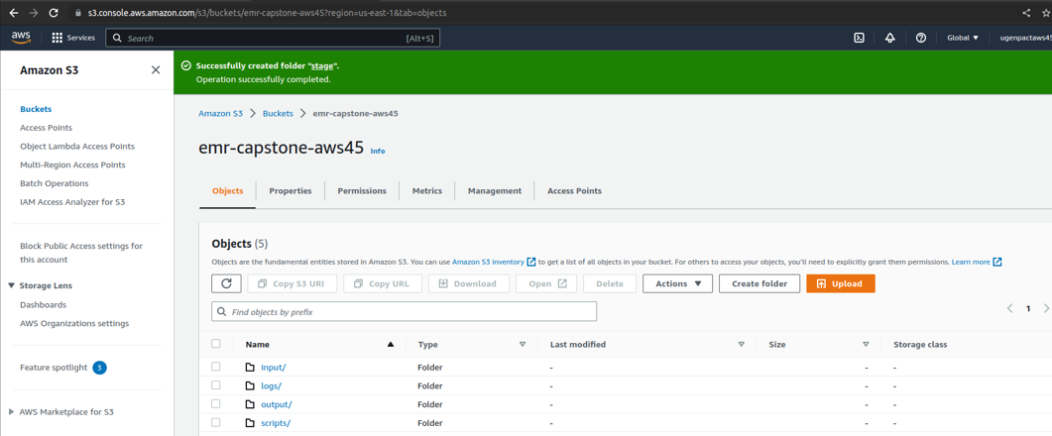
3. S3 Permissions for read and write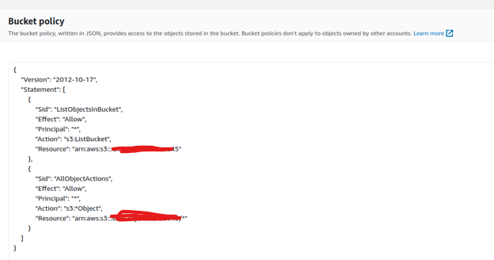
4. EMR creation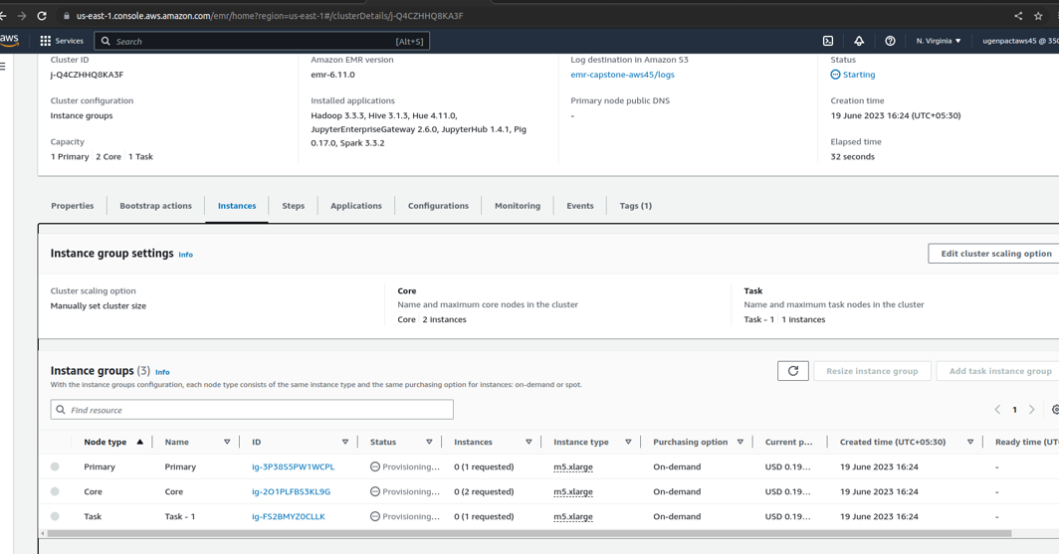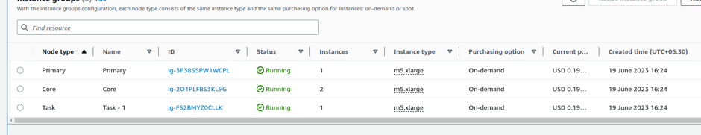
5. Configuring the network for EMR Cloud-9 and Jupyter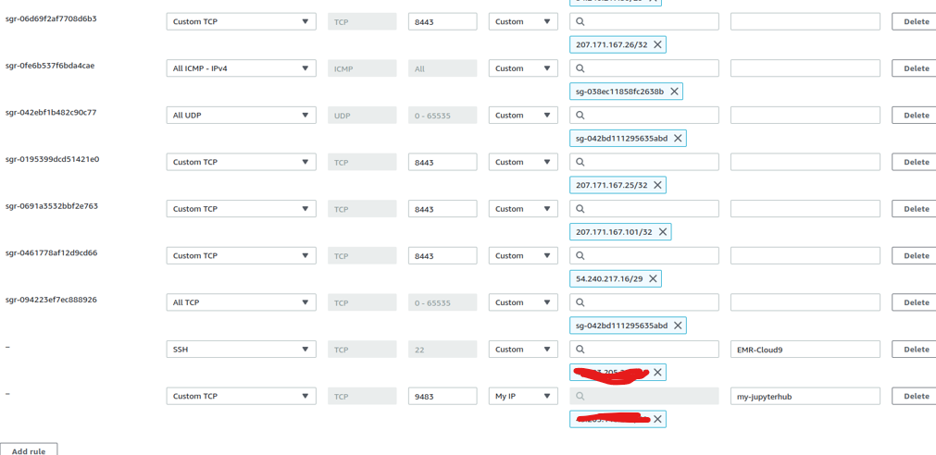
6. EMR started and connected using cloud9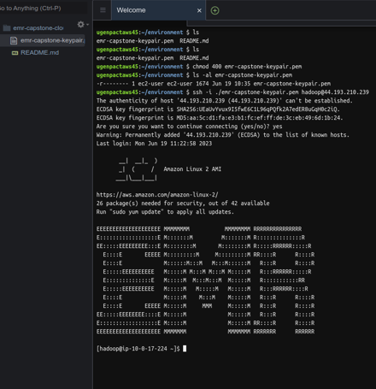
7. Running the Spark- code inside Cloud-9 EMR