MongoDB:-

1. Created the Shared(free) account with MongoDb Atlas, cluster created using the AWS cloud as option, 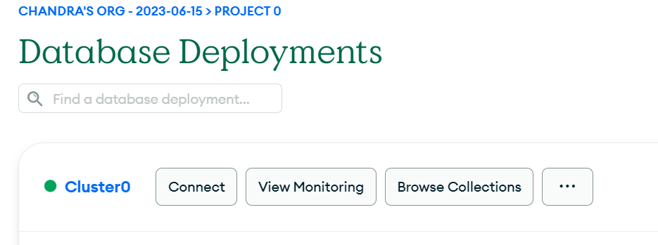
2. Loan data is loaded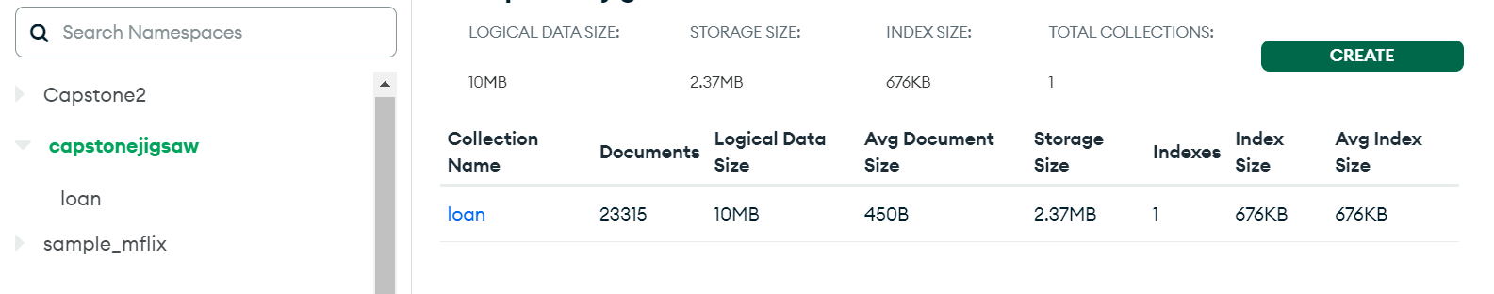
3. Connected locally using the MongoDB compass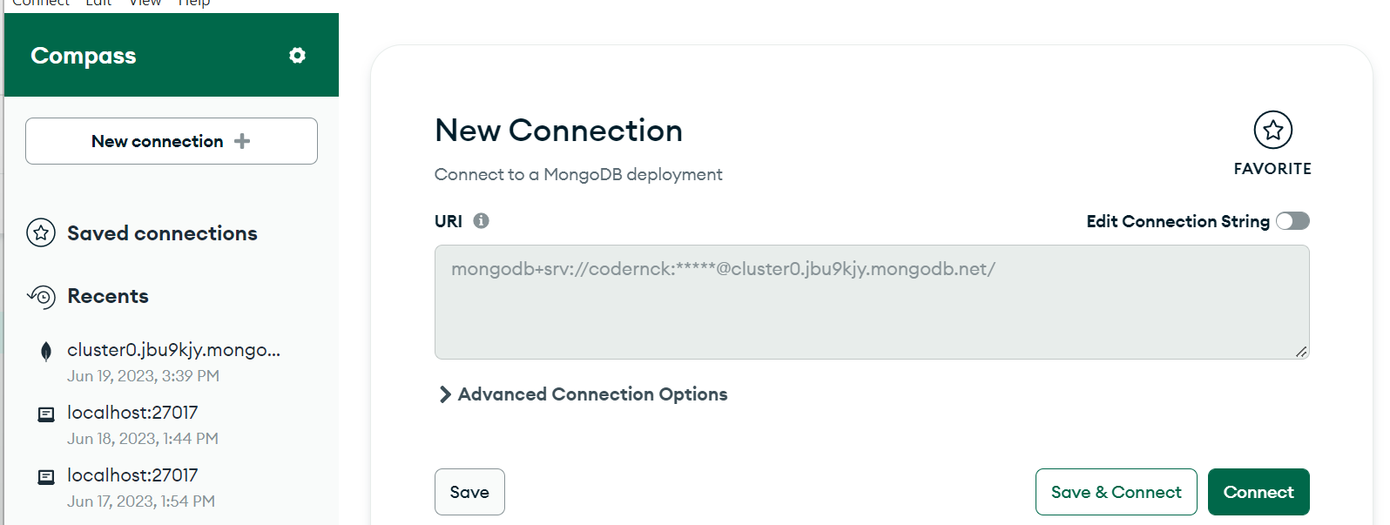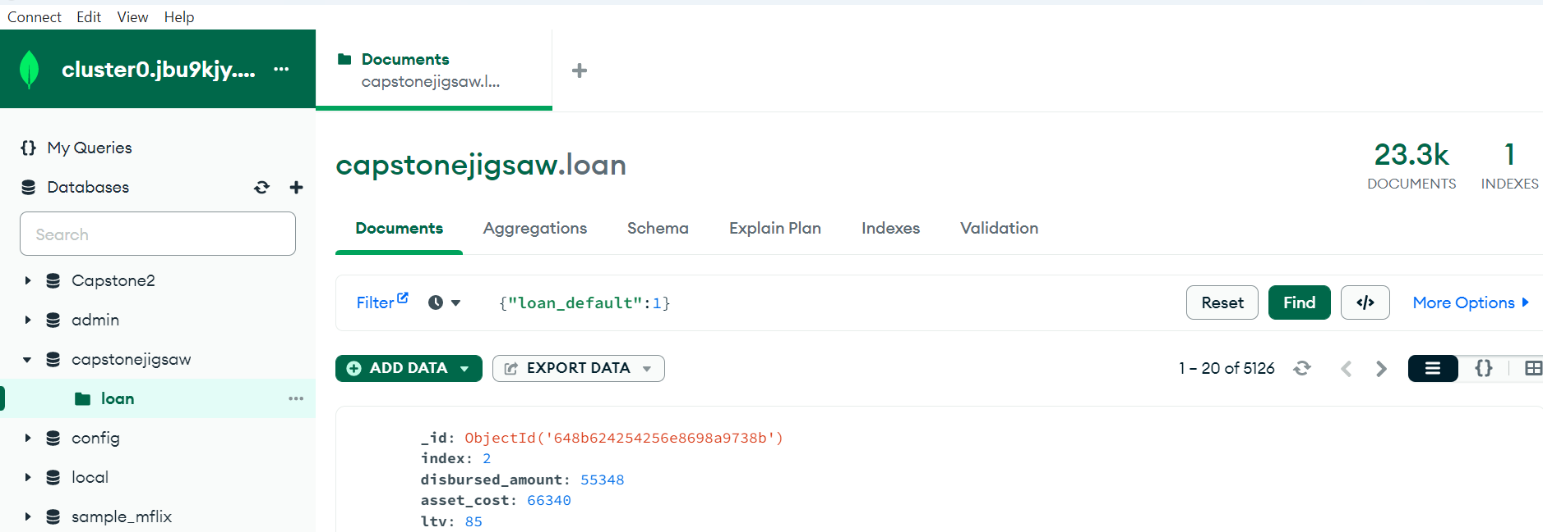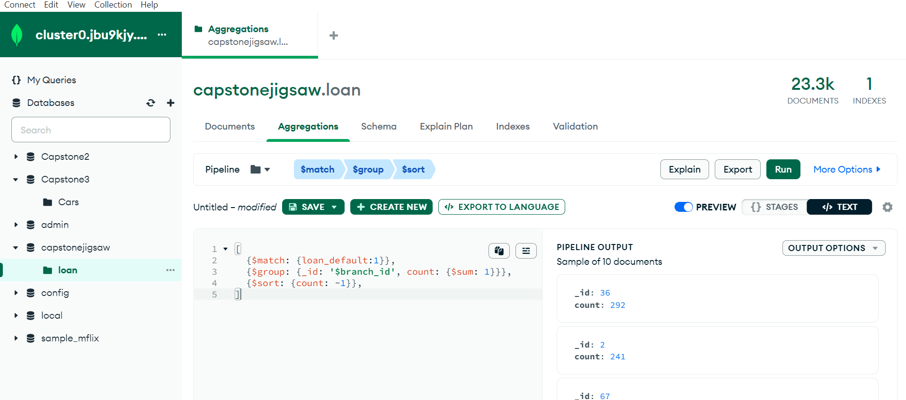
4. MongDB DB & Collectiondetails
   1. DB Name : capstonejigsaw
   2. Collection: loan
   3. Documents: the row in the loan.csv file loaded
5. Few of the Reports:
   1. Number of Loans Defaults, and percentage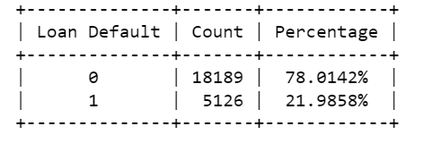
   2. Different Types of Employees
   3. Number of Defaulters and Non-Defaulter across Employment Type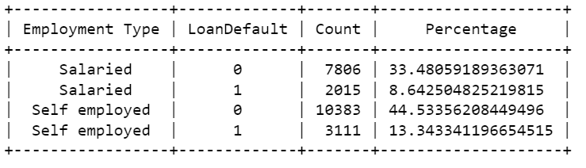
   4. Branch Wise Default loans sorted (snapshot-does not include entire data) 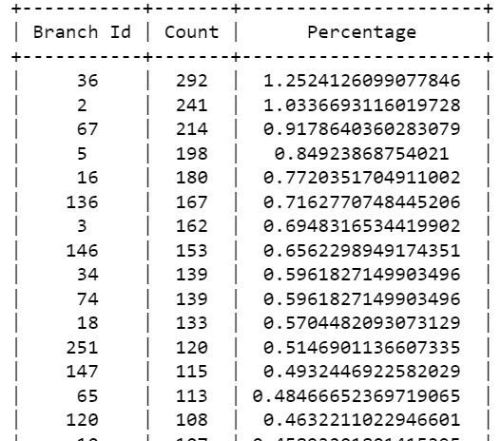
   5. Loan Default across the Age Generation name