Nama : Akmal Muhamad Firdaus

NIM : 1301204188

**Laporan Praktikum**

1. **Eksplorasi HTML**
   1. **Heading**



* 1. **Hyperlink**



* 1. **Tabel**

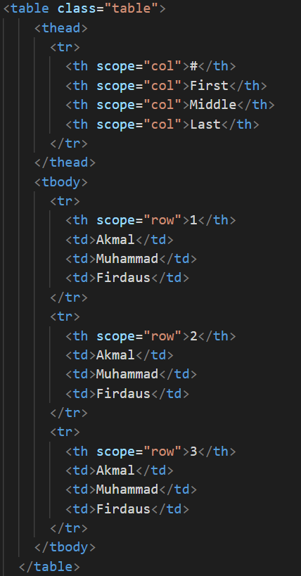

* 1. **Image**



* 1. **Audio / Video**



* 1. **Form**

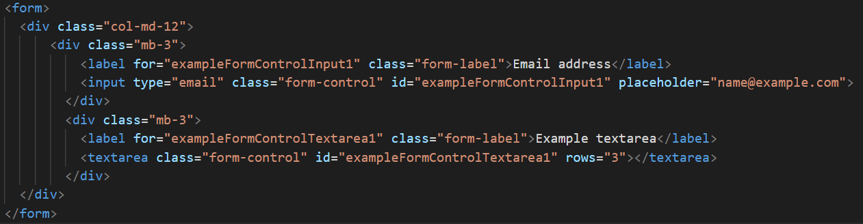

* 1. **Output**

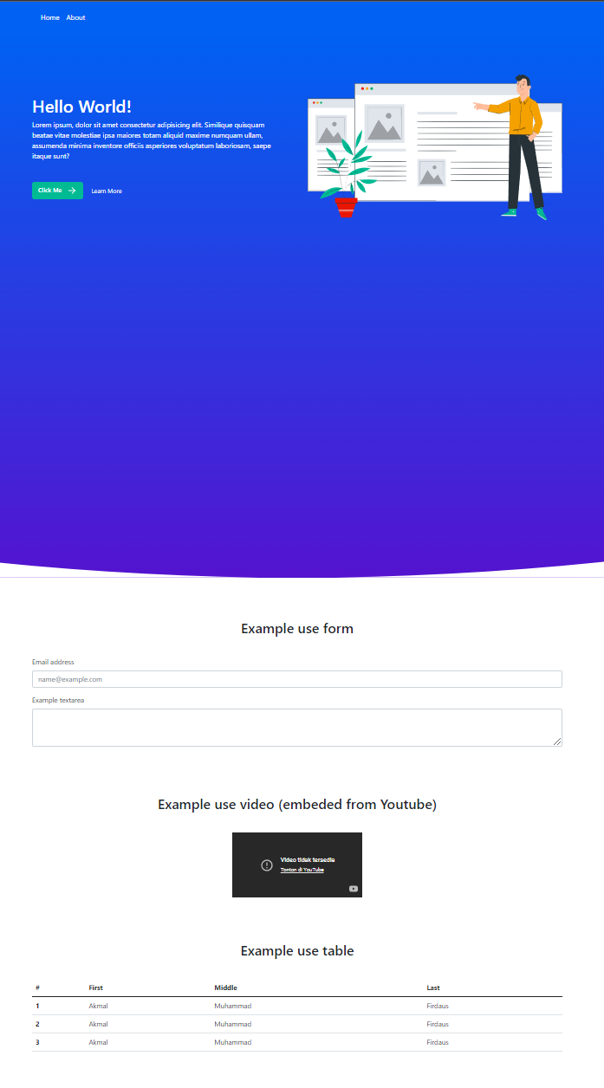

1. **GIT**
   1. **Initial Project**

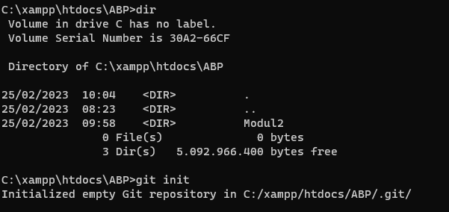

* 1. **Add to staging**

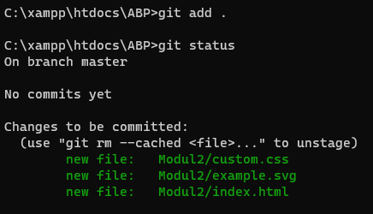

* 1. **Commit**

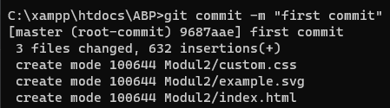

* 1. [**Create Online Repository**](https://github.com/codernewbie04/CII3H4-ABP-Praktikum)

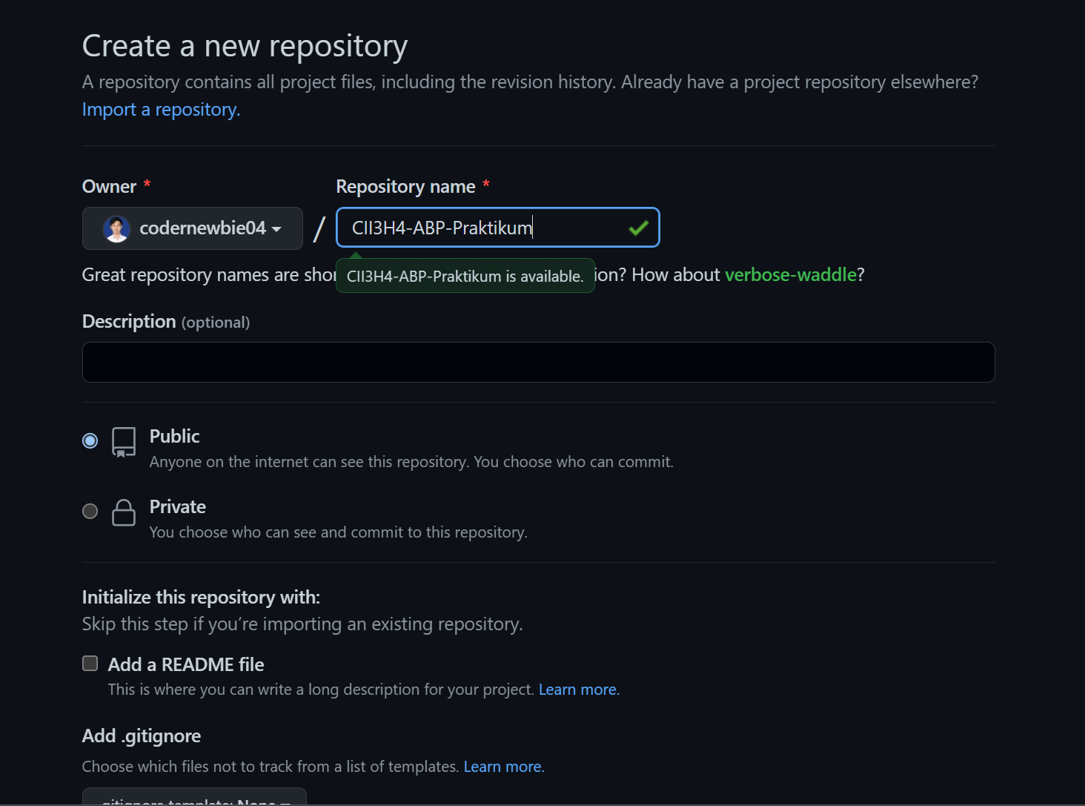

* 1. **Add remote & Push**

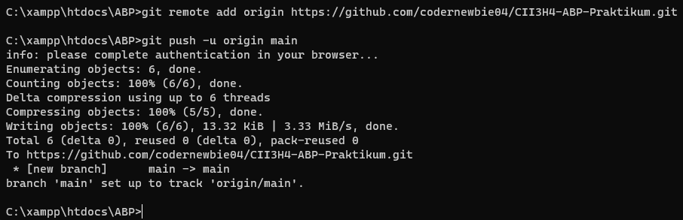

* 1. **Output**

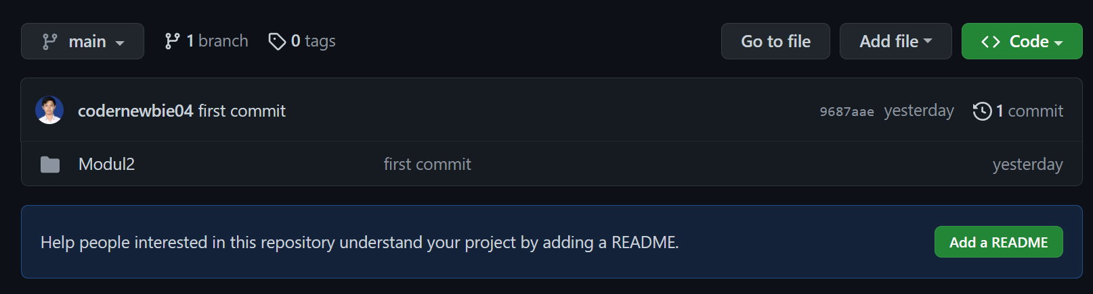

* 1. **Clone Repository**



