**Midterms TP01**

**Syntax:**

**Main class:**

using System;

using static TPGame.GameCharacter;

namespace TPGame

{

class MainClass

{

static INFO info;

static STATS stats;

static PROFESSION prof;

public static void Main(string[] args)

{

//INFO

Console.Write("Enter your Character's Name : ");

info.name = Console.ReadLine();

info.level = getLevel();

printInfo(info.name, info.level);

//STATS

getStats();

printStats();

//PROFESSION

chooseProf();

congrats();

}

static int getLevel()

{

int level = 0;

while (level <= 0 || level >= 100) {

Console.Write("Enter your character level (1 - 99) : ");

level = Convert.ToInt32(Console.ReadLine());

}

return level;

}

static void printInfo(string name, int level)

{

Console.WriteLine("\nGame Character's Information: ");

Console.WriteLine("Name : " + name);

Console.WriteLine("Level : " + level);

}

static void getStats()

{

string[] statsList = {"Strength", "Agility", "Vitality", "Intelligence", "Dexterity", "Luck"};

int[] statsValue = new int[statsList.Length];

int i = 0;

int value;

Console.WriteLine();

while (true)

{

Console.Write("Enter your Character's " + statsList[i] + " : ");

value = Convert.ToInt32(Console.ReadLine());

if (value <= 0 || value >= 100)

{

Console.WriteLine("\nInvalid Input. Dapat (1 - 99) lang po! ulit lahat!\n");

i = 0;

}

else

{

statsValue[i] = value;

i++;

if (i == statsList.Length)

{

break;

}

}

}

stats.Strength = statsValue[0];

stats.Agility = statsValue[1];

stats.Vitality = statsValue[2];

stats.Intelligence = statsValue[3];

stats.Dexterity = statsValue[4];

stats.Luck = statsValue[5];

}

static void printStats()

{

Console.WriteLine("\n" + info.name + "'s Stats : ");

Console.WriteLine("Strength : " + stats.Strength);

Console.WriteLine("Agility : " + stats.Agility);

Console.WriteLine("Vitality : " + stats.Vitality);

Console.WriteLine("Intelligence : " + stats.Intelligence);

Console.WriteLine("Dexterity : " + stats.Dexterity);

Console.WriteLine("Luck : " + stats.Luck);

}

static void chooseProf()

{

string[] profList = {"Swordman", "Merchant", "Theif", "Acolyte", "Mage", "Archer" };

Console.WriteLine("\n1. Swordman \n2. Merchant \n3. Thief \n4. Acolyte \n5. Mage \n6. Archer.\n");

while (true)

{

Console.Write("Enter the number of your desire profession: ");

int input = Convert.ToInt32(Console.ReadLine());

if (input <= 0 || input >= 7)

{

Console.WriteLine("Mali ka, Dapat kasi (1-6) lang e! wag hanapin ang wala!");

}

else

{

prof.profession = profList[input - 1];

break;

}

}

}

static void congrats()

{

Console.WriteLine("\nWow naman, Congrats isa ka nang ganap na " + prof.profession + "!!!!");

Console.WriteLine("Goodluck sa iyong mahabang paglalakbay!");

}

}

}

**GameCharacter class:**

using System;

namespace TPGame

{

public class GameCharacter

{

public struct INFO

{

public string name;

public int level;

}

public struct STATS

{

public int Strength;

public int Agility;

public int Vitality;

public int Intelligence;

public int Dexterity;

public int Luck;

}

public struct PROFESSION

{

public string profession;

}

}

}

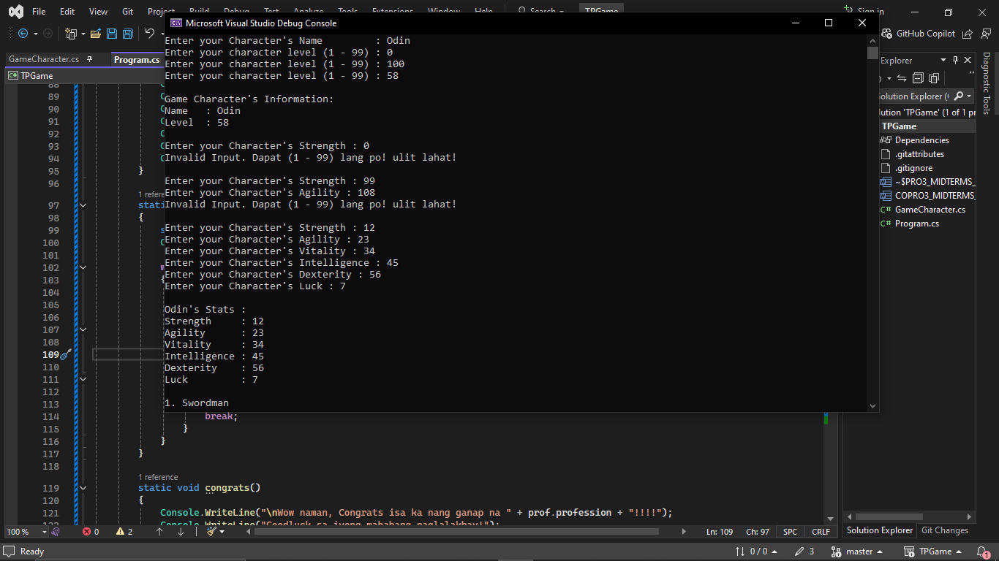**Output:**

