Tools:

* Nmap
* SmbClient

Walkthrough:

Let us start with scanning of the given IP address

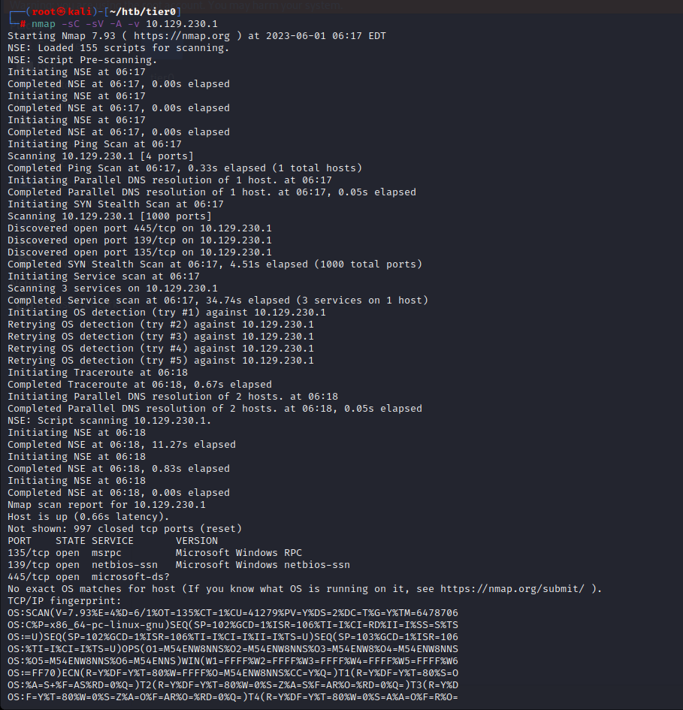

So here can see that there is an open port on 445 which is the port number for smbclient, Which means that we can connect with the IP address via smbclient.

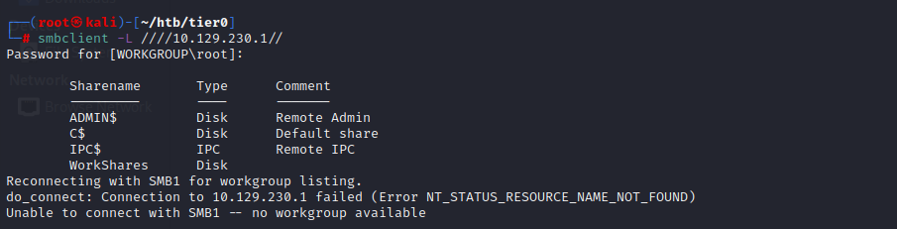

So, At first we listed out the files present in the IP address. The WorkShares file looks suspicious so, Lets us investigate that using the –N flag.

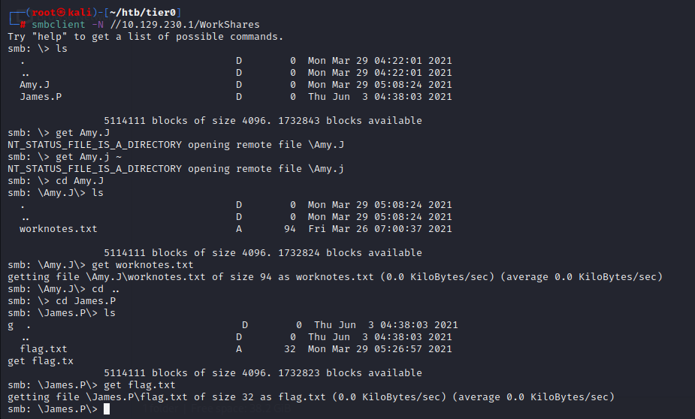

Ok, so we were able to connect to smbclient and can look up in it.

We found two new directories here. So, lets check on each directory one by one.

After spending few minutes I was able to get the flag.txt file and pawned the machine.