Tools:

* Nmap
* FTP

Walkthrough:

Let us start with scanning of the given IP address

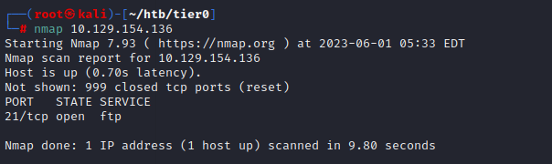

Here we can see that we have an open port at 21 with FTP service.

Now let us do some detailed scanning on this IP address.

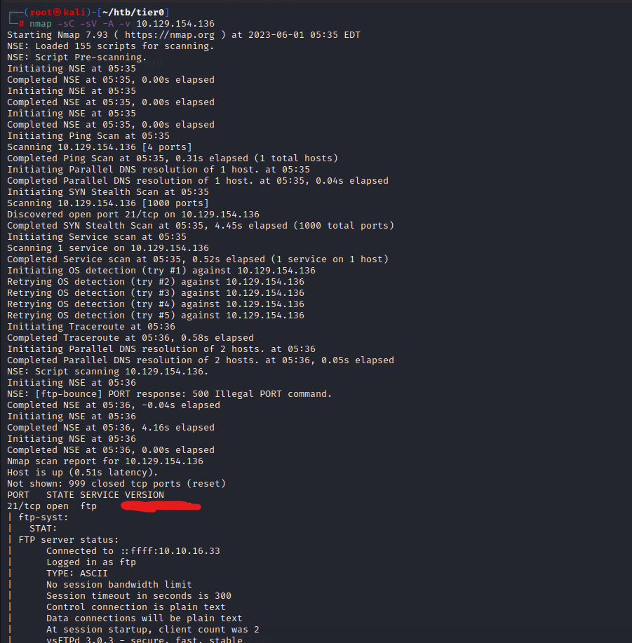

So, we got our information, that there is a login possible via FTP.

Once we got our file (that is flag.txt) we can look it in our local host and boom we have pawned the machine.