Tools:

* Nmap
* Telnet

Walkthrough:

Let us start with scanning of the given IP address

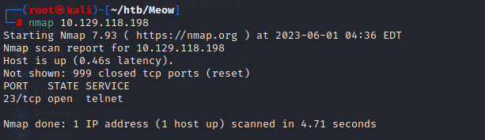

Here we can see that one port is open and that is port number 23 with the service of telnet

So let’s use the telnet command to login into the machine.

And boom we got pawned our first machine in hackthebox.