**Competition question to be solved by all to decide two winners**

Markov takes out his [Snakes and Ladders](https://www.hackerrank.com/external_redirect?to=http://en.wikipedia.org/wiki/Snakes_and_Ladders) game and stares at the board, and wonders: If he had absolute control on the die (singular), and could get it to generate any number (in the range ) he desired, what would be the least number of rolls of the die in which he'd be able to reach the destination square (Square Number ) after having started at the base square (Square Number )?

**Rules**

1. Markov has total control over the die and the face which shows up every time he tosses it. You need to help him figure out the minimum number of moves in which he can reach the target square (100) after starting at the base (Square 1).
2. A die roll which would cause the player to land up at a square greater than 100, goes wasted, and the player remains at his original square. Such as a case when the player is at Square Number 99, rolls the die, and ends up with a 5.
3. If a person reaches a square which is the base of a ladder, (s)he has to climb up that ladder, and he cannot come down on it. If a person reaches a square which has the mouth of the snake, (s)he has to go down the snake and come out through the tail - there is no way to climb down a ladder or to go up through a snake.

**Buffer question in case if people solve the competitive question too quickly ☺**

Jack has just moved to a new city called Rapture. However, he is confused by Rapture's public transport system. The rules of the public transport are as follows:

1. Every pair of connected stations has a fare assigned to it.
2. If a passenger travels from station A to station B, he only has to pay the difference between the fare from A to B and the cumulative fare that he has paid to reach station A [fare(A,B) - total fare to reach station A]. If the difference is negative, he can travel free of cost from A to B.

Since Jack is new to the city, he is unemployed and low on cash. He needs your help to figure out the most cost efficient way to go from the first station to the last station. You are given the number of stations N, and the fare between the E pair of stations that are connected.

1 2 60

3 5 70

1 4 120

4 5 150

2 3 80

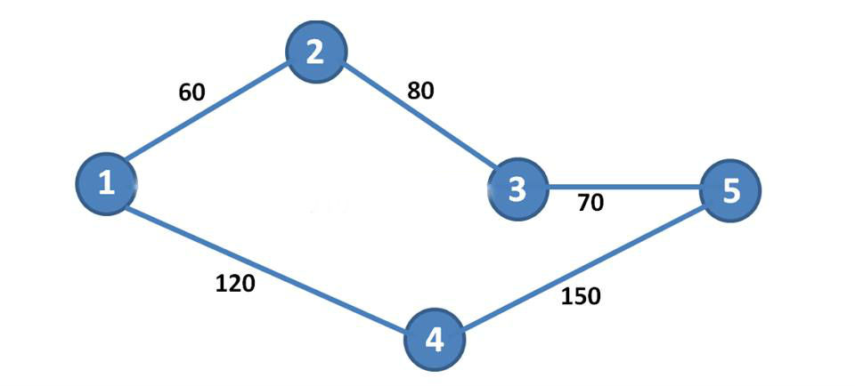

There are two ways to go from first station to last station.

* 1 -> 2 -> 3-> 5
* 1 -> 4 -> 5

For the first path, Jack first pays 60 units of fare to go from station 1 to 2. Next, Jack has to pay 80-60 = 20 units to go from 2 to 3. Now, to go from 3 to 5, Jack has to pay 70-(60+20) = -10 units, but since this is a negative value, Jack pays 0 units to go from 3 to 5. Thus the total cost of this path is (60+20) = 80 units.

For the second path, Jack pays 120 units to reach station 4 from station 1. To go from station 4 to 5, Jack has to pay 150-120 = 30 units. Thus the total cost becomes (120+30) = 150 units. So, the first path is the most cost efficient, with a cost of 80.

**Final round Question 1**

1) There is a museum organized as NxM room.

2) Some rooms are locked and inaccessible. Other rooms are open and some rooms have guards.

3) Guards can only move north, south, east and west, only through open rooms and only within the museum.

4) For each room, find the shortest distance to a guard.

**Final round Question 2**

Given a matrix of dimension m*n where each cell in the matrix can have values 0, 1 or 2 which has the following meaning:

0: Empty cell

1: Cells have fresh oranges

2: Cells have rotten oranges

So we have to determine what is the minimum time required so that all the oranges become rotten. A rotten orange at index [i,j] can rot other fresh orange at indexes [i-1,j], [i+1,j], [i,j-1], [i,j+1] (up, down, left and right). If it is impossible to rot every orange then simply return -1.