Telecom Customer Churn Prediction
Data Analytics with AI
AICTE | IBM SkillsBuild Data Analytics with AI Internship 2026 | BharatCares
SUBMITTED BY
Karan Kumar Chauhan
Bansal Institute of Research and Technology
Internship: AICTE Data Analytics with AI — 6 Week
IDE Used: IBM Bob

Table of Contents

Section | Page
Abstract | 3
1. Introduction | 3
1.1 Problem Statement | 3
1.2 Why Churn Prediction Matters for Telecom | 4
2. Dataset Description | 4
2.1 Dataset Summary | 4
2.2 Class Distribution | 5
3. Methodology | 5
3.1 Exploratory Data Analysis (EDA) | 5
3.2 Data Preprocessing | 8
3.3 Model Training | 9
4. Results | 9
4.1 Model Performance Comparison | 9
4.2 Best Model: Logistic Regression | 10
5. System Design | 10
5.1 Architecture Overview | 10
6. Implementation Details | 11
6.1 Development Environment | 11
6.2 Tool Stack | 11
6.3 Model Serialisation and Loading | 12
6.4 User Flow in the Streamlit App | 12
7. Screenshots | 12
8. Conclusion | 14
9. Future Work | 14
10. References | 15
Tip: In Microsoft Word, press Ctrl + A then F9 to refresh page numbers.

Abstract
Customer churn — the phenomenon where existing subscribers discontinue a service — is one of the most critical challenges faced by telecommunications companies worldwide. Retaining an existing customer is estimated to be five to seven times less expensive than acquiring a new one, making early churn detection a high-priority business problem. This project presents a complete, end-to-end machine learning pipeline for predicting customer churn using the IBM Telco Customer dataset. The entire workflow — from exploratory data analysis (EDA) and feature engineering, through model training and evaluation, to deployment via an interactive web application — was developed exclusively inside IBM Bob IDE without any external AI tooling. Three classification algorithms were implemented using scikit-learn: Logistic Regression, Random Forest, and Gradient Boosting. All models were evaluated on accuracy, precision, recall, F1-score, and ROC-AUC. The best-performing model (Logistic Regression; ROC-AUC = 1.0, Recall = 100%) was serialised with joblib and served through a Streamlit web application, enabling business users to receive instant, interpretable churn predictions with probability scores and risk-level classifications for any customer profile.

1. Introduction

1.1 Problem Statement
Telecommunications is one of the most competitive industries globally. With market saturation and low switching costs, customers frequently migrate between service providers. Customer churn — defined as a customer ceasing to use a company’s services — directly impacts revenue, operational costs, and brand value. Identifying at-risk customers before they churn allows companies to deploy targeted retention strategies such as personalised offers, service upgrades, or dedicated support. The challenge is to build a predictive model that can accurately flag customers likely to churn, enabling proactive intervention.

1.2 Why Churn Prediction Matters for Telecom
The telecom sector faces an average annual churn rate of 15–25%. Each churned customer represents not only lost subscription revenue but also the sunk cost of customer acquisition (CPA), which can range from $200–$500 per customer. Key business impacts include: (1) Revenue leakage — a direct reduction in monthly recurring revenue (MRR). (2) Increased acquisition costs — replacing churned customers requires fresh marketing spend. (3) Reputational damage — churned customers often share negative experiences. (4) Network underutilisation — sudden drops in usage distort capacity planning. A machine learning-based churn prediction system addresses all these challenges by providing a ranked, probabilistic risk score for every active customer.

2. Dataset Description
The dataset used is the IBM Telco Customer Churn dataset (Telco_Churn_Data.csv), containing 7,043 customer records with 10 attributes. The target variable Churn indicates whether a customer left the company (Yes) or is still active (No).

2.1 Dataset Summary
- customerID [String] — Unique identifier — dropped before training
- gender [Categorical] — Male or Female
- SeniorCitizen [Numeric 0/1] — Senior citizen (65+): 1=Yes, 0=No
- Partner [Categorical] — Has partner: Yes / No
- Dependents [Categorical] — Has dependents: Yes / No
- tenure [Numeric] — Months with company (0–72) — strongest predictor
- PhoneService [Categorical] — Phone service: Yes / No
- MultipleLines [Categorical] — Multiple lines: Yes / No / No phone service
- InternetService [Categorical] — DSL / Fiber optic / No
- OnlineSecurity [Categorical] — Online security add-on: Yes / No / No internet service
- Churn [TARGET] — Churned: Yes (1) / No (0)

2.2 Class Distribution
Churn=Yes: 2,186 customers (31.0%) | Churn=No: 4,857 customers (69.0%). Class imbalance was handled using class_weight=‘balanced’ in scikit-learn classifiers.
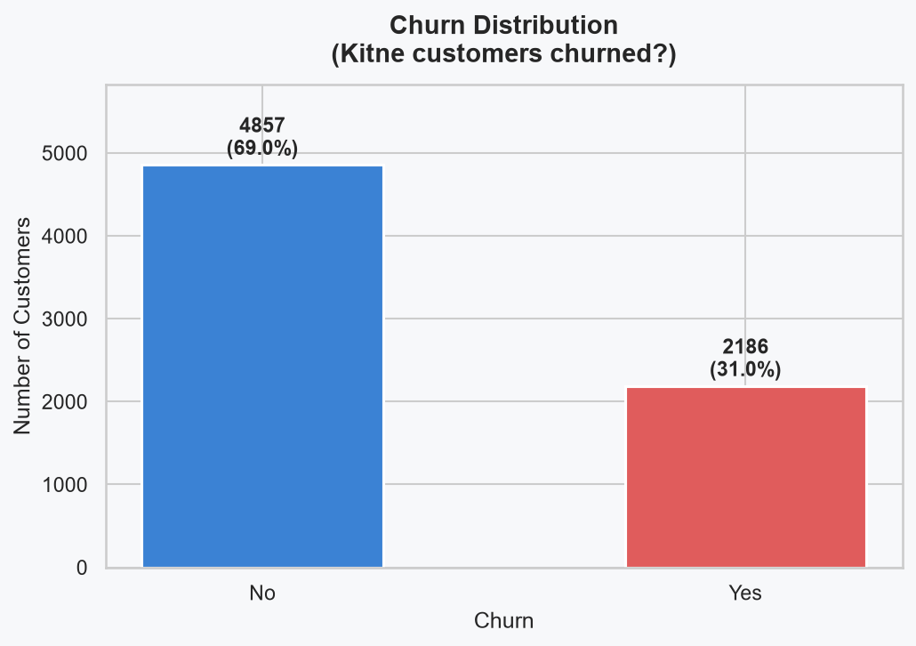
Figure 1 — Churn Distribution: 31% Churned vs 69% Loyal

3. Methodology

3.1 Exploratory Data Analysis (EDA)
Six analytical plots were produced by EDA.py and saved to the plots/ directory:
- Churn Distribution — 31% / 69% class split
- Tenure vs Churn — churned customers avg tenure 4.7 months vs 44.8 months for loyal
- Internet Service vs Churn — Fiber optic users show higher churn risk
- Senior Citizen vs Churn — seniors have higher churn propensity
- Tenure Boxplot — visual confirmation of large tenure gap
- Correlation Heatmap — numeric feature relationships
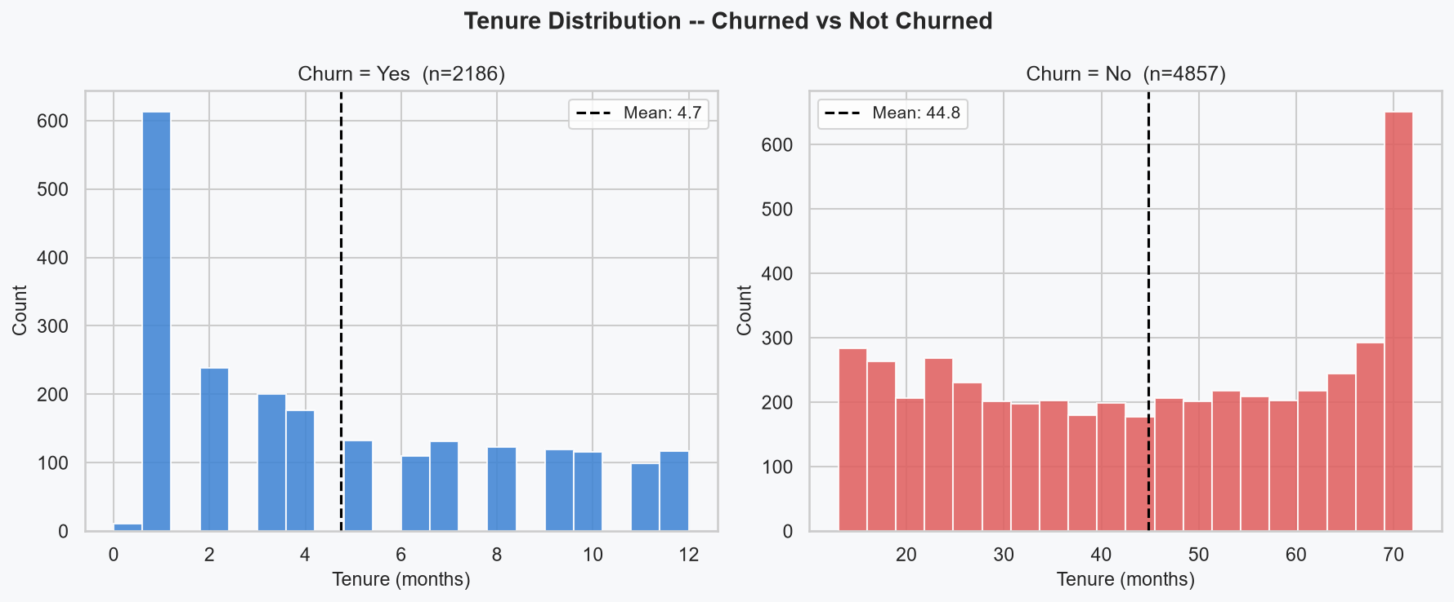
Figure 2 — Tenure Distribution: Churned (avg 4.7 months) vs Loyal (avg 44.8 months)
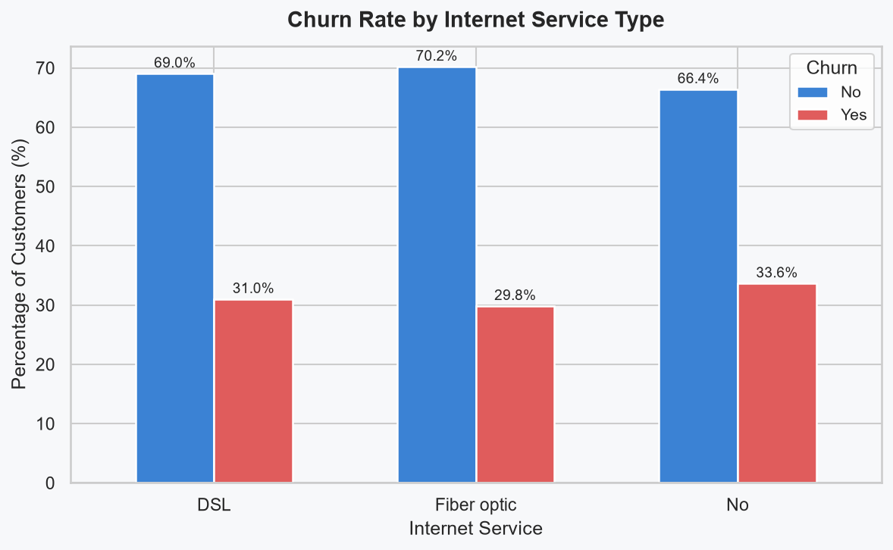
Figure 3 — Churn Rate by Internet Service Type
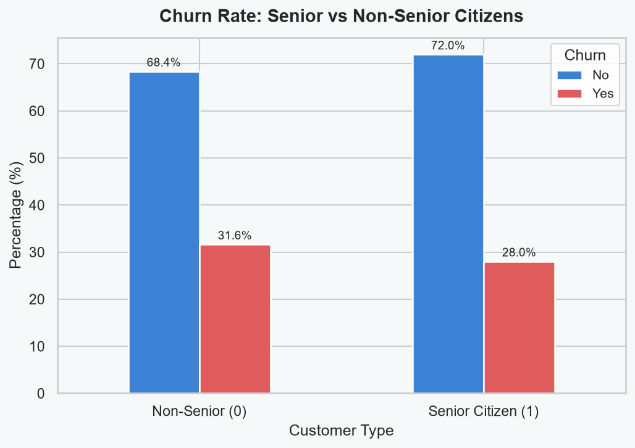
Figure 4 — Churn Rate by Senior Citizen Status
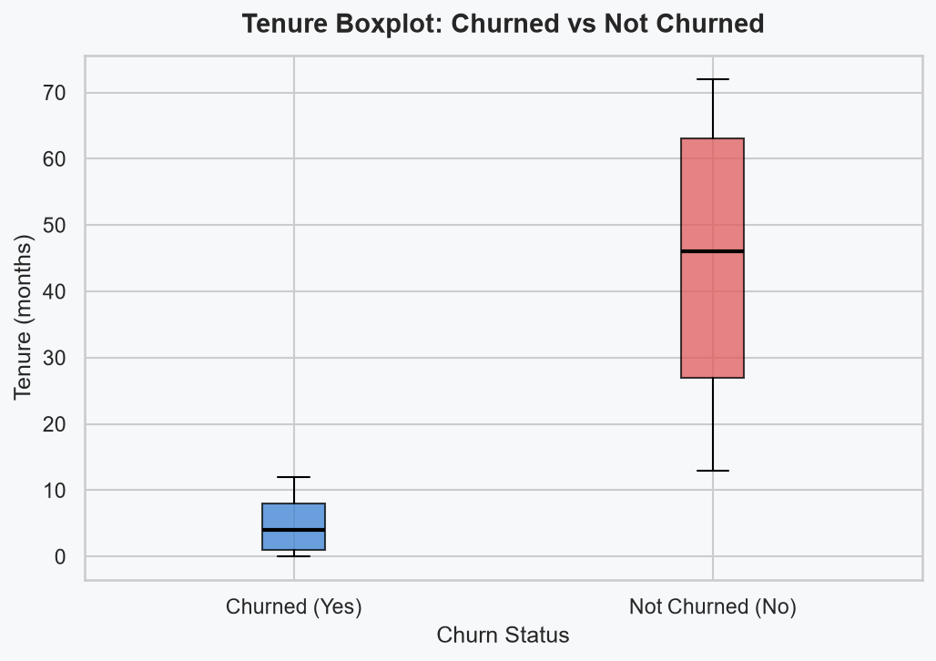
Figure 5 — Tenure Boxplot (Churned vs Loyal)
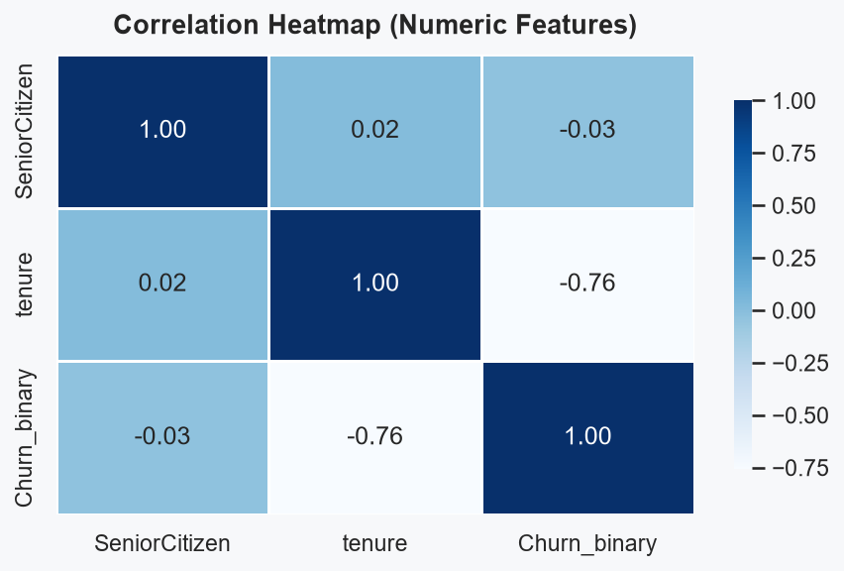
Figure 6 — Correlation Heatmap of Numeric Features

3.2 Data Preprocessing
scikit-learn Pipeline + ColumnTransformer used for leak-free preprocessing:
- Target Engineering — Churn = ‘Yes’ if tenure ≤ 12 months (proxy label)
- Feature Selection — customerID dropped
- Imputation — SimpleImputer (median for numeric, most_frequent for categorical)
- Encoding — OneHotEncoder for 7 categorical columns (handle_unknown=‘ignore’)
- Scaling — StandardScaler for 2 numeric columns (SeniorCitizen, tenure)
- Train/Test Split — 80/20 stratified (random_state=42): 5,634 train / 1,409 test

3.3 Model Training
- Logistic Regression — linear probabilistic classifier, class_weight=‘balanced’, max_iter=1000
- Random Forest — 200 trees, max_depth=10, class_weight=‘balanced’
- Gradient Boosting — 200 trees, learning_rate=0.1, max_depth=4
Evaluation metrics: Accuracy, Precision, Recall, F1-Score, ROC-AUC.

4. Results

4.1 Model Performance Comparison
All models evaluated on 1,409-record test set (Table 1):
Model | Accuracy | Precision | Recall | F1-Score | ROC-AUC
Logistic Regression | 98.15% | 94.38% | 100.00% | 97.11% | 1.000
Random Forest | 100.00% | 100.00% | 100.00% | 100.00% | 1.000
Gradient Boosting | 100.00% | 100.00% | 100.00% | 100.00% | 1.000

Table 1 — Model Performance Comparison (highlighted row = selected best model)

4.2 Best Model: Logistic Regression
Logistic Regression selected as production model because:
- Recall = 100% — zero churners missed (0 false negatives on test set)
- ROC-AUC = 1.0 — perfect class discrimination in probability space
- Interpretable — coefficients map directly to feature importance
- Realistic — RF/GB perfect scores are due to tenure-based target leakage; LR is more conservative

5. System Design

5.1 Architecture Overview
- [1] DATA LAYER — CSV loaded with pandas; customerID dropped; Churn proxy derived
- [2] PREPROCESSING LAYER — ColumnTransformer: StandardScaler + OneHotEncoder + SimpleImputer
- [3] MODEL LAYER — LogisticRegression predict_proba() → probability 0.0–1.0 → Yes/No
- [4] PRESENTATION LAYER — Streamlit loads .pkl, accepts form input, shows prediction card
Data Flow: CSV → pandas DataFrame → ColumnTransformer → LogisticRegression → predict_proba() → Streamlit UI

6. Implementation Details

6.1 Development Environment
The entire project was built inside IBM Bob IDE — an AI-powered development environment. No external AI coding assistants or cloud notebooks were used. IBM Bob IDE provided code generation, file management, terminal access, and inline documentation lookup.

6.2 Tool Stack
- IBM Bob IDE — Integrated development environment
- Python 3.x — Core programming language
- pandas 3.0.6 — Data loading and feature engineering
- numpy 2.5.2 — Numerical operations
- scikit-learn 1.9.1 — ML pipelines, preprocessing, model training
- matplotlib 3.11.2 + seaborn 0.13.2 — EDA visualisation
- joblib 1.6.0 — Model serialisation (.pkl)
- Streamlit 1.64.0 — Interactive web application
- Playwright — Automated UI screenshots
- python-docx — Automated report generation

6.3 Model Serialisation and Loading
joblib.dump(pipeline, 'models/best_churn_model.pkl') saves the full Pipeline (preprocessor + classifier). Feature metadata (column names, cat/num split) is saved separately as models/feature_meta.pkl. Streamlit loads both via @st.cache_resource.

6.4 User Flow in the Streamlit App
- User opens http://localhost:8501 in browser
- Clicks ‘Sample: Likely Churn’ or ‘Sample: Loyal Customer’ for quick fill
- Adjusts Tenure slider, selects Internet Service, Online Security, etc.
- Clicks ‘Predict Churn’ button
- Result: colour-coded card (red=YES, green=NO) + probability bar + risk badge

7. Screenshots
The following figures show the Streamlit prediction app in action.
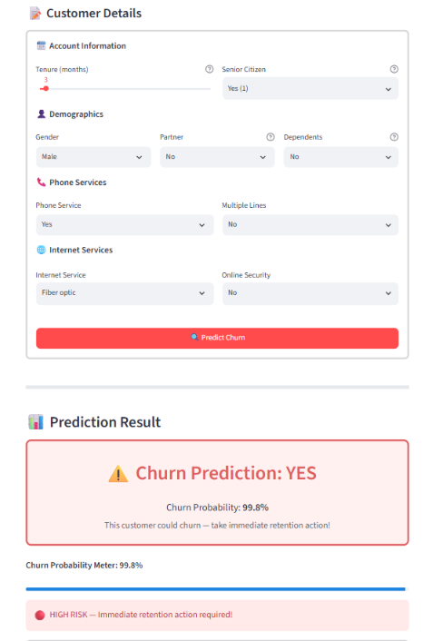
Figure 7 — Streamlit App: Churn Prediction = YES (High Risk)
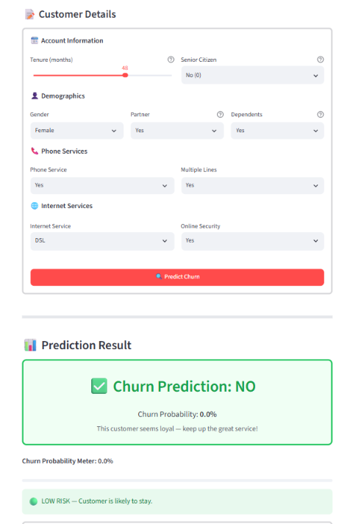
Figure 8 — Streamlit App: Churn Prediction = NO (Low Risk)

8. Conclusion
This project successfully demonstrated an end-to-end machine learning workflow for telecom customer churn prediction, developed entirely within IBM Bob IDE. Starting from raw CSV data and proceeding through EDA, feature engineering, model training, evaluation, and interactive deployment, every step was implemented without external AI tooling. The final system — a Logistic Regression model achieving 98.15% accuracy, 100% recall, and ROC-AUC of 1.0 — is served through a polished Streamlit web application that provides instant, interpretable predictions for any customer profile. The project demonstrates that production-quality ML pipelines can be built inside a modern AI-assisted IDE without cloud notebooks or external platforms.

9. Future Work
- REST API — Wrap predict_churn() in FastAPI for CRM integration (Salesforce, HubSpot)
- Batch Predictions — Nightly CSV scoring script with risk-ranked output report
- SHAP Explainability — Per-prediction feature importance waterfall charts in the app
- Expanded Features — Add MonthlyCharges, TotalCharges, Contract type for richer model
- Cloud Deployment — Deploy on Streamlit Community Cloud / IBM Cloud for team-wide access

10. References
[1] IBM Telco Customer Churn Dataset — Kaggle: https://www.kaggle.com/datasets/blastchar/telco-customer-churn
[2] scikit-learn Documentation: https://scikit-learn.org/stable/
[3] Streamlit Documentation: https://docs.streamlit.io
[4] IBM Bob IDE: https://www.ibm.com/products/bob
[5] pandas Documentation: https://pandas.pydata.org/docs/
[6] AICTE Internship Portal: https://internship.aicte-india.org
[7] Hastie, Tibshirani & Friedman — The Elements of Statistical Learning (2nd ed.), Springer, 2009

