Create a new folder with name models inside your fastapi project -> create a file with name student.py as below inside models folder

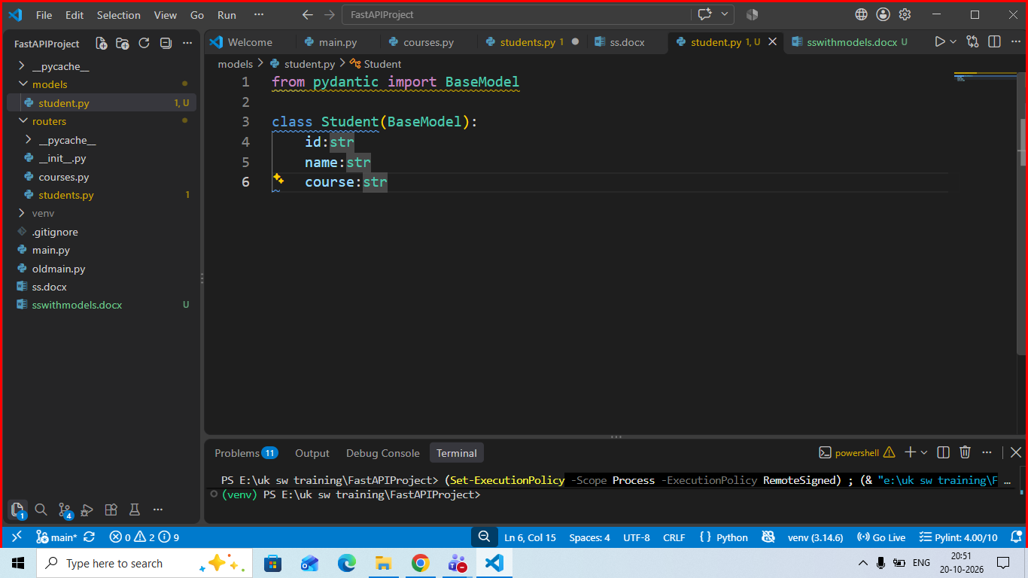

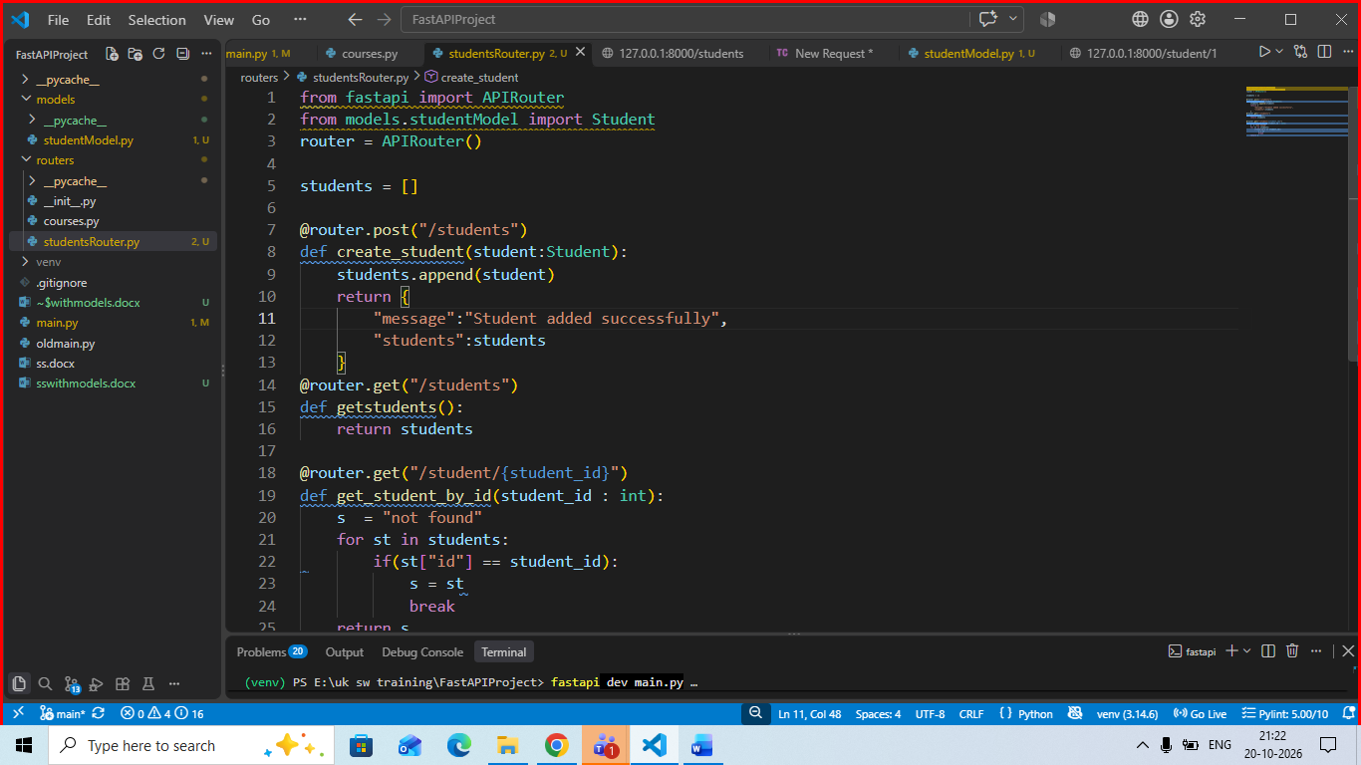

Now open thunderclient extension and call the url with get and post method for the corresponding work

