Create a new folder with name fastAPIProject
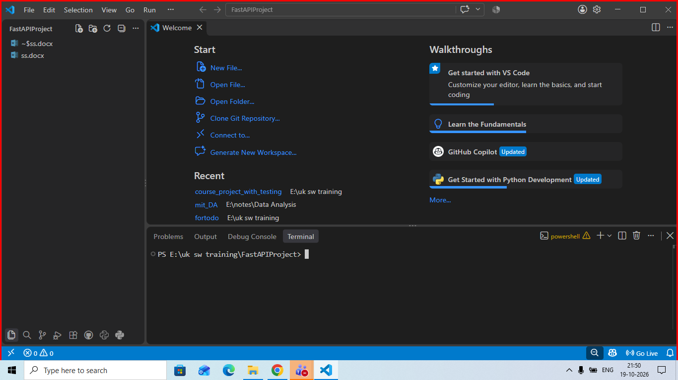

Open a new terminal and check python is installed or not
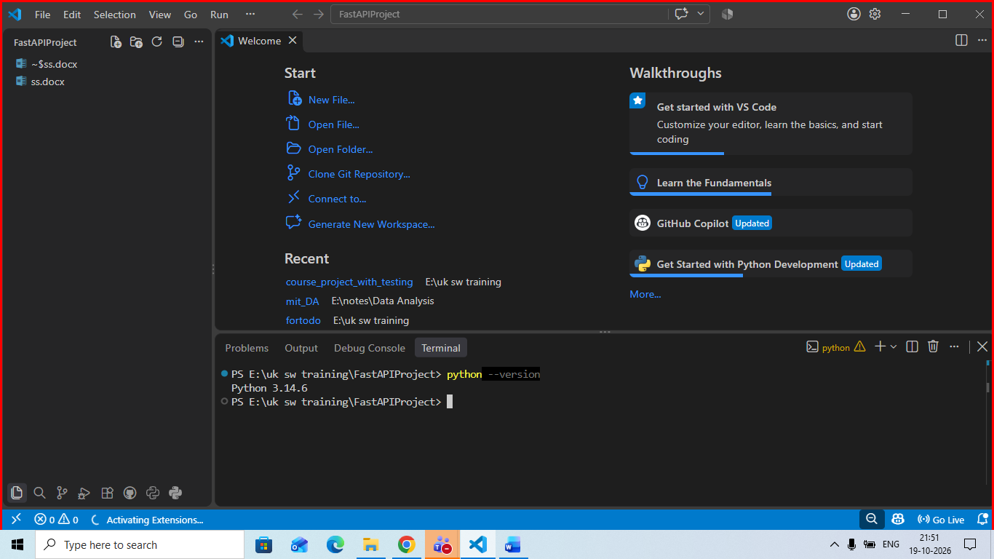

Creatte virual env
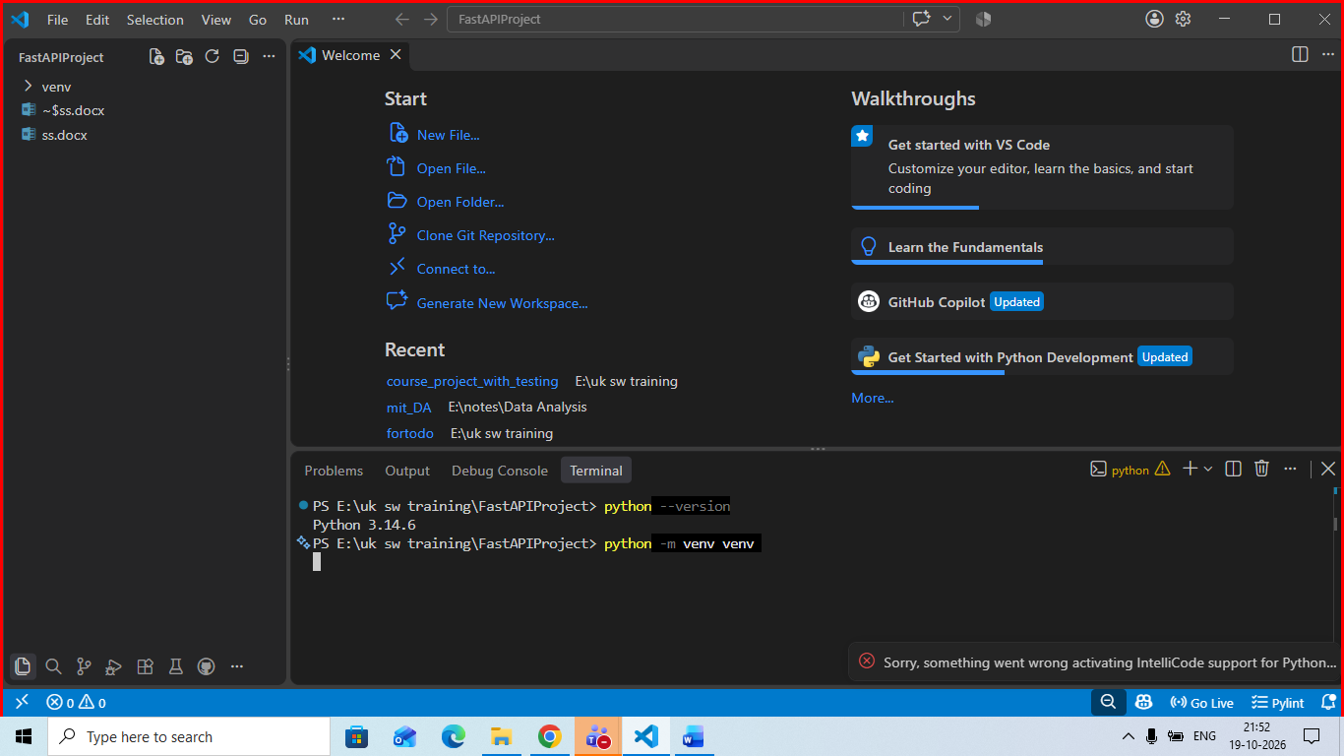

Create new file with name main.py
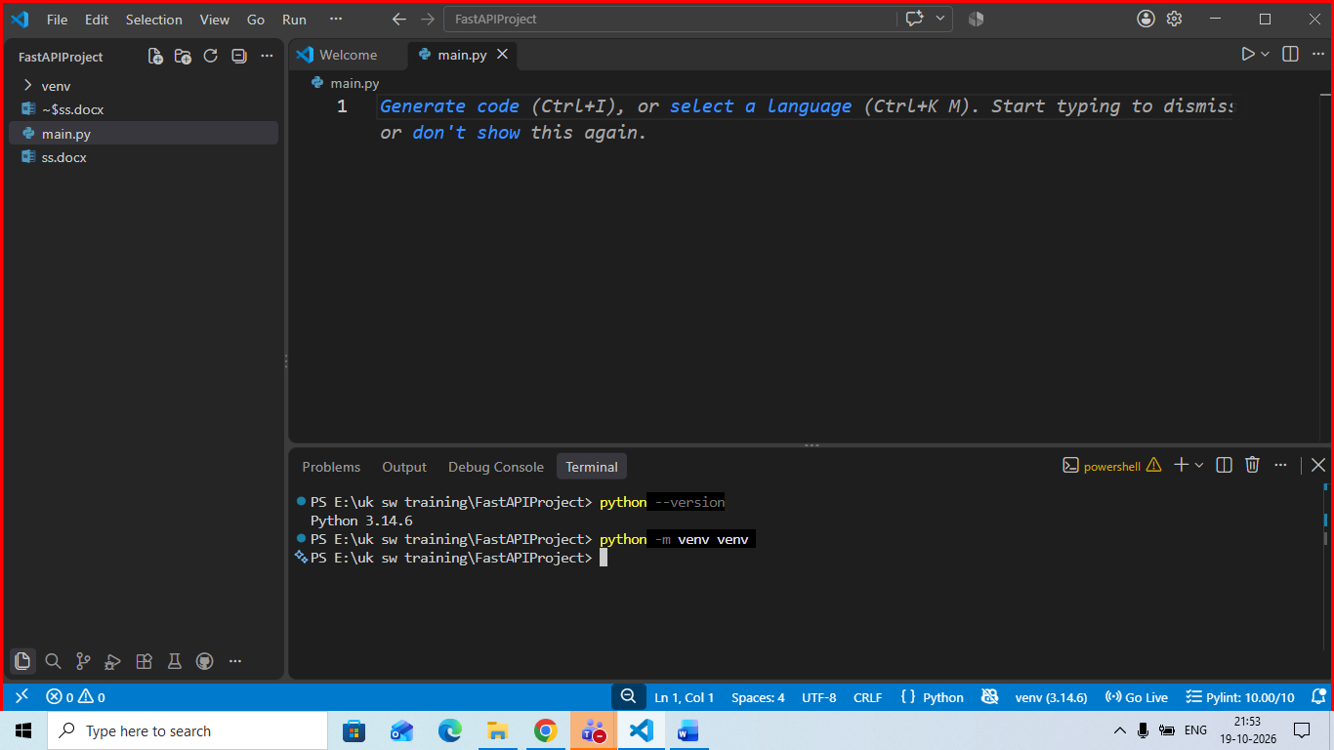

Activate your virtual env
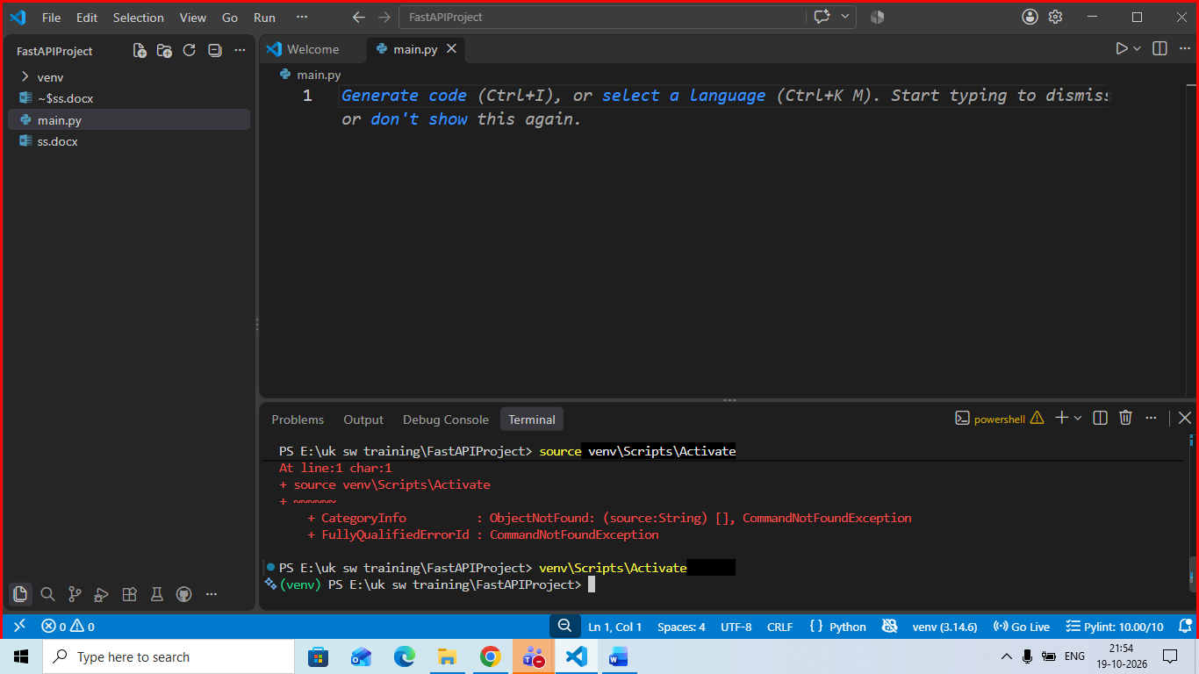

Install FASTAPI
python -m pip install "fastapi[standard]"
in your main.py
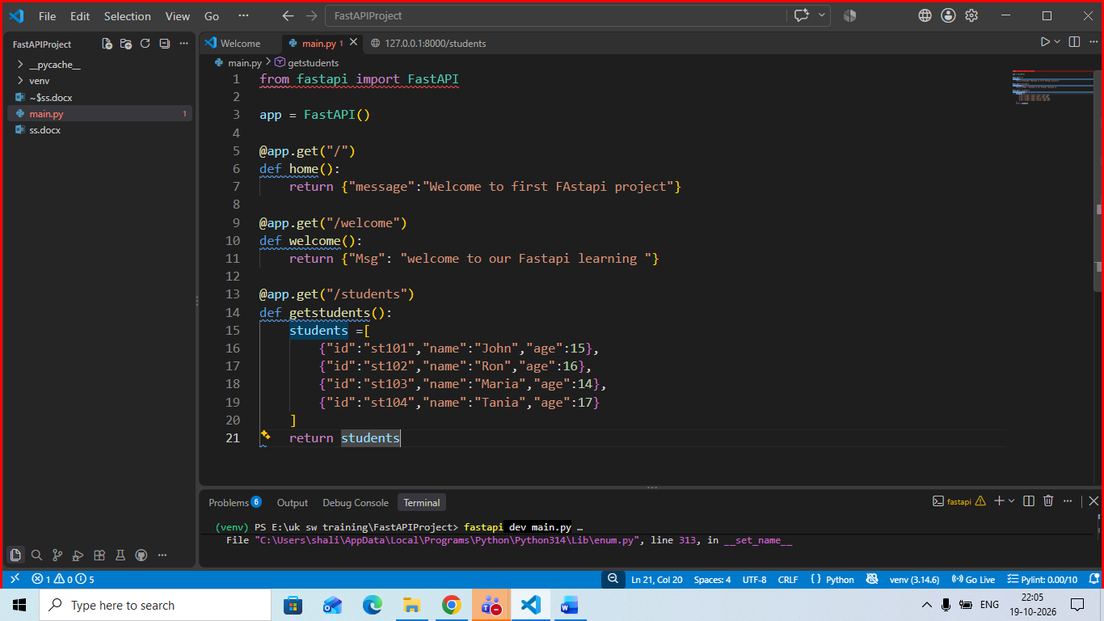

To run this app , excute below command
fastapi dev main.py
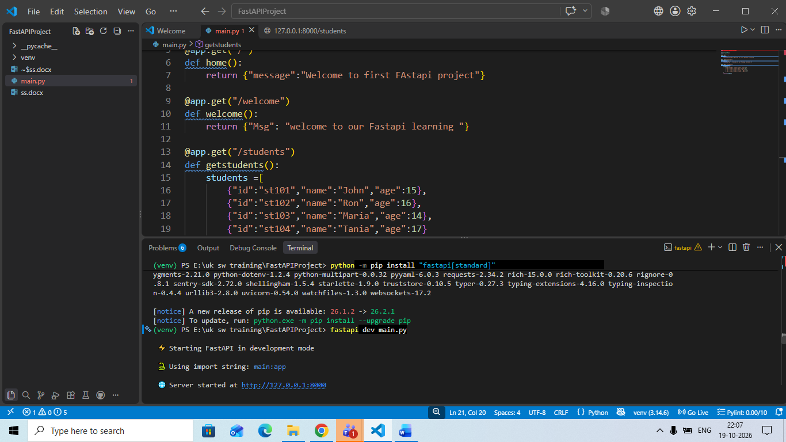

Create new folder with name routers
Create file __init__.py sho that it will become python package
Then courses.py inside routers as below
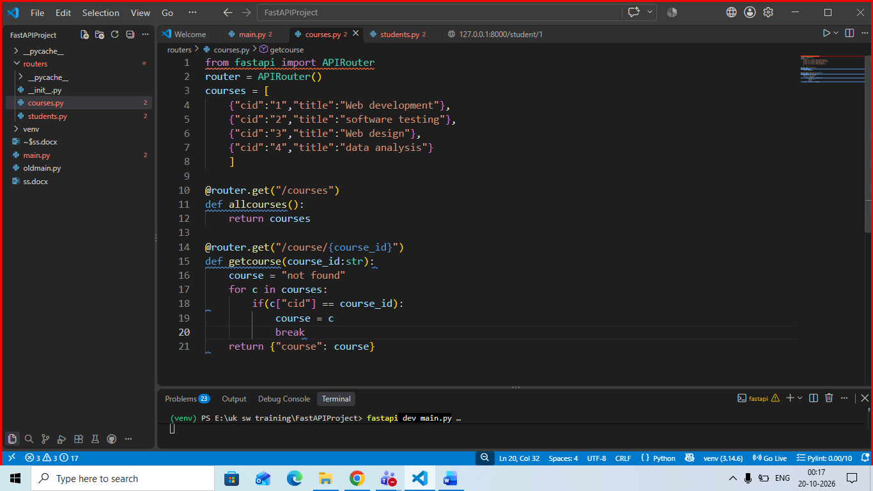
Then students.py in routers as below
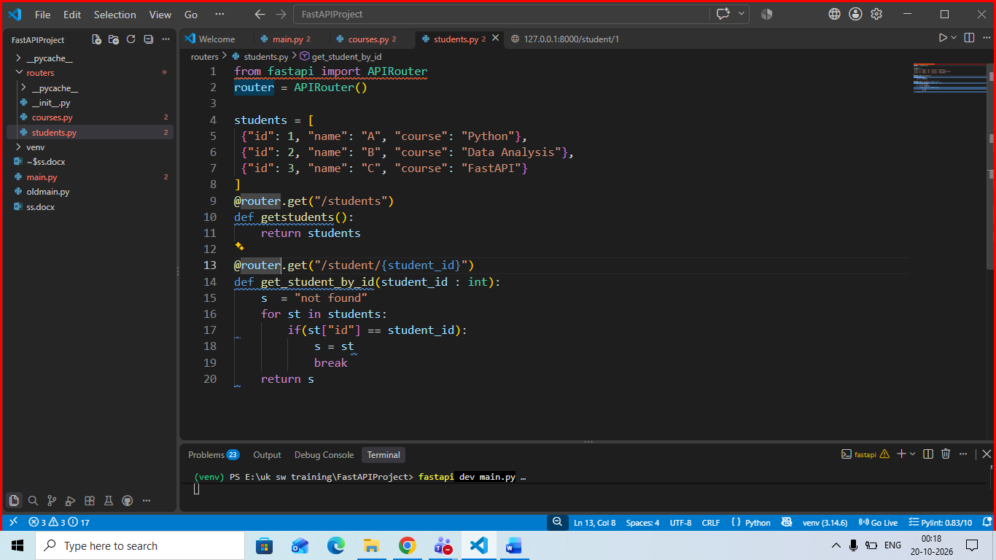

Then perform changes in main.py as below
