Create a database.py in models folder
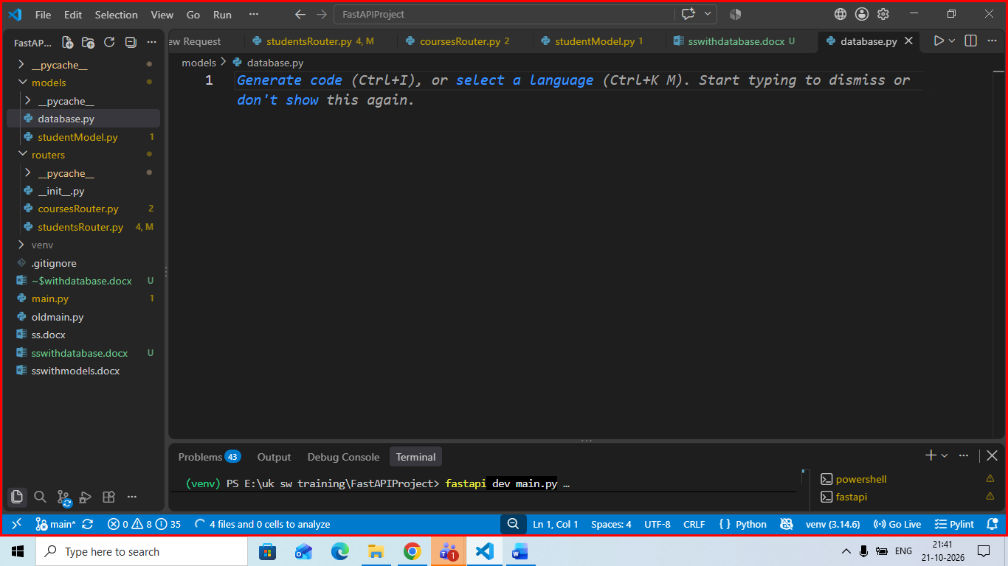
First install sqlalchemy in your virtual env using command
pip install sqlalchemy

now write ebelow code in database.py

from sqlalchemy import create_engine
from sqlalchemy.orm import declarative_base,sessionmaker
DATABASE_URL ="sqlite:///./items.db"

engine = create_engine(
DATABASE_URL,
connect_args = {"check_same_theread":False}
)
SessionLocal = sessionmaker(
autocommit =False,
autoflush=False,
bind=engine
)

Base = declarative_base()

def get_db():
db = SessionLocal()
try:
yield db
finally:
db.close()

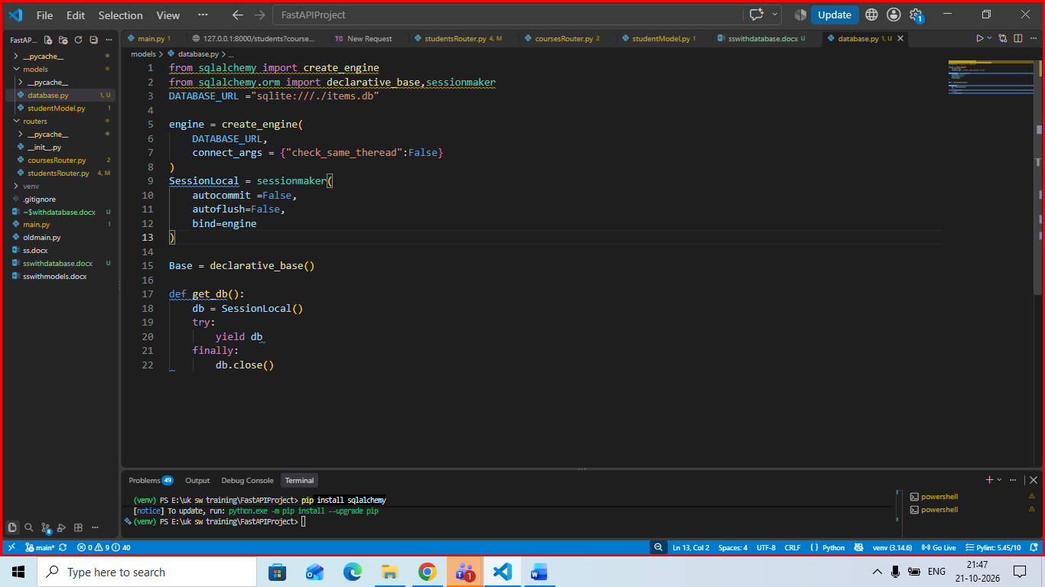

Create file withname itemModel.py inside models
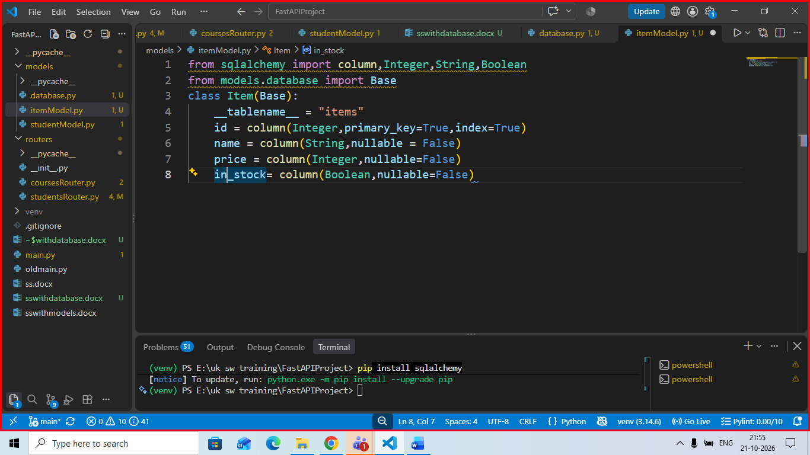

Create a new file with name itemSchema.py inside your models folder
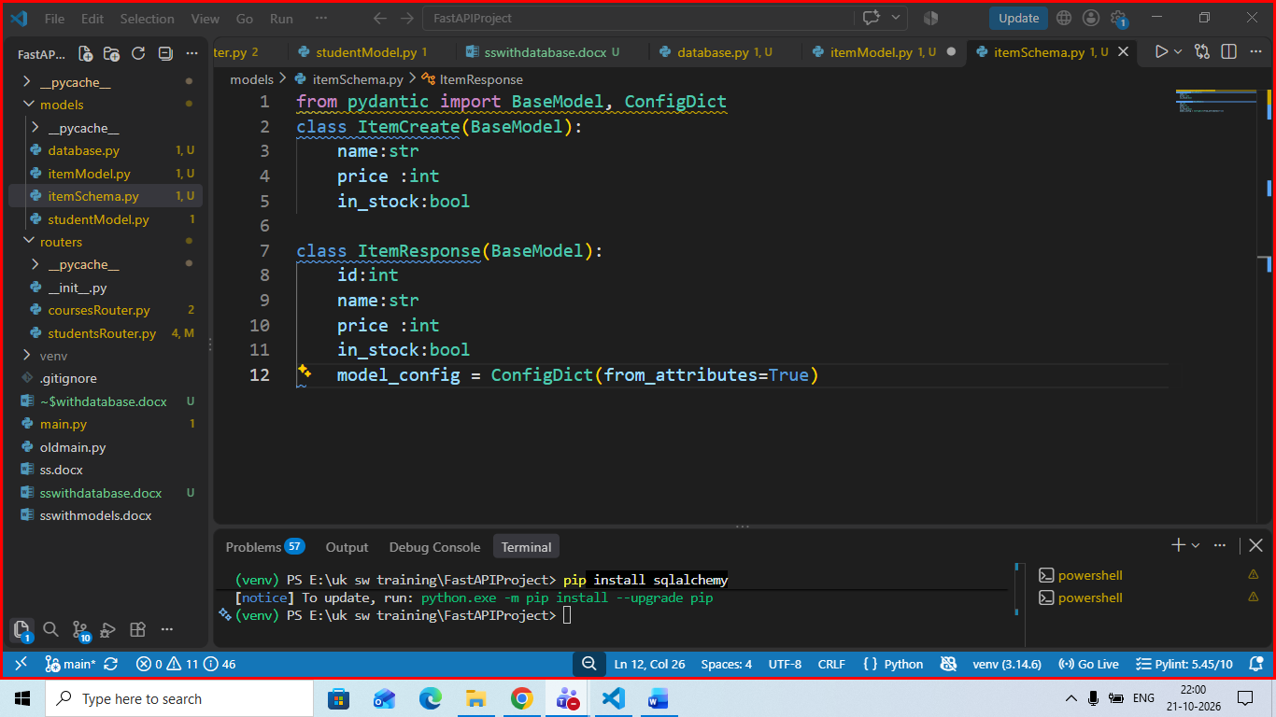

Now create a new file with name itemsrouter in your router folder
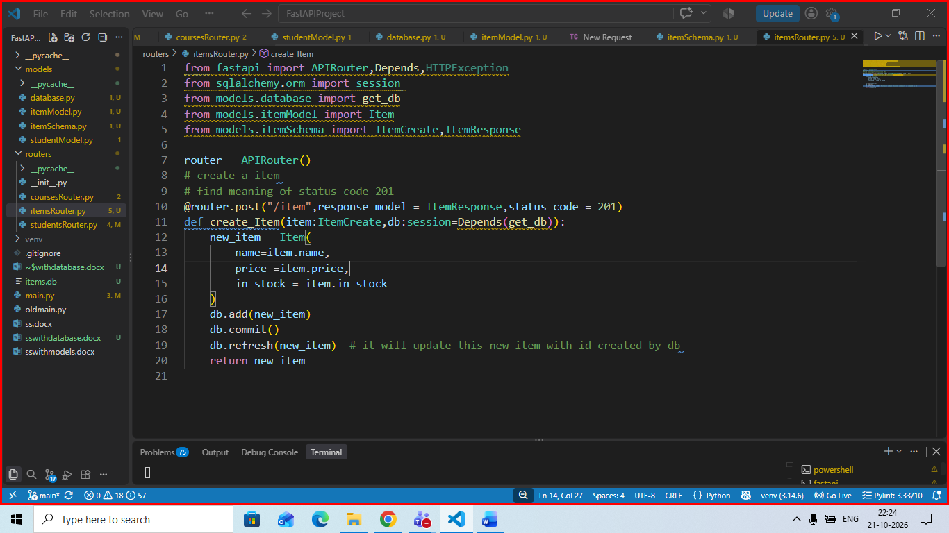

Perform changes in main.py
