Create a new folder with name course_project_with_testing and open it in vscode
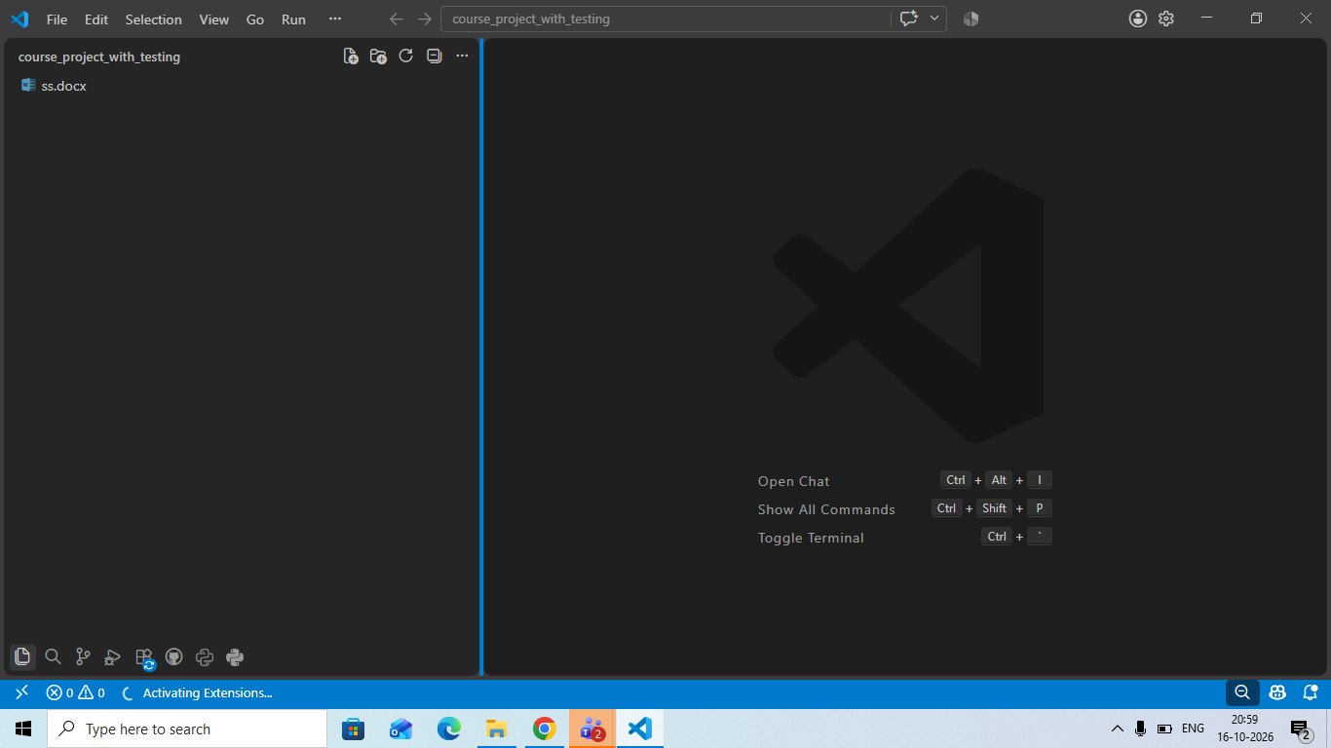

Create a virtual env in this folder
python -m venv venv
and activate it

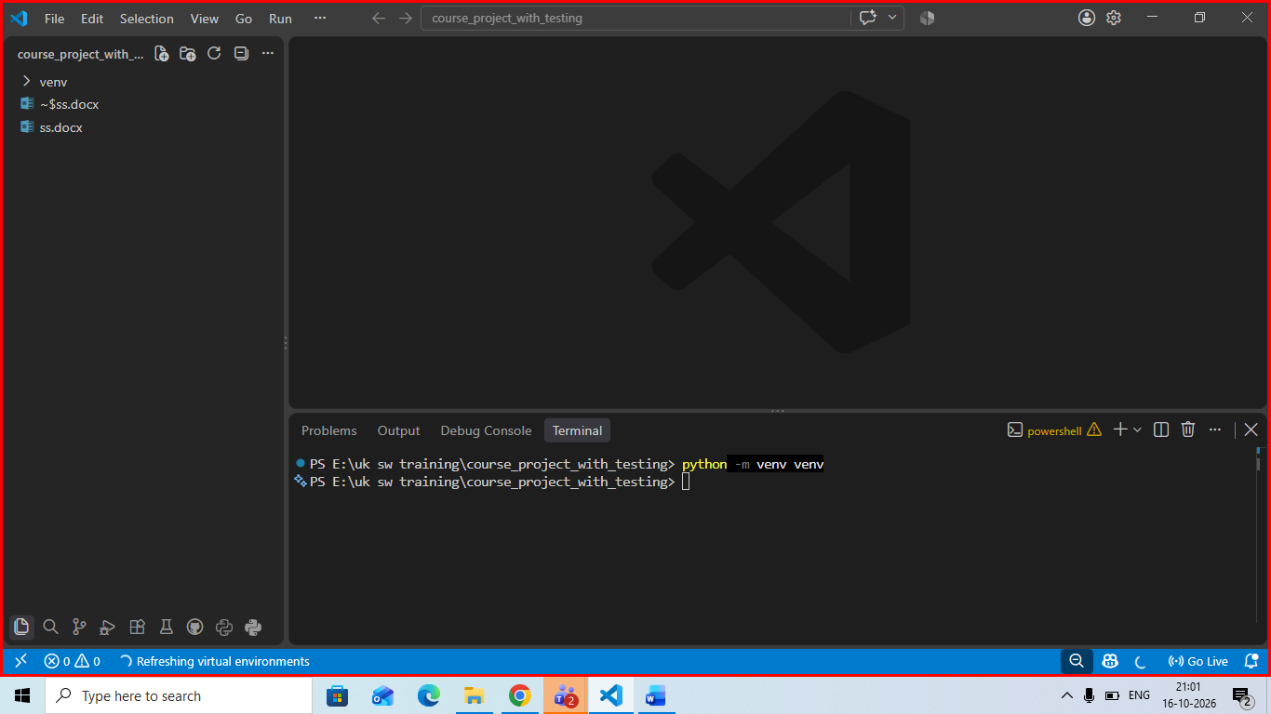
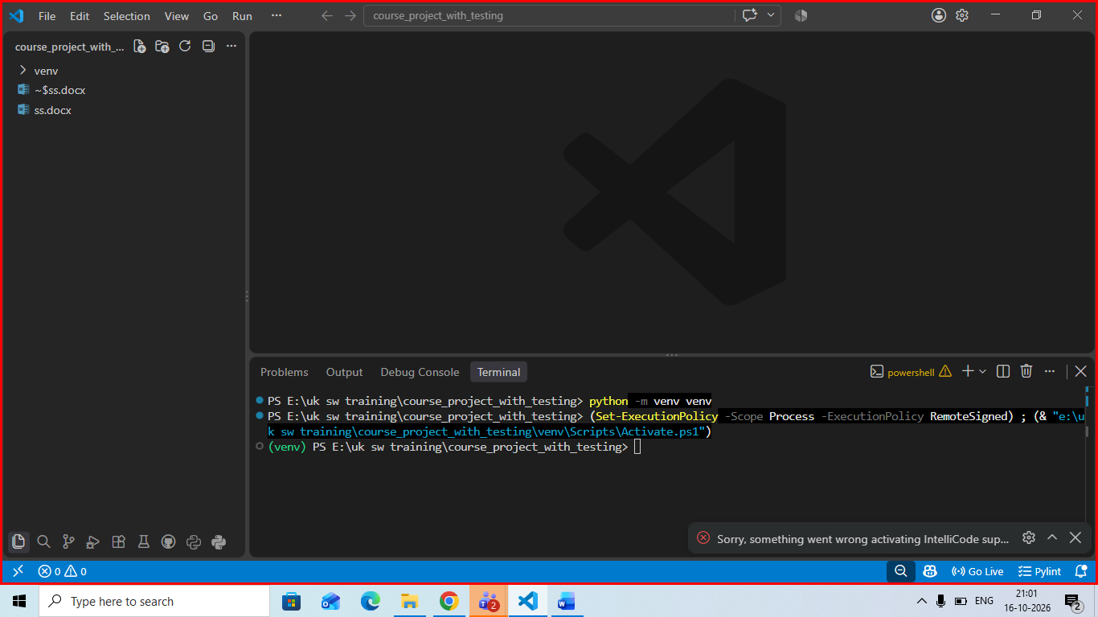

python -m pip install Django

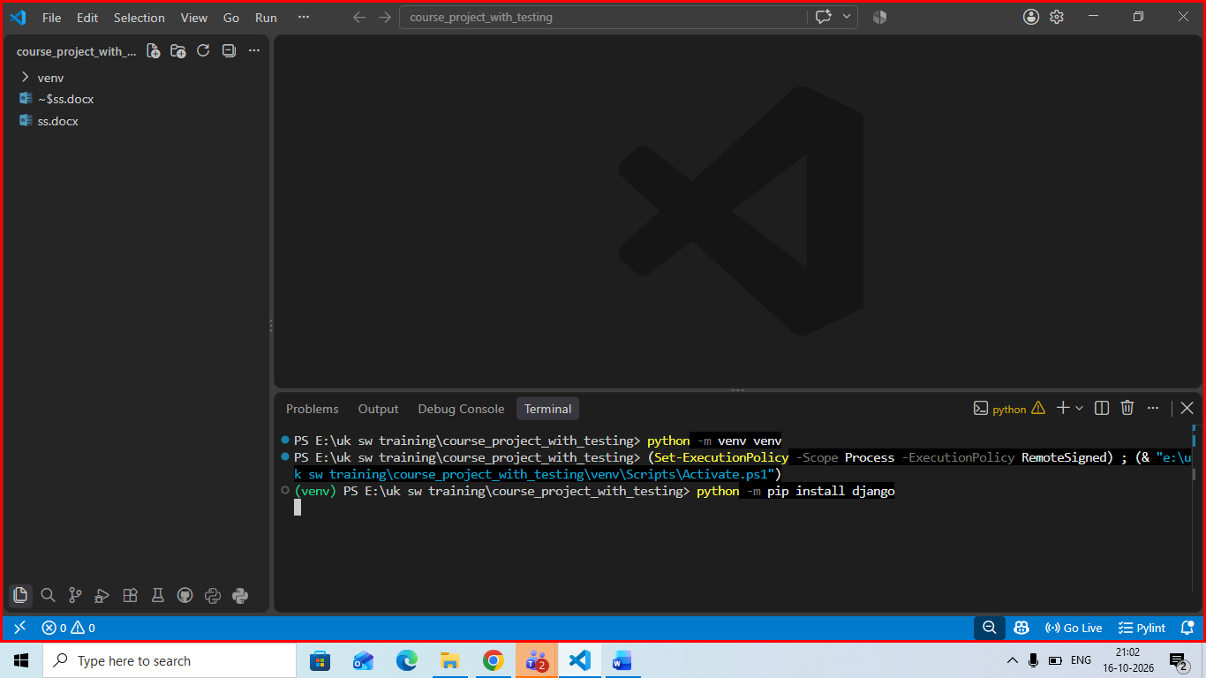

Create a newdjango project using command
django-admin startproject course_project_with_testing .
don’t forget . at the end it will create a new project in same directory

then create a new app with command : python manage.py startapp courses
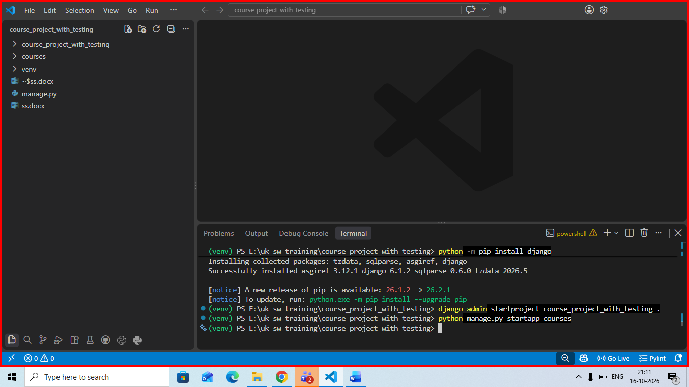
Registed this app in our installed app section of setting.py
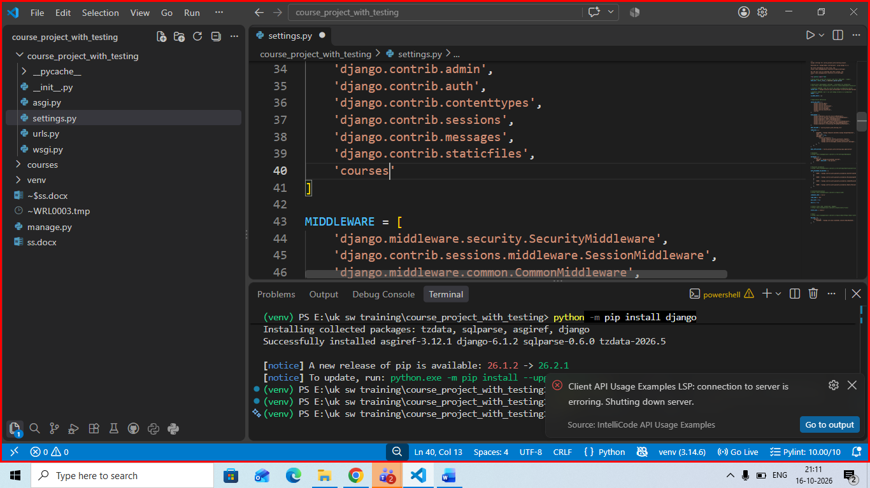

Initial project check : python manage.py check
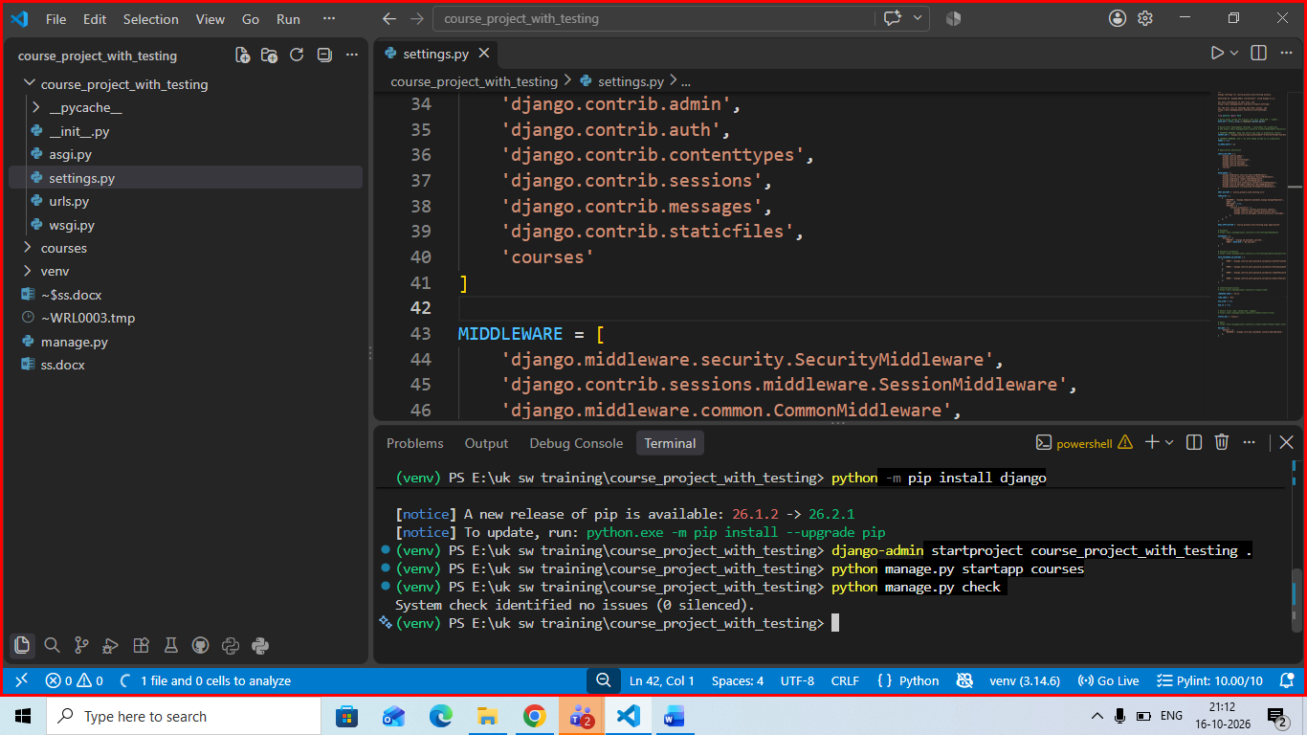

Create the test plan first at the same location as of your manage.py

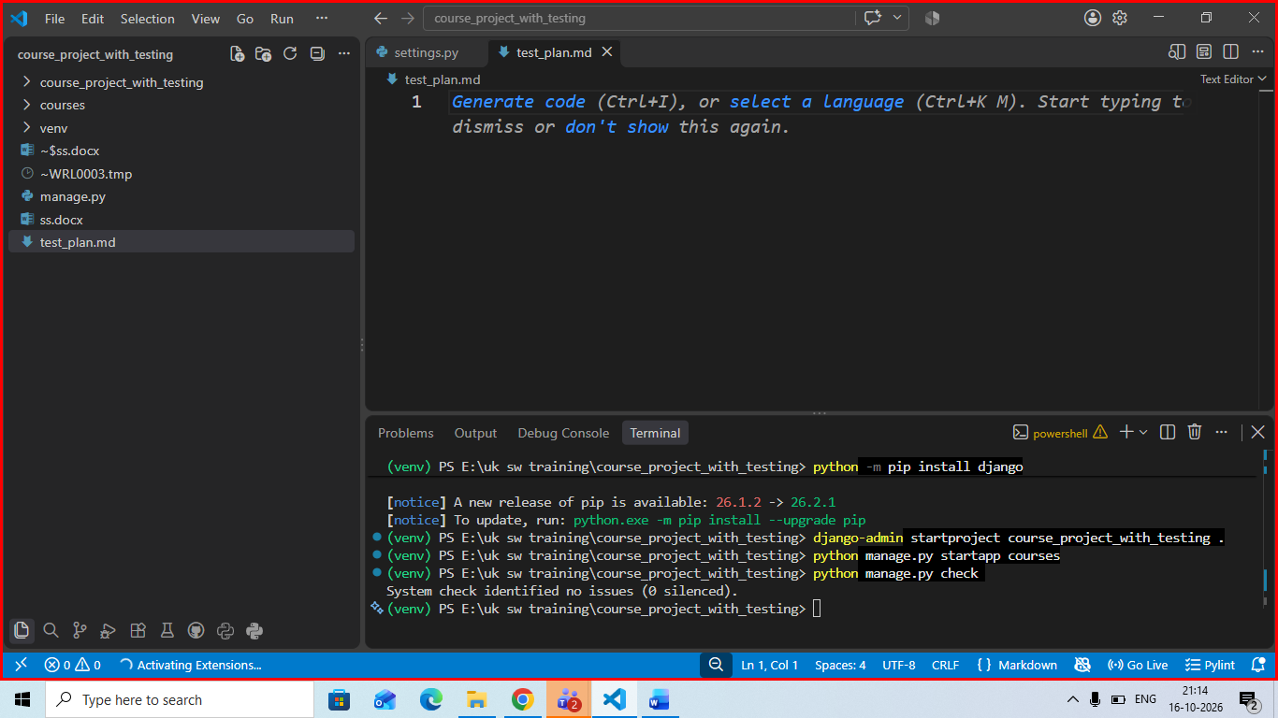

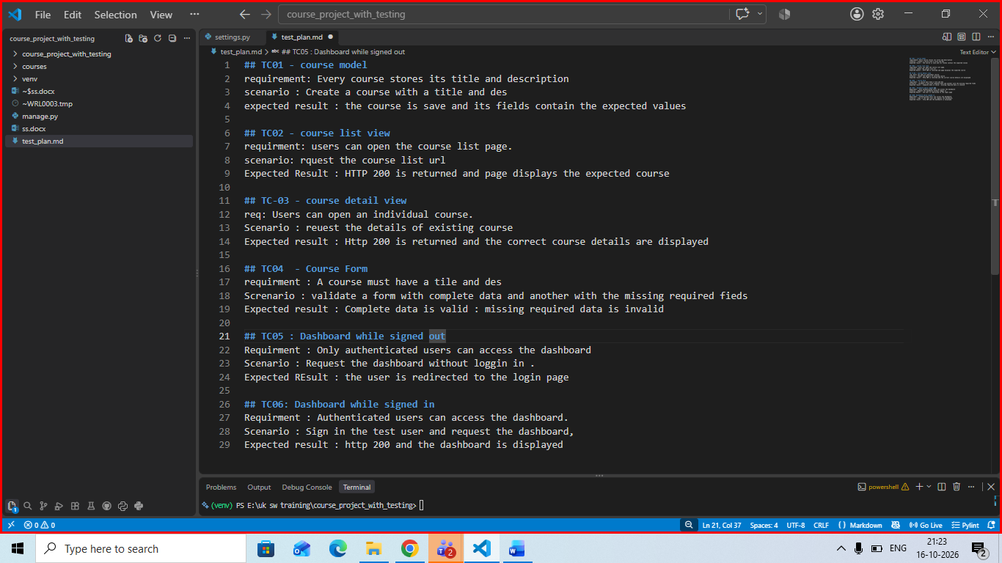

Create the course model
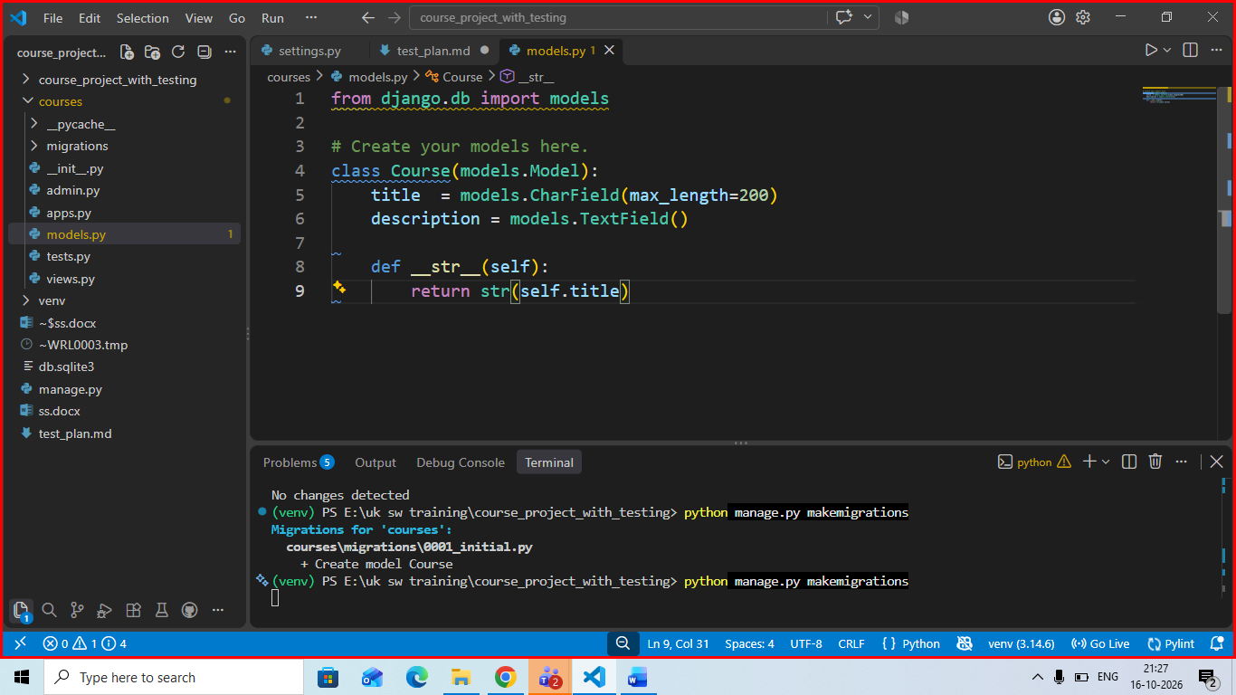

Createa and apply the migrations
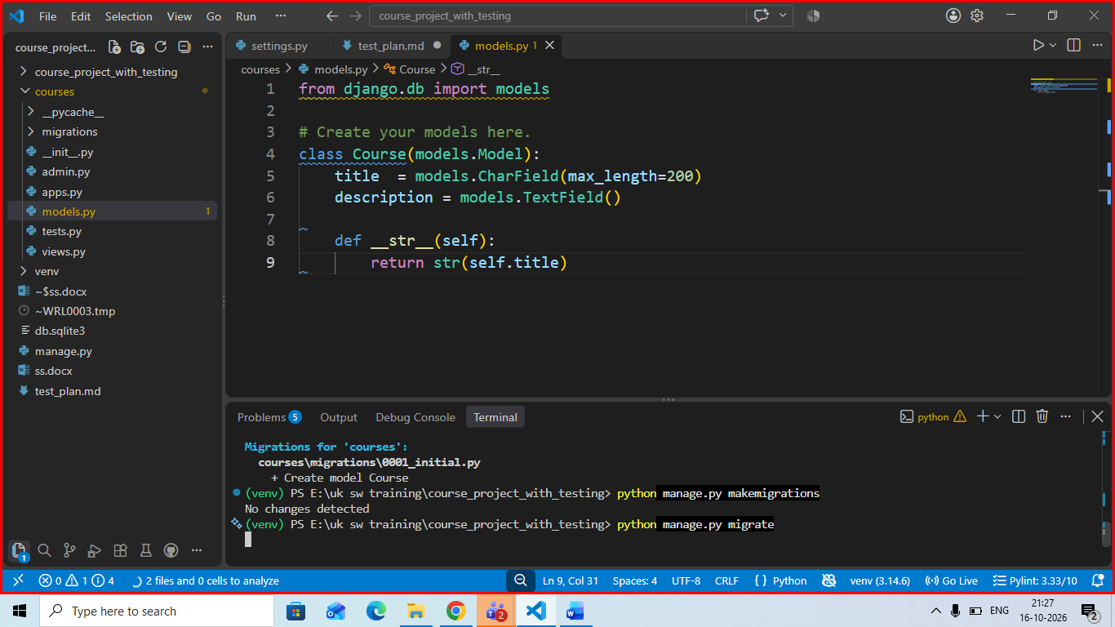

Create the course form
Create a new file with name forms.py im course folder
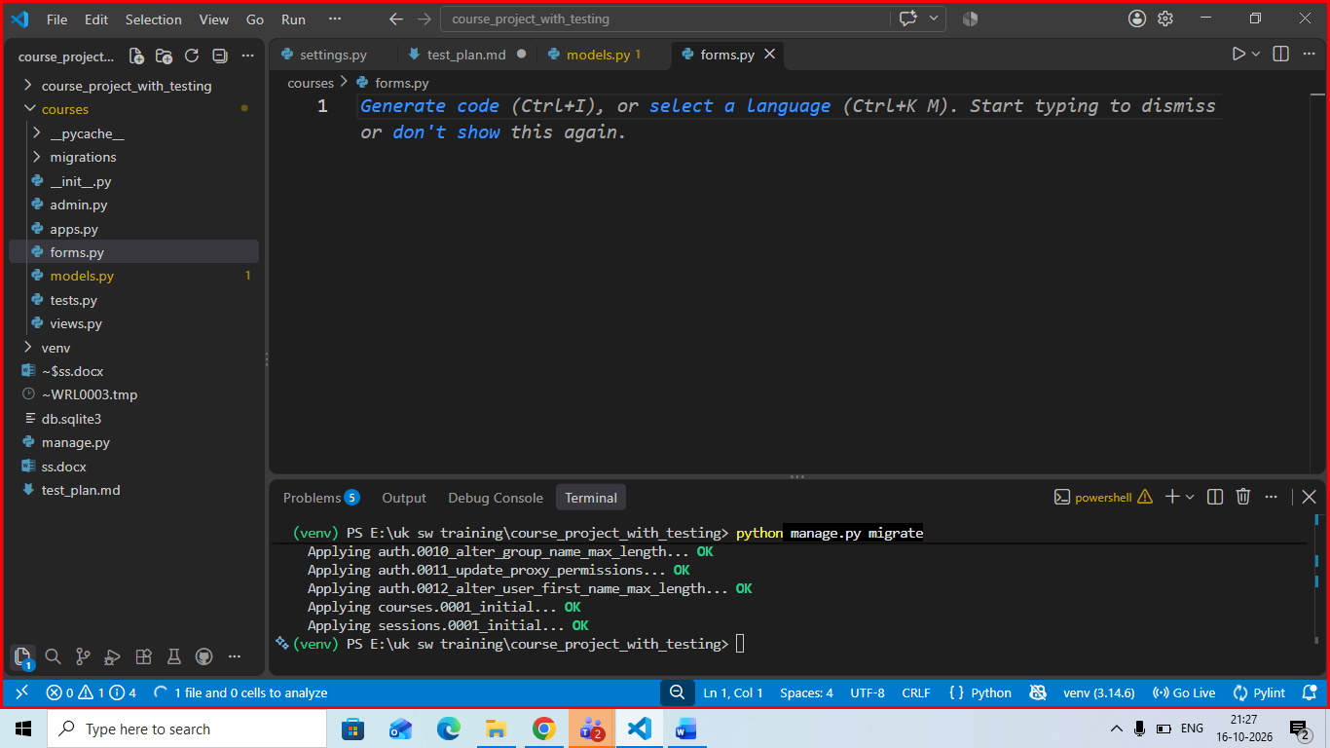
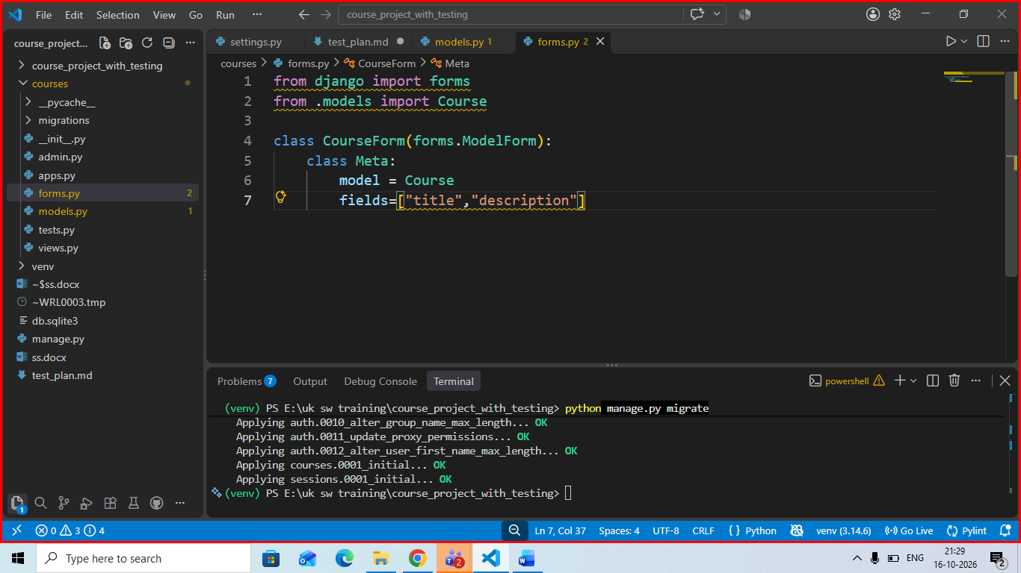

Create the views

