First open your project
Activate virtual enviromenet
Create new app with name contact
Like PS E:\uk sw training\SDGLA3\revisionofdjango> myvenv/Scripts/activate
(myvenv) PS E:\uk sw training\SDGLA3\revisionofdjango> python manage.py startapp contact

Then create forms.py
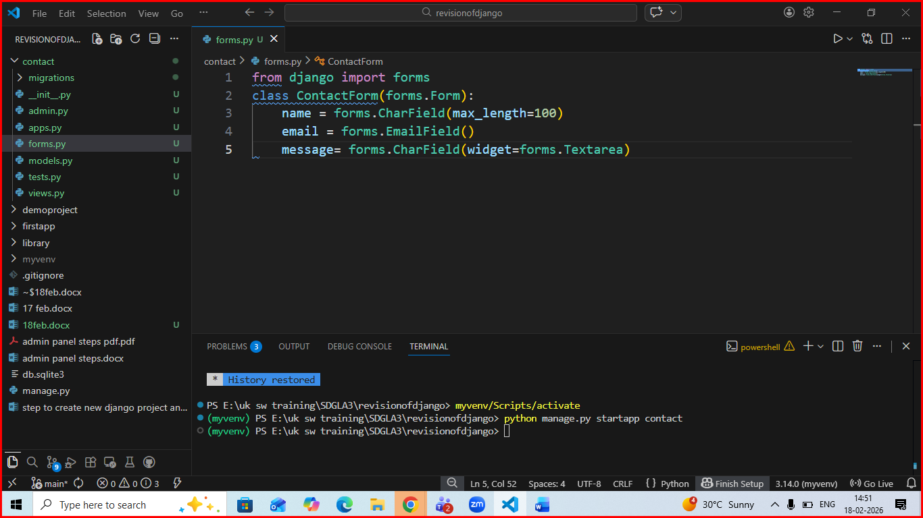
Then in views.py
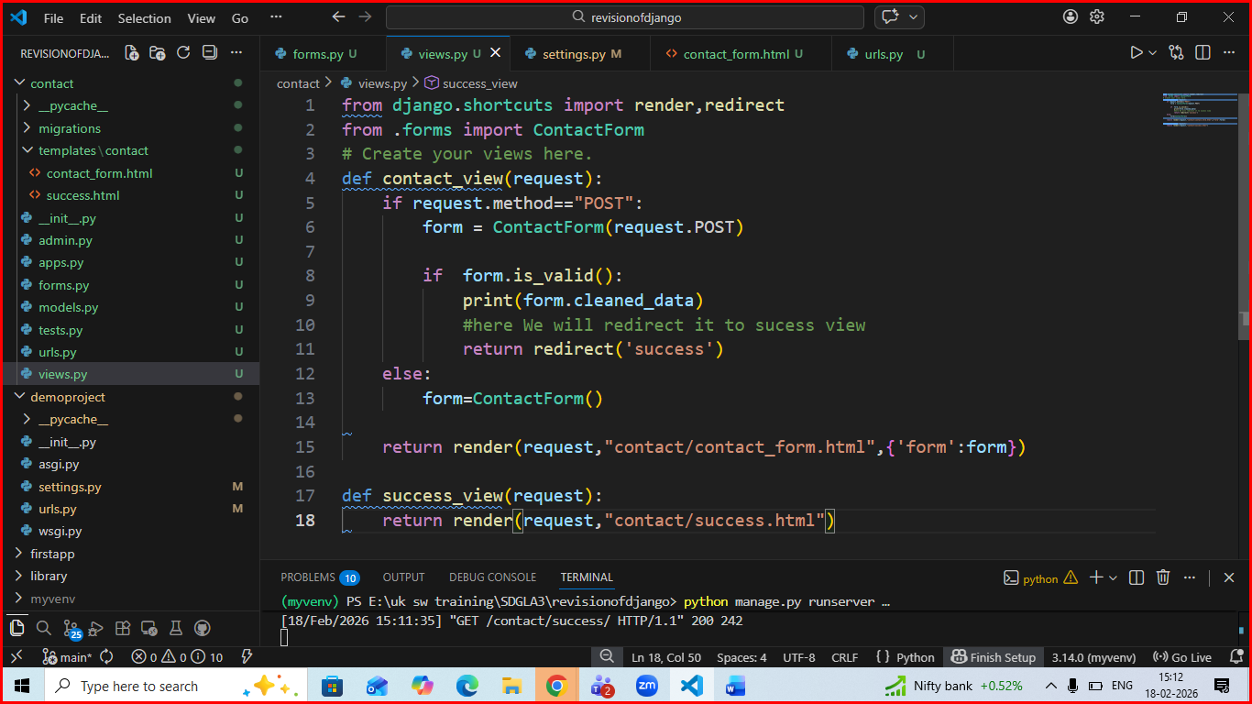
In urls.py of contact app
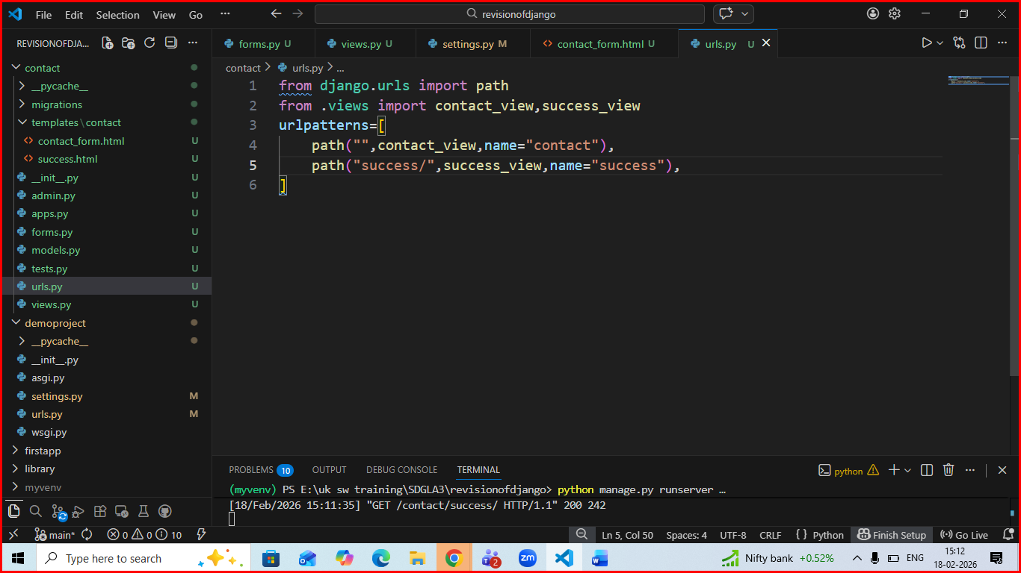
Createa template with name contact_form.html
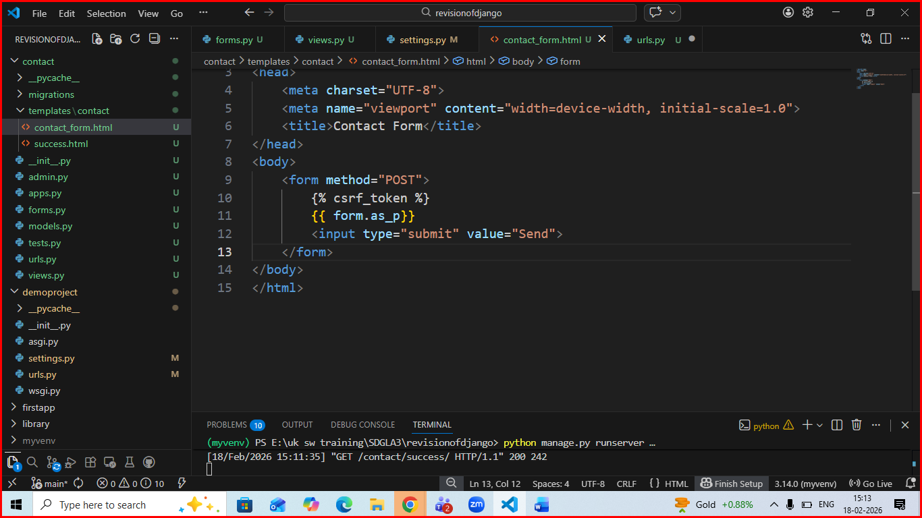
Then success.html like
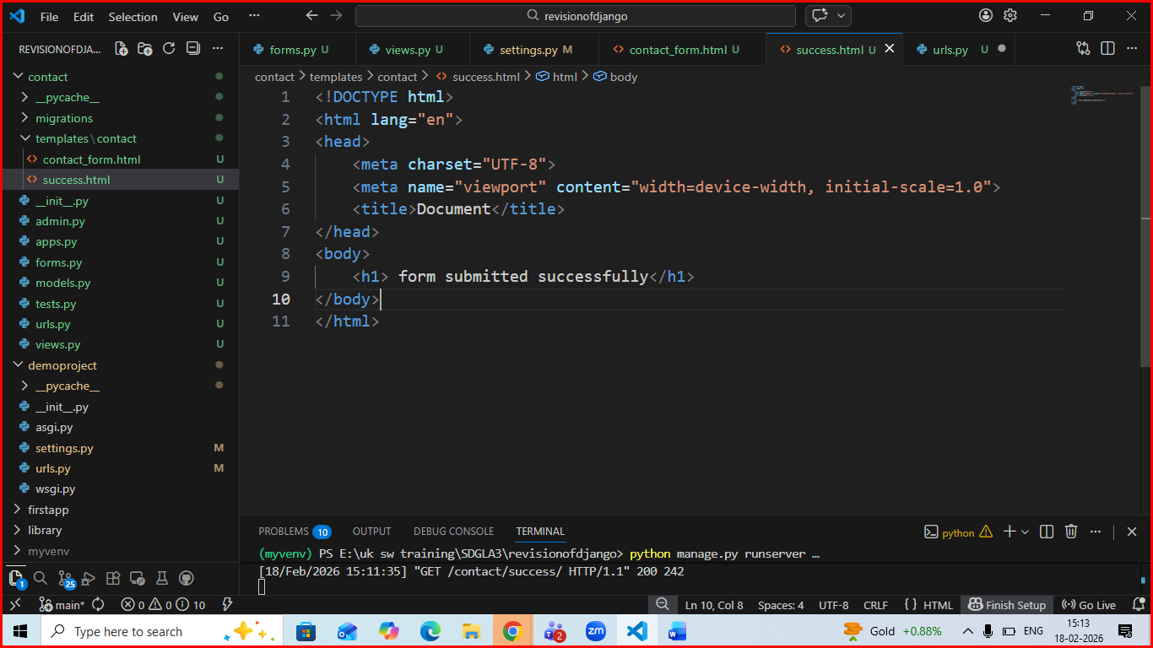
Register this app in installed app section of settings.py of main project
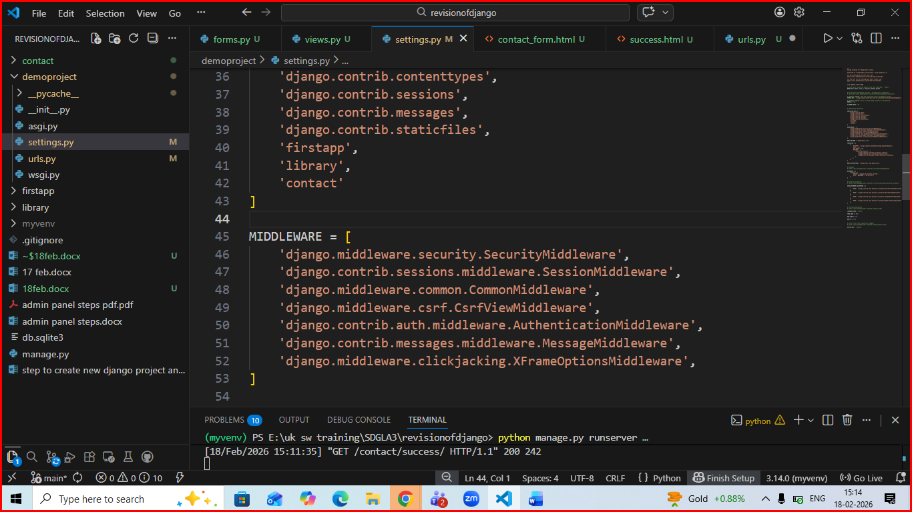update urls.py of main project to add route form contact app like :
