**CDA EDITOR**

**User Guide**

**User guide**

In the tab *View CDAs*, the existing CDA files are listed. By clicking on a list item the CDA content appears (in XML and HTML format). By pushing *Register Document*  button, the selected CDA is registered into XDS. By double clicking on a list item or pushing *Create CDA*, the user can edit the selected CDA file or create a new one (figure 2).

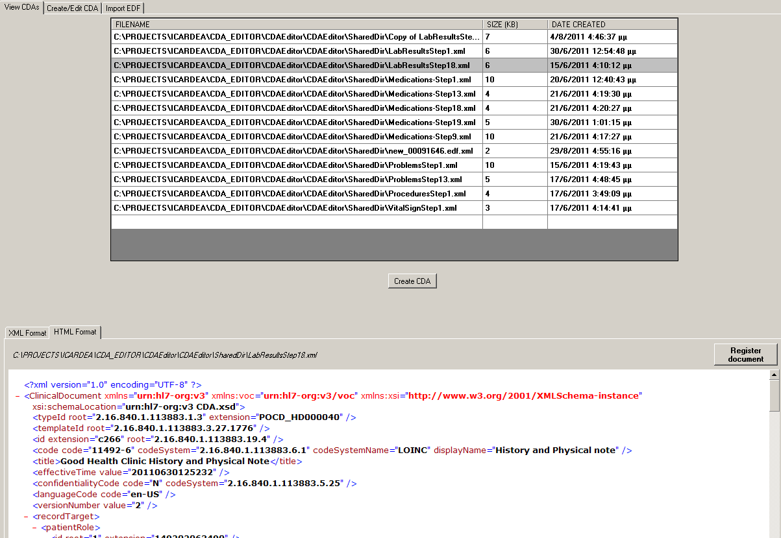

Figure 1

Figure 2 presents the interface for creating/editing CDA files. Button *Ask PIX* shows the form of figure 3 where the user gets the mapping between HIS id and protocol id and fills the patient info data. For each type of medical data categories (lab exams, problems, procedures, vital signs, medications) there is a list with the current CDA records. The user can add/edit/remove any of them.

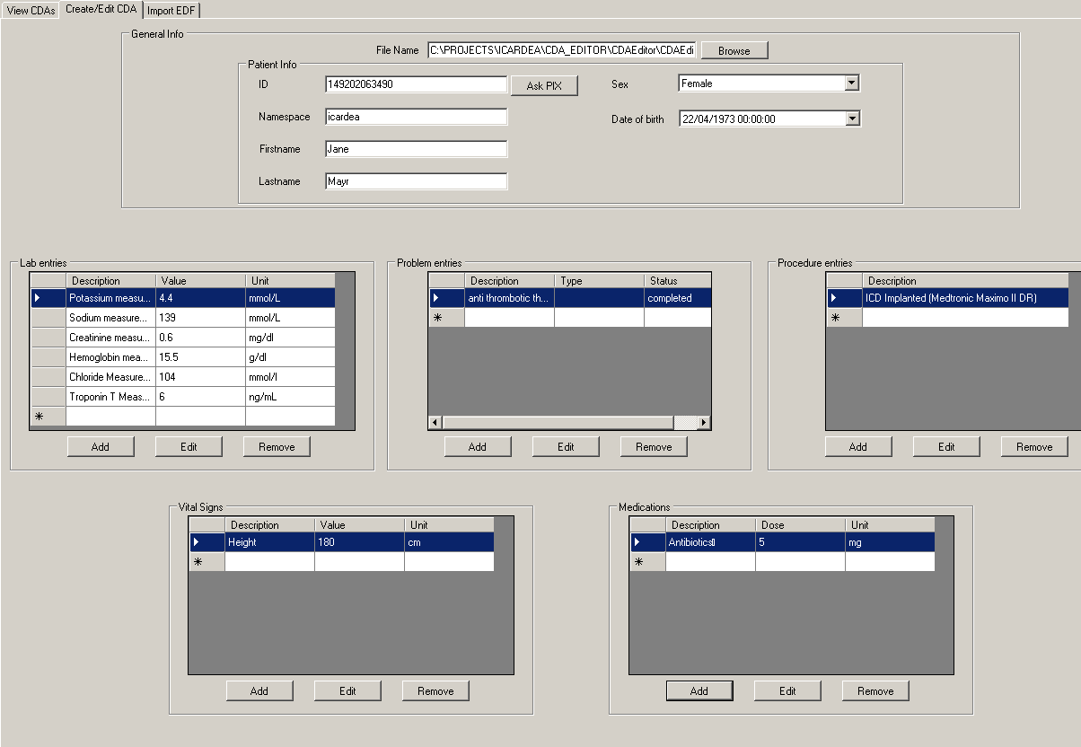

Figure 2

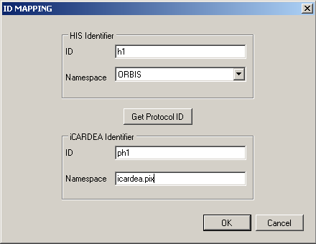

Figure 3

The form for add/edit is presented in figure 4 (i.e. for lab exams). The user selects the lab exam from a list of the available exams (search can be done by code and description) and fills the required attributes (value, unit, date)

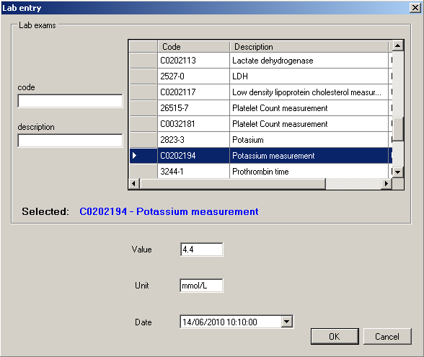

Figure 4

Finally in tab *Import EDF* the user selects an EDF file from the disk, selects the patient the EDF refers to, and creates the corresponding CDA by pushing *Create CDA* button (figure 5).

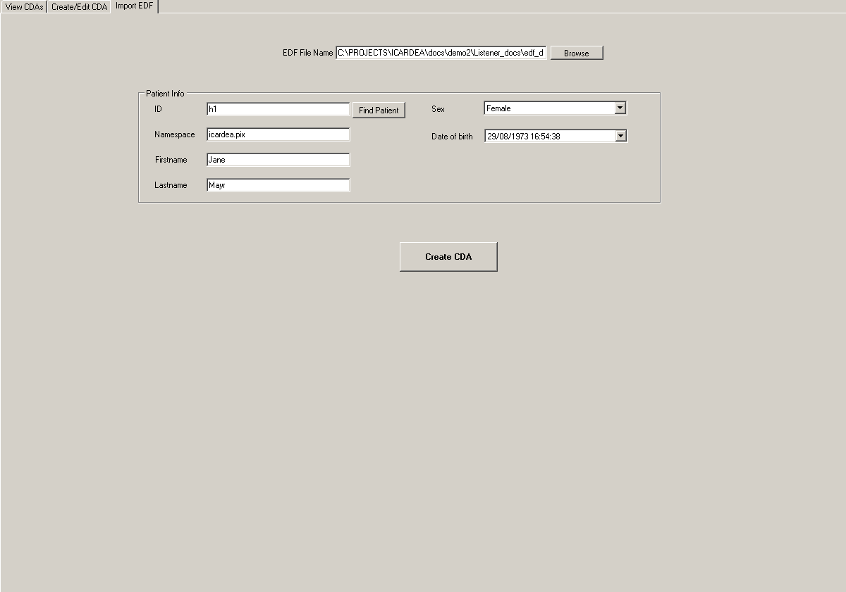

Figure 5

**Configuration**

In the installation directory there is a configuration file *app.config.xml*. The following parameters need to be configured in this file:

* *sharedDir*: the directory path that CDA EDITOR stores the CDA documents created. It is also the directory CDA EDITOR watches and presents the existing CDA documents
* *xds*: the url of the XDS service
* *PIX_ip*: the IP of the machine PIX server is running
* *PIX_port*: the port PIX server is running

These settings can also be configured by selecting the *Settings* tab in the CDA Editor user interface (figure 6).

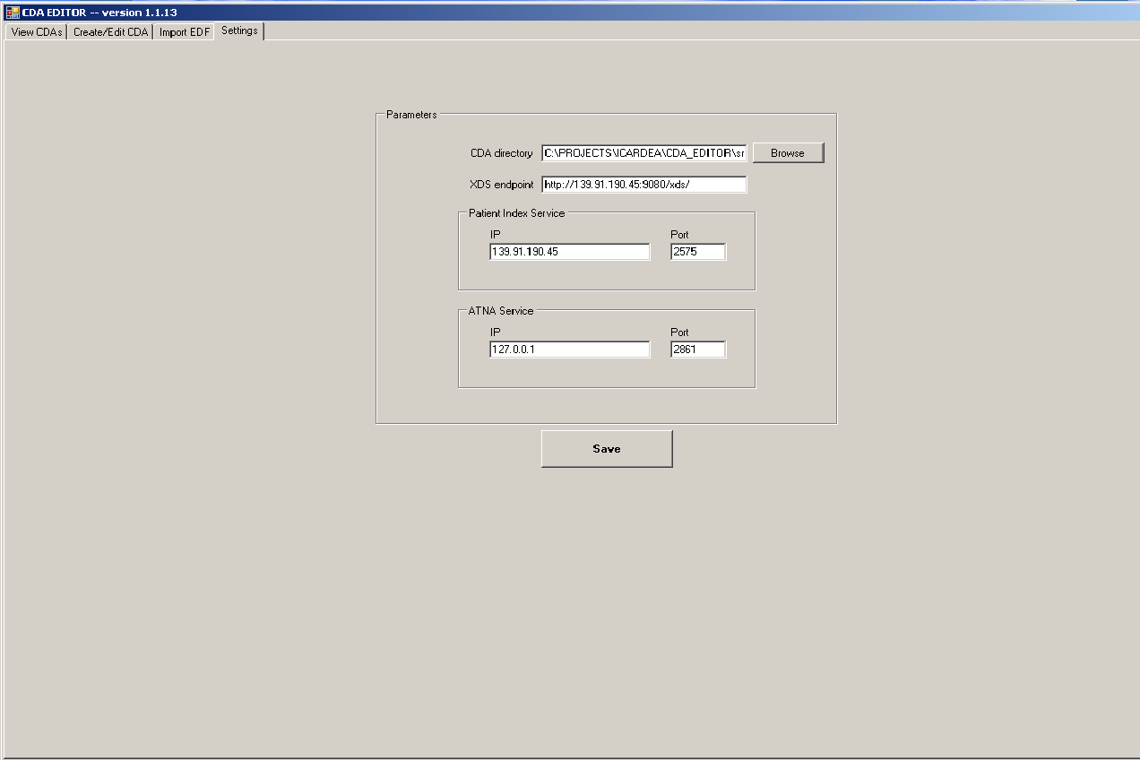

Figure 6