NAME- KANHA SHUKLA
HTML AND CSS ASSIGNMENT
Index.html
<!DOCTYPE html>
<html lang="en">

<head>
<meta charset="UTF-8">
<meta name="viewport" content="width=device-width, initial-scale=1.0">
<title>HTML and CSS Learning Project</title>
<link rel="stylesheet" href="styles.css">
</head>

<body>
<header>
<h1>Welcome to PayPal</h1>
<h2>Learn HTML and CSS with this Sample Project</h2>
</header>

<main>
<section>
<h2>List Example</h2>
<ol>
<li>item1</li>
<li>item2</li>
<li>item3</li>
</ol>
<ul>
<li>item4</li>
<li>item5</li>
<li>item6</li>
</ul>
</section>

<section>
<h2>Table Example</h2>
<table border="1">
<tr>
<td>Header 1</td>
<td>Header 2</td>
</tr>
<tr>
<td>Row 1, Cell 1</td>
<td>Row 1, Cell 2</td>
</tr>
<tr>
<td colspan="2">Row 2, Cell 1 and 2</td>
</tr>

</table>
</section>

<section id="navigation">
<h2>Navigation Example</h2>
<a href="page1.html">SamplePage1</a> or <a href="page2.html">Visit SamplePage2</a>
<p>Visit SamplePage1 or SamplePage2.</p>

</section>

<section>
<h2>Form Example</h2>
<form action="#" method="post">
<label for="name">Name:</label>
<input type="text" id="name" name="name">
<br>
<label for="email">Email:</label>
<input type="email" id="email" name="email">
<br>
<label for="phone">Phone:</label>
<input type="tel" id="phone" name="phone">
<br><br>
<input type="submit" value="Submit">
</form>
</section>
</main>

<footer>
<p>&copy; 2024 HTML and CSS Learning Project</p>
</footer>
</body>

</html>

Style.css
/* General reset and global styles */
body {
font-family: Arial, sans-serif;
margin: 0;
padding: 0;
}

body section {
margin: 20px;
}

/* Header styles */
header {
background-color: #333;
color: #fff;
text-align: center;
padding: 10px;
}

/* Aside styles */
aside {
background-color: #f0f0f0;
padding: 10px;
width: 25%;
float: right;
}

/* Main content styles */
main {
padding: 20px;
}

/* Form styles */
form {
background-color: #f0f0f0;
padding: 20px;
border-radius: 5px;
margin-bottom: 20px;
}

/* Form input styles */
input[type="text"],
input[type="email"],
input[type="tel"] {
width: calc(100% - 22px);
padding: 10px;
margin: 5px 0 10px;
border: 1px solid #ccc;
border-radius: 4px;
box-sizing: border-box;
}

/* Label styles */
label {
display: block;
margin: 10px 0 5px;
}

/* Footer styles */
footer {
background-color: #333;
color: #fff;
text-align: center;
padding: 10px;
position: fixed;
width: 100%;
bottom: 0;
}

/* Enhanced Task: Input Submit Button styles */
/* Uncomment the following properties to enable the button styling */
input[type="submit"] {

background-color: #4CAF50;
color: white;
padding: 10px 20px;
border: none;
border-radius: 4px;
cursor: pointer;

}

input[type="submit"]:hover {

background-color: #45a049;

}

Screenshot of the Output-
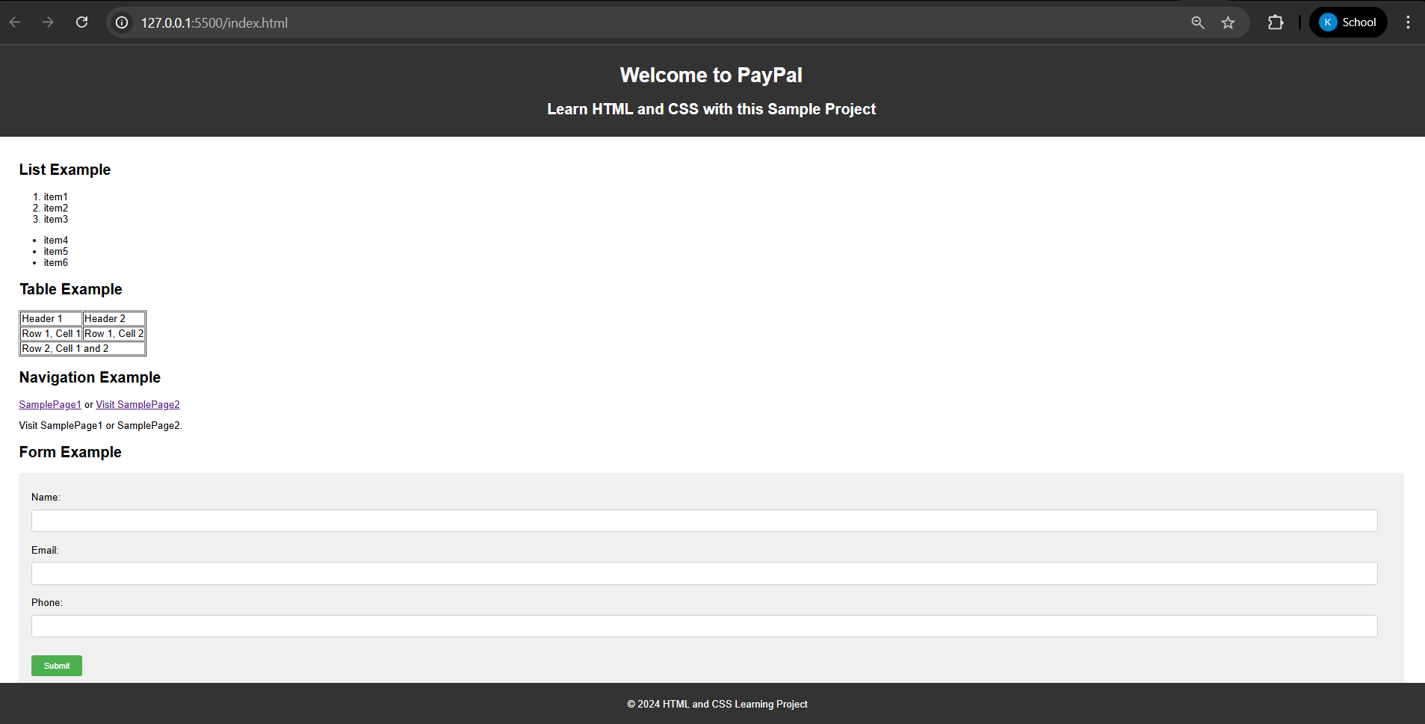

GIT AND INTELLIJ ASSIGNMENT
1. What is the use of the git add command?
The git add command is used to add changes in your working directory to the staging area. This prepares the changes to be included in the next commit.
2. Write the command to create a branch “feature-group”.
Use the following command to create a new branch named “feature-group”:
git branch feature-group
3. What is a pull request? Write the steps involved in creating a pull request.
A pull request is a way to propose changes you’ve made in a branch to be merged into another branch, often the main branch.
Steps: Push your branch to GitHub, go to the repository, click “Compare & pull request,” review your changes, and click “Create pull request.”
4. How do you add collaborators?
Go to your GitHub repository, click on “Settings,” then “Collaborators,” and add the username or email of the collaborator you want to invite.
They will receive an invitation to join your repository as a collaborator.
5. What is the command used to commit our changes in github repo?
The command to commit your staged changes is:
git commit -m "Your commit message"
6. Create a github account and repository to save all your assignment tasks. Example repository name: rg-assignments
Go to github.com, sign up for an account, and log in.
Click “New” to create a repository and name it “rg-assignments” to store your assignment tasks.
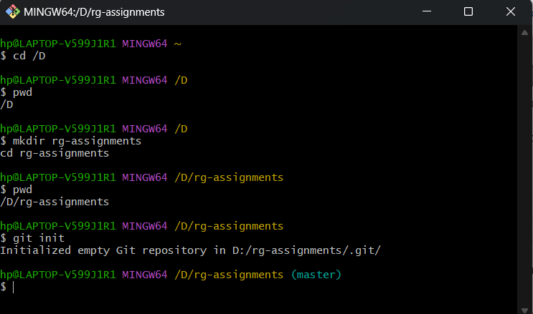
7. Create a branch called feature-java (you can use it later to push all your java related tasks to this branch)
Run the following command to create a branch called “feature-java”:
git branch feature-java
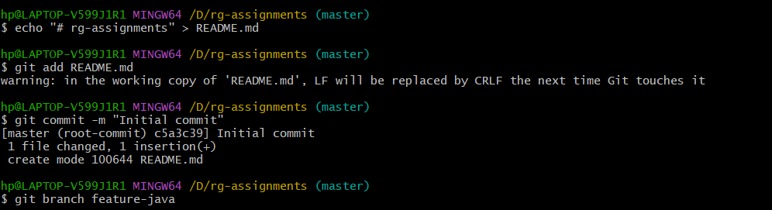
8. Install IntelliJ IDE. Create a simple java project displaying “Hello World!!” and share the screenshot.
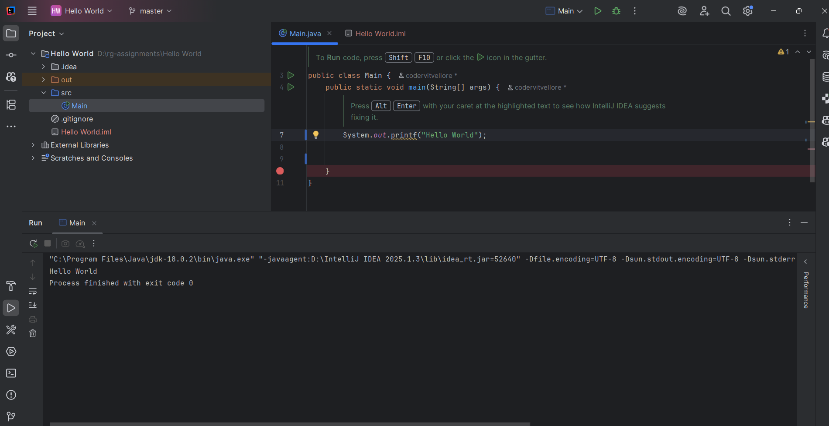 9. In IntelliJ IDE, explore the shortcut keys for the following:
- To run the project: Shift + F10
- To select a line: Place the cursor on the line and press Ctrl + W
- To comment/uncomment a line: Ctrl + /
- To delete a line: Ctrl + Y

GITHUB LINK FOR ALL THE TASKS- https://github.com/codervitvellore/rg-assignments/

