NAME- KANHA SHUKLA TASK-02
CORE JAVA ASSIGNMENT
GITHUB LINK for all the codes- https://github.com/codervitvellore/rg-assignments/

Given:
public class TaxUtil {
double rate = 0.15;
public double calculateTax(double amount) {
return amount * rate;
}
}
Would you consider the method calculateTax() a 'pure function'? Why or why not?
If you claim the method is NOT a pure function, please suggest a way to make it pure.
Ans-The method calculateTax() in the given code is not a pure function.
Why it's not a pure function:
A pure function must:
- Always return the same output for the same input.
- Have no side effects (i.e., it should not depend on or modify any external state).
- calculateTax() depends on the instance variable rate, which is external to the method.
- If rate is changed by another method or via object mutation, the same amount input could result in different outputs.
Hence, it’s not a pure function because it relies on external state (rate).
How to make it a pure function:
To make it pure, you need to remove dependence on external mutable state like rate. Instead, pass rate as a parameter:
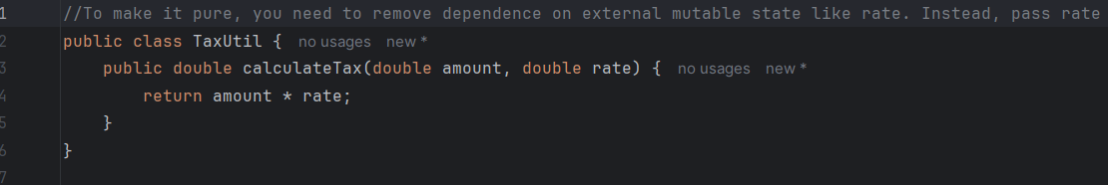
Now:
- The function’s output depends only on its inputs (amount and rate).
- It has no side effects or reliance on external state.
Thus, the modified calculateTax() is a pure function.
Github Link-

Q2) What will be the output for following code?
class Super
{
static void show()
{
System.out.println("super class show method");
}
static class StaticMethods
{
void show()
{
System.out.println("sub class show method");
}
}
public static void main(String[]args)
{
Super.show();
new Super.StaticMethods().show();
}
}

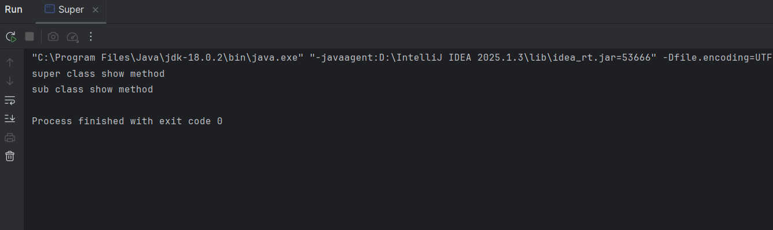
Q3) What will be the output for the following code?
class Super2
{
int num=20;
public void display()
{
System.out.println("super class method");
}
}
public class ThisUse extends Super2
{
int num;
public ThisUse(int num)
{
this.num=num;
}
public void display()
{
System.out.println("display method");
}
public void Show()
{
this.display();
display();
System.out.println(this.num);
System.out.println(num);
}
public static void main(String[]args)
{
ThisUse o=new ThisUse(10);
o.Show();
}
}

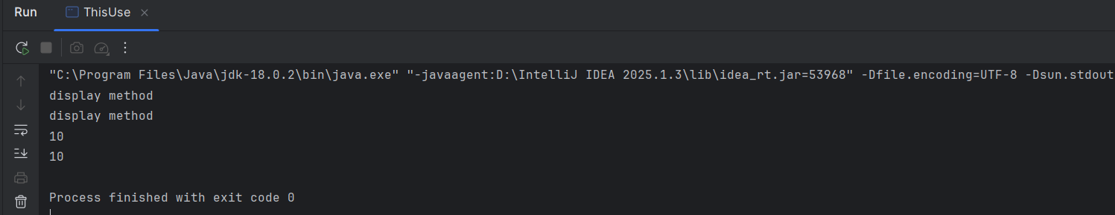

Q4) What is the singleton design pattern? Explain with a coding example.
The Singleton pattern ensures that exactly one instance of a class is created during the lifetime of an application and that this single instance is globally accessible.
Key characteristics
- Single instance: The class is responsible for keeping track of its sole instance.
- Global access point: The same instance can be obtained anywhere in the code through a static method (commonly called getInstance()).
- Controlled instantiation: The constructor is kept private (or otherwise restricted) so that no other code can create additional objects.
- /**
* Thread-safe, lazily-initialized Singleton.
*/
public final class LoggerSingleton {
// Volatile guarantees visibility of changes across threads.
private static volatile LoggerSingleton instance;
// Private constructor blocks external instantiation.
private LoggerSingleton() { }
/**
* Global access point.
* Uses double-checked locking to avoid the cost of synchronization
* after the instance has been created.
*/
public static LoggerSingleton getInstance() {
if (instance == null) { // 1st check (no lock)
synchronized (LoggerSingleton.class) {
if (instance == null) { // 2nd check (with lock)
instance = new LoggerSingleton();
}
}
}
return instance;
}
/* Example business method */
public void log(String message) {
System.out.println("[LOG] " + message);
}
}

public class Main {
public static void main(String[] args) {
// Obtain the same instance twice
LoggerSingleton logger1 = LoggerSingleton.getInstance();
LoggerSingleton logger2 = LoggerSingleton.getInstance();
// Use the logger
logger1.log("Hello, Singleton!");
// Verify both references point to the same object
System.out.println("logger1 == logger2 ? " + (logger1 == logger2));
}
}

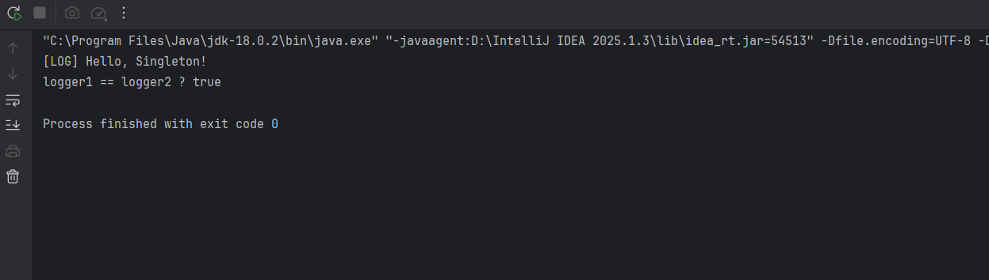

Q5)How do we make sure a class is encapsulated? Explain with a coding example?
Encapsulation is the object-oriented practice of hiding a class’s internal data and exposing only a controlled interface. By preventing outside code from touching (or even seeing) the fields directly, you keep the object in a valid state and can change its internals later without breaking other parts of the program .
How to guarantee a class is encapsulated
Step | What to do | Why it matters
1 | Make all data members private (or at least non-public). | Direct field access is impossible from outside code, ensuring data hiding.
2 | Expose behavior through public (or protected) methods. | Callers interact only with well-defined operations (getters, setters, or domain methods).
3 | Validate input inside mutator methods. | Keeps the object from entering an illegal state.
4 | Avoid returning references to mutable internals. | Prevents callers from quietly mutating your private state.
5 | Prefer immutability when feasible (final fields, no setters). | Eliminates whole classes of bugs by making state unchangeable after construction.

/**
* A fully-encapsulated bank-account model.
*/
public final class BankAccount {
/* ---------- private state (not accessible outside) ---------- */
private final String owner; // immutable once set
private double balance; // mutable, but guarded
/* ---------- constructor ---------- */
public BankAccount(String owner, double openingBalance) {
if (owner == null || owner.isBlank()) {
throw new IllegalArgumentException("Owner name required");
}
if (openingBalance < 0) {
throw new IllegalArgumentException("Opening balance cannot be negative");
}
this.owner = owner;
this.balance = openingBalance;
}
/* ---------- public read-only accessors ---------- */
public String getOwner() { return owner; }
public double getBalance() { return balance; }
/* ---------- public behaviour (the only way to change state) ---------- */
public void deposit(double amount) {
validatePositive(amount);
balance += amount;
}
public void withdraw(double amount) {
validatePositive(amount);
if (amount > balance) {
throw new IllegalArgumentException("Insufficient funds");
}
balance -= amount;
}
/* ---------- private helpers ---------- */
private static void validatePositive(double amount) {
if (amount <= 0) throw new IllegalArgumentException("Amount must be positive");
}
}

public class Main {
public static void main(String[] args) {
BankAccount acct = new BankAccount("Alice", 1_000);
acct.deposit(250); // balance → 1 250
acct.withdraw(300); // balance → 950
System.out.println("Owner : " + acct.getOwner());
System.out.println("Balance : " + acct.getBalance());
}
}

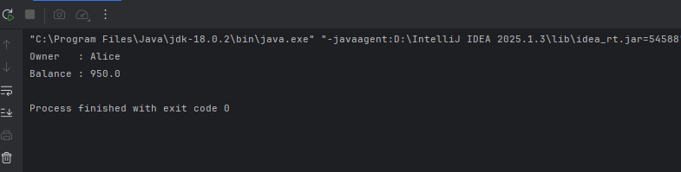

Q6)Perform CRUD operation using ArrayList collection in an EmployeeCRUD class for the below Employee
class Employee{
private int id;
private String name;
private String department;
}
public class Employee {
private final int id;
private String name;
private String department;
public Employee(int id, String name, String department) {
this.id = id;
this.name = name;
this.department = department;
}
/* getters & setters */
public int getId() { return id; }
public String getName() { return name; }
public String getDepartment() { return department; }
public void setName(String name) { this.name = name; }
public void setDepartment(String d){ this.department = d; }
@Override
public String toString() {
return String.format("Employee{id=%d, name='%s', dept='%s'}",
id, name, department);
}
}

import java.util.ArrayList;
import java.util.List;
/* ---------- CRUD Service ---------- */
public class EmployeeCRUD {
private final List<Employee> employees = new ArrayList<>();
/* CREATE */
public void addEmployee(Employee e) {
employees.add(e);
}
/* READ (by id) */
public Employee getEmployee(int id) {
return employees.stream()
.filter(e -> e.getId() == id)
.findFirst()
.orElse(null);
}
/* UPDATE (name & dept) */
public boolean updateEmployee(int id, String newName, String newDept) {
Employee e = getEmployee(id);
if (e == null) return false;
e.setName(newName);
e.setDepartment(newDept);
return true;
}
/* DELETE */
public boolean deleteEmployee(int id) {
return employees.removeIf(e -> e.getId() == id);
}
/* READ-ALL (utility) */
public List<Employee> getAll() {
return new ArrayList<>(employees); // defensive copy
}
/* ---------- Demo ---------- */
public static void main(String[] args) {
EmployeeCRUD crud = new EmployeeCRUD();
// Create
crud.addEmployee(new Employee(1, "Alice", "HR"));
crud.addEmployee(new Employee(2, "Bob", "IT"));
crud.addEmployee(new Employee(3, "Cathy", "Finance"));
// Read
System.out.println("Employee 2 -> " + crud.getEmployee(2));
// Update
crud.updateEmployee(3, "Cathy Brown", "Accounting");
System.out.println("After update -> " + crud.getEmployee(3));
// Delete
System.out.println("Before delete -> " + crud.getEmployee(1));
crud.deleteEmployee(1);
System.out.println("After delete -> " + crud.getEmployee(1));
// List all
System.out.println("Current employees:");
crud.getAll().forEach(System.out::println);
}
}

OUTPUT-
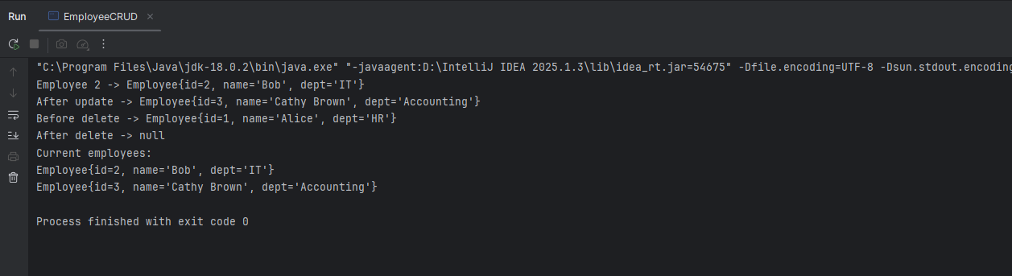
Q7) ConnectionFactory.java
package org.example;
import java.io.InputStream;
import java.sql.Connection;
import java.sql.DriverManager;
import java.util.Properties;
public final class ConnectionFactory {
private static final String PROPS_FILE = "db.properties";
private static String url;
private static String user;
private static String pass;
static {
try (InputStream in = ConnectionFactory.class
.getClassLoader()
.getResourceAsStream(PROPS_FILE)) {
Properties p = new Properties();
p.load(in);
url = p.getProperty("jdbc.url");
user = p.getProperty("jdbc.user");
pass = p.getProperty("jdbc.password");
/* load driver explicitly only if running on JDK ≤ 8 */
Class.forName(p.getProperty("jdbc.driver"));
} catch (Exception ex) {
throw new ExceptionInInitializerError("DB config error: " + ex);
}
}
private ConnectionFactory() { }
public static Connection getConnection() throws Exception {
return DriverManager.getConnection(url, user, pass);
}
}

Employee.Java
package org.example;
public class Employee {
private int id;
private String name;
private String department;
public Employee() { }
public Employee(int id, String name, String department) {
this.id = id;
this.name = name;
this.department = department;
}
public int getId() { return id; }
public String getName() { return name; }
public String getDepartment() { return department; }
public void setId(int id) { this.id = id; }
public void setName(String name) { this.name = name; }
public void setDepartment(String dept) { this.department = dept; }
@Override public String toString() {
return String.format("Employee{id=%d, name='%s', dept='%s'}",
id, name, department);
}
}

EmployeeDAO.java
package org.example;
import java.sql.Connection;
import java.sql.PreparedStatement;
import java.sql.ResultSet;
import java.util.ArrayList;
import java.util.List;
public class EmployeeDAO {
/* ---------- CREATE ---------- */
public void add(Employee e) throws Exception {
String sql = "INSERT INTO employees (id, name, department) VALUES (?,?,?)";
try (Connection c = ConnectionFactory.getConnection();
PreparedStatement ps = c.prepareStatement(sql)) {
ps.setInt(1, e.getId());
ps.setString(2, e.getName());
ps.setString(3, e.getDepartment());
ps.executeUpdate();
System.out.println("[CREATE] " + e);
}
}
/* ---------- READ (one) ---------- */
public Employee find(int id) throws Exception {
String sql = "SELECT * FROM employees WHERE id=?";
try (Connection c = ConnectionFactory.getConnection();
PreparedStatement ps = c.prepareStatement(sql)) {
ps.setInt(1, id);
try (ResultSet rs = ps.executeQuery()) {
if (rs.next()) {
return new Employee(rs.getInt("id"),
rs.getString("name"),
rs.getString("department"));
}
}
}
return null;
}
/* ---------- READ (all) ---------- */
public List<Employee> findAll() throws Exception {
List<Employee> list = new ArrayList<>();
String sql = "SELECT * FROM employees";
try (Connection c = ConnectionFactory.getConnection();
PreparedStatement ps = c.prepareStatement(sql);
ResultSet rs = ps.executeQuery()) {
while (rs.next()) {
list.add(new Employee(rs.getInt("id"),
rs.getString("name"),
rs.getString("department")));
}
}
return list;
}
/* ---------- UPDATE ---------- */
public boolean update(Employee e) throws Exception {
String sql = "UPDATE employees SET name=?, department=? WHERE id=?";
try (Connection c = ConnectionFactory.getConnection();
PreparedStatement ps = c.prepareStatement(sql)) {
ps.setString(1, e.getName());
ps.setString(2, e.getDepartment());
ps.setInt(3, e.getId());
int rows = ps.executeUpdate();
System.out.println("[UPDATE] rows=" + rows);
return rows > 0;
}
}
/* ---------- DELETE ---------- */
public boolean delete(int id) throws Exception {
String sql = "DELETE FROM employees WHERE id=?";
try (Connection c = ConnectionFactory.getConnection();
PreparedStatement ps = c.prepareStatement(sql)) {
ps.setInt(1, id);
int rows = ps.executeUpdate();
System.out.println("[DELETE] rows=" + rows);
return rows > 0;
}
}
}

Main.java
package org.example;
public class Main {
public static void main(String[] args) {
EmployeeDAO dao = new EmployeeDAO();
try {
// CREATE
dao.add(new Employee(1, "Alice", "HR"));
dao.add(new Employee(2, "Bob", "IT"));
dao.add(new Employee(3, "Cathy", "Finance"));
// READ
System.out.println("Employee 2 → " + dao.find(2));
// UPDATE
dao.update(new Employee(3, "Cathy Brown", "Accounting"));
System.out.println("After update → " + dao.find(3));
// DELETE
dao.delete(1);
// READ ALL
System.out.println("Current employees:");
dao.findAll().forEach(System.out::println);
} catch (Exception ex) {
ex.printStackTrace();
}
}
}

OUTPUT
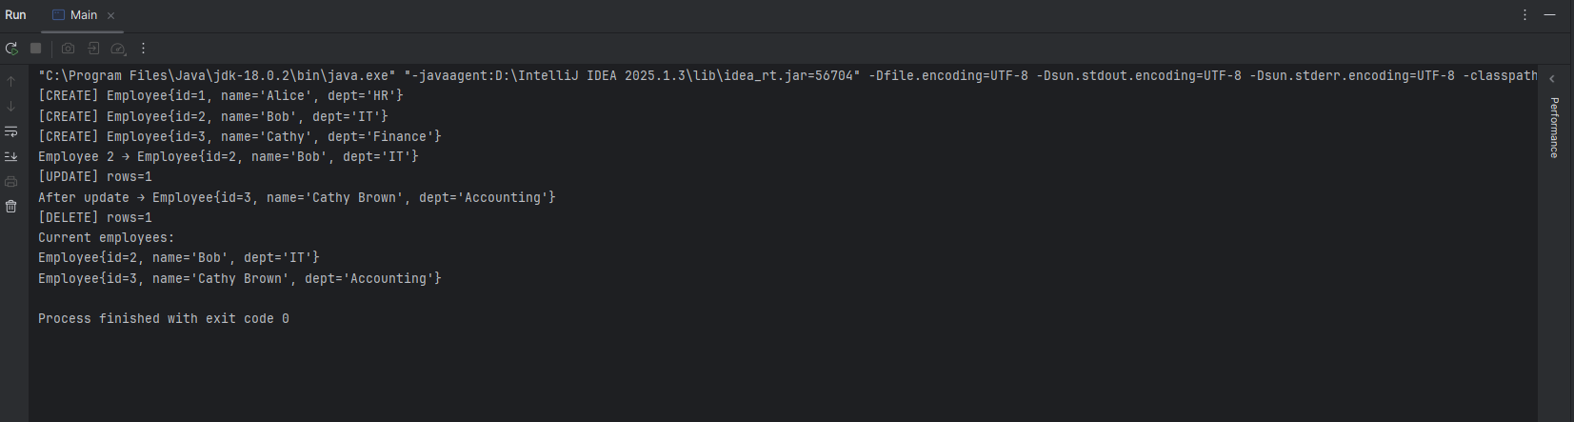

JAVASCRIPT ASSIGNMENT
TASK 1
// Task1: Complete the below statement to initialize the variable 'transactions' as an empty array.
let transactions = [];

TASK-2
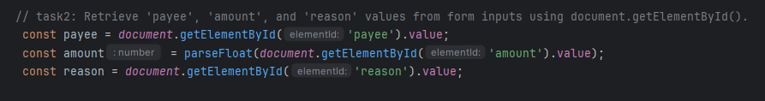

TASK-3
// Task3: Complete the 'newTransaction' object by replacing the placeholder values with appropriate data.
const newTransaction = {
id: id,
payee: payee,
amount: amount,
reason: reason
};

TASK-4
// task4: Complete the below statement to add the 'newTransaction' object into the 'transactions' array using the 'push' method.
transactions.push(newTransaction);

TASK-5
// Task5: Find the transaction with the given 'id' in the 'transactions' array.
const transaction = transactions.find(t => t.id === id);

TASK-6
// Task6: Find the index of the transaction with the given 'id' in the 'transactions' array and remove it using 'splice'.
const index = transactions.findIndex(t => t.id === id);

GITHUB LINK - https://github.com/codervitvellore/rg-assignments/

