CS498_HW11

Mostafa Elkabir, Sooraj Kumar

Elkabir2, Sskumar5

Part 1. Show grid of 10 x 9 for a single MNIST digit- decoded images.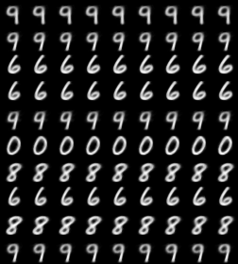

Part 2. Show a grid of 10 x 9 for different digits - decoded images.

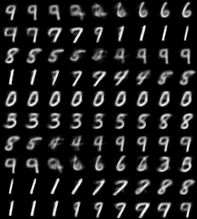

**Code Snippet:**

Below is the lines of code for the most important parts of the assignment. Containing decoder, encoder parts, and building the model.

