I.K GUJRAL PUNJAB TECHNICAL UNIVERSITY,JALANDHAR

**Project Report On**

PROJECT NAME

Submitted in partial fulfillment of the requirements for the award of degree of

## CLASS NAME

**GOLEN INSTITUTE OF MANAGEMENT AND TECHNOLOGY, GURDASPUR**

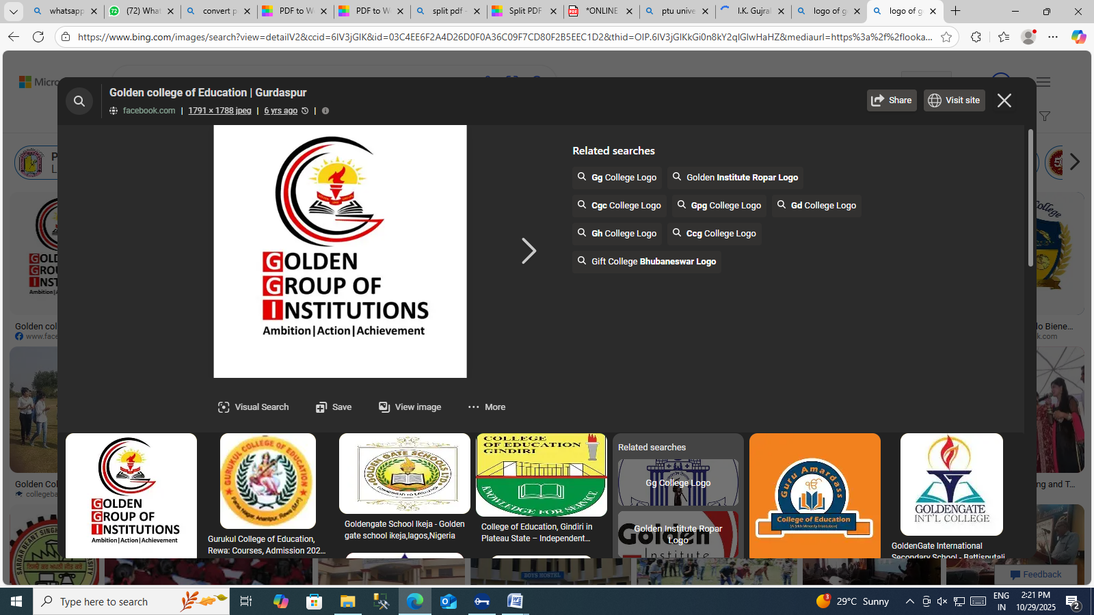

**Submitted To:-**

**Teacher Name**

**Assistant Professor**

**Computer Application Department**

**Submitted By: Name 1**

**(Roll No)**

**Name 2**

**(Roll No)**

# ACKNOWLEDGEMENT

With deep sense of gratitude we express our sincere thanks and obligation to our esteemed guide Teacher Name (Assistant Professor). It is because of her able and mature guidance and co- operation without which it would not have been possible for us to complete our project.

We would also like to thanks Mr Sandeep Sharma, HOD,Computer Applications Department, Golden Institute of Management & Technology, Gurdaspur for providing the institute with an environment where one can use her intellect and creativity to develop something fruitful and also for allowing us the opportunity to experience dynamic professional environment during our Training. This environment facilitated us in pursuing this project.

It is our pleasant duty to thank all the staff members of the Computer Application Department for their time to time suggestions.

Finally, we would like to thanks the almighty and our parents for their moral support and our friends with whom we shared our day-to-day experience and received lots of suggestions that improved our quality of work.

**Name1**

**SHAMSHER SINGH**

**(Roll No)**

**2321369**

**Name2**

**MANJEET**

**KAUR**

**(Roll No)**

# CERTIFICATEOFAPPROVAL

This is certify that the project report entitled **Netflix website clone (UI/front end landing page )** submitted Golden Institute of Management & Technology, Gurdaspur in partial fulfillment of the requirement for the award of degree of MSC(IT)),is an authentic and original work carried out by **shamsher singh 2321369 manjeet kaur**  under my guidance and supervision. The Computer Application Department has accepted the report as the fulfillment of the requirements for the degree of MSC(IT). No part of this report has been submitted to any other College/ University for the reward of any Degree to the best of my knowledge.

## Teacher Name

**Assistant Professor**

**(Project Supervisor)**

**Golden Institute of Mgt & Technology Gurdaspur**

## Mr. Sandeep Sharma

**Head, Computer Application Department**

**Golden Institute of Mgt & Technology Gurdaspur**

# DECLARATION

We hereby declare that this project report on “Netflix website front end/ landing page” which is being submitted in partial fulfillment of the Training Program of B.A.C to Golden Institute of Management & Technology Gurdaspur , is the result of the work carried out by us, under the guidance of Teacher Name (Assistant Professor) Golden Institute of Management & Technology Gurdaspur

**Name1**

**SHAMSHER SINGH**

**(Roll No)**

**2321369**

**Name2**

**MANJEET**

**KAUR**

**(Roll No)**

Project Report: Netflix Website Clone

**1. Project Overview and Objectives**

The **Netflix Website Clone** project is a front-end web development project created to replicate the visual design and layout of the official Netflix landing page. The main objective of this project was to enhance front-end development skills by recreating a popular website interface using only **HTML and CSS**.

The project focuses on understanding real-world UI/UX structure, responsive design principles, layout alignment, and proper use of semantic HTML. By completing this project, I aimed to strengthen my ability to design professional, pixel-perfect, and fully responsive web pages.

**2.Tools and Technologies Used**

* **HTML5:** Used to structure the content and define the layout of the website with proper semantic tags.
* **CSS3:** Used for styling, animations, hover effects, and creating a responsive design for different screen sizes.
* **Visual Studio Code (VS Code):** Chosen as the main IDE for efficient coding, live preview, and extension support.
* **Git & GitHub:** Used for version control and project deployment. The completed code was pushed to my **GitHub repository** for sharing and documentation.

**3. Design and Layout Explanation**

The design closely follows the official Netflix homepage structure. The layout consists of:

* **Header Section:** Includes the Netflix logo and navigation options (Sign In, Language Selection, etc.).
* **Hero Section:** Displays a large background image with overlay text, a headline, and a call-to-action button (“Get Started” or “Watch Now”).
* **Content Sections:** Multiple content rows showcasing movies or features, arranged with images, titles, and short descriptions.
* **Footer Section:** Contains navigation links, contact information, and social media icons, resembling Netflix’s original footer design.

The overall layout was developed using **CSS Flexbox** and **Grid** for alignment and spacing. Careful attention was paid to typography, colors (#E50914 Netflix Red, Black, and White), and proportions to achieve a close visual match.

**4. Key Features and Responsiveness**

* **Fully Responsive Design:** Adjusts seamlessly across desktop, tablet, and mobile screens.
* **Modern UI Elements:** Includes hover animations, image overlays, and consistent spacing.
* **Clean and Semantic Code:** Ensures accessibility and maintainability.
* **Pixel-Perfect Layout:** Matches the spacing, typography, and structure of Netflix’s landing page.
* **Optimized Styling:** Reusable CSS classes for improved code efficiency and consistency.

**5. Challenges Faced and How I Solved Them**

* **Challenge 1: Layout Alignment Issues**  
  Initially, aligning elements perfectly in the hero and content sections was challenging.  
  **Solution:** I used **CSS Flexbox** and **Grid Layout** to control alignment and spacing more precisely.
* **Challenge 2: Responsive Design Adjustments**  
  Adapting sections for smaller screens caused overlapping elements.  
  **Solution:** I used **media queries** to adjust font sizes, image widths, and flex directions for various screen widths.
* **Challenge 3: Image Quality and Scaling**  
  Some background images appeared distorted.  
  **Solution:** I applied the background-size: cover; and object-fit: cover; properties to maintain aspect ratio and image clarity.

**6. Conclusion and Learnings**

This project was an excellent opportunity to apply **front-end development fundamentals** to a real-world design. By cloning the Netflix landing page, I learned how to:

* Create professional and responsive layouts with **HTML and CSS only**.
* Implement **consistent UI patterns** using reusable CSS classes.
* Understand **modern web layout techniques** (Flexbox & Grid).
* Manage and publish a project using **GitHub**.

Overall, the Netflix Website Clone helped me gain confidence in structuring real-world web pages and sharpened my design-to-code conversion skills. It serves as a strong addition to my portfolio, demonstrating my ability to build modern, responsive interfaces with clean and maintainable code.